Chronomètre

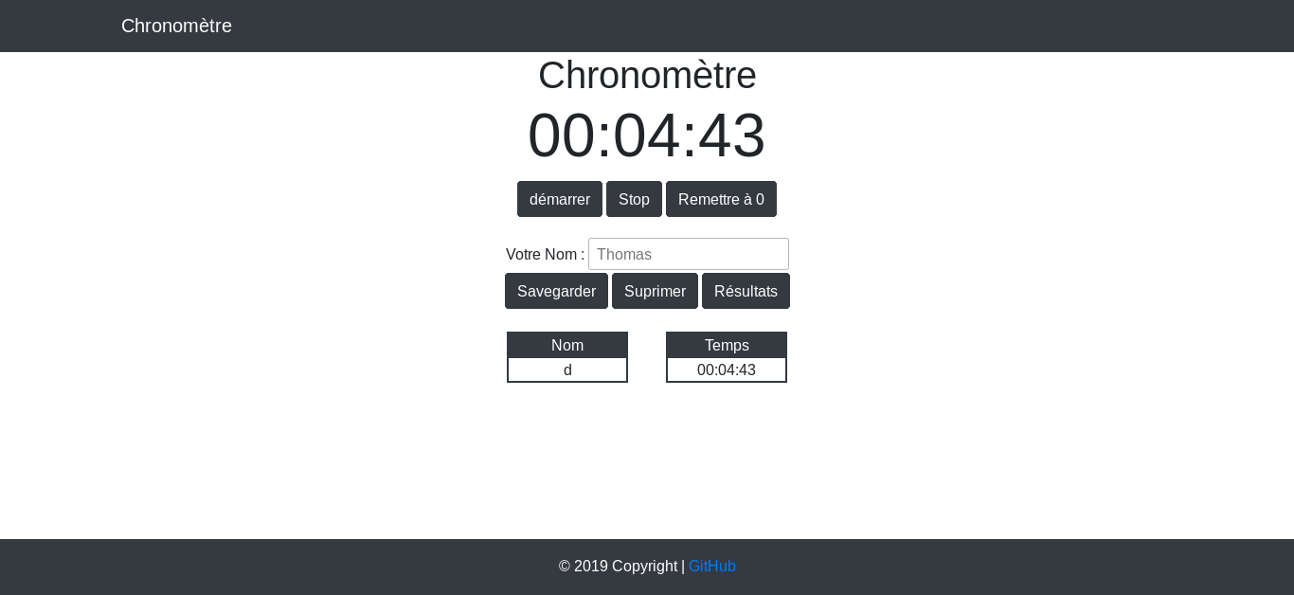
1
3
4
2
5
8
7
6
10
9
- Button to start the stopwatch
- Button to stop the stopwatch
- Button to reset the stopwatch
- Your current time
- Location to fill in your Name / Nickname
- Button to save your score
- Button to delete your score
- button to see all of your saved score
- Table where your name appears, which you have entered
- Table where your score will appear

