Chronomètre

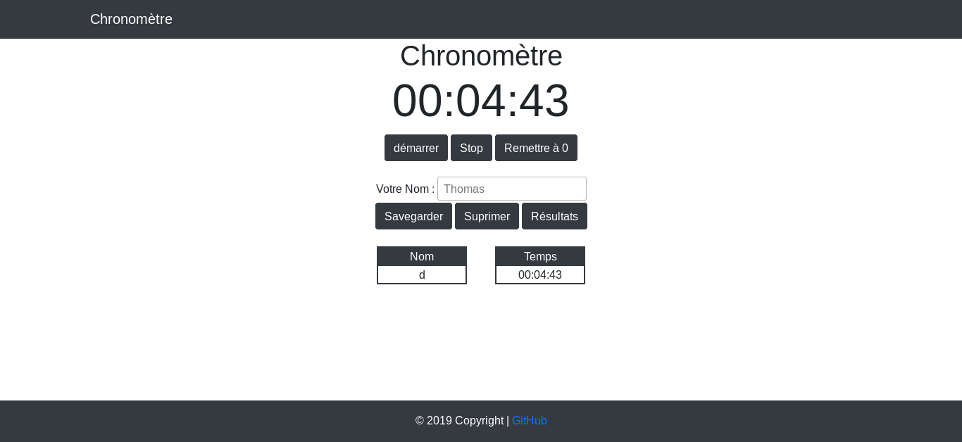
1
3
4
2
5
8
7
6
10
9
- This button start the function 'startTimer'
- This button start the function 'Stop button, onclick'
- This button start the function 'buttonReset, onclick'
- The current time is declared in HTML with 'span'
- This location is an 'input' that must be filled in to record a score
- This button is the function 'savedernierTime', it saves the saved times with a localStorage,setItem
- Use the function 'removeTimer' with this command: localStorage, clear () / it reset the input value
- Use the function ‘display’ which adds a table to each score saved (1 table per score) we use 'li' in the HTML for tables
- Location of your saved scorecards

