INTERNSHIP REPORT
OF
GENERATIVE AI INTERNSHIP
Submitted
To
School of Computer Science and Engineering
IILM University, Greater Noida, U.P.
In partial fulfilment of the requirement of degree of
B.Tech CSE
By
Roll Number / Admission Number: 25SCS1003004969
Name of Student: GAURAV TRIPATHI
Batch: 2025 – 2029
Academic Year: 2026 – 2027


- CANDIDATE’S DECLARATION
I, GAURAV TRIPATHI, do hereby declare that the internship report titled “GENERATIVE AI INTERNSHIP” has been completed by me to fulfil the requirement for the award of the degree of Bachelor of Technology in CSE. All the references have been quoted and I have not taken as such any material from any other source. I affirm to you that this report is my own and has not been submitted to any other institute for any degree/diploma requirement and further I shall be solely responsible for any kind of copyright violation in this regard.
Signature
Student Name: GAURAV TRIPATHI
Roll No.: 25SCS1003004969

2. ACKNOWLEDGEMENT
I would like to express my sincere gratitude to everyone who supported and guided me throughout my Generative AI Internship at Prodigy InfoTech. This internship provided me with an opportunity to strengthen my practical knowledge of Generative AI and apply my understanding of pre-trained generative models, statistical text generation and neural image processing through practical tasks.
I am thankful to IILM University, the faculty members and Prodigy InfoTech for providing me with this learning opportunity. I am also grateful to my parents for their continuous support and encouragement throughout this internship. The experience gained during this internship has helped me improve my practical AI skills, problem-solving ability and confidence in working with generative models and Python-based experimentation.
Signature
Student Name: GAURAV TRIPATHI
Roll No.: 25SCS1003004969

3. INTERNSHIP COMPLETION CERTIFICATE
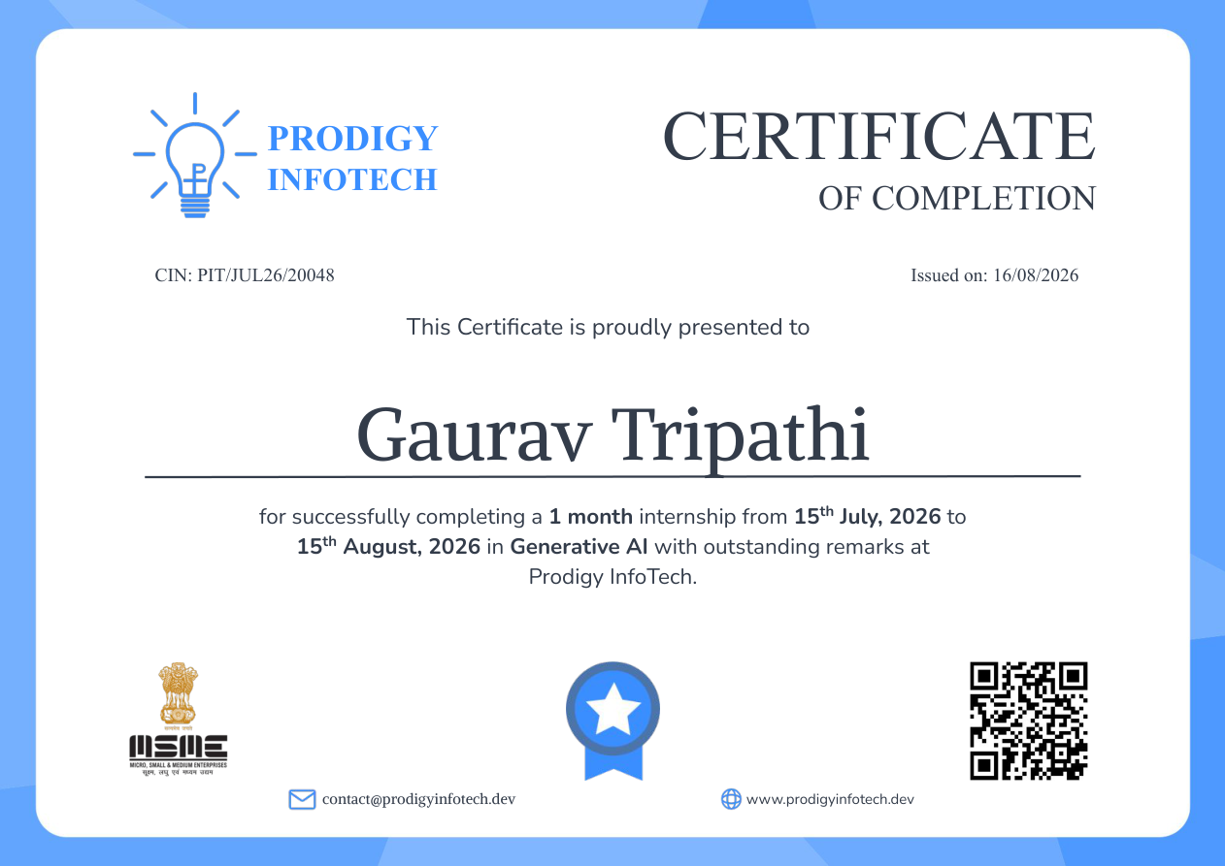

4. PROJECT DESCRIPTION
4.1 INTRODUCTION
The Generative AI Internship at Prodigy InfoTech provided an opportunity to gain practical exposure to modern generative artificial intelligence concepts. The internship was conducted for one month from 15th July 2026 to 15th August 2026. The internship tasks focused on understanding how AI systems can generate new content and transform existing content using different computational techniques.
From the assigned task list, three comparatively approachable tasks are documented in this report: Image Generation with Pre-trained Models, Text Generation with Markov Chains, and Neural Style Transfer. These tasks cover image generation, statistical sequence generation and neural image transformation, giving practical exposure to different areas of Generative AI.
4.2 ORGANIZATION PROFILE
Prodigy InfoTech provided the opportunity for this Generative AI Internship. I joined the organization as a Generative AI Intern for an educational internship program. The offer letter states that the internship provided an opportunity to work on real-world projects, build practical skills and contribute meaningfully to the team. The program was scheduled from 15th July 2026 to 15th August 2026.
Organization: Prodigy InfoTech
Domain: Generative AI
Internship Duration: 15 July 2026 – 15 August 2026
4.3 PROBLEM STATEMENT
The internship required the exploration and implementation of different Generative AI techniques according to the specified task requirements. The main problem was to understand how generative systems can create new text or images, or transform existing images, while producing outputs that are relevant to the given input or objective.
The selected tasks cover three different approaches: generating images from text prompts using pre-trained models, generating text using Markov-chain transition probabilities, and transferring the artistic style of one image to the content of another image using neural style transfer.
4.4 PROJECT OBJECTIVES
• To understand fundamental concepts of Generative AI and content generation.
• To explore image generation using pre-trained generative models.
• To implement a simple statistical text generation approach using Markov chains.
• To understand content and style representations in neural style transfer.
• To gain practical experience with Python and notebook-based AI experimentation.
• To improve problem-solving, experimentation and documentation skills.
• To understand practical applications and limitations of different generative approaches.
4.5 SCOPE OF THE PROJECT
The scope of this internship report is focused on the three selected Generative AI tasks that are suitable for clear practical documentation. The project covers prompt-based image generation, Markov-chain-based text generation and neural style transfer. The work provides a foundation for understanding more advanced generative models such as transformers, GANs and diffusion-based systems.
4.6 TECHNOLOGIES AND TOOLS USED
4.6.1 Python
Python was used as the primary programming language for implementing and experimenting with the selected AI tasks.
4.6.2 Google Colab / Jupyter Notebook
A notebook environment can be used for running Python code step-by-step, experimenting with models and observing outputs.
4.6.3 Pre-trained Generative Models
Pre-trained models such as DALL-E-mini or Stable Diffusion can be used to generate images from descriptive text prompts.
4.6.4 Markov Chains
Markov chains were used as a statistical technique for predicting the next character or word from previous sequence information.
4.6.5 Neural Style Transfer
Neural style transfer was used to combine the content characteristics of one image with the artistic style of another image.
4.6.6 Python Libraries
Common Python libraries and model-specific packages can be used for data handling, image processing, numerical computation and model execution.
4.7 SYSTEM ARCHITECTURE
The selected Generative AI tasks follow an input-processing-generation-output workflow. For image generation, a text prompt is supplied to a pre-trained model and an image is generated. For Markov text generation, a text corpus is converted into transition probabilities and those probabilities are used to generate a new sequence. For neural style transfer, a content image and a style image are processed to produce a stylized output.
INPUT → PRE-PROCESSING → MODEL / ALGORITHM → GENERATED OUTPUT → EVALUATION
4.8 METHODOLOGY
Step 1 – Understanding Requirements
The requirements of each selected task were studied before beginning the implementation.
Step 2 – Preparing Inputs
Text prompts, text corpus, content image and style image were prepared according to the selected task.
Step 3 – Model / Algorithm Selection
A suitable pre-trained model or statistical/neural technique was selected for the task.
Step 4 – Implementation
The selected method was implemented and executed in a Python/notebook environment where applicable.
Step 5 – Output Generation
The model or algorithm generated the required text or image output.
Step 6 – Testing and Observation
The output was reviewed for relevance, quality and expected behaviour.
Step 7 – Documentation
The methodology, learning outcomes and supporting internship documents were compiled into this report.
4.9 EXPECTED OUTCOMES
Task 02 – Image Generation with Pre-trained Models
The objective of Task 02 was to utilize pre-trained generative models such as DALL-E-mini or Stable Diffusion to create images from text prompts. The workflow involves preparing a descriptive prompt, passing it to the selected model, generating an image and reviewing the result for relevance to the prompt.
• Preparation of a clear and descriptive text prompt.
• Use of a pre-trained text-to-image generative model.
• Generation and observation of an image based on the prompt.
• Understanding of prompt quality and model output relevance.
Figure 1: Image Generation with Pre-trained Models
Task 03 – Text Generation with Markov Chains
The objective of Task 03 was to implement a simple text generation algorithm using Markov chains. The method builds a statistical model that predicts the probability of a character or word based on previous sequence information. The workflow includes preparing a text corpus, calculating transitions, deriving probabilities and generating a new text sequence.
• Preparation and cleaning of the text corpus.
• Calculation of character- or word-level transitions.
• Conversion of transition counts into probabilities.
• Generation of new text using the learned transition probabilities.
Figure 2: Text Generation with Markov Chains
Task 05 – Neural Style Transfer
The objective of Task 05 was to apply the artistic style of one image to the content of another image using neural style transfer. The method uses neural representations of content and style and optimizes an output image so that it retains the important content while adopting visual characteristics from the selected style image.
• Selection of a content image and a style image.
• Extraction of content and style representations.
• Optimization of an output image using content and style objectives.
• Observation and evaluation of the final stylized image.
Figure 3: Neural Style Transfer
Overall Outcome
The completion and study of these three tasks provided practical exposure to different Generative AI approaches. The work helped in understanding prompt-based image generation, statistical text generation and neural image transformation. It also improved familiarity with experimentation, model workflows and technical documentation.
4.10 CERTIFICATES OF COMPLETION AND COMMUNICATION MAIL PROOF
The internship completion certificate and offer letter are attached below as supporting documents. The completion certificate confirms successful completion of a one-month Generative AI internship from 15th July 2026 to 15th August 2026 at Prodigy InfoTech.
Figure 4: Internship Completion Certificate


Figure 5: Internship Offer Letter
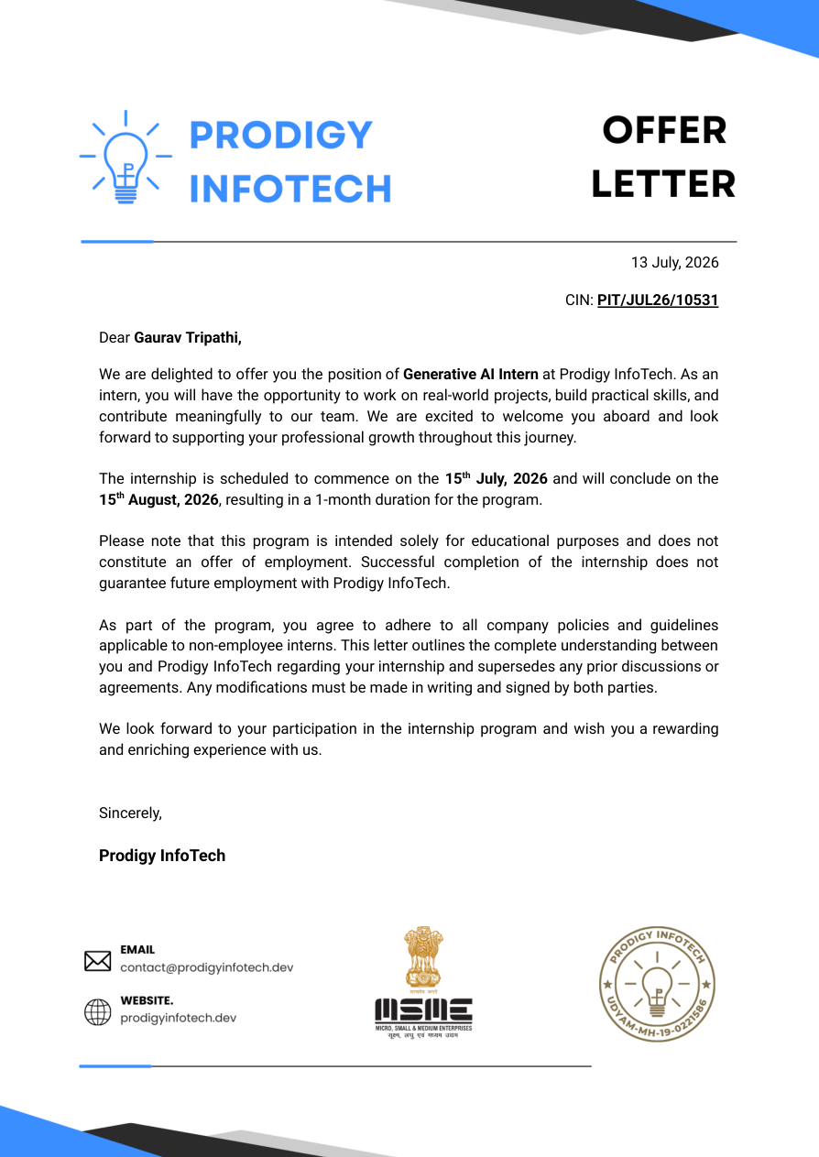
Note: If required by the university, internship communication-mail screenshots can be added after the offer letter as an additional supporting figure.

5. BIBLIOGRAPHY / REFERENCES
[1] Prodigy InfoTech, Generative AI Internship Task Material, 2026.
[2] Prodigy InfoTech, Offer Letter for Generative AI Internship, dated 14 July 2026.
[3] Prodigy InfoTech, Certificate of Completion, issued 16 August 2026.
[4] Python documentation and standard library references used during experimentation.
[5] General technical references on Markov Chains, Generative AI and Neural Style Transfer.

