ccc

Final robotic report

The cigarette collector robot

2024

Author name: Darish Nursing

Author student ID: M00956040

4/14/2024





**University:** Middlesex University of Mauritius

**Module:** [PDE3413 Systems Engineering for Robotics](https://mdx.mrooms.net/login/index.php?saml=on)

**Abstract**

This project report details the design and implementation of a robotic system inspired by a spider for the purpose of autonomously collecting cigarette butts. The aim of this project is to address the environmental issue of cigarette butt litter by developing a specialized robot capable of navigating outdoor environments and effectively removing discarded cigarette butts.

The report begins with an introduction highlighting the problem of cigarette butt pollution and the proposed solution of using a robotic spider for automated collection. The project's objectives include designing and building a functional prototype of the robot, implementing motion and collection mechanisms, and evaluating its effectiveness in real-world scenarios.

A comprehensive literature review explores existing robotic systems for environmental cleanup, highlighting relevant technologies such as sensing, and grasping methods. The design phase outlines the conceptual behavior of the spider robot, detailing its mechanical structure, locomotion capabilities, and cigarette butt collection mechanism.

Implementation involves the physical construction of the robot prototype, integration of sensors for environmental perception, and development of algorithms for autonomous navigation and butt collection. The testing phase includes component testing to validate individual functionalities, as well as system-level testing to assess overall performance in outdoor environments.

Throughout the report, diagrams and tables are utilized to illustrate design concepts, sensor integration, and testing procedures. The evaluation and conclusion section summarizes the achievements of the project, discusses challenges encountered, and suggests future improvements such as enhancing robot autonomy and optimizing collection efficiency.

The references section provides a comprehensive list of all sources consulted during the project, including academic literature and online resources related to robotics, environmental science, and waste management.

This project aims to demonstrate the feasibility of using robotics technology to address specific environmental challenges and contribute to the advancement of autonomous systems for sustainable urban maintenance.

**Table of content**

|  |  |
| --- | --- |
| **content** | **Page number** |
| **Title page** | **Cover page & pg1** |
| **abstract** | **Pg1-pg2** |
| **Table of content** | **Pg3** |
| **Introduction** | **Pg3-pg4** |
| **Aims and objectives** | **Pg4-pg5** |
| **Literature review** | **Pg7-pg9** |
| **Design** | **Pg9-pg15** |
| **Implementation** | **Pg16-pg32** |
| **Testing** | **Pg33-pg36** |
| **Evaluation and conclusion** | **Pg39-pg42** |
| **references** | **Pg42-pg43** |

**Introduction**

In almost all countries, in society, smoking poses as a serious health hazard but not only that. The discarding of cigarette butts also has serious impacts such as:

**\*Environmental pollution:** Cigarette butts are a common form of litter, and they pose a significant environmental hazard. They do not biodegrade quickly, and the toxic chemicals in cigarette filters can leach into the soil and water, harming ecosystems.

**\* Fire risk:** Discarded cigarette butts can pose a fire risk in dry or flammable areas.

**\*Aesthetic degradation:** Littered cigarette butts are unsightly and can negatively affect the aesthetics of public spaces.

**\*Increased cleaning cost:** governments spend significant resources on manual litter cleanup.

**Proposed Solution:**

The creation of a novel robotic device designed especially for gathering abandoned cigarette butts in public areas is the suggested remedy. By implementing an autonomous and effective collection system, this project seeks to address the ongoing problem of cigarette butt littering by using breakthroughs in robotics, object detection, and environmental conservation.

**Aim & Objectives**

**Aims:**

The proposed solution aims to use an autonomous robot that can travel through different terrains and public spaces on its own to gather hazardous waste products in order to address cigarette butt littering. The robot will distinguish cigarette butts from other trash items by using cutting-edge sensor technology and object detection algorithms, guaranteeing accurate and focused collecting.

**\*Environmental aim:**

According to the American Burn Association, about 900 people in the United States die each year in fires started by cigarettes butts. Wildfires are often caused by cigarette butts too thus being a dangerous hazard and this project aims to minimize this danger.

**\*Public Health aim:**

Cigarette butts, especially in public spaces, can serve as a visual cue and influence young individuals to start smoking. Exposure to cigarette litter can normalize smoking behavior, which can contribute to youth initiation of smoking and its associated health risks.Reducing cigarette butt litter and discouraging smoking in public areas can have a positive impact on public health by decreasing exposure to toxic chemicals and creating cleaner, safer environments.

**Objectives:**

* Construct a small, nimble robot that can go across a variety of settings and terrains to efficiently gather cigarette butts.

*Use object detection and sensors to give the robot the ability to distinguish cigarette butts from other waste products.

* Create a strong collection system to collect and safely store cigarette butts inside the robot.

* Integrate self-navigating technologies to move about and cover assigned regions more effectively.

*Thorough testing and optimization are necessary to guarantee the robot's dependability, robustness, and effectiveness in practical situations.

**Background research**

Creating a robot to collect cigarette butts involves several areas of study, including robotics, environmental science, and public health. Here is some background research on the topic;

**\*Robotics and Automation:**

The aim of the robot is to identify cigarette butts and collect them and this action can be done in a variety of ways using different mechanical concepts such as robot arms and grippers, which are essential for designing a robot to pick up cigarette butts. Robots can also learn and adapt to their environment, improving their ability to navigate and collect litter.

**\*Environmental Science:**

It is estimated that approximately 5.8 trillion cigarettes is consumed worldwide and this number also logically reflect the number of cigarette butts that pollute our environment.

Also according to the American Burn Association, about 900 people in the United States die each year in fires started by cigarettes butts. Wildfires are often caused by cigarette butts too thus being a dangerous hazard.

**\*Public Health:**

Cigarette butts, especially in public spaces, can serve as a visual cue and influence young individuals to start smoking. Exposure to cigarette litter can normalize smoking behavior, which can contribute to youth initiation of smoking and its associated health risks.Reducing cigarette butt litter and discouraging smoking in public areas can have a positive impact on public health by decreasing exposure to toxic chemicals and creating cleaner, safer environments.

**\*Waste Recycling:**

Cigarette butts can be recycled, but it is a complex and challenging process due to the toxic materials found in cigarette filters. The recycling process for cigarette butts can be costly and may not be widely available in many regions. Efforts are underway to find more sustainable and eco-friendly alternatives to cigarette filters, as they are a significant source of litter and environmental pollution.

**Literature review**

Different robots have been built over the years which relate to the theme of our project, such as Beachbot and Cigbot. Both robots reduce human labor through Automation. They also cover specific areas efficiently.

**Beachbot**

\***Description & features**

It has two cameras located at the front and rear. Under the robot, there are two arms that can pick up cigarette butts. The waste will be identified thanks to AI, and more precisely thanks to visual recognition and image detection algorithms.

\***strengths**

BeachBot has successfully picked 10 cigarette butts in 30 minutes in its first demo. It was successful because it uses AI that has been specifically developed to detect cigarette butts effectively.

\***Limitations**

Limited scalability in handling widespread littering.

Dependence on user compliance or human intervention.

Cannot operate in bad weather or when its raining as robot is not waterproof.

\***Improvements**

The beach bot could first make sure that the cigarette butt has stop burning before putting it in the internal bin as a fire could spread from there.

Advanced Sensor Technology: Developing sensors specifically tuned to detect and differentiate cigarette butts from other waste.

**CigBot**

\***Description & features**

Safely drive around the sidewalks in the city. Collect and dispose of the cigarette butts. Use a Raspberry Pi and a Pi Camera to take pictures of cigarettes, process the image, and then output coordinates of the location of the cigarette for the robot.

\***strengths**

The cigbot was successful as solid works were used to design the chassis, roller/sweeper-mechanism, and mounts for the camera of the robot. For the robot, VEX parts were used to assemble it. Also the mount was 3D-printed based on the solid works model.

\***Limitations**

The cigbot had a few limitations such as it cannot go on various terrains, though cigbot is made for the sidewalk, it may encounter rough terrain, A more powerful battery or motor could be an improvement.

Cannot operate in bad weather or when its raining as robot is not waterproof.

\***Improvements**

Robotic Precision: Designing robots with precise collection mechanisms and AI that specifically target and collect cigarette butts without missing them.

A waterproof casing for the whole electronic parts of the robot would be great against rain or water pools on the road.

An alarm system if the robot is robbed by someone as the electronic parts might be expensive.

These improvements could significantly elevate the efficacy of existing solutions and move closer toward mitigating the environmental hazards caused by cigarette butt littering.

**Design**

**System proposal and concept behavior**

**Proposed solution**

This project aims to address the persistent issue of cigarette butt litter by providing a technological solution that complements existing waste management practices. Through the implementation of an autonomous robot, the objective is to significantly reduce the environmental impact caused by discarded cigarette butts.

This creative solution not only tackles the problem of cigarette butt litter, but it also fits in with larger initiatives to support environmentally friendly practices and responsible trash disposal especially at the beach.

Additionally, the design will concentrate on producing a small, nimble, and intuitive robot with the similar appearance of a crab outfitted with strong electronic devices for gathering/collecting and safely storing cigarette butts as the main zone of work for the robot is the beach. The robot's efficiency and coverage within the assigned collection zones will be improved by the integration of autonomous navigation technologies and cigarette butts detection will be implemented using AI.

**Key Features of Proposed System**

**Sensors and camera:** The sensors that will be used to build the robot include ultrasonic distance sensor which will be used to detect presence of obstacles in front of the robot. The camera will use object and image detection software to identify cigarette butts in the environment.

**Collection system**: To collect and store cigarette butts, a gripper powered by servo motors in front of the robot will be used. After identification of cigarette butts the gripper will position itself at the top of the cigarette butt before moving downwards to collect it and dispose it in a container found below the robot’s core.

**Mobility:** Since the robot will resemble a crab as its targeted zone is the beach, the robot will have six legs powered by servo motors to allow the robot to move forwards, backwards, to rotate itself and to allow it to move over various types of surfaces.

**Functional Components and their Interconnection**

**Arduino Microcontroller:** the arduino mega will be used in this project and it serves as the brain of the whole robot. It is the arduino microcontroller that upon processing the codes we upload and the sensor data received, control the robot's movements and actions by activating actuators.

**Sensors and camera:** Ultrasonic Sensors and the camera detect the presence of people, obstacles and cigarette butts respectively and send this data to the arduino microcontroller which then processes it to know what to do next (activates actuators).

**Servo Motors:** servo motors are used a lot in this project. The microcontroller enables the servo motors to activate and rotate when the camera detects a cigarette butt. Think about the joints in the leg of a crab the servo motors acts as such and are used for navigation as well as for the gripper to collect the cigarette butts.

**Power Supply:** Batteries will Supply power to the Arduino, servo motors, and other components for those electronic components to work.

**Push button**: a push button will activate and also switch off the whole robot as the push button will interrupt the power supply to any of the electronic components used.

**Interaction**

**Robot-Human Interaction:** through the LED lights the robot can interact with the user to indicate that its battery is nearly dead by blinking or the robot can turn the LEDs red to indicate that storage is full and that the user needs to empty the robot’s container manually.

**Human-Robot Interaction:** users may interact with the robot by providing the initial setup program that will enable the robot to achieve the expected task or for maintenance. The user can also interact with the robot using the push button to switch the robot on or off before uploading new codes or before empting the robot’s container. This push button also serves as a security system for the user.

**Robot-Environment Interaction:** The robot uses sensors to navigate across the area and identify obstructions and cigarette butts. It stays clear of obstacles in its route and gathers cigarette butts while also detecting human presence and stop briefly to prevent bumps or collisions

.

**Logical diagram for functional components**

Push button

Gripper servo motors

Movement servo motors

Arduino

battery

sensors

camera

**Physical construction**

Careful consideration goes into the physical building of a robot intended to gather cigarette butts, including the choice of development board, connection diagrams, and component configuration.

**Components Selected**

**Arduino mega board:**(Arduino Mega 2560) Selected for its ease of use, numerous pin outlets and It provides an ideal platform for integrating electronic components.

**Gripper Actuator:** makes use of servo motors for the collection of cigarette butts.

**Servo motors: (**tower pro SG90) servo motors are used for the legs and the gripper to enable movement through the rotation of the servo motors.

**Ultrasonic Sensor: (**HC-SR04**)** in used in obstacle avoidance during navigation.

**Pi Camera: (**Module rev 1.3**)** used to detect cigarette butts through image and object detection software using rasbery pi.

**Rasbery pi:** (Pi 4 Model B) used to host the software nessesary for the cigarette butt imge detection. Also needed for the robot visual recognition of cigarette butts in the environment.

**Battery: (**Panasonic CR2032**)** used to power the whole robot even the arduino board.

**Push button: (**Omron B3F Series**)** used to switch on and off the robot.

**Physical Configuration**

Arduino mega placed at the core, serving as the central control unit.

Ultrasonic sensor positioned in front on the robot's body for efficient detection.

Servo motors responsible for movement in the legs of the robot and the servo motor powered gripper actuator responsible for collecting cigarette butts.

Camera connected to rasbery pi, and arduino for correct cigarette butt identification.

Battery connected to arduino board to power the whole robot.

Leds connected to arduino board to blink when appropriate.

Push button connected to the arduino and battery to switch on or off the robot.

**Development board**

The development board that will be used in this project is the arduino mega development board and the reasons for using this development board are below.

*More Pins: When compared to the Arduino Uno, the Mega has a substantially higher number of digital and analogue I/O pins. Larger projects or those requiring a high number of sensors, actuators, or components will benefit from this.

*Greater Processing Power: Compared to the Uno, the Mega has a microcontroller with greater processing power, which enables it to perform calculations and handle more complicated tasks. This makes it appropriate for applications like robotics and data processing.

**Initial Connection diagram & pinout table**

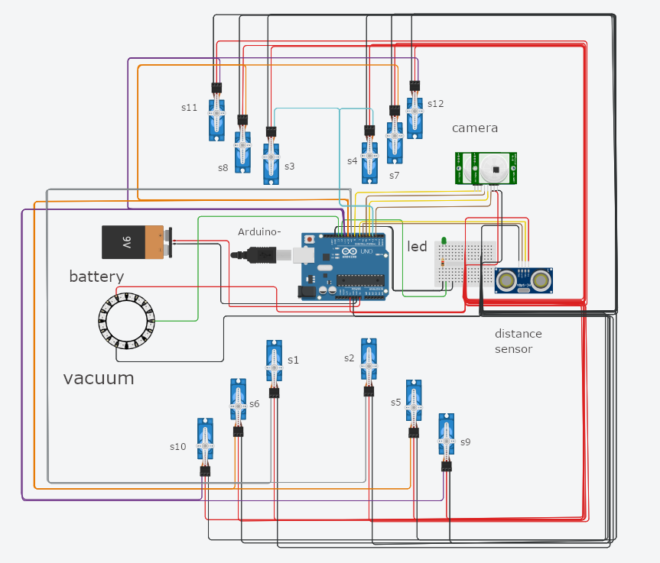

|  |  |  |
| --- | --- | --- |
| Features | Color wire | pin |
| battery | Red, black | Gnd, v1 |
| Led light | Green | Gnd, 12 |
| Ultrasonic distance sensor | Brown, yellow | 6, ~7 |
| camera | Brown, yellow | 8, ~5, 4, 2 |
| Servo motor 1& 2 | grey | ~9 |
| Servo motor 3 & 4 | blue | ~3 |
| servo 5,6,7,8 | Orange | ~10 |
| Servo 9,10,11,12 | Purple | ~11 |
| vacuum | Green | 13 |

**3D diagram of model**

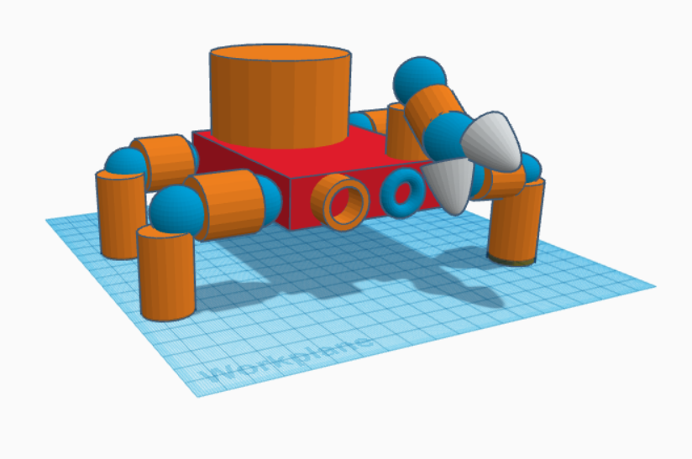

**Implementation**

The implementation for this project after the design phase starts of by the physical construction of the robots body parts which are not electronic.

The use of plastic bottle caps was made by melting and molding them into structure for the robot.



The molding of plastic into structural shapes for the robot arm.

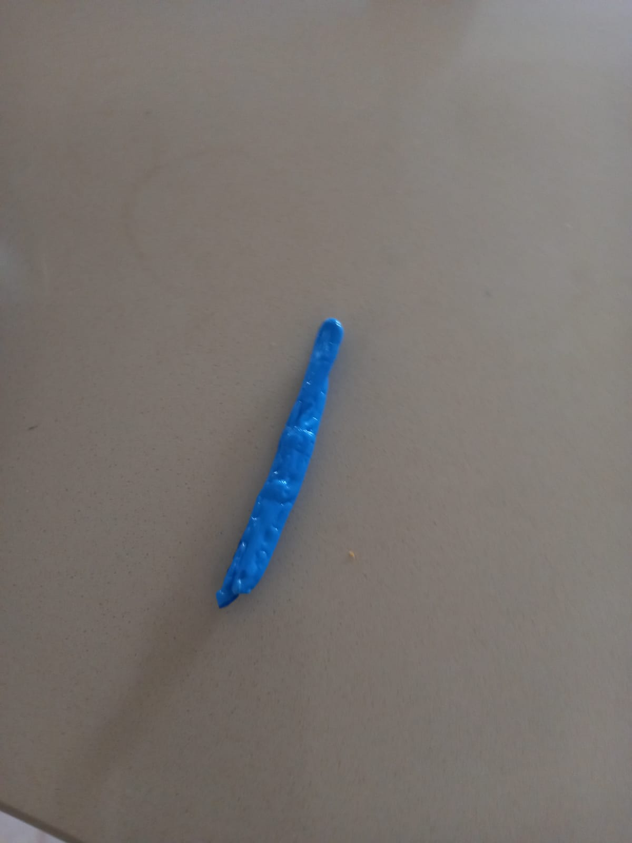

**The editing and polishing of the components to decrease the weight.**

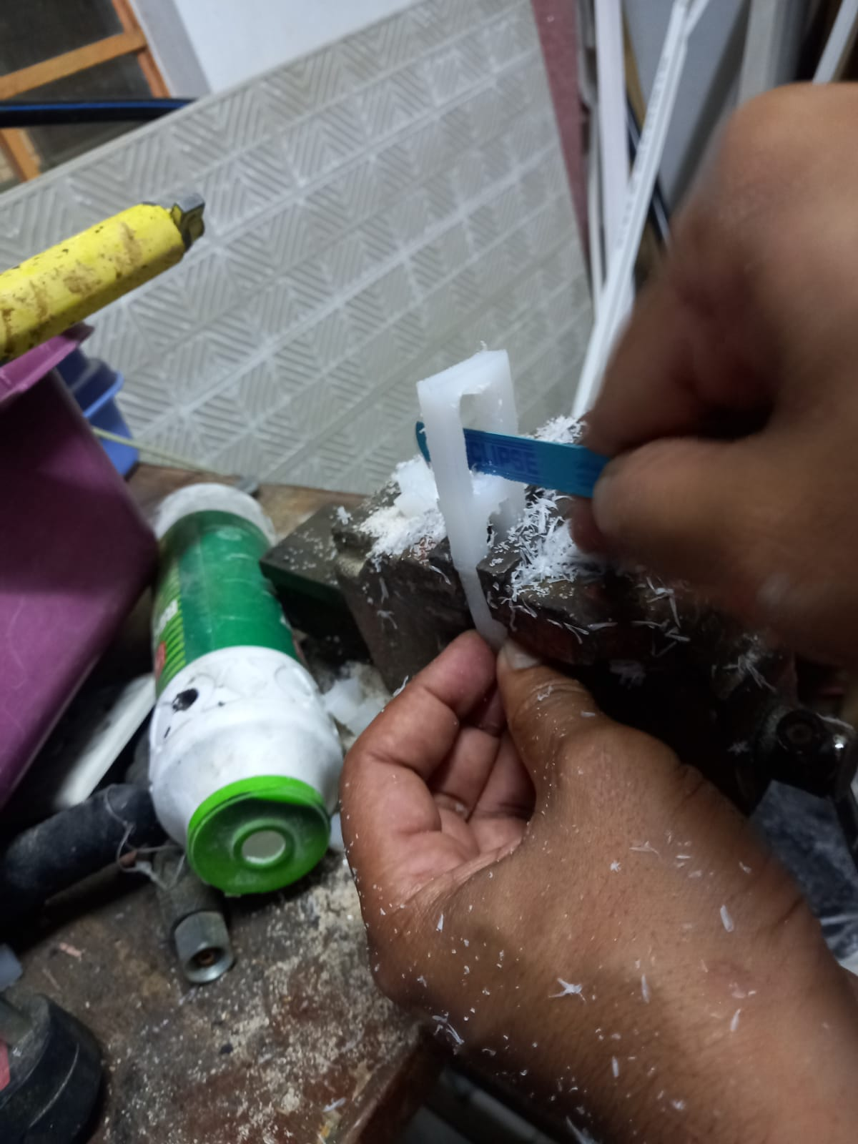

**Checking if servo motors fit into the leg to function.**

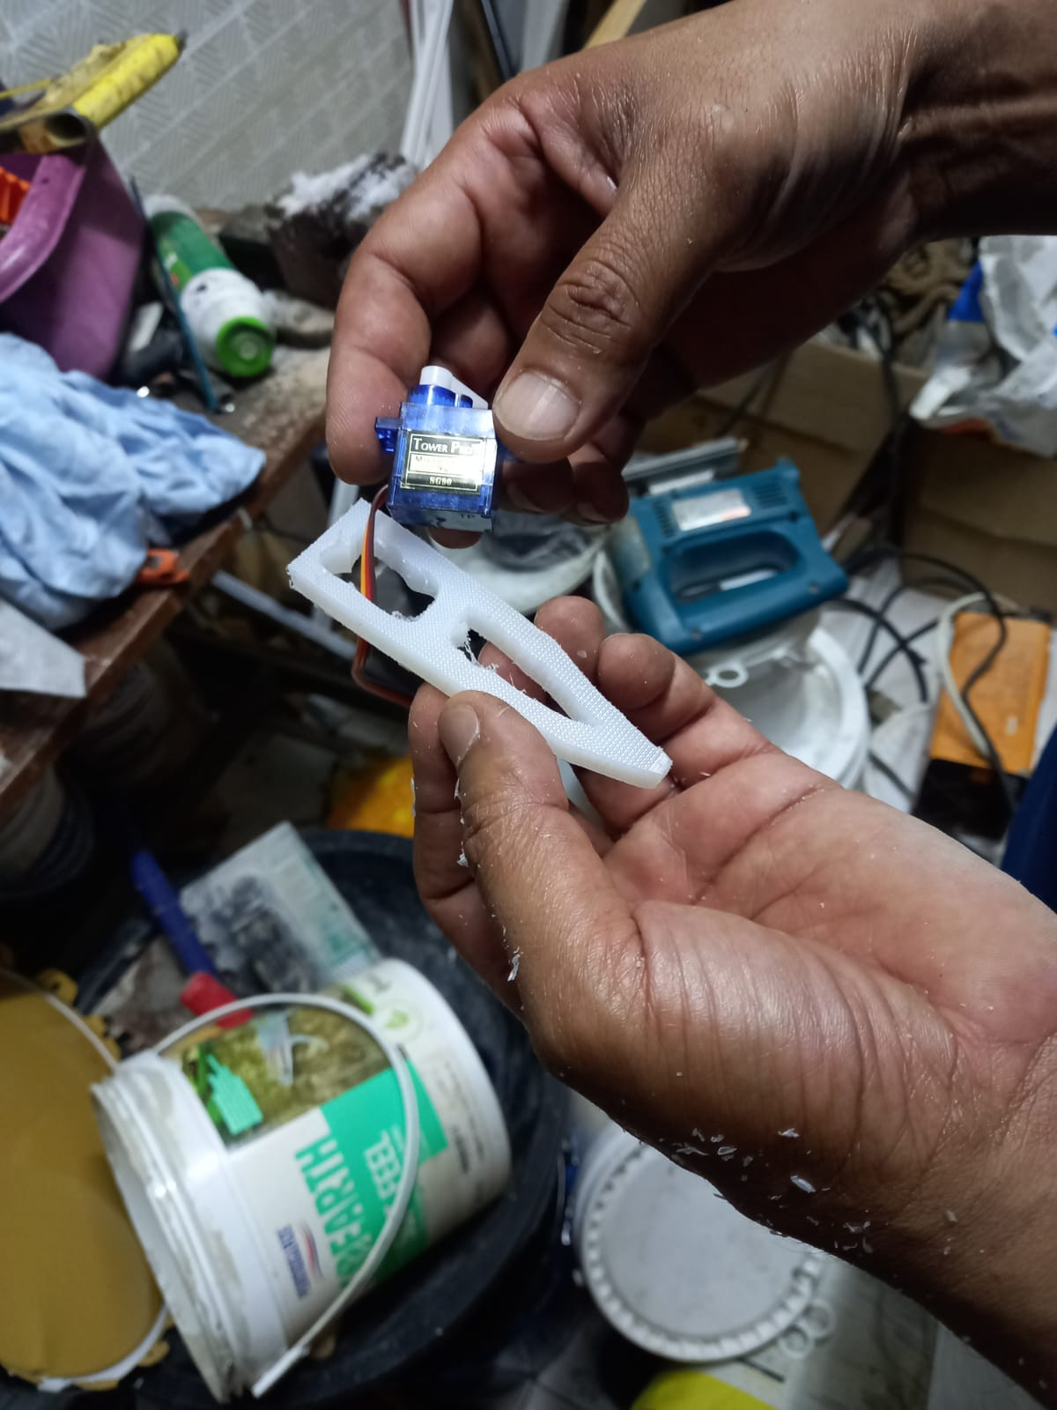

**Some of the structure for the robots body also comes from cutting and refining plastic chopping boards.**

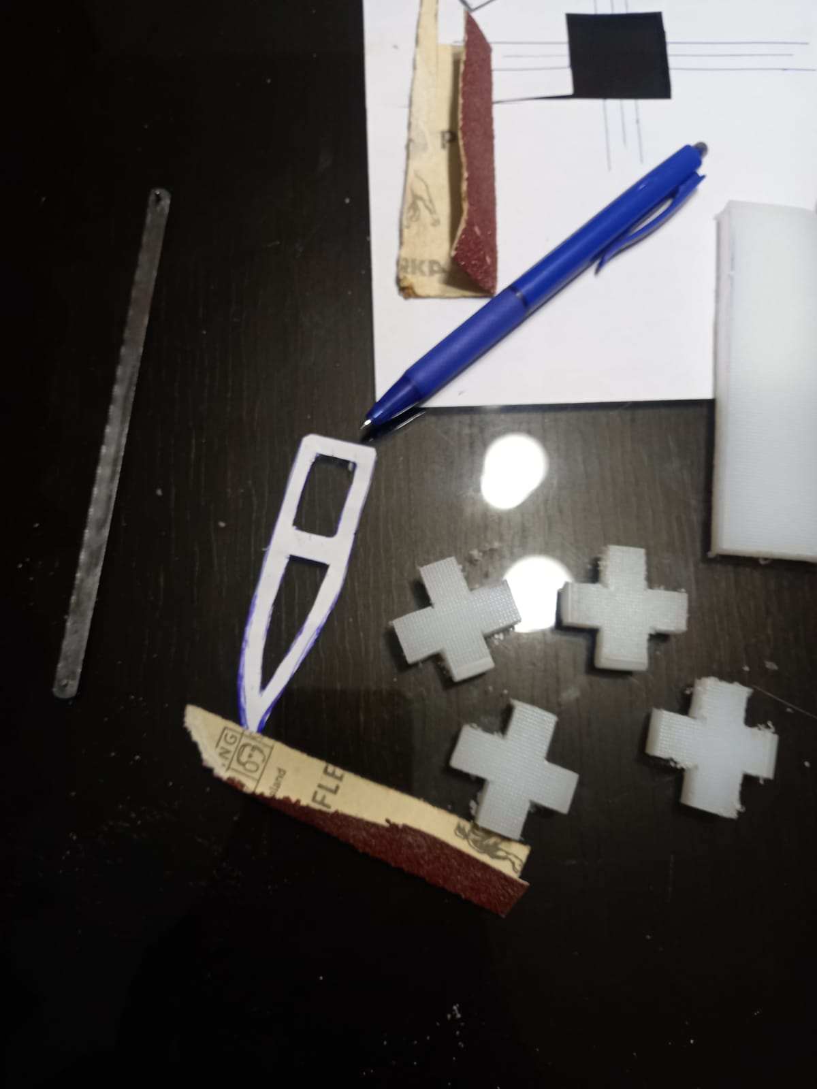

**A first prototype was created and tested**

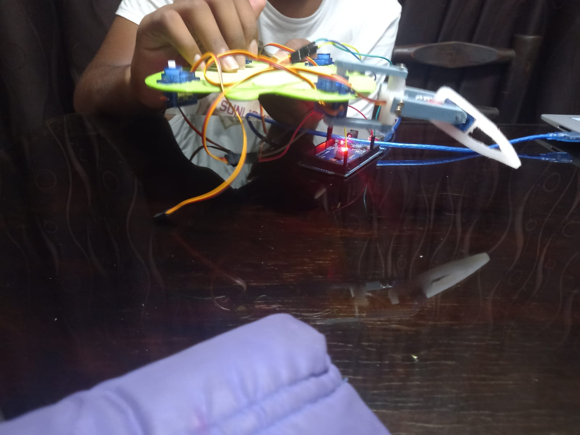

**The robot along with its sensors and grip was mounted and connected.**

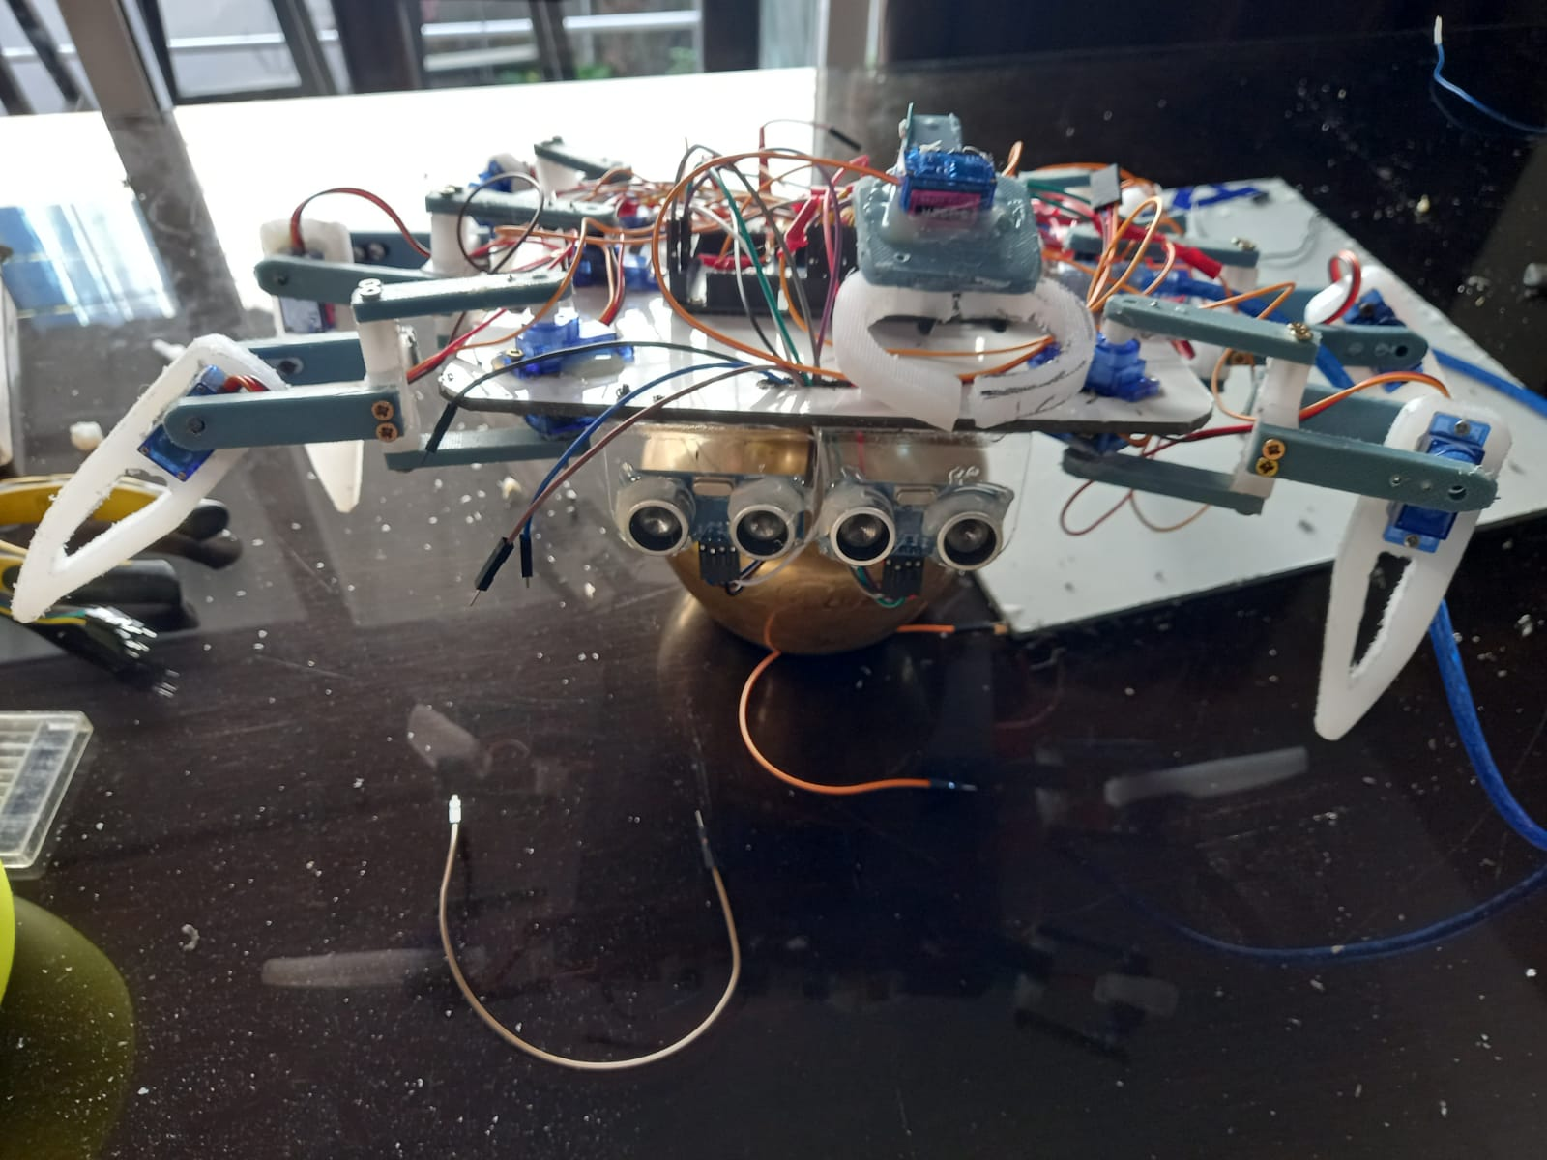

**Computer vision for object detection of a cigarette filter with confidence of 0.45 is enabled.**

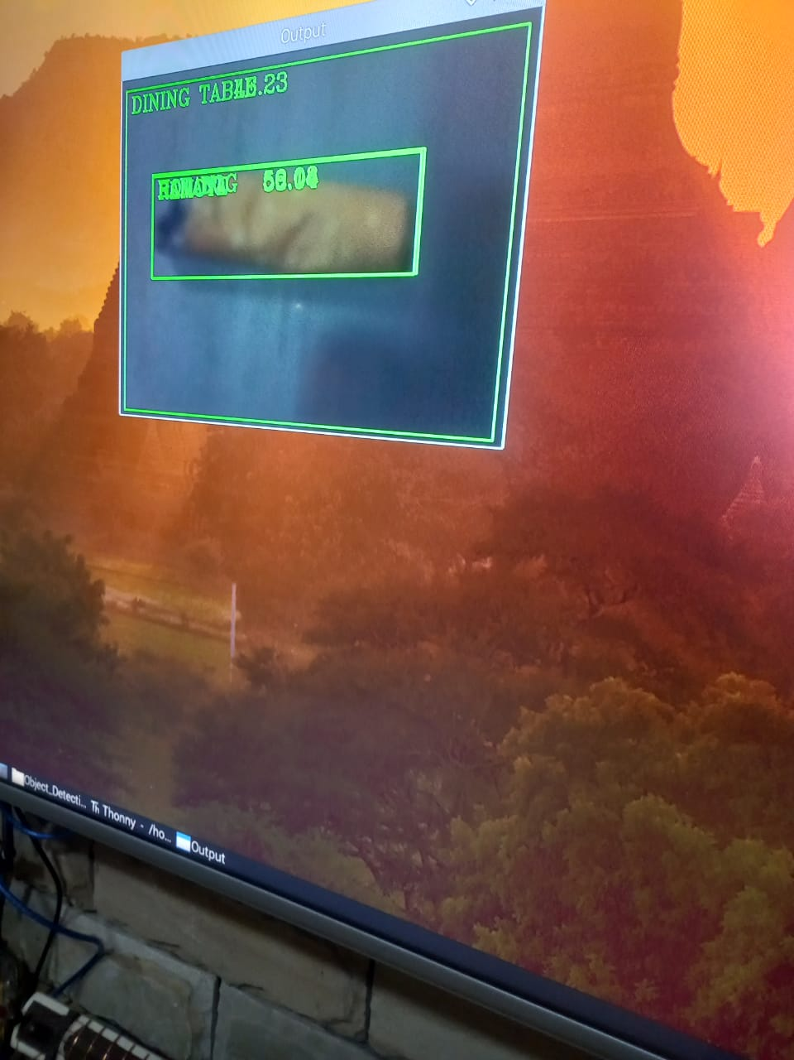

**Code for object detection. Library has been install from online.**

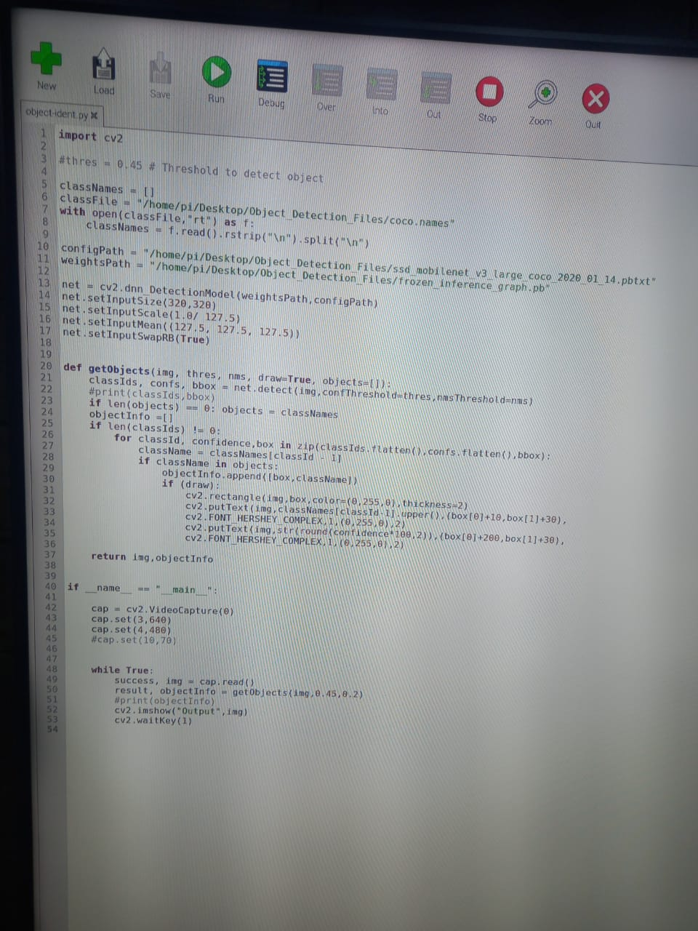

**Below are arduino codes for the different functions implemented**

**The different functions include the forward movement, the backwards movement, the turning movement of the robot, also the grip function for the arm to collect the cigarette filter. Also the sensor detecting distance for object avoidance.**

**The pin declarations**

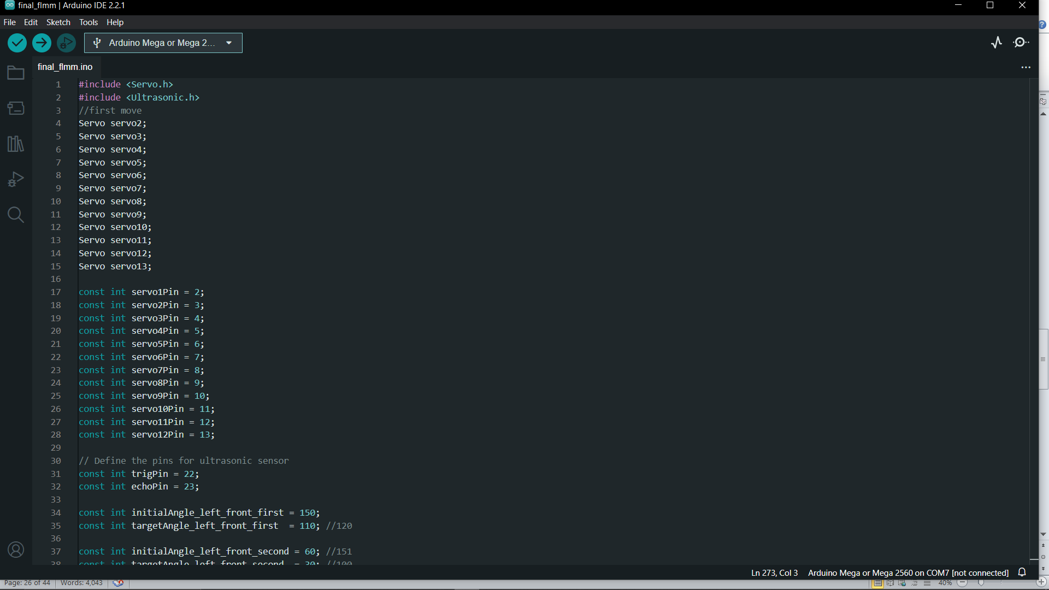

**The angles calibration as initial and target**

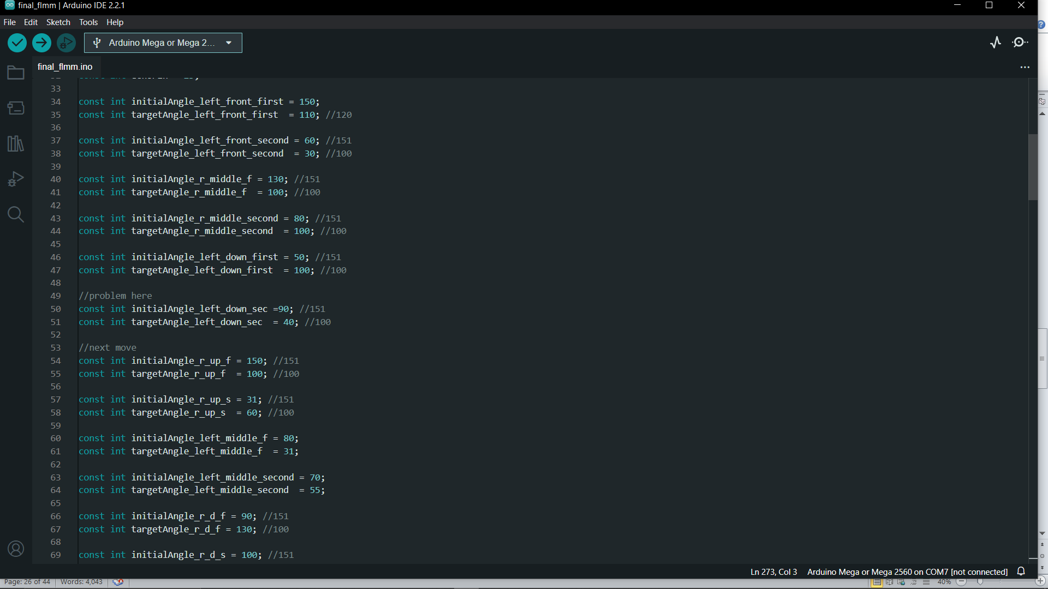

**The setup function**

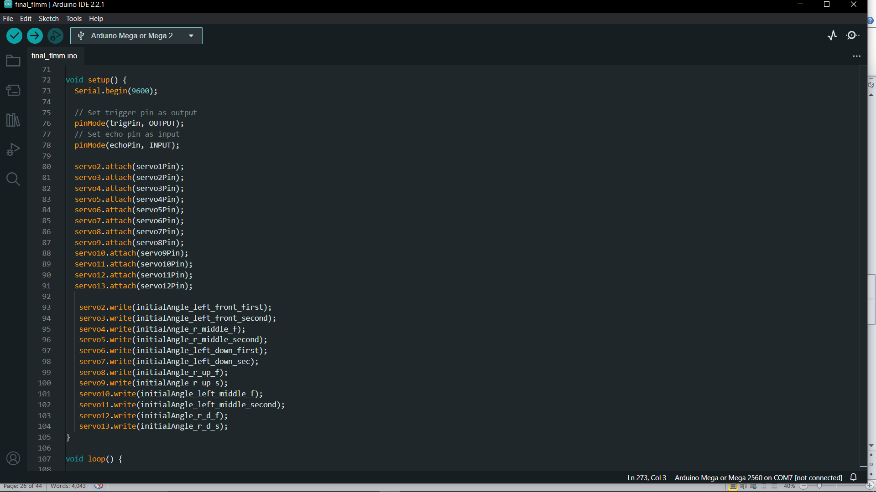

**The codes below start the motion of the robot by first detecting if there is no obstacle in front of the robot.**

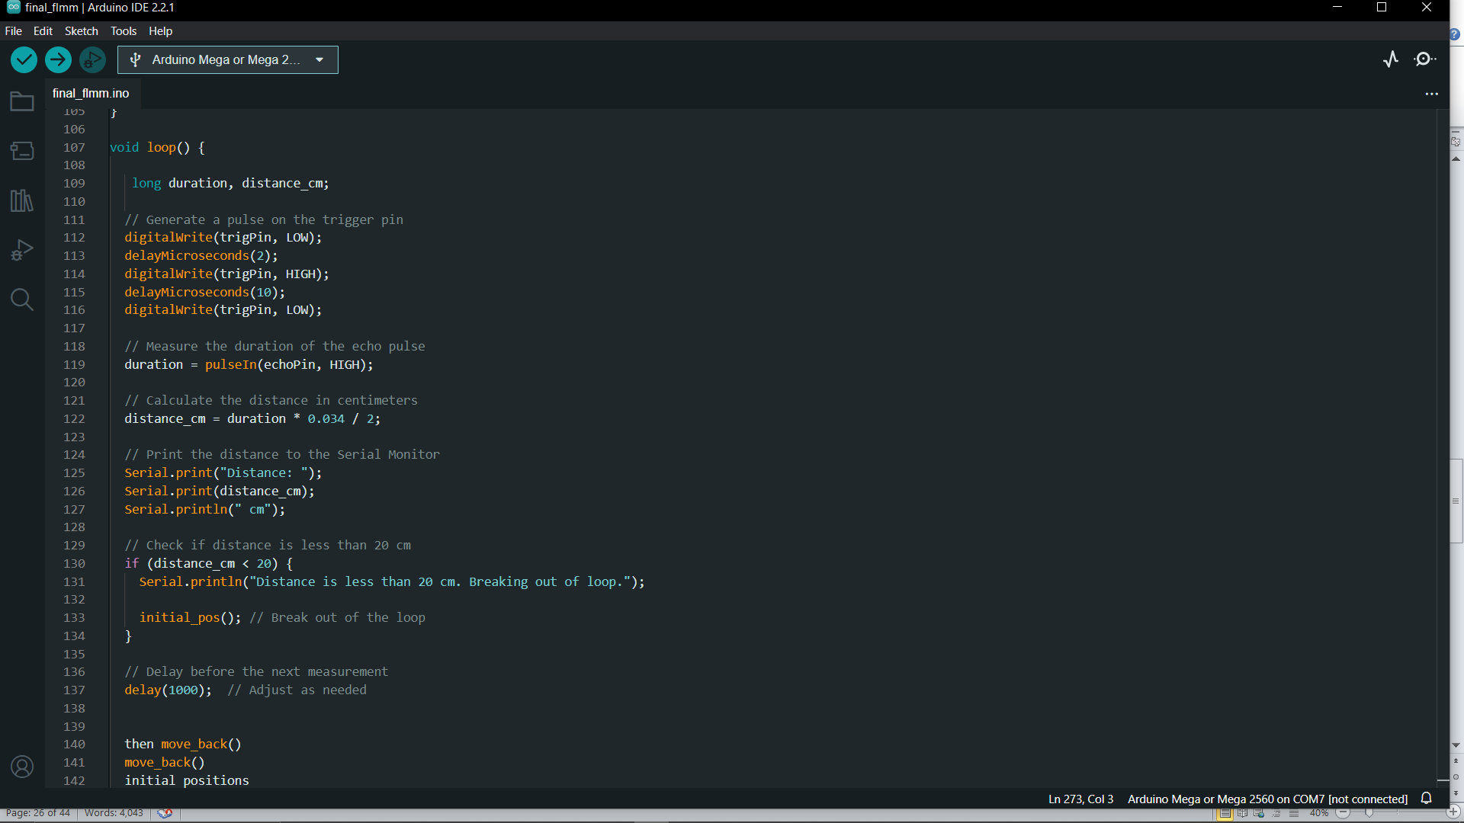

**The forward movement function**

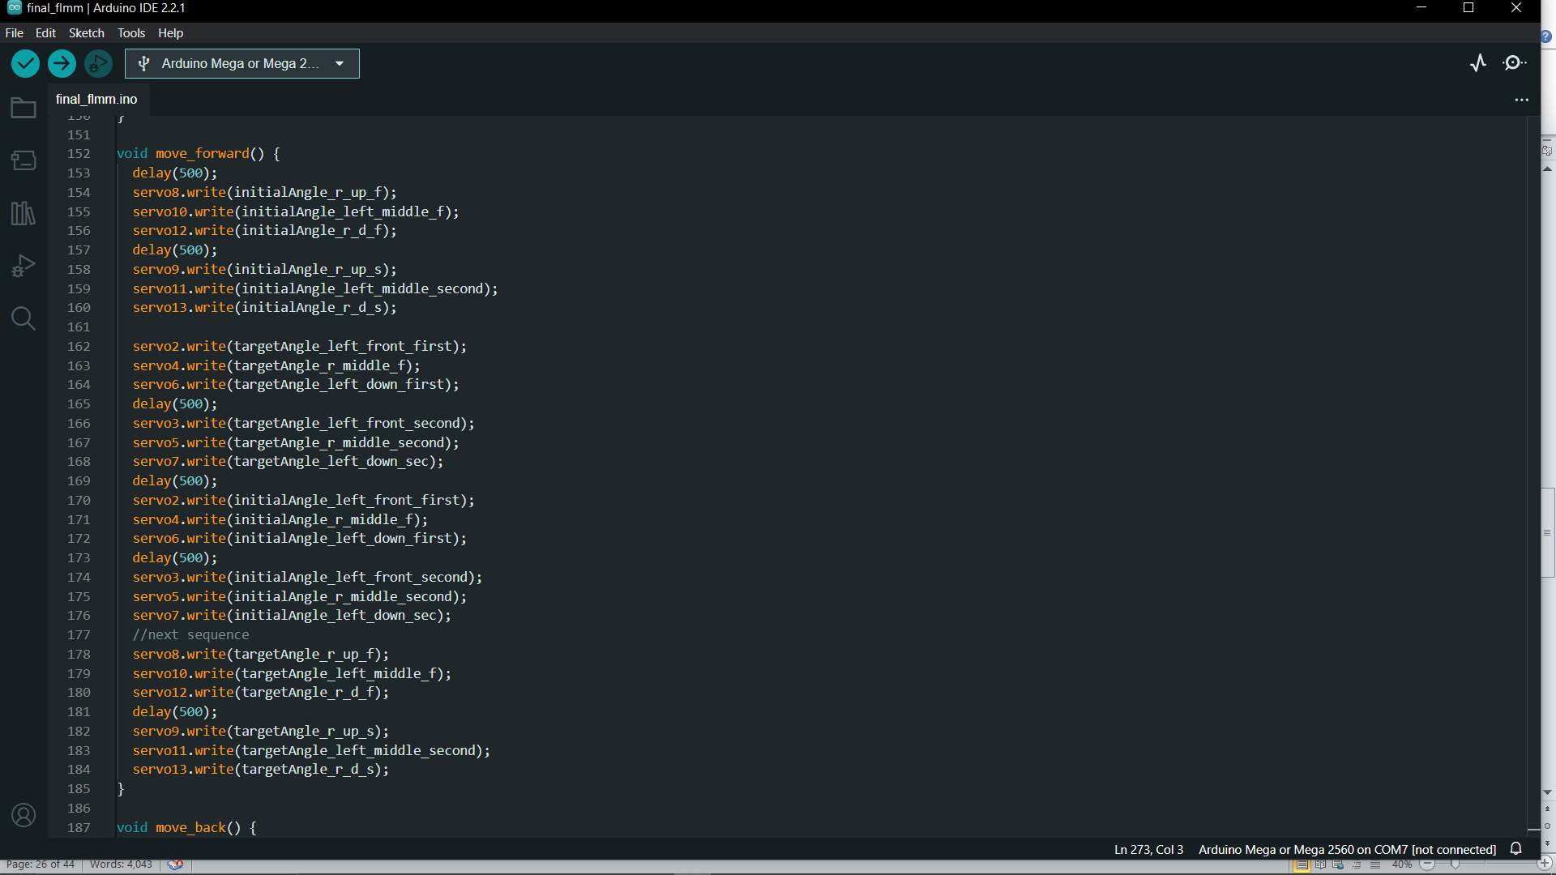

**The initial position function as well as the gripping function of the robot**

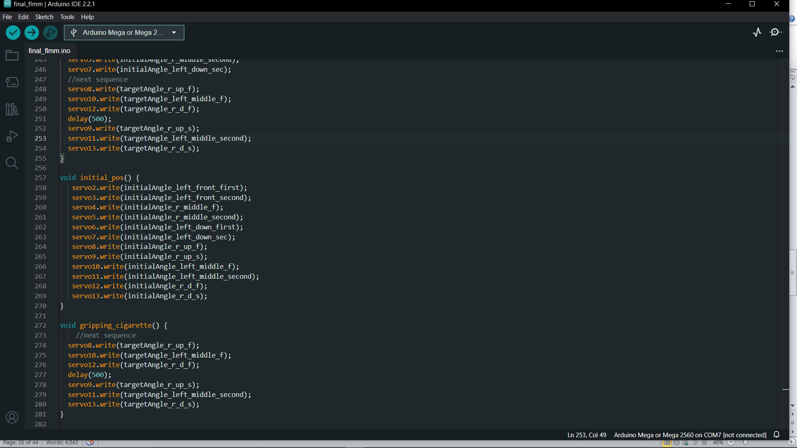

**The turning function for the rotation of the robot in the left direction until sensor detects no obstacle**

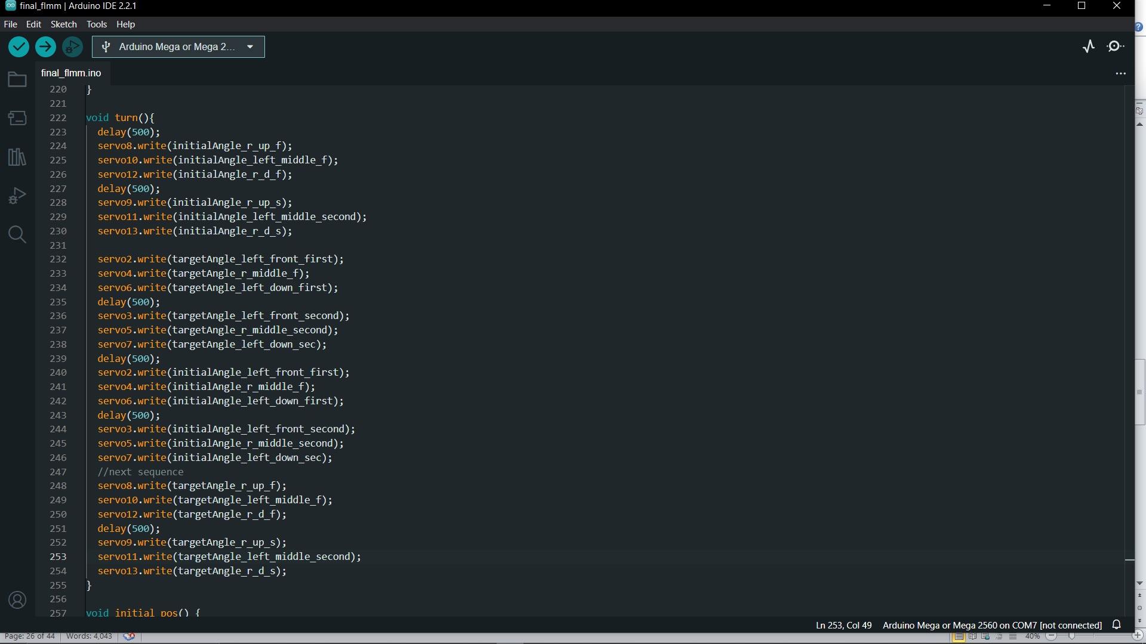

**The move backwards function for the robot to move back when detecting an obstacle before turning to the left and only if there is no obstacle does it moves forward**

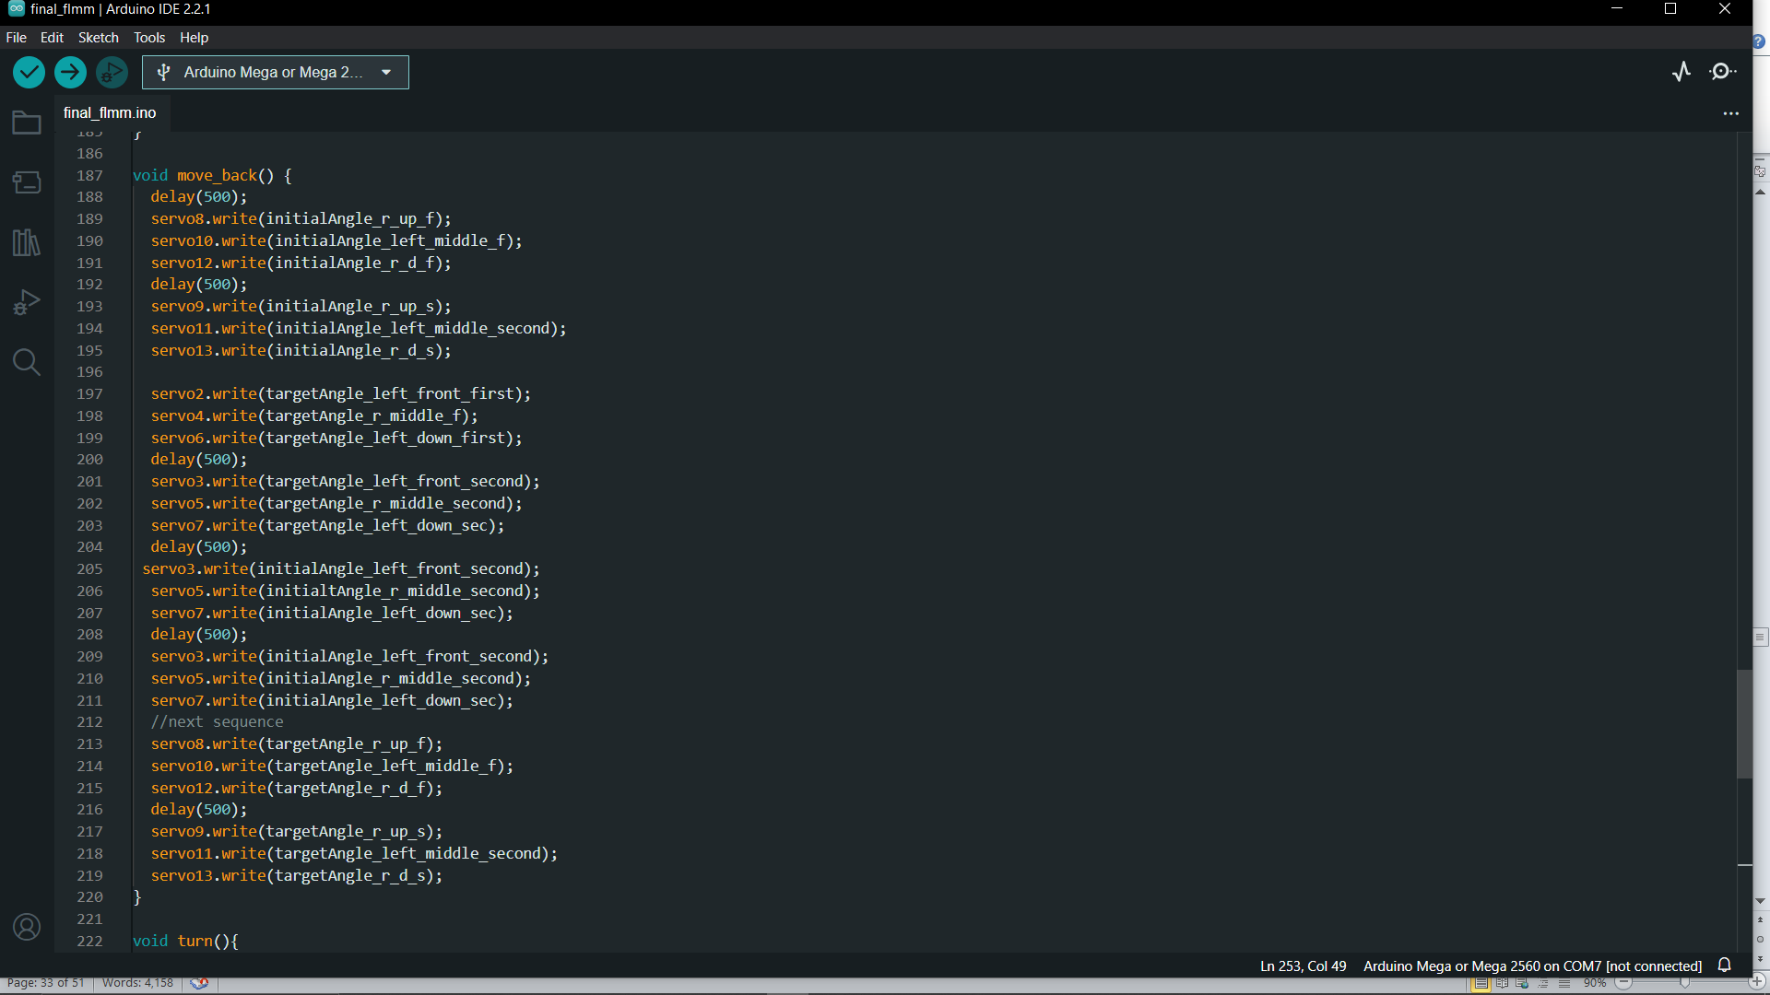

**Testing**

**Functionality test cases**

**\*Components - Technical & Calibration Testing**

**Ultrasonic Sensor Accuracy**

Check the ultrasonic sensor's accuracy in identifying obstructions.

To test the accuracy of the sensor's obstacle avoidance, place barriers of various sizes and materials at different distances.

**Actuator Functionality:**

To ensure that it can securely gather and hold on to cigarette butts, test the gripper.

Make sure it runs without dropping the items that have been gathered.

**Microcontroller functionality:**

Try to upload simple code for led light on the board to light up, try different pin numbers to ensure all pin numbers are working.

**Servo motor actuator:**

Test each servo motor by uploading codes and test accuracy of rotation of each servo motors.

**\*Functional Parts - Case Scenarios**

**Navigation and Detection**

Scenario case: The robot moves through its given area where there is cigarette butts scattered over and some rocks as obstacles.

Expected Output: The robot’s camera accurately locates the cigarette butt and moves towards the cigarette butt without colliding with obstacles placed over the area.

**Collection and Storage**

Scenario: The robot has located the cigarette butt and is about to start the collection process using the gripper.

Expected Output: The gripper successfully positions itself on top of the cigarette butt before moving downwards and picking it up without letting it fall down. The gripper then releases the cigarette butt in the storage container of the robot.

**Obstacle Avoidance**

Scenario: The robot is placed on a surface with a lot of obstacles of different sizes.

Expected Output: The robot appropriately identifies obstacles using the ultrasonic sensor and adjusts its path to avoid collisions.

**Full storage**

Scenario: the robot has collected a number of cigarette butts and is now full.

Expected output: the robot’s LED light start blinking to alert any nearby user to empty its container.

**Robot stop/go:**

**Scenario:** the user presses the push button as he/she wants to upload new codes or the user wants to empty the storage of the robot.

**Expected output:** the robot stops or the robot starts to work.

**\*Whole System - Case Scenarios**

**Robot System Testing**

Scenario: Use the robot at the assigned environment to run the entire system including the collection, navigation, and detection of cigarette butts.

Expected output: the robot does the assigned duties by effectively detecting, gathering, and navigating without any issues.

**Different Environmental Adaptability:**

Scenario: Test the robot in different outdoor environments.

Expected output: the robot maintains its function of detecting and collecting cigarette butts across different types of environment.

**Battery Test:**

Scenario: Run the robot continuously for an extended period of time to assess its battery life.

Expected output: the robot operates efficiently without battery depletion in the specified time limit.

These test cases aim to validate the functionality of individual components, functional aspects, and the entire system in different scenarios, ensuring the robot's reliability and effectiveness in collecting cigarette butts.

**Project plan**

The Gantt chart below illustrates the main goals to achieve for the robotics project to be successful.

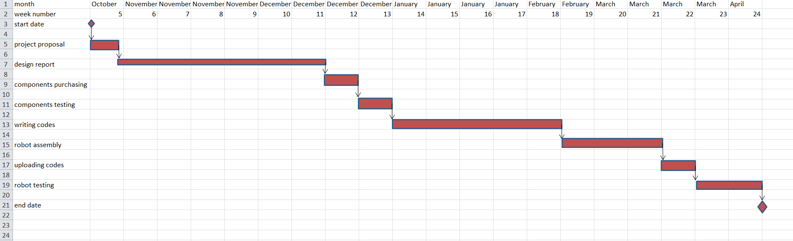

**Bill of materials**

|  |  |  |  |  |
| --- | --- | --- | --- | --- |
| **components** | **Make & model** | **quantity** | **Price(Rs)** | **Supplier** |
| **Arduino mega board** | **Arduino Mega 2560** | **1** | **800** | **Local** |
| **Servo motors** | **Futaba S3003** | **20** | **125** | **Local** |
| **ultrasonic sensor** | **HC-SR04** | **1** | **90** | **Local** |
| **Camera** | **Module v2** | **1** | **210** | **Local** |
| **Battery** | **Panasonic CR2032** | **4** | **300** | **Local** |
| **Led lights** | **Kingbright KB-2750SGD** | **1** | **3** | **Local** |
| **Jumper cables** | **10cm** | **30** | **30** | **Local** |
| **Rasbery pi** | **Pi 4 Model B** | **1** | **7000** | **Local** |
| **Infrared sensor** | **HC-SR501 PIR Sensor** | **1** | **100** | **Local** |

**Evaluation**

**Limitations of project**

*Meteorological circumstances, such rain, snow, or extremely high or low temperatures, could compromise the robot's longevity and functionality.

*The robot's storage capacity for collecting cigarette butts may be limited, requiring frequent emptying or disposal by user or nearby people.

*The small and compact robot might get stolen as electronic parts are quite expensive.

*The small and compact robot might not be robust enough and can be damaged due to people walking or colliding with the robot.

**System evaluation**

The overall evaluation of the system is good and the device is expected to work accordingly however there are some pitfalls that limit the robot in terms of accuracy and efficiency.

**Various Terrains:** it may encounter rough terrain or even topple, so it would be good to add some self-stabilizing mechanism at some point

**Anti-theft:** the robot is currently small and can easily be picked up by anyone. This would be dangerous if we left the robot in the streets since it would easily be damaged or stolen.

**Environmental Conditions:** the robot is not robust enough to handle more extreme weather conditions such as heavy rain or cold. Need a better encasing.

**Changes made during the project process**

Unfortunately the leds that were supposed to show the battery level did not work as expected.

As per the initial connection diagram two more legs were added to the robot which makes a total of 6 legs.

As per first proposal where a vacuum would have been used, in the final project a gripper controlled by servo motors is in use to collect the cigarette filters.

Also the navigation of the robot is not pre determine, for example if does not cover a specific area.

**Most problematic implementation:-**

**Calibrating and Fine-Tuning:** To achieve desired performance, you may need to calibrate sensors, adjust parameters, and fine-tune the robot's behavior during the implementation phase.

**Integration of Sensors and Actuators:** Implementation includes the integration of various sensors (e.g., ultrasonic, cameras) and actuators (e.g. servos) into the robot's design.

**Future works**

In the near future, the system proposed could be improved, modify and develop to fit different domains.

**Scaling and Deployment:** the project is a prototype. It could be scaled up or deployed in a real-world context.

**New Applications:** potential applications of the system in different domains or industries. The system can be used in contexts other than the one initially targeted. This can help identify new avenues for research or development

**Possible future**

The system idea, that of an automated robot following an assign path and collecting cigarette butts through a vacuum could be translated to serve a bigger purpose such as replacing the manual work of people who work to collect and manage garbage, often referred to as "garbage collectors" or "waste management professionals," who play a vital role in maintaining public health and cleanliness in communities. Their responsibilities involve collecting, transporting, and disposing of waste and recyclable materials. Similarly the system robot could be built in a large scale context and collect garbage out of specific bins.

**Conclusion**

In conclusion, the suggested robotic method seeking to solve the problem of cigarette butt litter was implemented. Through the proposal, design and final report a clear understanding of the project concepts was made. There were drawbacks and difficulties with implementation. Solutions to those difficulties were made and testing and evaluation were carried out. The time management about this project through the gnat chart is also presented in this final report as well as the bill of materials. The robot presented during the showcase being a second prototype can still be improved in terms of navigation, precision and security.

**References**

Spong, M. W., Hutchinson, S., & Vidyasagar, M. (2006). Robot Modeling and Control. Wiley.

Eriksen, M., Mason, S., Wilson, S., Box, C., Zellers, A., Edwards, W., ... & Kiessling, T. (2013). Microplastic pollution in the surface waters of the Laurentian Great Lakes. Marine Pollution Bulletin, 77(1-2), 177-182.

U.S. Department of Health and Human Services. (2006). The Health Consequences of Involuntary Exposure to Tobacco Smoke: A Report of the Surgeon General. U.S. Department of Health and Human Services, Centers for Disease Control and Prevention, National Center for Chronic Disease Prevention and Health Promotion, Office on Smoking and Health.

Marques, M., Rosa, R., & Nunes, L. J. (2016). A review on the application of portable X-ray fluorescence spectrometry to the analysis of cigarette butts for quantification of metallic elements of environmental concern. Environmental Science and Pollution Research, 23(20), 20441-2045