|  |
| --- |
| Table of content |
| 1. Introduction |
| 2. Background research |
| 3. Literature review |
| 4. Proposal description |
| 5. Concept behaviour |
| 6. Physical architecture (configuration) |
| 7. Components used |
| 8. Interaction |
| 9. System Testing |
| 10. System Evaluation |
| 11. Future works |

**Introduction**

In almost all countries, in society, smoking poses as a serious health hazard but not only that. The discarding of cigarette butts also has serious impacts such as:

**\*Environmental pollution:** Cigarette butts are a common form of litter, and they pose a significant environmental hazard. They do not biodegrade quickly, and the toxic chemicals in cigarette filters can leach into the soil and water, harming ecosystems.

**\* Fire risk:** Discarded cigarette butts can pose a fire risk in dry or flammable areas.

**\*Aesthetic degradation:** Littered cigarette butts are unsightly and can negatively affect the aesthetics of public spaces.

**\*Increased cleaning cost:** governments spend significant resources on manual litter cleanup.

The project we propose is a robot that would help solve and minimize the above problems. By collecting cigarette butts, the robot would help reduce environmental pollution, also potentially preventing wildfires or urban fires caused by discarded cigarettes. The robot would clean areas contributing to a cleaner and more visually appealing environment. The robot would reduce the costs by automating the process and no manual assistance would be needed.

**Background research**

Creating a robot to collect cigarette butts involves several areas of study, including robotics, environmental science, and public health. Here is some background research on the topic;

**\*Robotics and Automation:**

The aim of the robot is to identify cigarette butts and collect them and this action can be done in a variety of ways using different mechanical concepts such as robot arms and grippers, which are essential for designing a robot to pick up cigarette butts. Robots can also learn and adapt to their environment, improving their ability to navigate and collect litter.

**\*Environmental Science:**

It is estimated that approximately 5.8 trillion cigarettes is consumed worldwide and this number also logically reflect the number of cigarette butts that pollute our environment.

Also according to the American Burn Association, about 900 people in the United States die each year in fires started by cigarettes butts. Wildfires are often caused by cigarette butts too thus being a dangerous hazard.

**\*Public Health:**

Cigarette butts, especially in public spaces, can serve as a visual cue and influence young individuals to start smoking. Exposure to cigarette litter can normalize smoking behavior, which can contribute to youth initiation of smoking and its associated health risks.Reducing cigarette butt litter and discouraging smoking in public areas can have a positive impact on public health by decreasing exposure to toxic chemicals and creating cleaner, safer environments.

**\*Waste Recycling:**

Cigarette butts can be recycled, but it is a complex and challenging process due to the toxic materials found in cigarette filters. The recycling process for cigarette butts can be costly and may not be widely available in many regions. Efforts are underway to find more sustainable and eco-friendly alternatives to cigarette filters, as they are a significant source of litter and environmental pollution.

**Literature review**

Different robots have been built over the years which relate to the theme of our project, such as Beachbot and Cigbot which can be purchased by the government or institutions for the public`s benefit.

|  |  |  |  |
| --- | --- | --- | --- |
| **Robot** | **Review/**  **analysis** | **Successful /**  **Unsuccessful**  **And**  **why** | **improvement** |
| BeachBot | It has two cameras located at the front and rear. Under the robot, there are two arms that can pick up cigarette butts. The waste will be identified thanks to AI, and more precisely thanks to visual recognition and image detection algorithms. | BeachBot has successfully picked 10 cigarette butts in 30 minutes in its first demo. It was successful because it uses AI that has been specifically developed to detect cigarette butts | The beach bot could first make sure that the cigarette butt has stop burning before putting it in the internal bin as a fire could spread from there. |
| Cigbot | Safely drive around the sidewalks in the city. Collect and dispose of the cigarette butts. Use a Raspberry Pi and a Pi Camera to take pictures of cigarettes, process the image, and then output coordinates of the location of the cigarette for the robot. | The cigbot was successful as solid works were used to design the chassis, roller/sweeper-mechanism, and mounts for the camera of the robot. For the robot, VEX parts were used to assemble it. Also the mount was 3D-printed based on the solid works model. | The cigbot had a few limitations such as it cannot go on various terrains, though cigbot is made for the sidewalk, it may encounter rough terrain, A more powerful battery or motor could be an improvement. |

**Proposal description**

The proposed project aim is a robot that collects cigarettes butts to enhance society and people health. The robot is to operate on smoking areas, road sides or on the beach. The robot shall be able to move through rough ground and collect cigarettes butts in front of it using its arms as a vacuum tube, the cigarettes butts go afterwards in a container inside the robot and the robot goes on as such cleaning its assign spot.

**Concept behavior**

*What does the device do?

*The robot will be in constant motion looking for the cigarettes butts in a spot assigned to it where the environment and infrastructure differ from place to place. The robot will move similar to a crab and not similar to a car which provides with much more variety of motion for the robot to move around. It will also be adapted to not bump into people or any object.

*The device will also be equip with a camera that enables it to see forward in a range(100 degrees), the robot looks for the cigarettes butts and through an AI it is able to distinguish the cigarettes butts from other items and proceeds to move close to the detected object before being still.

* Calculating the coordinates of the cigarette butt the robot makes use of one of its front arm, places it near the object to collect the cigarettes butts similar to as a vacuum would, taking in the cigarette butts to a container inside the robot which will later on be disposed when full. Upon completion the robot continues its motion until it repeats the steps above again cleaning its area.

*functional components

**1.Arduino:-** acts as control unit **6. Dustbin Compartment:-** acts as storage

**2. Sensors :-** proximity sensor **7. Exoskeleton:-** robot body for safety

**3. Vacuum System:-** includes a suction fan

**4. Power Source:-** batteries

**5. Manipulation Mechanism:-** mechanical arms

**Physical architecture**

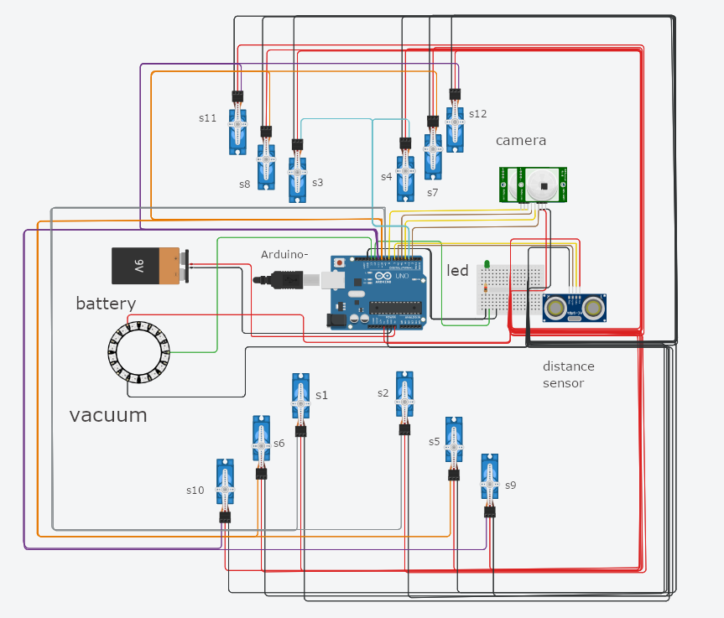

|  |  |  |
| --- | --- | --- |
| Features | Color wire | pin |
| battery | Red, black | Gnd, v1 |
| Led light | Green | Gnd, 12 |
| Proximity sensor | Brown, yellow | 6, ~7 |
| camera | Brown, yellow | 8, ~5, 4, 2 |
| Servo motor 1& 2 | grey | ~9 |
| Servo motor 3 & 4 | blue | ~3 |
| servo 5,6,7,8 | Orange | ~10 |
| Servo 9,10,11,12 | Purple | ~11 |
| vacuum | Green | 13 |

**Components used**

Vacuum System: This includes the vacuum motor and collection storage.

Mobility System: The mobility system comprises legs, motors, and controllers for moving the robot.

Proximity Sensors: Used to detect the presence of cigarette butts and obstacles.

Cameras: To capture visual data and images for identification and navigation.

Microcontroller: The brain of the robot, which processes sensor data, controls actuators, and makes decisions based on algorithms and programming. (arduino)

Power System: This includes the power source, batteries and related components.

**Data Collection:**

Cigarette Butt Detection: Proximity sensors and cameras will be used to detect cigarette butts on the ground. Proximity sensors can identify the presence of objects within a certain range, and cameras can capture images that will be processed for object recognition. Proximity sensors and cameras also serve to detect obstacles and avoid collisions.

**Data Processing:**

Image Processing: Image data from cameras will be processed to recognize and locate cigarette butts. Image processing algorithms, such as object recognition and machine learning, can be used to identify cigarette butts in images.

**Data Fusion:**

Combining data from multiple sensors is essential for a comprehensive understanding of the robot's environment. Sensor fusion techniques, such as Kalman filters or complementary filters, can be used to integrate data from different sensors. An example would be combining camera data with proximity sensor data for accurate positioning. The microcontroller will then process the sensor data and make decisions about the robot's movements.

**Interaction**

**Interaction with People:**

**User-Friendly:** The robot is designed for public spaces, it shall be user-friendly. People will be able to interact with it easily, by pressing a button to activate the collection process or led lights indicating that the container is full and needs to be emptied.

**Safety:** The robot shall be designed to operate safely around people. Implement safety features to prevent accidents or collisions. Sensors can detect obstacles or people in its path, and the robot can slow down or stop to avoid them.

**Interaction with the Environment:**

**Litter Reduction:** The primary environmental impact is the reduction of cigarette butt litter. Cigarette butts are non-biodegradable and can harm the environment. By collecting them, the robot contributes to environmental cleanliness.

**Efficiency:** Ensuring that the robot is able to move through rough uneven grounds and reach corners.

**Actuators:**

The actuators in the robot play a critical role in its operation. In this context actuators may include:

**Leg Actuators:** These are responsible for the robot's movement. They allow the robot to navigate and position itself to collect cigarette butts efficiently.

**Vacuum Actuator:** The vacuum actuator creates the suction force necessary for collecting cigarette butts. It controls the vacuum mechanism to pick up and store.

**Sensors Actuators**: Sensors are essential for detecting cigarette butts, obstacles, and people.

**Communication Actuators:** These might involve voice, sound, or visual displays for interacting with the public.

**System testing**

Testing is a critical phase in the development of the cigarette butt-collecting robot. Testing should be conducted at various levels, including individual, component testing and system testing.

**Individual Component Testing:**

Vacuum System Testing: The vacuum component is tested independently to ensure it generates enough suction to pick up cigarette butts.

Mobility Testing: Robot's ability to move in various directions, navigate terrains where cigarette butts are found. Should be smooth and control movement.

Sensors Testing: Test the sensors proximity sensors, cameras to verify their accuracy in detecting cigarette butts and obstacles.

Power Testing: start the robot and ensure that the robot's power system, the batteries can sustain operations for a reasonable amount of time. (1 hour)

**Component Integration Testing:**

Vacuum and Mobility Integration: start the robot and ensure that the robot is still while operating the vacuum. Simultaneous operation is possible too.

Sensor-Actuator Integration: Verify that the sensors can trigger the actuators appropriately based on detected cigarette butts and obstacles.

**System Testing:**

Collection Efficiency: Perform tests for the robot's overall efficiency. This means evaluating how many cigarette butts it can collect within a given time frame.

Navigation and Obstacle Avoidance: Test the robot's navigation capabilities in avoiding obstacles and pedestrians while still collecting cigarette butts.

User Interaction: Evaluate the robot's mechanisms (led lights) to ensure it can interact safely with people in public spaces when it is full.

**System evaluation**

The overall evaluation of the system is good and the device is expected to work accordingly however there are some pitfalls that limit the robot in terms of accuracy and efficiency.

**Various Terrains:** it may encounter rough terrain or even topple, so it would be good to add some self-stabilizing mechanism at some point

**Anti-theft:** the robot is currently small and can easily be picked up by anyone. This would be dangerous if we left the robot in the streets since it would easily be damaged or stolen.

**Environmental Conditions:** the robot is not robust enough to handle more extreme weather conditions such as heavy rain or cold. Need a better encasing.

**Most problematic implementation:-**

**Calibrating and Fine-Tuning:** To achieve desired performance, you may need to calibrate sensors, adjust parameters, and fine-tune the robot's behavior during the implementation phase.

**Integration of Sensors and Actuators:** Implementation includes the integration of various sensors (e.g., ultrasonic, cameras) and actuators (e.g. servos) into the robot's design.

**Future works**

In the near future, the system proposed could be improved, modify and develop to fit different domains.

**Scaling and Deployment:** the project is a prototype. It could be scaled up or deployed in a real-world context.

**New Applications:** potential applications of the system in different domains or industries. The system can be used in contexts other than the one initially targeted. This can help identify new avenues for research or development.

**Possible future**

The system idea, that of an automated robot following an assign path and collecting cigarette butts through a vacuum could be translated to serve a bigger purpose such as replacing the manual work of people who work to collect and manage garbage, often referred to as "garbage collectors" or "waste management professionals," who play a vital role in maintaining public health and cleanliness in communities. Their responsibilities involve collecting, transporting, and disposing of waste and recyclable materials. Similarly the system robot could be built in a large scale context and collect garbage out of specific bins.

**References**

Spong, M. W., Hutchinson, S., & Vidyasagar, M. (2006). Robot Modeling and Control. Wiley.

Eriksen, M., Mason, S., Wilson, S., Box, C., Zellers, A., Edwards, W., ... & Kiessling, T. (2013). Microplastic pollution in the surface waters of the Laurentian Great Lakes. Marine Pollution Bulletin, 77(1-2), 177-182.

U.S. Department of Health and Human Services. (2006). The Health Consequences of Involuntary Exposure to Tobacco Smoke: A Report of the Surgeon General. U.S. Department of Health and Human Services, Centers for Disease Control and Prevention, National Center for Chronic Disease Prevention and Health Promotion, Office on Smoking and Health.

Marques, M., Rosa, R., & Nunes, L. J. (2016). A review on the application of portable X-ray fluorescence spectrometry to the analysis of cigarette butts for quantification of metallic elements of environmental concern. Environmental Science and Pollution Research, 23(20), 20441-2045