**Tutorial2 Report:**

In this tutorial, I have used a few Spark transformations and actions for a simple use case of finding mutual friends between two persons.

The Spark Transformations used are: Union, Intersection, distinct

The Spark Actions used are: count, foreach, collect.

**Input:**

Two files named Person1 and Person2 are given as input for the program. Both the files contain respective friends names.

Person1’ s Friends:

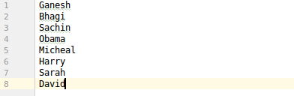

Person2’s Friends:

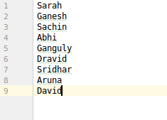

And then created RDD’s for both the files using sc.textFile() function

**OutPut:**

Count of total number of friends for respective persons:

Person1 Freinds count:



Person2’s friends count:



Mutual Friends List of both the persons:

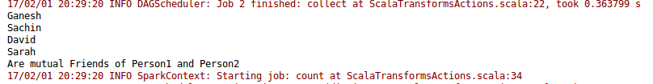

Total number of distinct freinds in both the list



Combined list of Distinct frineds:

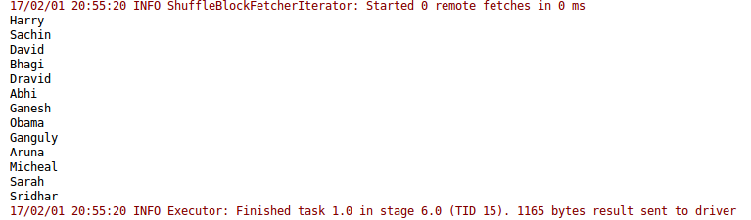

UseCase Paradigm:

