1a.

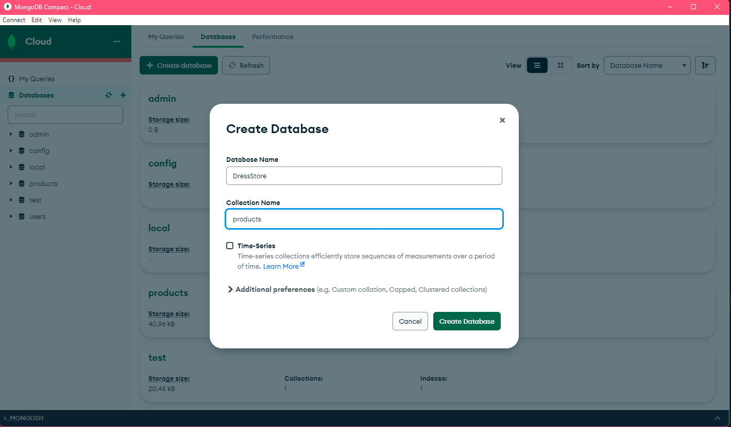

1b. (products was already made from 1a)

2a.

2b.

API Tests:

GET Products

GET Product

POST Product

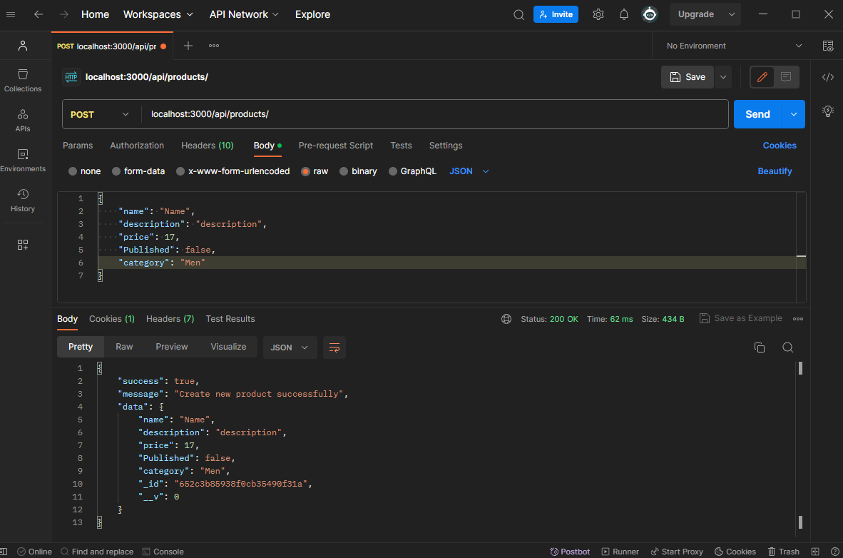

PUT Product

DELETE Product

