LIVE DATAVALIDATION: jQuery, Ajax and PHP
TOPIC AREA: WEB TECHNOLOGIES

TERM PAPER


GURU GOBIND SINGH INDRAPRASTHA UNIVERSITY

SUBMITTED TO: SUBMITTED BY:
MR.S.K MALIK PIYUSH MATHUR
SIGN: SIGN:

U.S.I.C.T.
MCA (SE), 2ND SEM
05816404512
PAPER CODE-IT-658

Data validation:
Data validation is the process of ensuring that a program operates on clean, correct and useful data. It uses routines, often called "validation rules" or "check routines", that check for correctness, meaningfulness, and security of data that are input to the system.
Live Data validation:
In live data validation the data is validated as the user enters it and live feedback is given to user thus making the act of filling in a form less daunting for a user, and to saves there time. It works on the client side and that’s why it is important to do post checks on the backhand i.e. on server side.
The common ways to achieve the live validation is using frameworks and languages such as jQuery, Ajax and PHP
jQuery:
jQuery is a multi-browser JavaScript library designed to simplify the client-side scripting of HTML [1]. jQuery is used to validate the data on the client side. The data is fetched as soon as user enters the data in the input field and validation process beings which uses various jQuery functions, data can also be send to server side using Ajax to a PHP file to evaluate the data (e.g. checking the availability of a username).
Ajax:
Ajax or acronym for Asynchronous JavaScript and XML is a group of interrelated web development techniques used on the client-side to create asynchronous web applications. With Ajax, web applications can send data to, and retrieve data from, a server asynchronously (in the background) without interfering with the display and behaviour of the existing page.[2]
PHP:
PHP is an open-source server-side scripting language designed for Web development to produce dynamic Web pages. It is one of the first developed server-side scripting languages to be embedded into an HTML source document rather than calling an external file to process data. The code is interpreted by a Web server with a PHP processor module which generates the resulting Web page.[3]

Objective of the term paper:
To develop a library to perform live data validation using jQuery, Ajax and PHP. Achieving following functionalities:
- Presence:
Presence will fail if there is no value entered in the field.

- Format:
Format will fail if the value does not match the regular expression.

- Numericality:
This kind of validation is concerned with numbers. It checks if field contains a number or not, entered number is a integer or not and to check for a specific number and thus makes filling form simple and as you would expect it to throughout.
- Length
Length is concerned with the number of characters in a value. You can do various validations on it, like check it is a specific length, less than or equal to a maximum length, greater than or equal to a minimum length, or falls within a range of lengths.

- Inclusion
Inclusion lets you validate against a list of allowed values. You can do an exact match or a partial match.

- Exclusion
Exclusion lets you validate against a list of values that are not allowed. You can do an exact match or a partial match.
- Acceptance
Acceptance lets you validate that a checkbox has been checked.
- Confirmation
This is used to check that the value of the confirmation field matches that of another field. The most common use for this is for passwords
- Composite validations (combining validations)
Most of the time, you will want to combine multiple types of validation on a single field. As your user is given real-time feedback.
- Validating entire Registration form
- Check for username availability
In this the username is fetched using jQuery and send to a PHP file using Ajax which checks the database for username availability.
- Email address
In this the email address is fetched using jQuery and send to a PHP file using Ajax which checks if email address is valid or not.
HTML MARKUP
Now to demonstrate our live data validation we use a file called livedatavalidation.html
- <html>
- <head>
- <link href="css/stylesheet.css" type="text/css" rel="stylesheet">
- </head>
- <body>
- <br><br><br>
- <div id="wrap">
- <span style="font-size:2em ;font-family:f1;">Live</span>
- <span style="font-size:2em;font-family:f1;">Data</span>
- <span style="font-size:2em;font-family:f1;">Validation</span>
- </div>
- <br><br>
- <div id="wrap">
- <h4>Say "Hello"</h4> <input type="text" id="hello" /><span id="span1"></span>
- </div>
- <br><br>
- <div id="wrap">
- <h3>Presence</h3>
- Check whether the input is empty or not.
- <br>
- Input here
- <input type="text" id="pre" /><span id="span2"></span>
- </div><br><br>
- <div id="wrap">
- <h2>Numericality</h2></div>
- <br><br>
- <div id="wrap">
- To check if input value is a number or not.
- <br>
- Input a number
- <input type="text" id="basic_n"/><span id="span3"></span>
- </div><br><br>
- <div id="wrap">
- To check if input value is a integer or not.
- <br>Input a integer
- <input type="text" id="basic_i"/><span id="span4"></span>
- </div><br><br>
- <div id="wrap">
- To check if input value is a specific number or not. ( eg 100 )
- <br>Type '100'
- <input type="text" id="basic_s"/><span id="span5"></span>
- </div>
- <br><br>
- <div id="wrap">
- <h2>Inclusion</h2></div>
- <br><br>
- <div id="wrap">
- <h3>Exact match</h3>
- <br>
- This example will check that the value is the same as any in your allowed values.
- <br>
- Should be "XBOX-360", "PS3", or "Wii":
- <input type="text" id="exact"/><span id="span6"></span>
- </div>
- <script type="text/javascript" src="js/jquery.js"></script>
- <script type="text/javascript" src="js/validate.js"></script>
- </body>
- </html>
CSS STYLING
To style livedatavalidation.html CSS file is used namely “stylesheet.css”.
- @font-face{ font-family:f1; src: url('../fonts/coah.ttf');}
- @font-face{font-family:f2 ; src:url('../fonts/DistProTh.ttf');}

- body{
- margin: 0 auto;
- padding:0px;
- background:#2c4762;
- }
- #wrap{
- margin:0 auto;
- max-width:700px;
- border:1px solid white;
- border-radius:5px;
- color:gray;
- background:white;
- padding:15px;
- font-size:1.2em;
- font-family:f2;
- }
- h1,h2,h3,h4,h5{margin:0;}

PRESENCE

Presence will fail if there is no value entered in the field.
This functionality uses three files namely.
1. livedatavalidation.html : For the entire HTML markup
2. validate.js: For data validation
3. stylesheet.css: To style livedatavalidation.html
In validate.js we check the input on client side for Presence as

- $('#pre').keyup(function() { //check on keyup

- var len=$('#pre').val().length; //Get the length of the input
- if(len!=0){
- $('#span2').text(''); //Do nothing if field is not empty
- }
- if(len==0){ //If empty then output can't be empty
- $('#span2').html('<span style="color:red"> can\'t be empty</span>');
- }
- }).blur(function() { //Again check on leaving that
- var len=$('#pre').val().length;
- if(len==0){
- $('#span2').html('<span style="color:red"> can\'t be empty </span>');
- }
- });

TEST CASES
We generate test cases using Equivalence class testing . We have divided Input in two classes i.e. valid input class and invalid input class.
1. Invalid Input
First we test by giving invalid input i.e. we leave the field empty
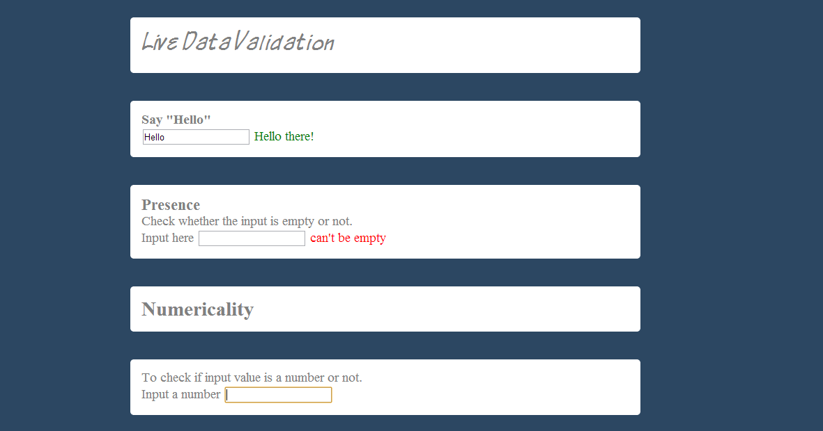

Result:
Success! , as “can’t be empty” error message is shown when field is left empty.
2. Valid Input
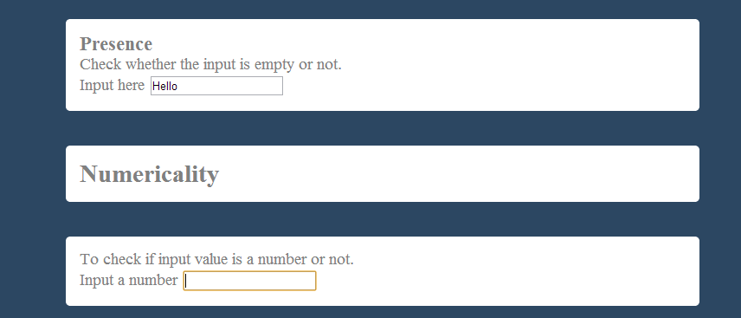
Result:
Success! , as No error message is shown.

Numericality
This kind of validation is concerned with numbers. It checks if field contains a number or not, entered number is a integer or not and to check for a specific number and thus makes filling form simple and as you would expect it to throughout.

1. Check if entered value in a field is number or not?
This functionality uses three files namely.
1. livedatavalidation.html : For the entire HTML markup
2. validate.js: For data validation
3. stylesheet.css: To style livedatavalidation.html
In validate.js we check the input on client side if entered value in a field is number or not?
Code used is as follows :

- $('#basic_n').keyup(function() { //Check on keyup
- var input=$('#basic_n').val(); //Get the Inputted value
- var len=$('#basic_n').val().length; //Get the length of Input
- if(isNaN(input)==false){ //Use NaN(x) to check if entered value is number or not
- $('#span3').html('<span style="color:green"> Thankyou! </span>');
- }
- else{
- $('#span3').html('<span style="color:red"> Not a number ! </span>');
- }
- if(len==0){ // Remove any message if field is empty
- $('#span3').html('');
- }
- });

TEST CASES

We generate test cases using Equivalence class testing . We have divided Input in two classes i.e. valid input class and invalid input class.
1. Invalid Input
a) Character String
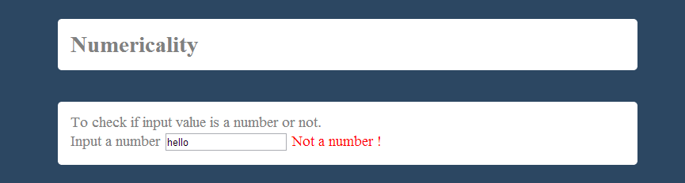
Result:
Success! , as error message ‘Not a number is displayed’.
b) Special Characters
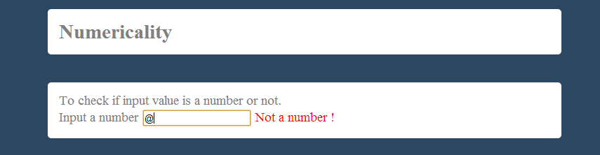
Result:
Success! , as error message not a number is displayed.
2. Valid Input
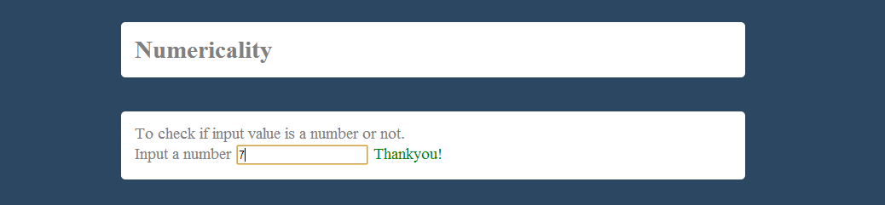

Result:
Success! , as message ‘Thankyou!’ is displayed.
2. Entered number is a integer or not?

This functionality uses three files namely.
1. livedatavalidation.html : For the entire HTML markup
2. validate.js: For data validation
3. stylesheet.css: To style livedatavalidation.html
In validate.js we check the input on client side if entered value in a field is a integer or not?
Code used is as follows :

- $('#basic_i').keyup(function() { //Check on keyup
- var input=$('#basic_i').val(); //Get the Inputted value
- var len=$('#basic_i').val().length; //Get the length of Input
- if((input%1)===0){ /*Every number divided by 1 gives
- remainder as zero and if entered
- number is a integer then '==='
- will return true when checked against
- integer 0 as it '===' compares value
- and datatype as well */
- $('#span4').html('<span style="color:green"> Thank you!
- </span>');
- }
- else{
- $('#span4').html('<span style="color:red"> I think you
- know what integer is, this ain\'t one!</span>');
- }
- if(len==0){ // Remove any message if field is empty
- $('#span4').html('');
- }
- });

TEST CASES

We generate test cases using Equivalence class testing . We have divided Input in two classes i.e. valid input class and invalid input class.
1. Invalid Input
a) Character
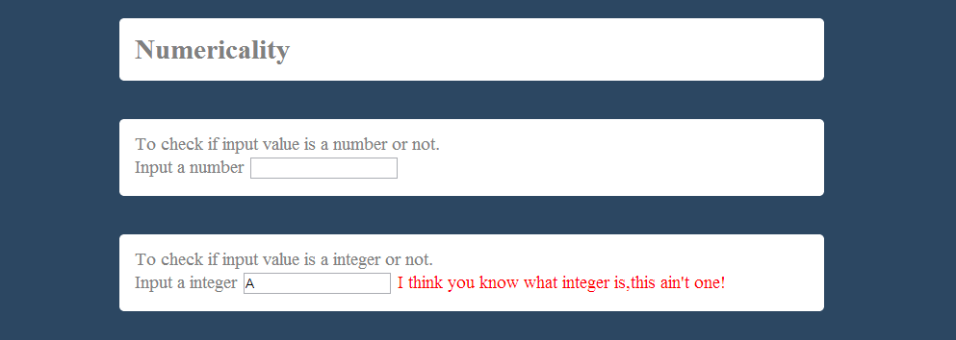

Result:
Success! , as error message is displayed.
b) Floating Point
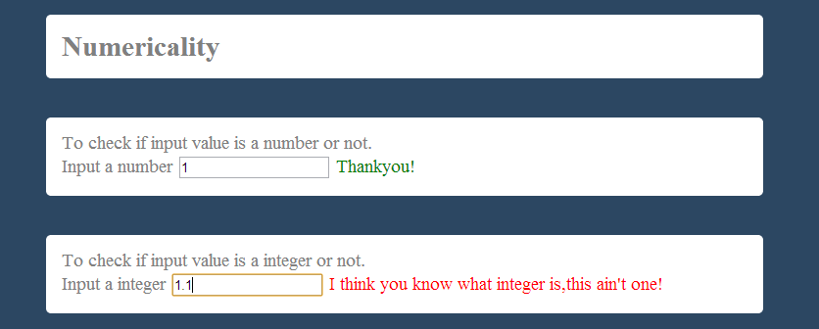
Result:
Success!, as error message is displayed.

2. Valid Input
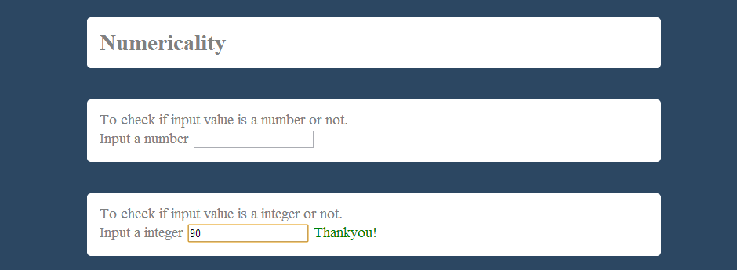
Result:
Success! , as message ‘Thankyou!’ is displayed.

3. Check for a specific number
In this case we will take our specific number as ‘100’
This functionality uses three files namely.
1. livedatavalidation.html : For the entire HTML markup
2. validate.js: For data validation
3. stylesheet.css: To style livedatavalidation.html
In validate.js we check the input on client side if entered is ‘100’ or not.
Code used is as follows :
- $('#basic_s').keyup(function() { //Check on keyup
- var input=$('#basic_s').val(); //Get the Inputted value
- var len=$('#basic_s').val().length; //Get the length of Input
- if(input==100){ //check if inputted value is 100 or not
- $('#span5').html('<span style="color:green"> Thankyou! </span>');
- }
- else{
- $('#span5').html('<span style="color:red"> Not \'100\' </span>');
- }
- if(len==0){ //Remove any message if field is empty
- $('#span5').html('');
- }
- });

TEST CASES
We generate test cases using Equivalence class testing . We have divided Input in two classes i.e. valid input class and invalid input class.
1. Invalid Input
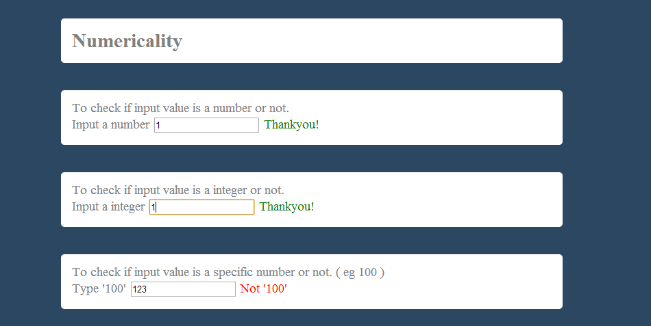
Result:
Success!, as error message is displayed.
2 .Valid Input
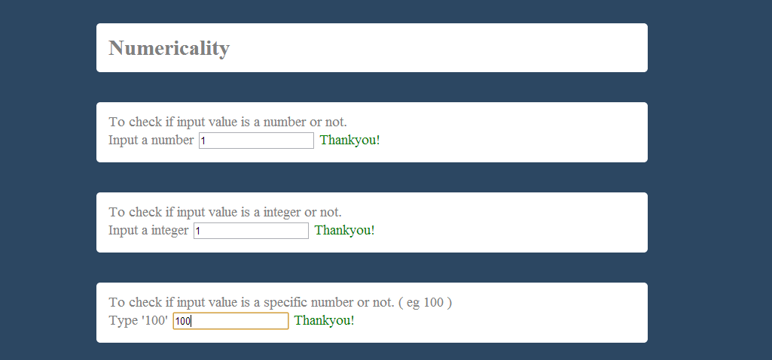
Result:
Success! , as message ‘Thankyou!’ is displayed.
Inclusion

Inclusion lets you validate against a list of allowed values. . You can do an exact match or a partial match.
Exact match
This functionality uses three files namely.
1. livedatavalidation.html : For the entire HTML markup
2. validate.js: For data validation
3. stylesheet.css: To style livedatavalidation.html
In validate.js we check the input on client side if entered value in a field is in list or not?
Code used is as follows :
- $('#exact').keyup(function() { //Check on keyup
- array=['xbox-360','ps3','wii']; //Define the list you want to check against
- var input=$('#exact').val().toLowerCase(); //conver entered vales into lowercase
- var len=$('#exact').val().length; //Get the length of Input
- if(jQuery.inArray(input,array)==-1) /* use jQuery inArray function to check
- against the list it return -1 if not present
- and return indexof element if found*/
- {
- $('#span6').html('<span style="color:red"> Not OK. </span>');
- }
- else
- {
- $('#span6').html('<span style="color:green"> OK. </span>');
- }
- if(len==0){ //Remove any message if field is empty
- $('#span6').html('');
- }
- });

TEST CASES
We generate test cases using Equivalence class testing . We have divided Input in two classes i.e. valid input class and invalid input class.
1. Invalid Input
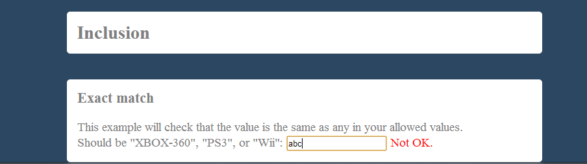
Result:
Success!, as error message is displayed.
2 .Valid Input
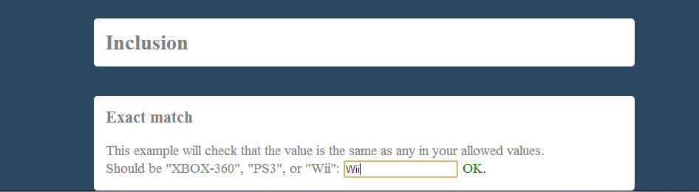
Result:
Success! , as message ‘OK.’ is displayed.

Partial match
This functionality uses three files namely.
1. livedatavalidation.html : For the entire HTML markup
2. validate.js: For data validation
3. stylesheet.css: To style livedatavalidation.html
In validate.js we check the input on client side if entered value in a field is partially in list or not?
Code used is as follows :

- $('#notpartial').keyup( function(){ //Check on keyup
- array=['xbox-360','ps3','wii']; //Define the list you want to check against
- var input=$('#notpartial').val().toLowerCase(); //convert entered vales into lowercase
- var len=$('#notpartial').val().length; //Get the length of Input
- var inputArray=input.split(" "); //split the input into array with slipt() using space
- for (var i = 0; i < inputArray.length; i++) { // check for each inputed word separated by space
- if(jQuery.inArray(inputArray[i],array)==-1)/* use jQuery inArray function to check
- against the list it return -1 if not present
- and return indexof element if found*/
- {
- $('#span9').html('<span style="color:green"> Thank You! </span>');
- }
- else
- {
- $('#span9').html('<span style="color:red"> Must not be included in the list! </span>');
- break;
- }
- }
- if(len==0){ //Remove any message if field is empty
- $('#span9').html('');
- }

- });

TEST CASES
We generate test cases using Equivalence class testing . We have divided Input in two classes i.e. valid input class and invalid input class.
1. Invalid Input
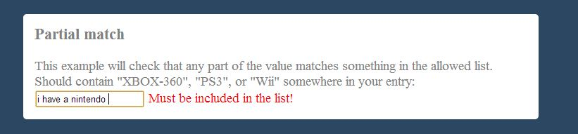
Result:
Success!, as error message is displayed.
2 .Valid Input
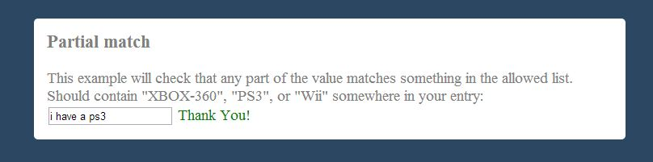
Result:
Success! , as message ‘Thank you!’ is displayed.

Exclusion

Exclusion lets you validate against a list of values that are not allowed. You can do an exact match or a partial match.
Exact match
This functionality uses three files namely.
1. livedatavalidation.html : For the entire HTML markup
2. validate.js: For data validation
3. stylesheet.css: To style livedatavalidation.html
In validate.js we check the input on client side if entered value in a field is in list or not?
Code used is as follows :
- $('#notexact').keyup(function() { //Check on keyup
- array=['xbox-360','ps3','wii']; //Define the list you want to check against
- var input=$('#notexact').val().toLowerCase(); //convert entered vales into lowercase
- var len=$('#notexact').val().length; //Get the length of Input
- if(jQuery.inArray(input,array)==-1) /* use jQuery inArray function to check
- against the list it return -1 if not present
- and return indexof element if found*/
- {
- $('#span8').html('<span style="color:green"> Thank you! </span>');
- }
- else
- {
- $('#span8').html('<span style="color:red"> Must not be included in the list! </span>');
- }
- if(len==0){ //Remove any message if field is empty
- $('#span8').html('');
- }
- });

TEST CASES
We generate test cases using Equivalence class testing . We have divided Input in two classes i.e. valid input class and invalid input class.
1. Invalid Input

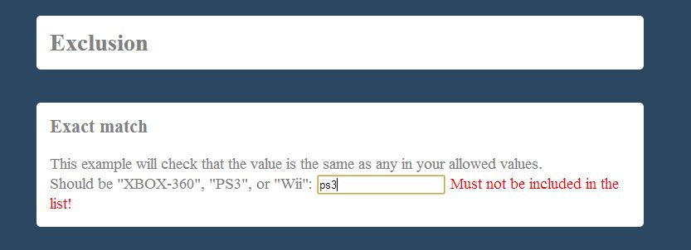

Result:
Success!, as error message is displayed.
2 .Valid Input
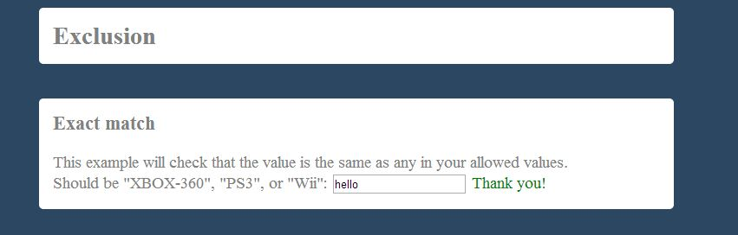

Result:
Success! , as message ‘Thank you!’ is displayed.

Partial match
This functionality uses three files namely.
1. livedatavalidation.html : For the entire HTML markup
2. validate.js: For data validation
3. stylesheet.css: To style livedatavalidation.html
In validate.js we check the input on client side if entered value in a field is partially in list or not?
Code used is as follows :
- $('#notpartial').keyup( function(){ //Check on keyup
- array=['xbox-360','ps3','wii']; //Define the list you want to check against
- var input=$('#notpartial').val().toLowerCase(); //convert entered vales into lowercase
- var len=$('#notpartial').val().length; //Get the length of Input
- var inputArray=input.split(" "); //split the input into array with slipt() using space
- for (var i = 0; i < inputArray.length; i++) { // check for each inputed word separated by space
- if(jQuery.inArray(inputArray[i],array)==-1)/* use jQuery inArray function to check
- against the list it return -1 if not present
- and return indexof element if found*/
- {
- $('#span9').html('<span style="color:green"> Thank You! </span>');
- }
- else
- {
- $('#span9').html('<span style="color:red"> Must not be included in the list! </span>');
- break;
- }
- }
- if(len==0){ //Remove any message if field is empty
- $('#span9').html('');
- }

- });

TEST CASES
We generate test cases using Equivalence class testing . We have divided Input in two classes i.e. valid input class and invalid input class.
1. Invalid Input

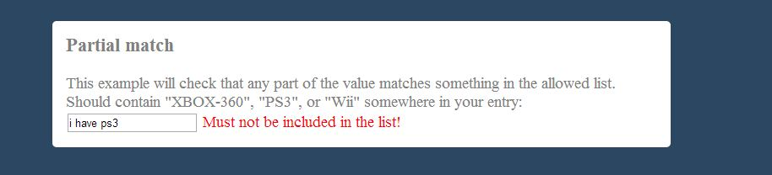
Result:
Success!, as error message is displayed.
2 .Valid Input
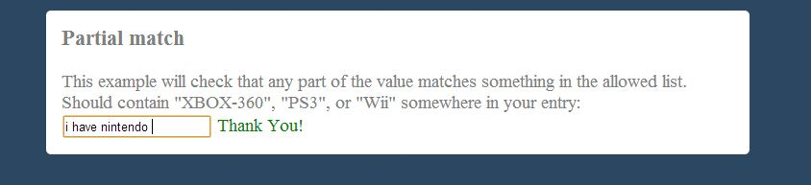
Result:
Success! , as message ‘Thank you!’ is displayed.

Acceptance

Acceptance lets you validate that a checkbox has been checked.
This functionality uses three files namely.
1. livedatavalidation.html : For the entire HTML markup
2. validate.js: For data validation
3. stylesheet.css: To style livedatavalidation.html
In validate.js we check the input on client side if check box is ticked or not?
Code used is as follows :
- $('#chkbox').change( function() { //check on change

- if($('#chkbox').is(':checked')) //returns true is checked else false
- $('#span10').html('<span style="color:green"> Thank You!</span>');
- else $('#span10').html('<span style="color:red"> Must be accepted </span>');
- });

TEST CASES
We generate test cases using Equivalence class testing . We have divided Input in two classes i.e. valid input class and invalid input class.
1. Invalid Input
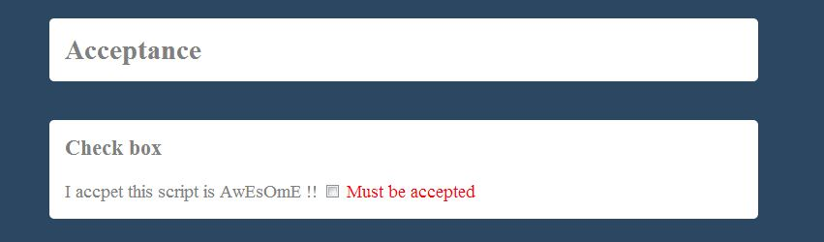
Result:
Success!, as error message is displayed.

2 .Valid Input
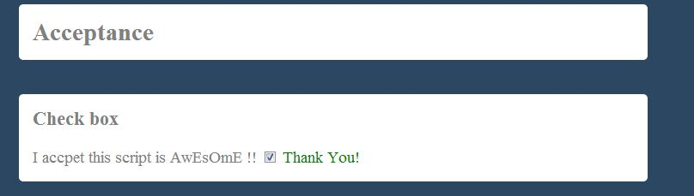
Result:
Success! , as message ‘Thank you!’ is displayed.

Confirmation
This is used to check that the value of the confirmation field matches that of another field. The most common use for this is for passwords.
This functionality uses three files namely.
1. livedatavalidation.html : For the entire HTML markup
2. validate.js: For data validation
3. stylesheet.css: To style livedatavalidation.html
In validate.js we check the input on client side if conformation field match the another field or not,
in this case we its password field .
Code used is as follows :
- $('#pass2').keyup( function () { //check on keyup of another field
- if ( $('#pass1').val()==$('#pass2').val()) //compare the values in both field
- $('#span11').html('<span style="color:green"> Password Match!</span>');
- else
- $('#span11').html('<span style="color:red"> Password does not Match!</span>');
- });

TEST CASES
We generate test cases using Equivalence class testing . We have divided Input in two classes i.e. valid input class and invalid input class.

1.Invalid Input

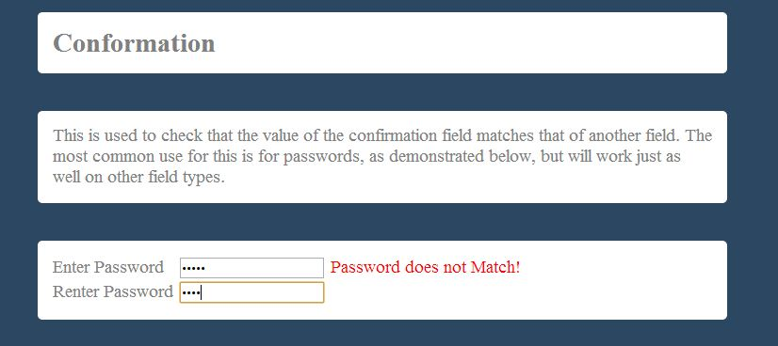
Result:
Success!, as error message is displayed.

2 .Valid Input

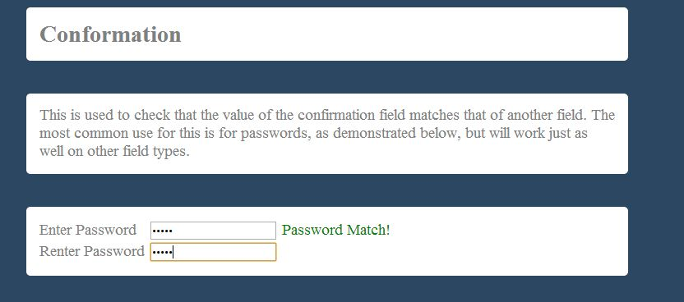

Result:
Success! , as message ‘Password Match!’ is displayed.

Composite validations (combining validations)

Most of the time, you will want to combine multiple types of validation on a single field. As your user is given real-time feedback.

To demonstrate this functionality we use username field i.e. it must be at least 6 character long and available for this we require four files namely.
1. livedatavalidation.html : For the entire HTML markup
2. validate.js: For data validation
3. stylesheet.css: To style livedatavalidation.html
4. usr_chk.php :To check the availability of user which in turn uses a ‘global.php’ which connects it to database.
Usr_chk.php is as follows:
- <?php
- include 'global.php';
- $username=mysql_real_escape_string($_POST['username']);
- $check = mysql_query("SELECT * FROM users WHERE user_name='$username'");
- if (mysql_num_rows($check)>=1){
- $str='<strong><span style="color:red;">Username already taken!</span></strong>';
- echo $str;

- }
- else echo'<strong><span style="color:green;">Username available!</span>';

- ?>
In this the username is fetched using jQuery and send to a PHP file using Ajax which checks the database for username availability.
Code in validate.js is as follows:
- $('#username').focus(function(){ //start on focus
- $('#username').keyup(function(){ //check on keyup
- var username=$('#username').val(); //get the inputted value
- var len=username.length; //length of input
- if(len<6){ //if less than 6 display error message
- $('#span12').html('<strong><span style="color:red;">Must greater than 5 charcters</span></strong>');
- }
- else{
- $.ajax({ // send value to usr_chk.php for availability
- type:'POST',
- url: 'usr_check.php',
- data:'username='+ username,
- success: function(data){ /*get value from usr_chk.php
- using call back function */
- $('#span12').html(data); //output the data

- }
- });
- }
- });
TEST CASES
We generate test cases using Equivalence class testing . We have divided Input in two classes i.e. valid input class and invalid input class.
1.Invalid Input
A) Less than 6 character long .
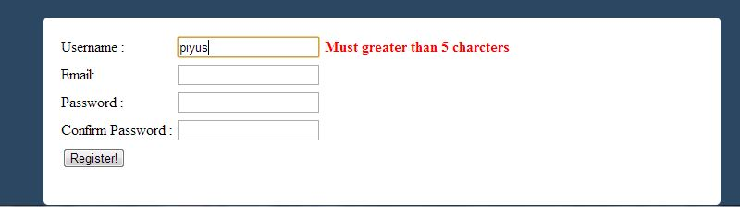
Result:
Success!, as error message is displayed.
B) Username not available
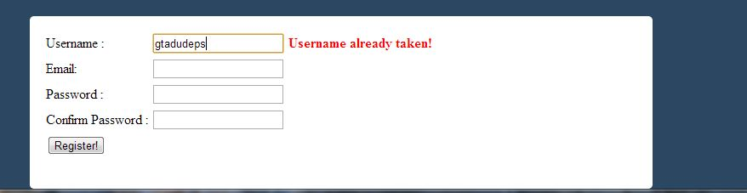
Result:
Success!, as error message is displayed.
2 .Valid Input

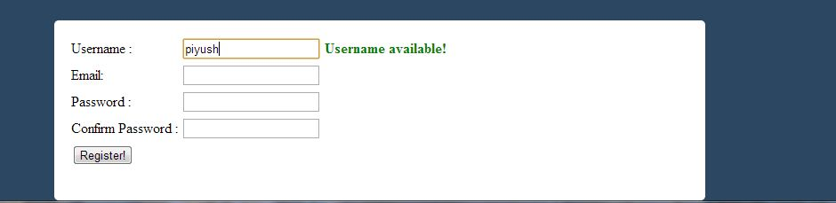
Result:
Success!, as message ‘username available!’ is displayed.

Validating entire registration form

- Check for username availability
- Username must be at least six characters long.
- Email address must be valid.
- Stop user from submitting if form does not validates.

  - Username is fetched using jQuery and send to a PHP file using Ajax which checks the database for username availability.
  - Username length is checked in validate.js
  - In this the email address is fetched using jQuery and send to a PHP file using Ajax which checks if email address is valid or not.

Code to check username availability and length of username in validate.js is as follows:

- var tmp=1;
- $('#username').focus(function(){ //start on focus
- $('#username').keyup(function(){ //check on keyup

- var username=$('#username').val(); //get the input value
- var len=username.length; //length of input
- $('#span14').html(' ');//clear form submitting error
- if(len<6){ //if less than 6 display error message
- tmp=0;
- $('#span12').html('<strong><span style="color:red;">Must be greater than 5 charcters</span></strong>');
- }
- else{
- tmp=1;
- $.ajax({ // send value to usr_chk.php for availability
- type:'POST',
- url: 'usr_check.php',
- data:'username='+ username,
- success: function(data){ /*get value from usr_chk.php
- using call back function */
- if (data==0)
- {
- tmp=0;
- $('#span12').html('<strong><span style="color:red;">Username already taken!</span></strong>'); //output the data
- }
- else
- $('#span12').html('<strong><span style="color:green;">Username available!</span></strong>');
- }
- });
- }
- });
- });

Code to check email address is as follows:
- var temp=1;
- $('#email_id').keyup(function(){//check on keyup
- var email=$('#email_id').val();//get the input value
- $('#span14').html(' ');//clear form submitting error
- $.ajax({
- type:'POST',
- url: 'email_check.php',
- data:'email='+ email,
- success: function(data){
- temp=1;
- if(data==0) /*if 0 is returned by email_check.php that means
- email address is not valid */
- {
- temp=0; //set temp to 0 so that form can't be submitted
- $('#span13').html('<strong><span style="color:red;">Does not appears to be a valid email address :(</span></strong>');
- }
- else
- $('#span13').html(data);
- }
- });
- });
Code to stop user from submitting if form does not validates is:
- $('#submitForm').submit(function() {
- if(tmp==0 || temp==0) /*tmp==0 =>username is not valid and
- temp==0 =>email address is not valid */
- {
- $('#span14').html('<strong><span style="color:red;">Form not correctly filled! </span></strong>');
- return false; //return false so that form is not submitted
- }
- });

TEST CASES
We generate test cases using Equivalence class testing . We have divided Input in two classes i.e. valid input class and invalid input class.

1.Invalid Input

- Username not available and user submits the form

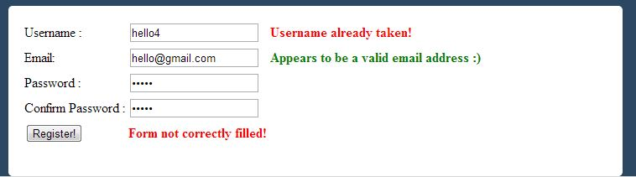

Result:
Success as form was stopped from submitting at client side, since tmp equates to 0 in validate.js script.
- Username too short

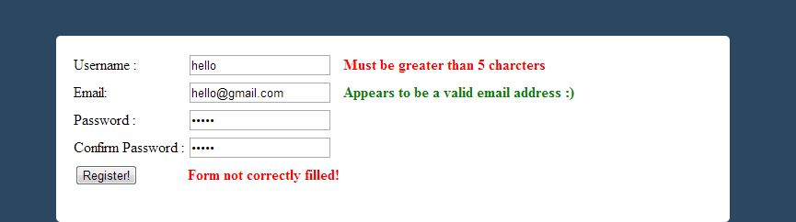

Result:
Success as form was stopped from submitting at client side, since tmp equates to 0 in validate.js script.
- Email address appears to be invalid

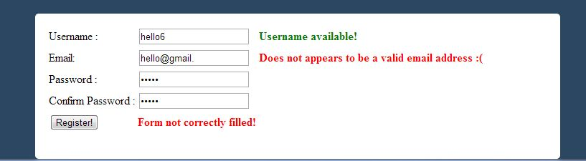

Result:
Success as form was stopped from submitting at client side, since temp equates to 0 in validate.js script.
2. Valid Input

User fills in the form as expected.

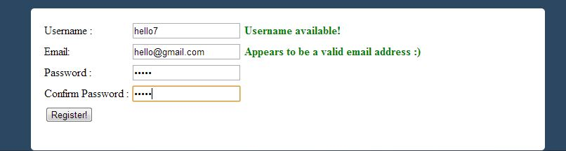

Result:
Success as form gets validated on client side using validate.js and is successfully submitted!

