# LUDWIG – INTERMEDIATE STEPS

VERSION 1: no optimization

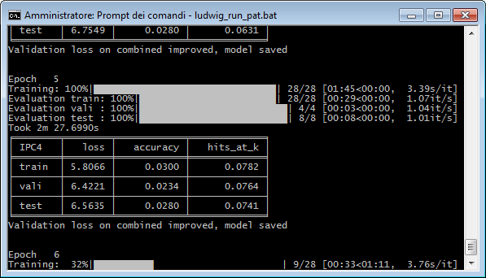

input_features:

-

name: EARLIEST_FILING_YEAR

type: numerical

-

name: APPLN_ABSTRACT

type: text

level: word

-

name: PSN_NAME

type: category

output_features:

-

name: IPC4

type: category

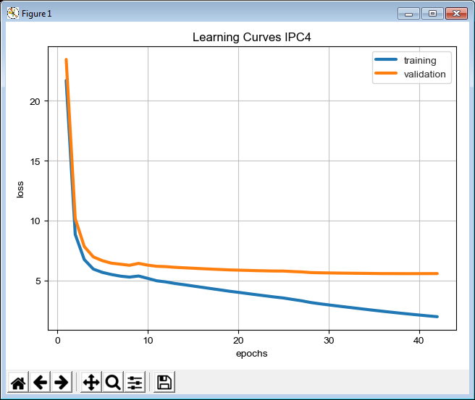

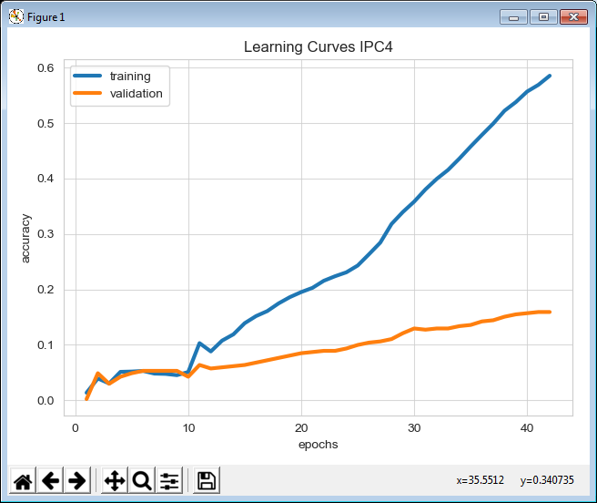

Version 2:

modeldefinition_ipc4

input_features:

-

name: APPLN_ABSTRACT

type: text

level: word

encoder: parallel_cnn

preprocessing:

word_format: english_tokenize

output_features:

-

name: IPC4

type: category

training:

batch_size: 128

epochs: 1000

early_stop: 50

learning_rate: 0.003

optimizer:

type: adagrad

