1.
Size: 1000
Nr DC: 1000 (1 node datacenters)
only sender and receiver are long links
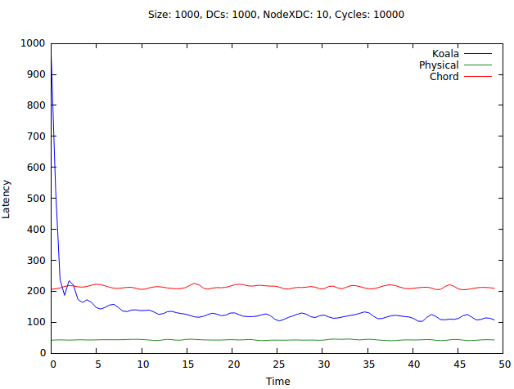

2.
Size: 1000
Nr DC: 100 (10 nodes datacenters)
only sender and receiver are long links

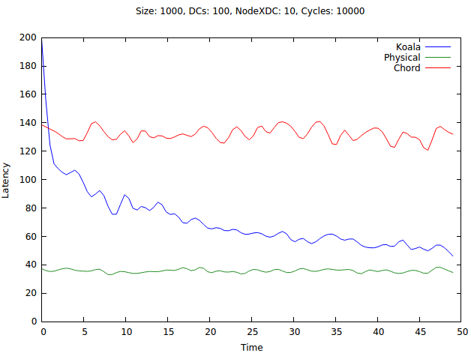

3.
Size: 2000
Nr DC: 2000 (1 node datacenters)
only sender and receiver are long links
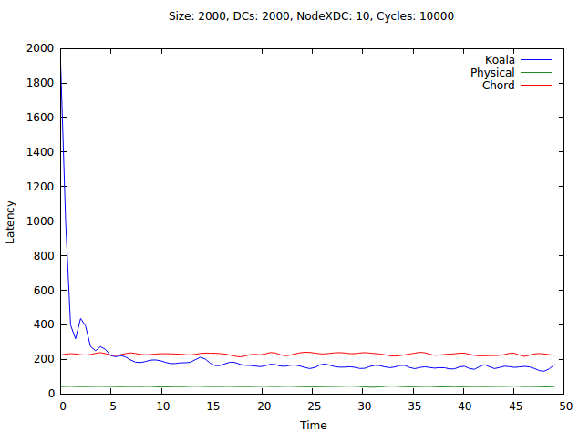

4.
Size: 2000
Nr DC: 200 (10 node datacenters)
only sender and receiver are long links
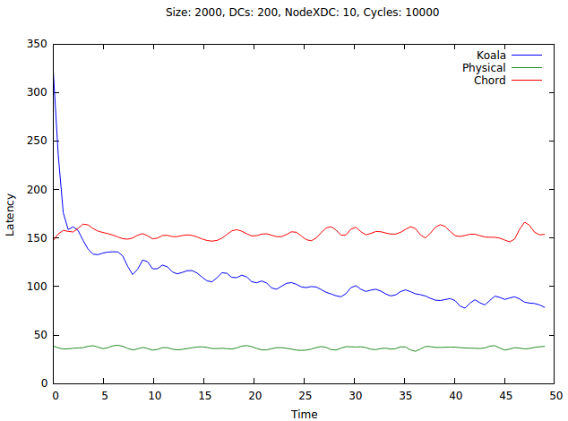

5.
Size: 3000
Nr DC: 3000 (1 node datacenters)
only sender and receiver are long links
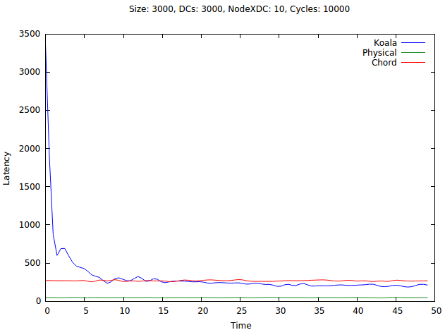
6.
Size: 3000
Nr DC: 300 (10 node datacenters)
only sender and receiver are long links

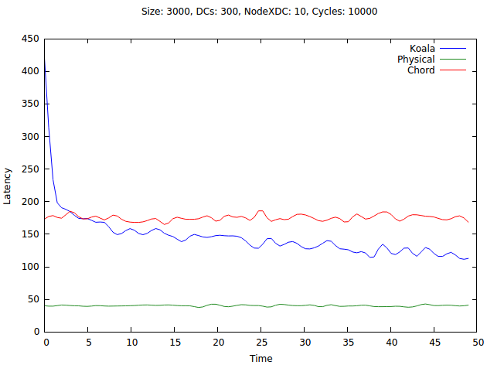

7. Like 1 but the latency is not taken into consideration

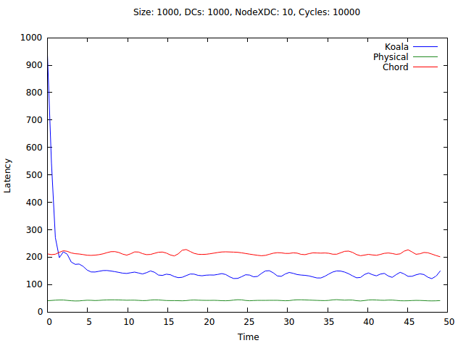

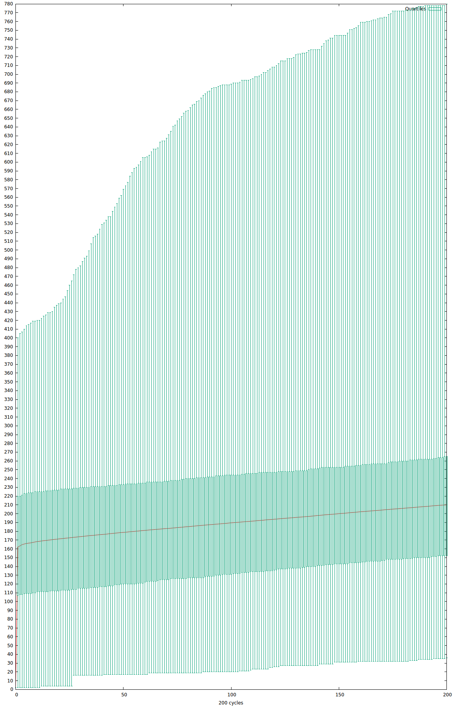
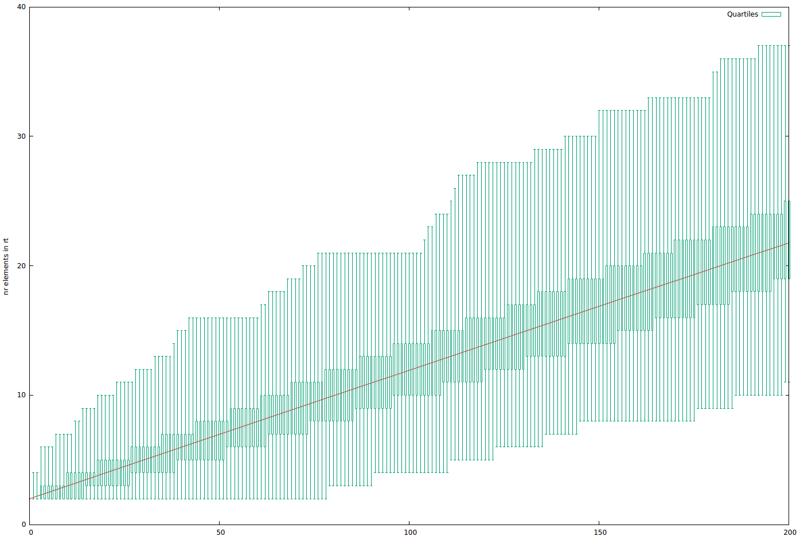

A=0.0

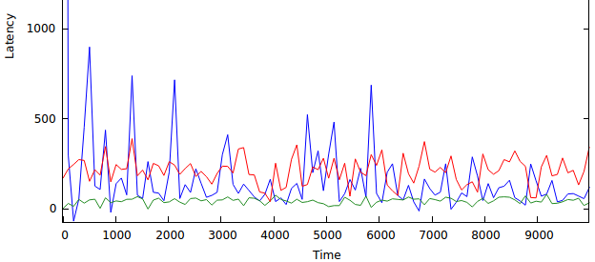
A=0.5

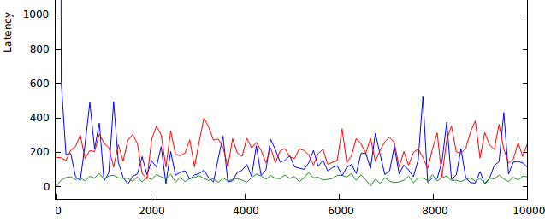
A=1

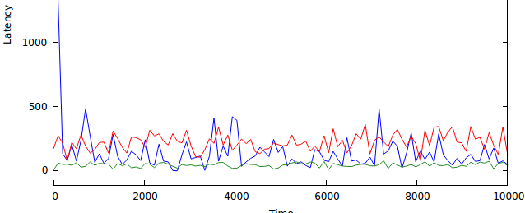
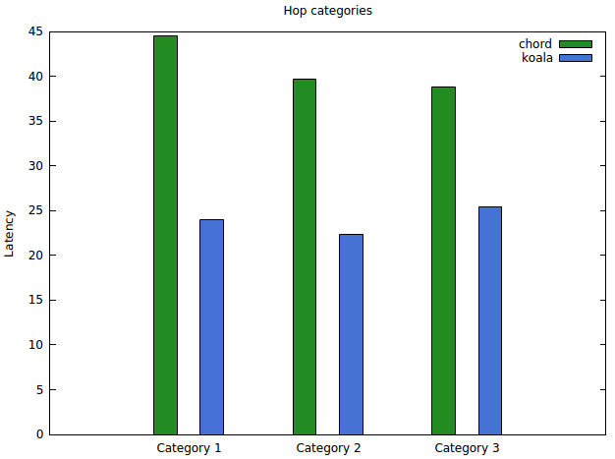

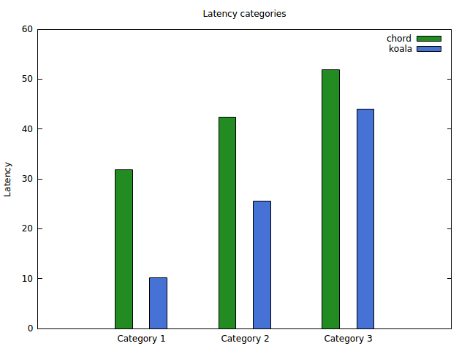

14 September
Averaged latency when alphas change. An average of 10 runs.
1000 nodes, topology star of stars (gradual)
1 time = 500 cycles.

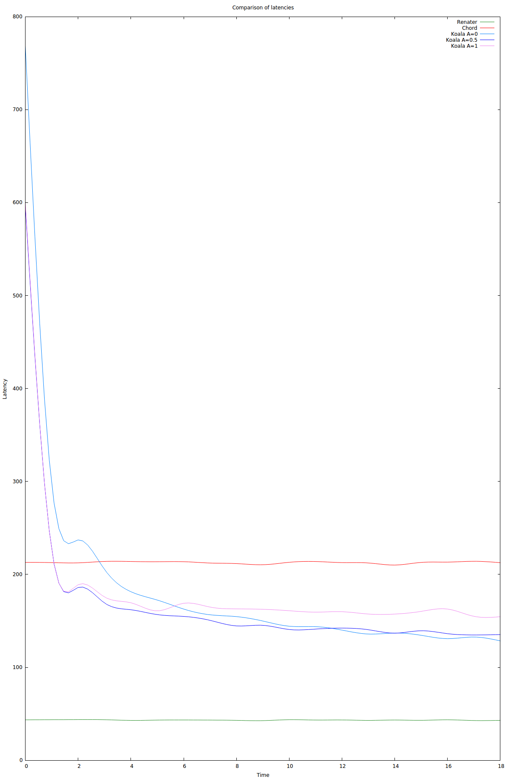

15 September
Averaged latency when alphas change. An average of 10 runs.
1000 nodes, waxman linked with closest (a=0.05, b=.13)
1 time = 500 cycles.
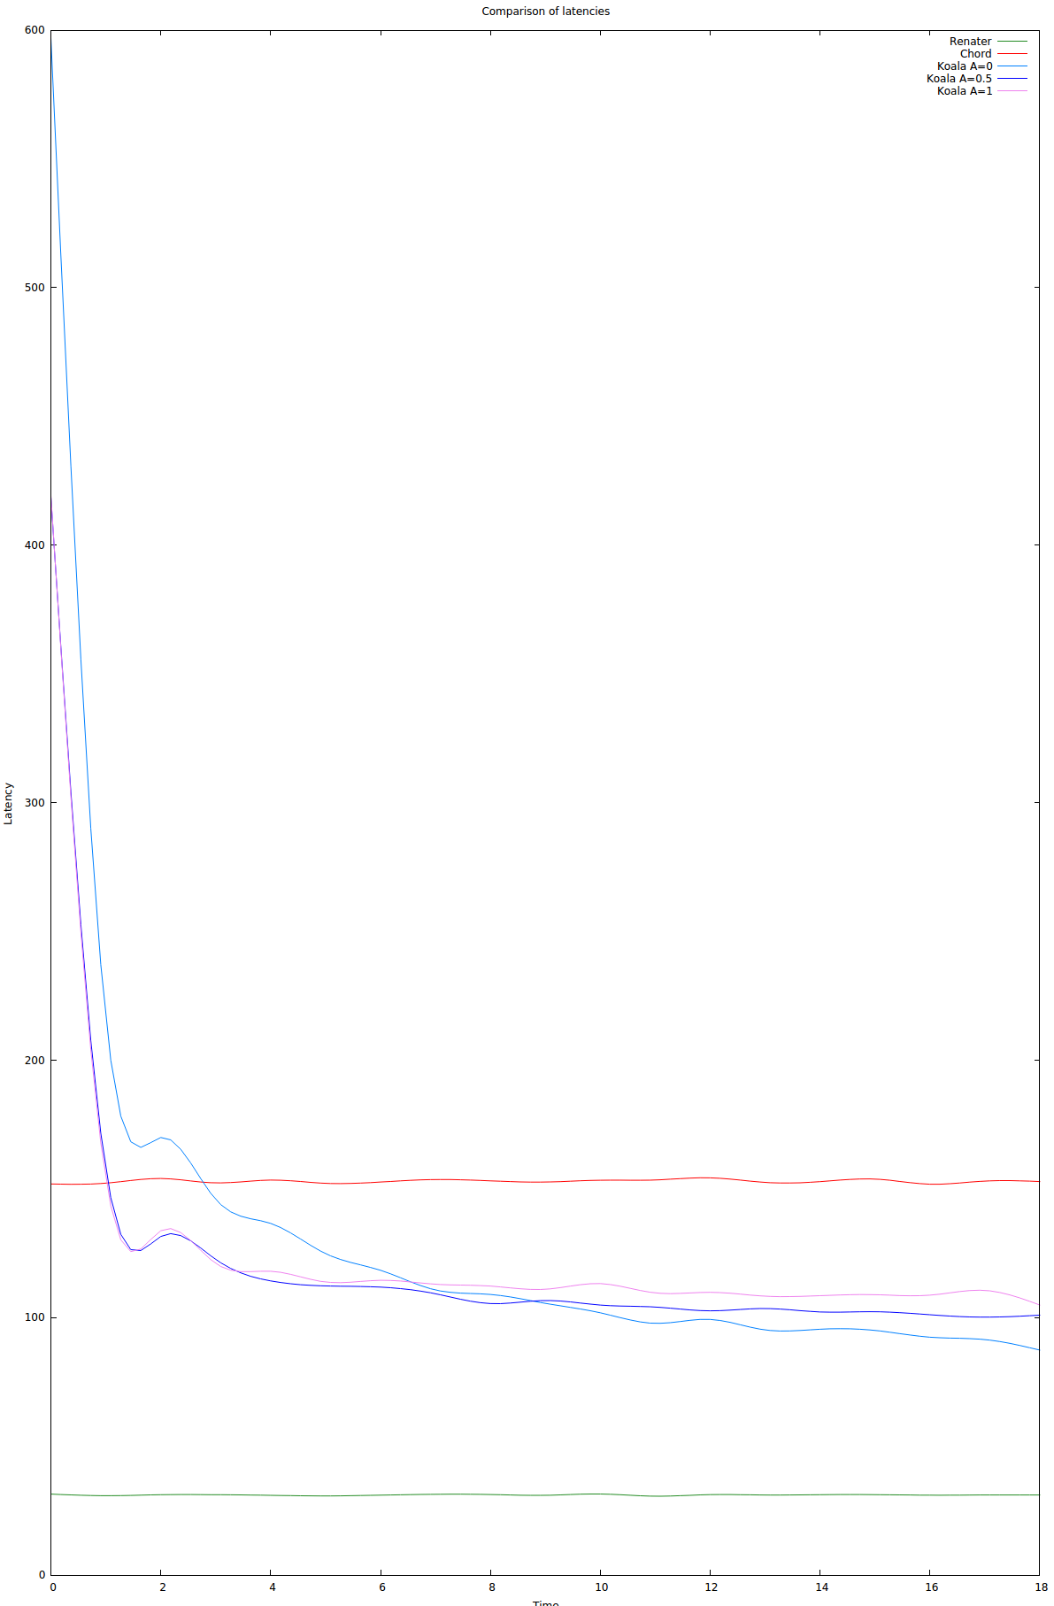
Averaged latency when alphas change. An average of 10 runs.
1000 nodes, closest linked with closest
1 time = 500 cycles.

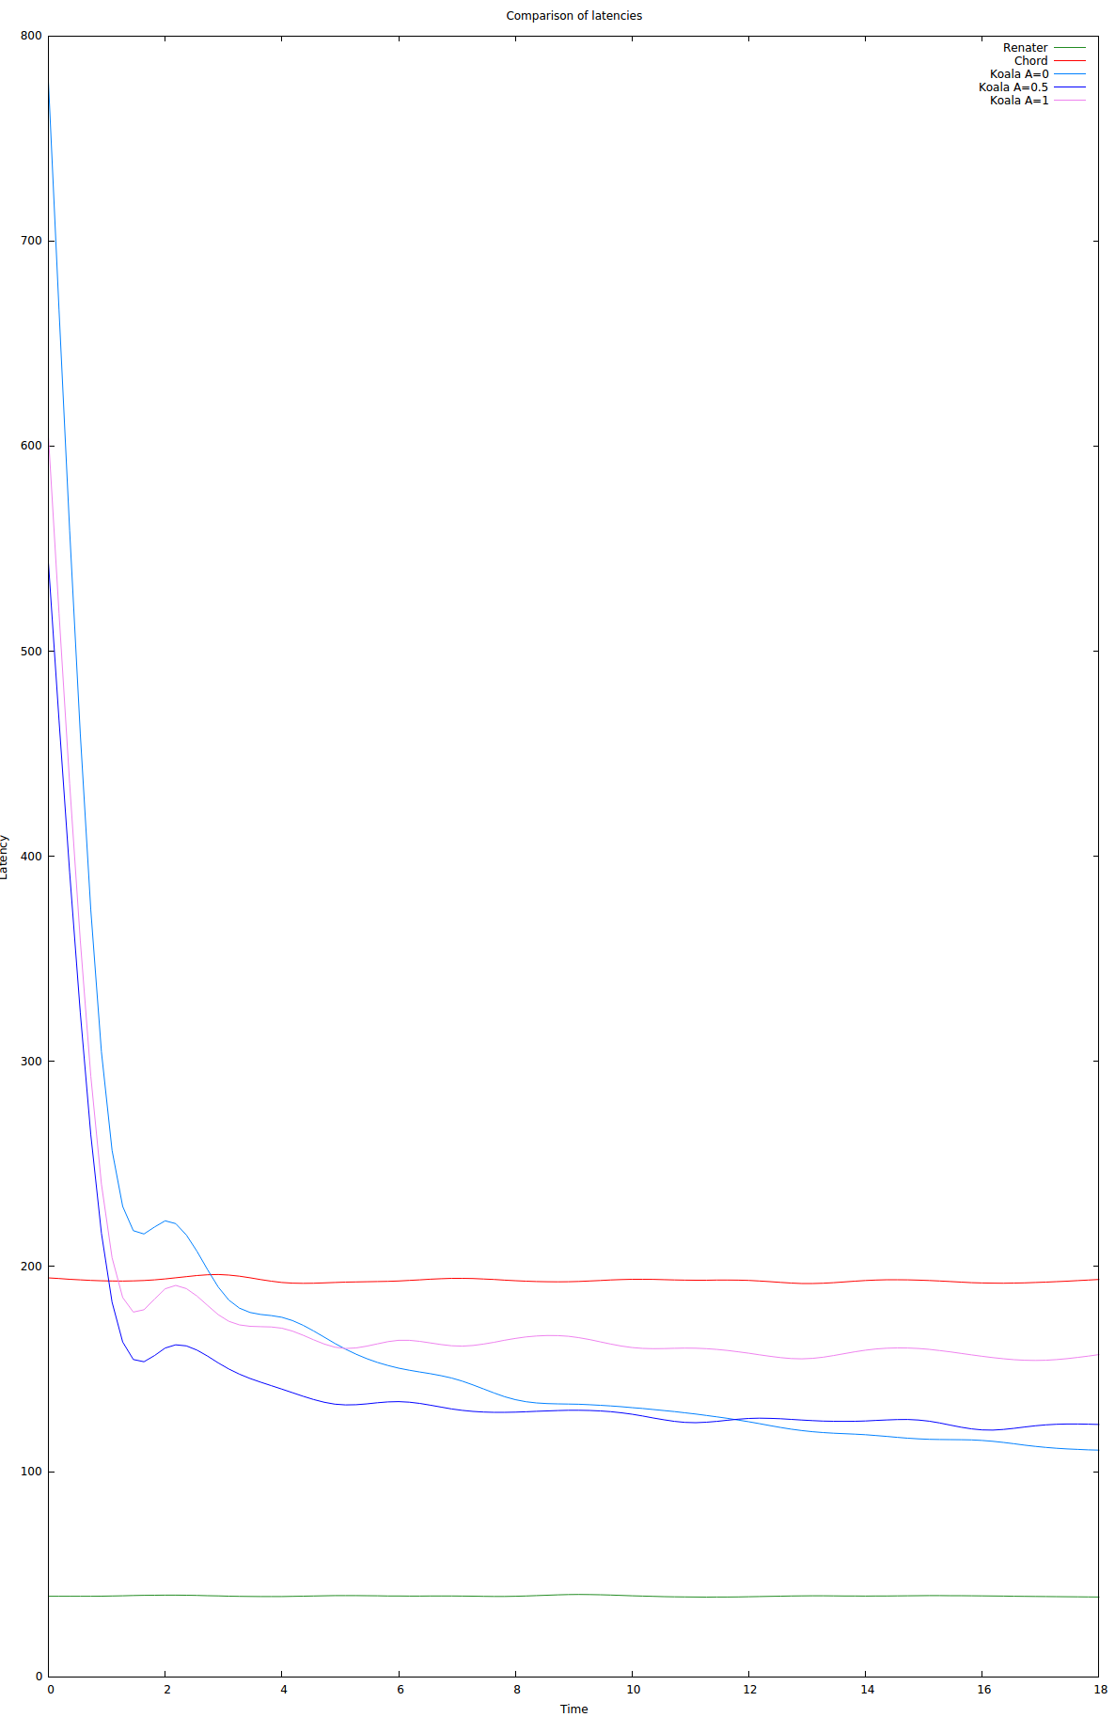
16 september

routing table size for gradual
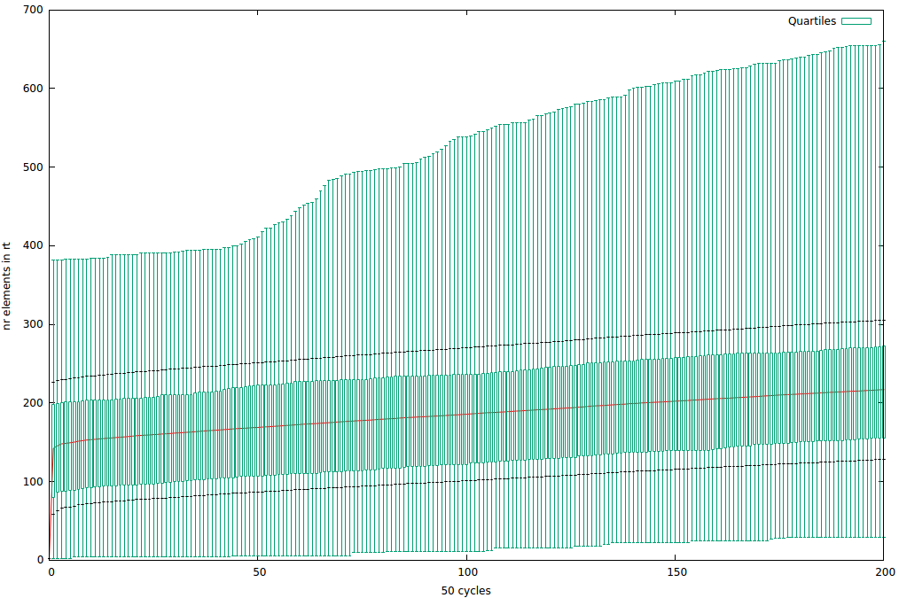

18 September

Message distribution
1. Waxman
(left renater, right koala alpha=0.5)
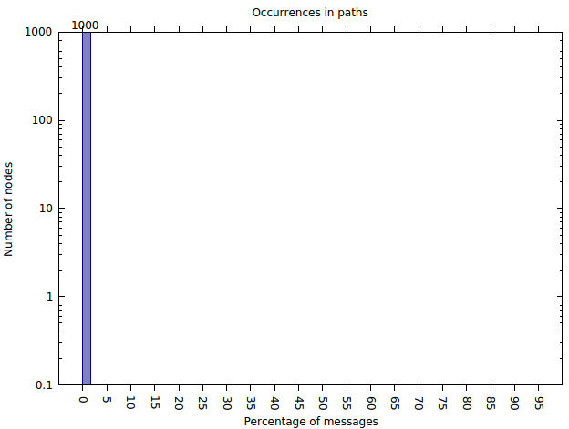
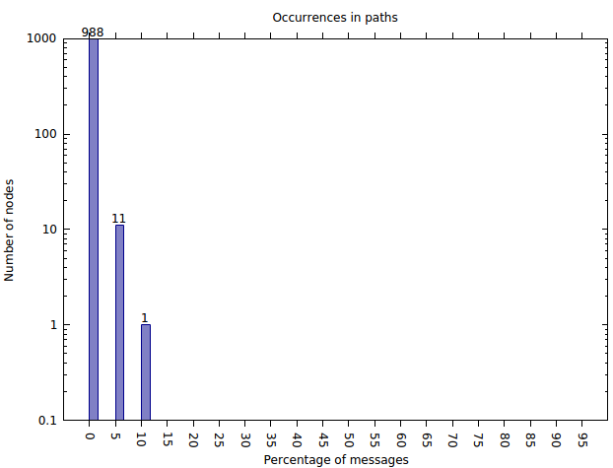

2. Gradual
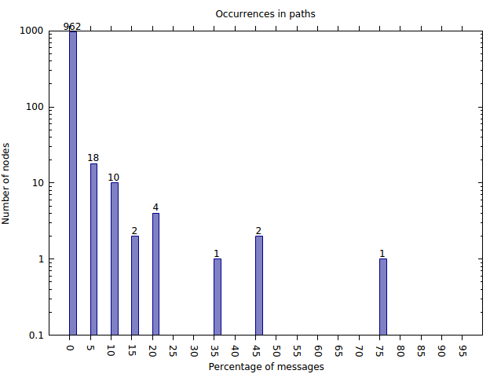
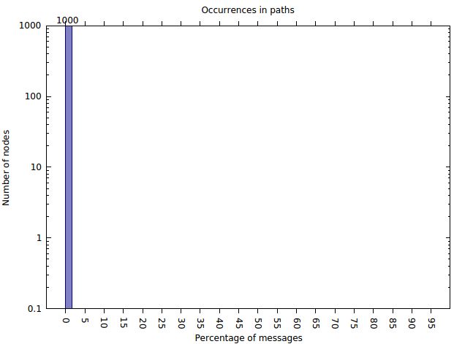

3. Closest

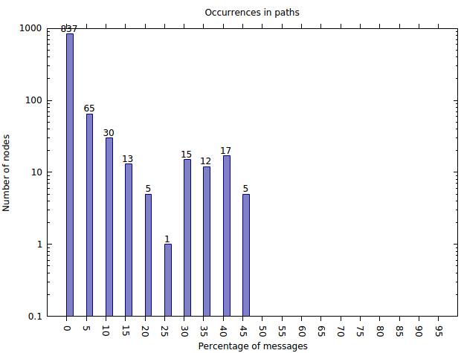
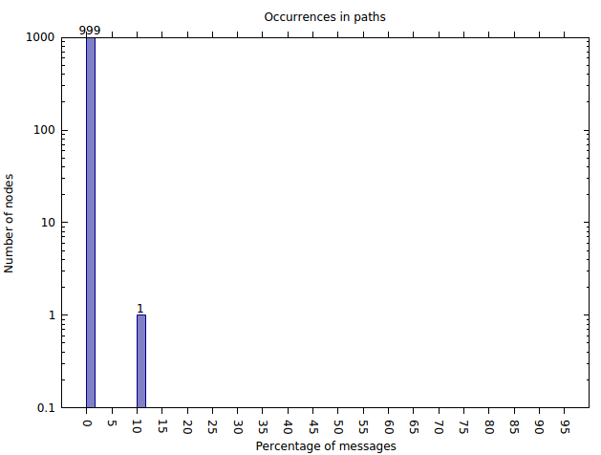

19 September

With long links at the beginning, no learning during running

1/distance, average long links: ~1.5
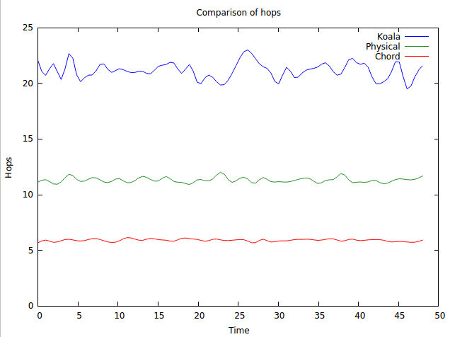
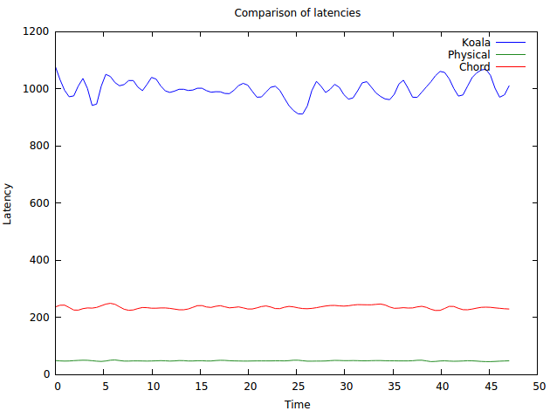

1/distance + 0.2, average long links: ~21.2
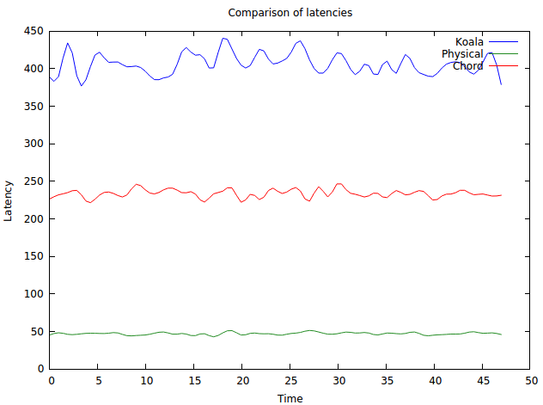
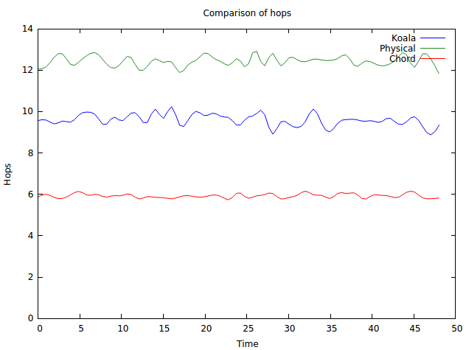

1/distance + 0.3, average long links: ~31.4

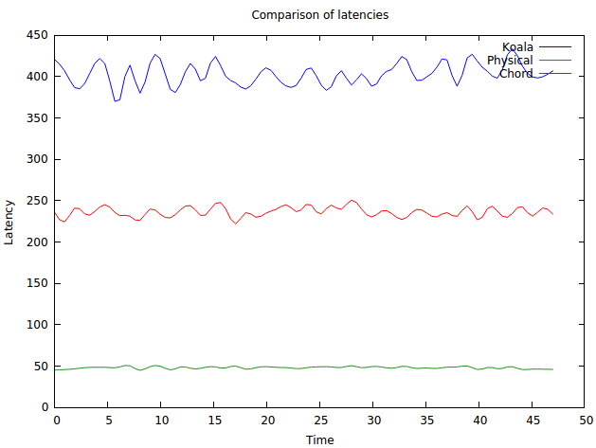
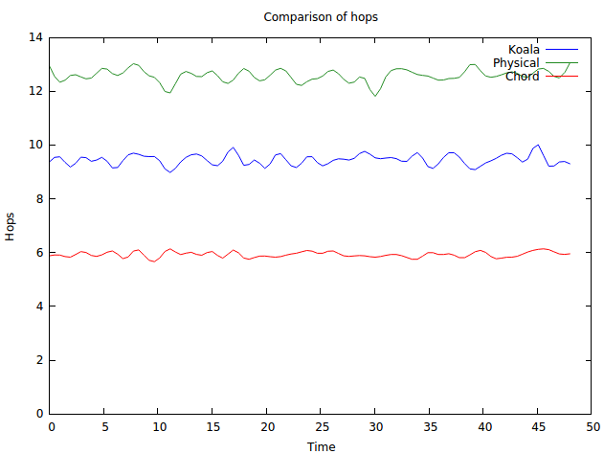

1/distance + 0.4, average long links: 41.306
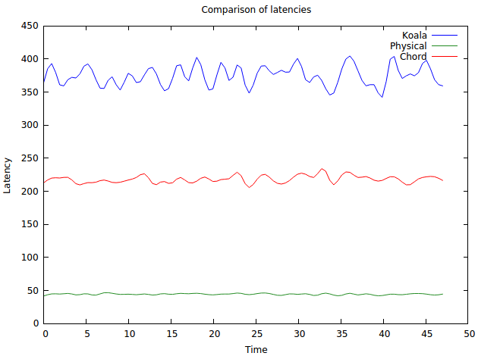
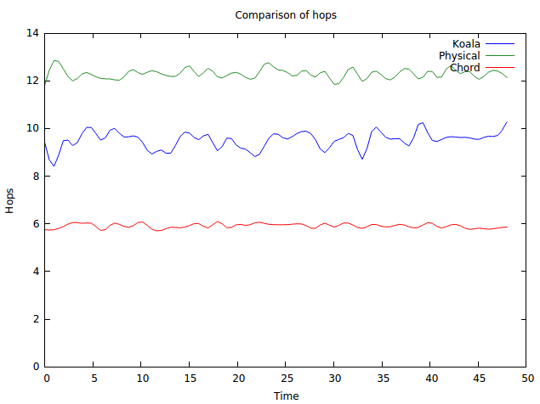

1/distance + 0.5, Average nr of long links: 51.521
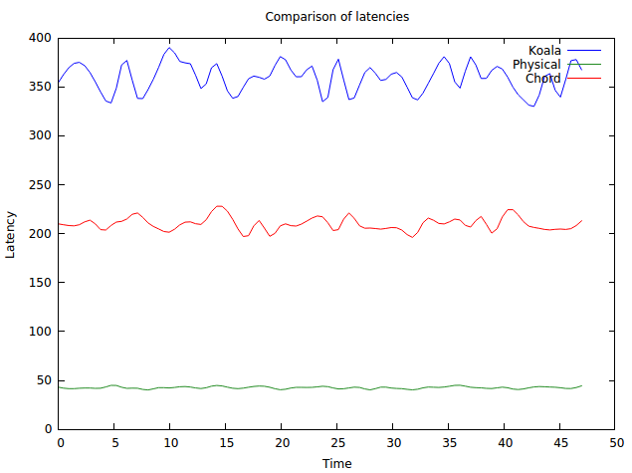
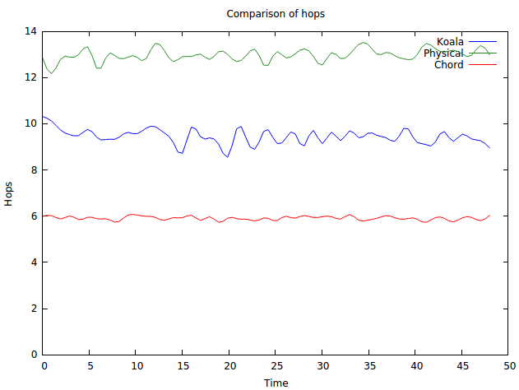

1/distance + 1, (select all of them ).Average nr of long links: 100

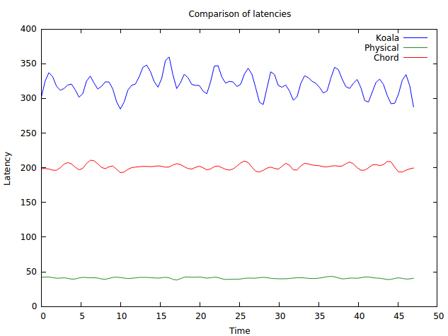
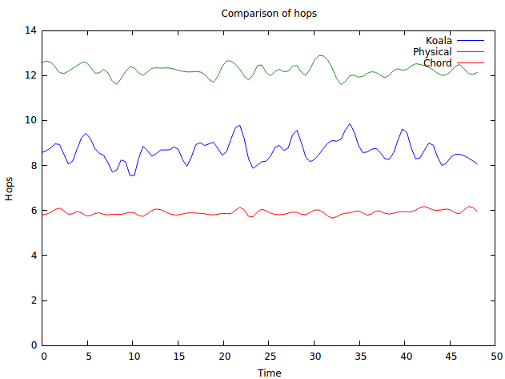

The effect on alpha (1/distance + 0.2)
1. gradual (averaged 10)
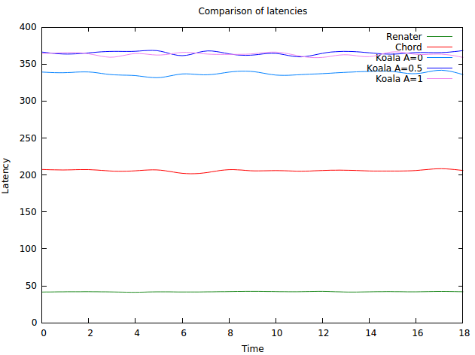
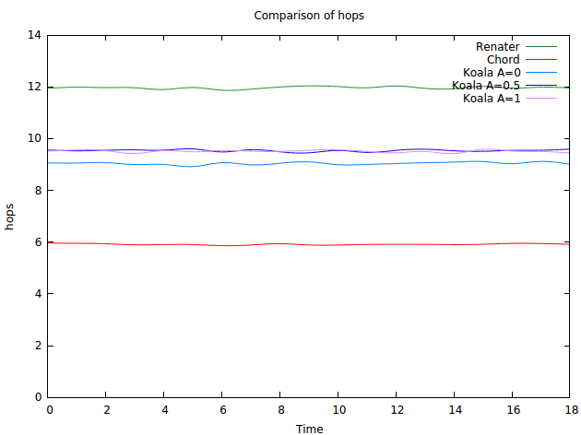
2. waxman (averaged 10)

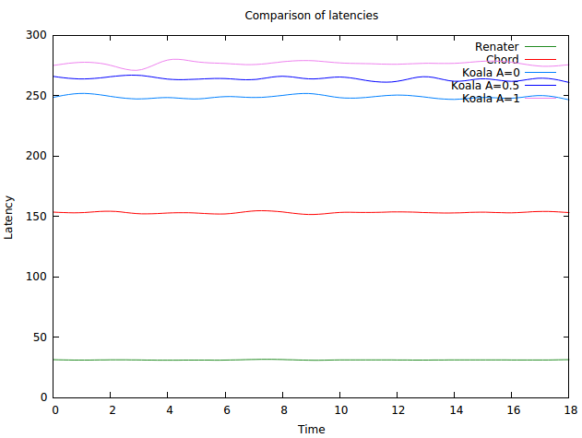
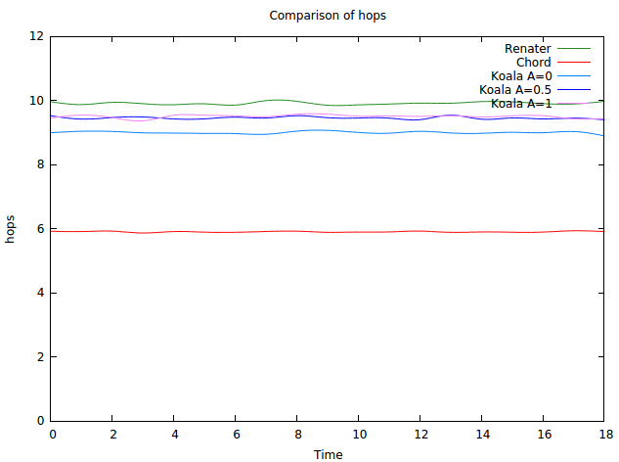

3. closest (averaged 10)
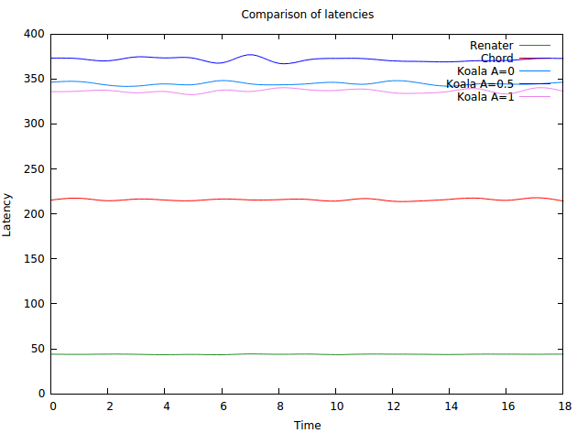
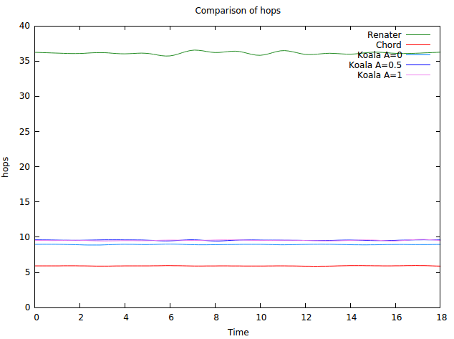

20 September

The number of nodes according to the percentage of nodes they know
1. Waxman
alpha=-1 (avg 10) alpha=0 (avg 10)
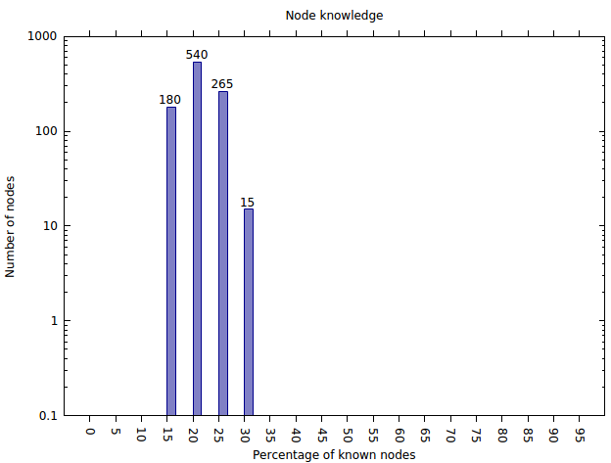
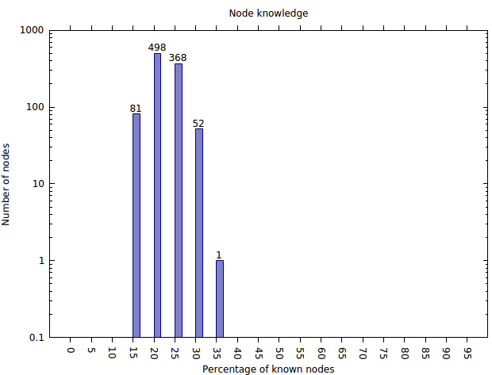

alpha=0.5 (avg 10) alpha=1 (avg 10)
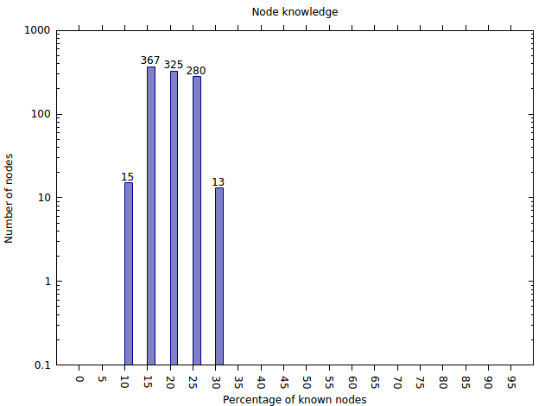
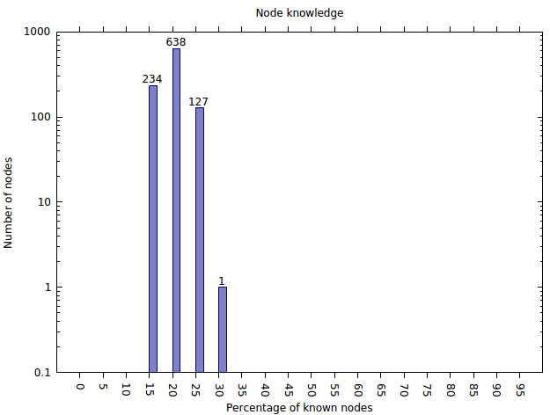

Plotting random with other alphas

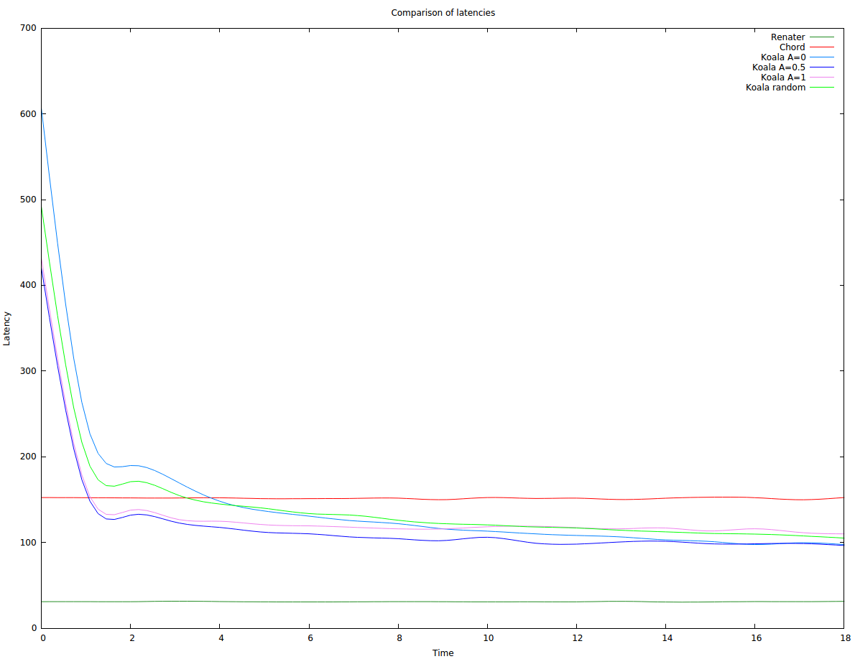

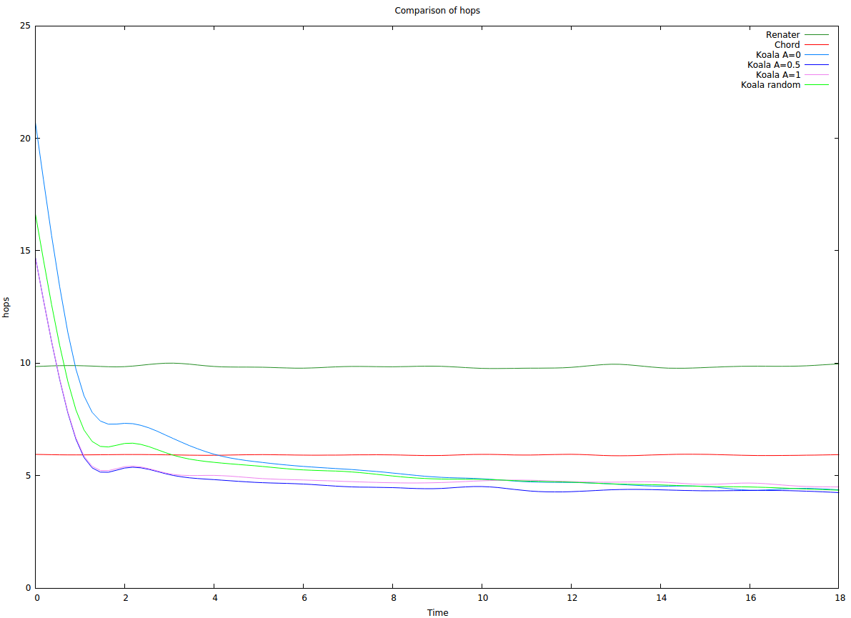

27 September (after bug)

waxman, alpha=1, k=10

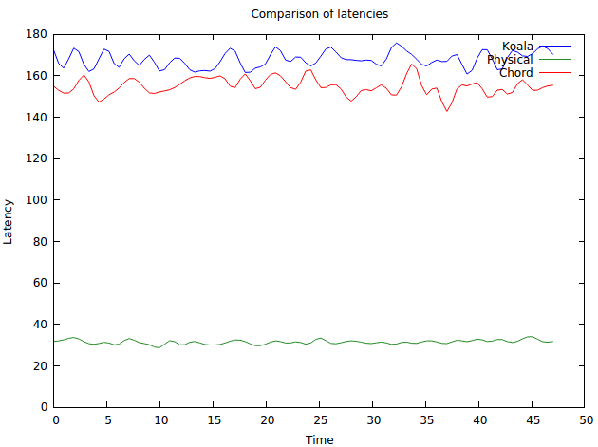
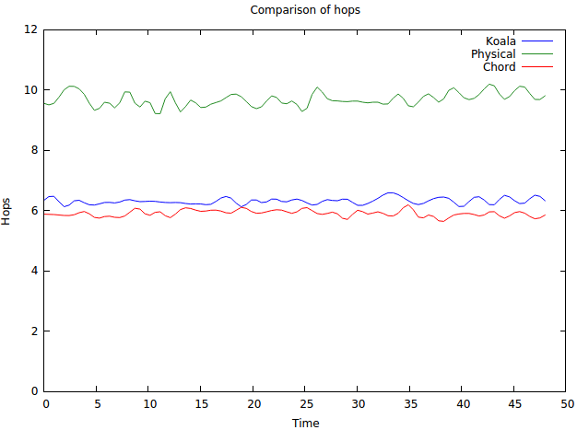

waxman, alpha=1, k=20

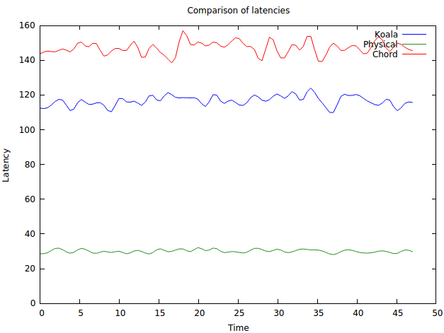
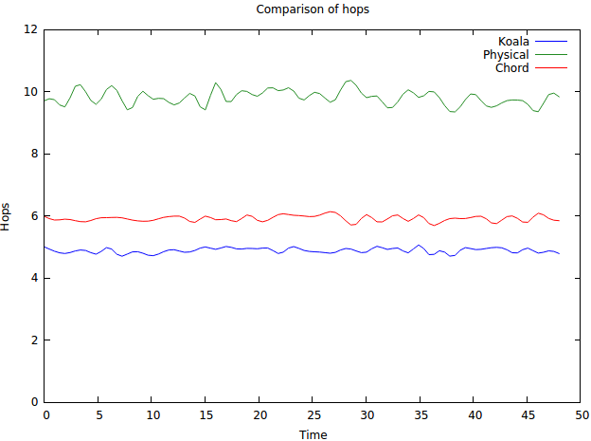

waxman, alpha=1, k=30
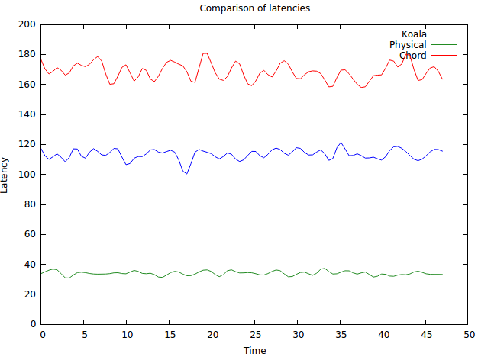
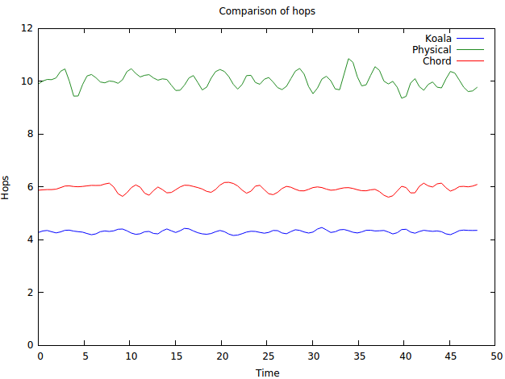

waxman, alpha=1, k=40

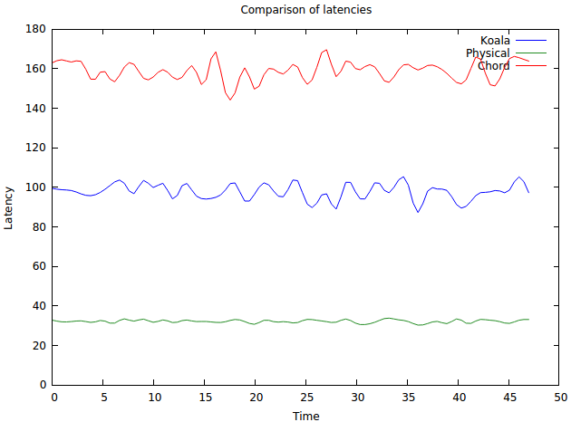
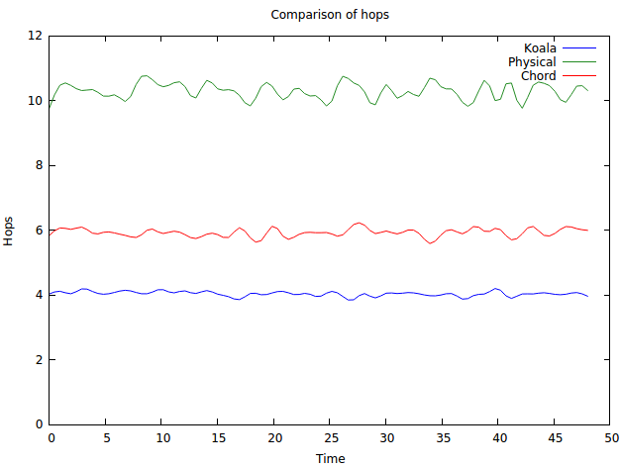

waxman, alpha=1, k=100
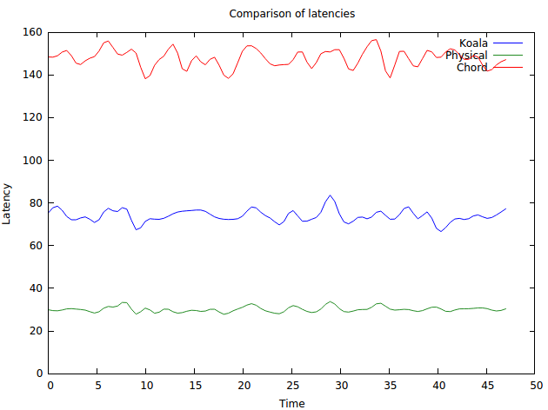
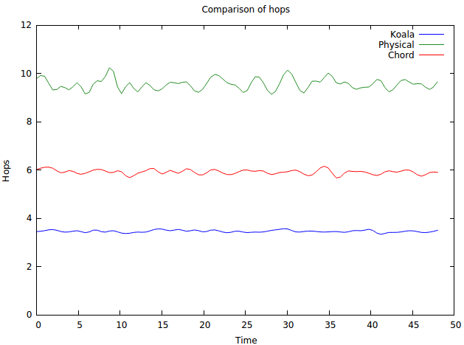

waxman, alpha=1, k=200

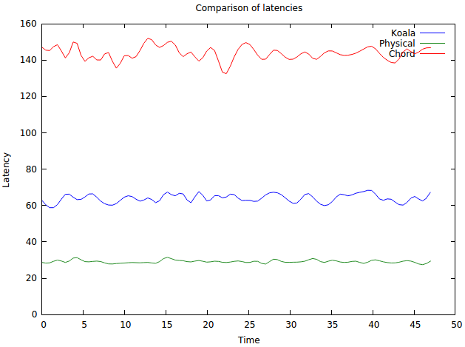
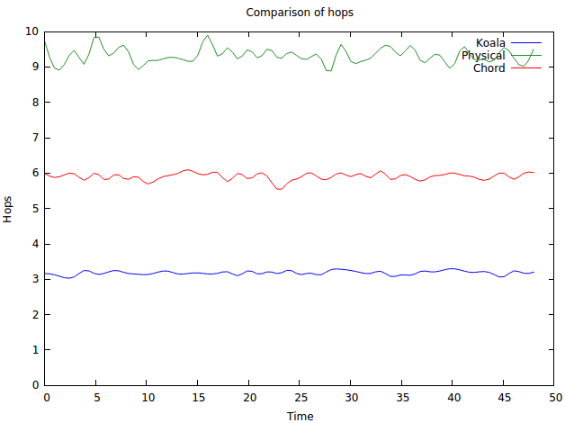

waxman, alpha=1, k=500

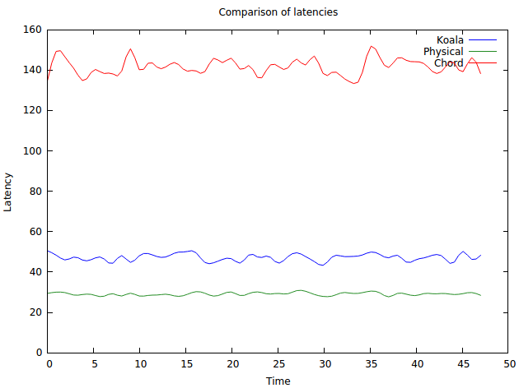
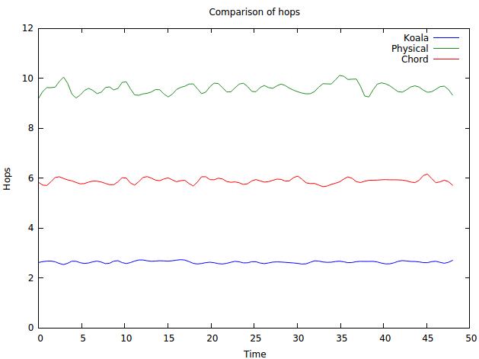

waxman, k=20, comparison of alphas, default lat = max/16
total routed: 38447, based on latency: 1436 ratio: 0.03735011834473431

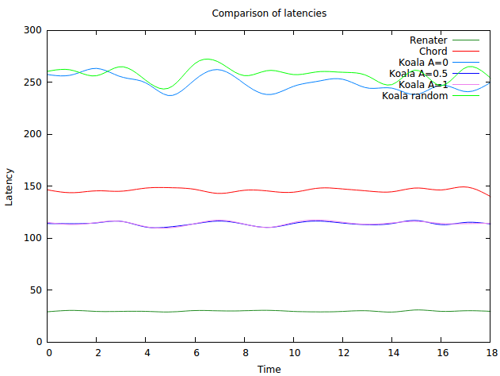
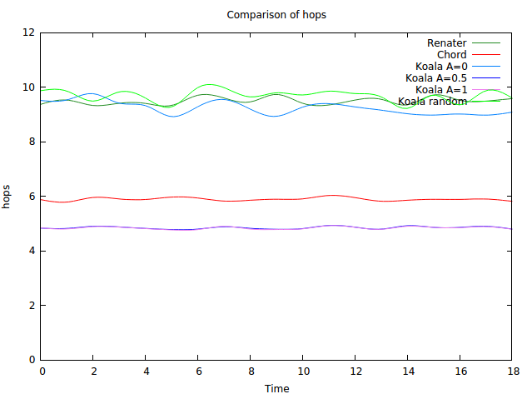

in hops 1 generally wins, in latency 0.5 generally wins

same as before but different seed
total routed: 38544, based on latency: 1370 ratio: 0.03554379410543794
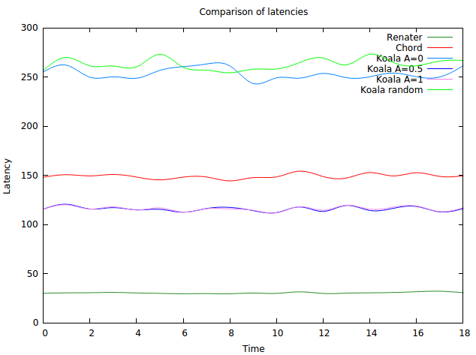
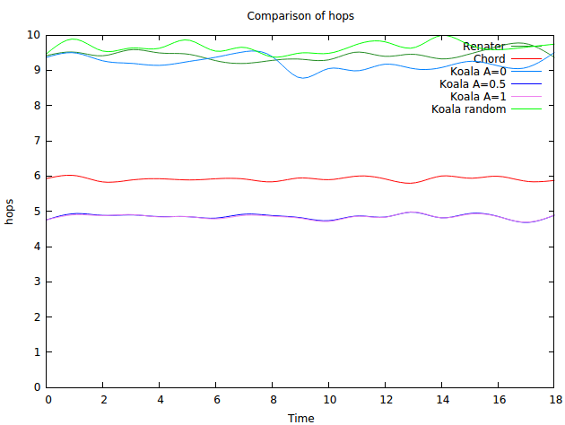

same as before but lower the default lat = max/32 (first seed)
total routed: 38447, based on latency: 1436 ratio: 0.03735011834473431
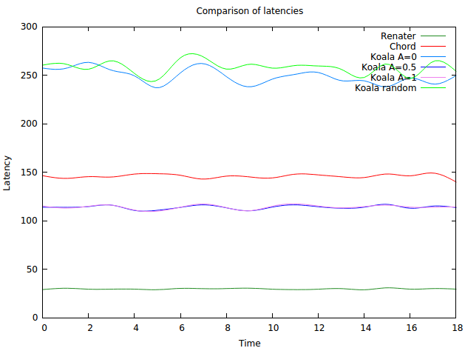
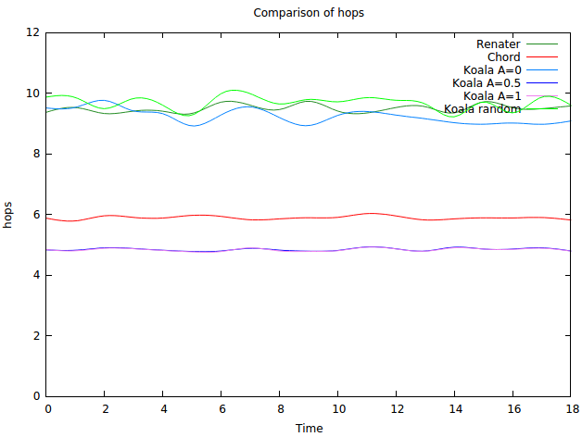

Now the same but nodes have exact latencies about their long links
total routed: 39470, based on latency: 5303 ratio: 0.13435520648593868

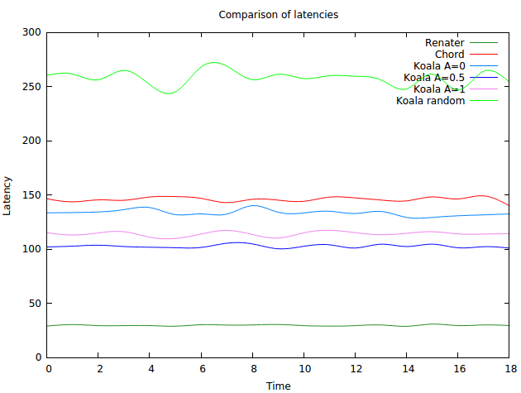
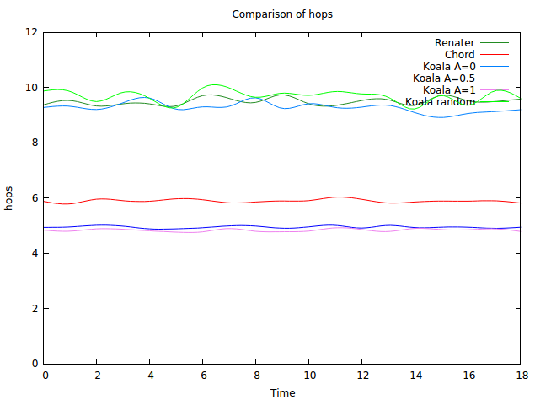

when learning is involved (default latency: max/16)
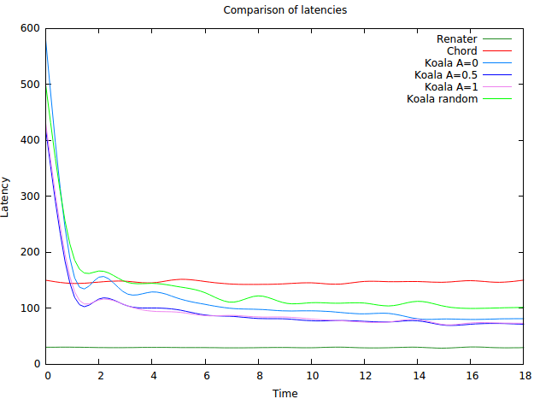
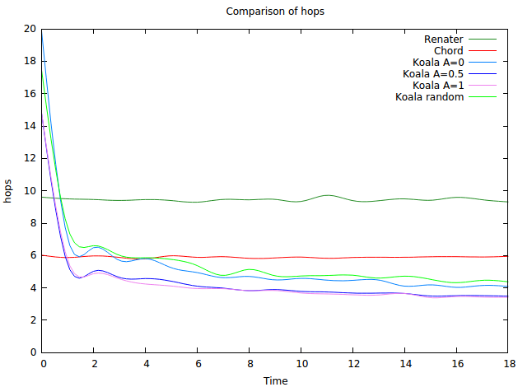

default latency: max/32

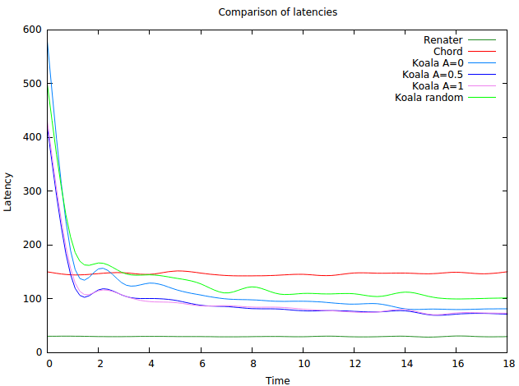
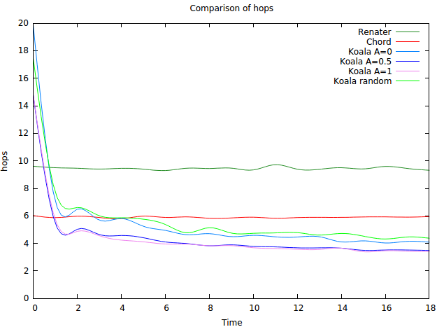

28 September

min: 0.07, avg: 29.785833993993922, max: 108.44000000000001, std:
14.529329453161491, between +-std: 78.24564564564565%

between 2*std: 94.55235235235236%

with the new normalization (latency within 2 std)
total routed: 40904, based on latency: 8444 ratio: 0.2064345785253276
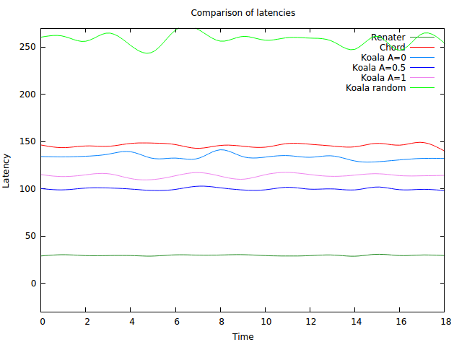
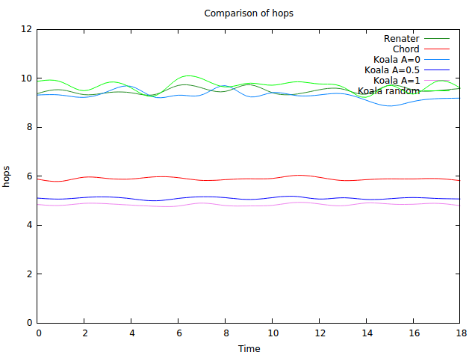

some other alphas

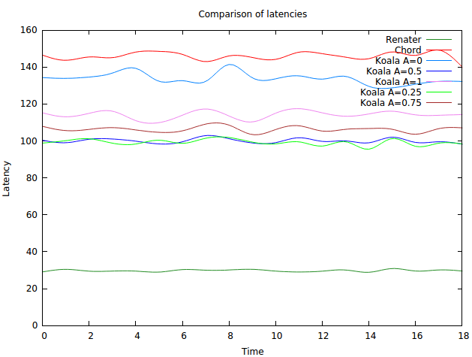
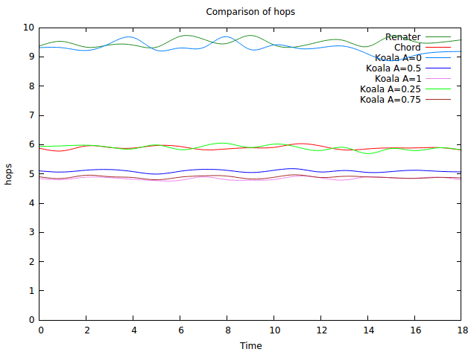

same but k is 100 now (more choice)
hops are still consistent but the latencies change

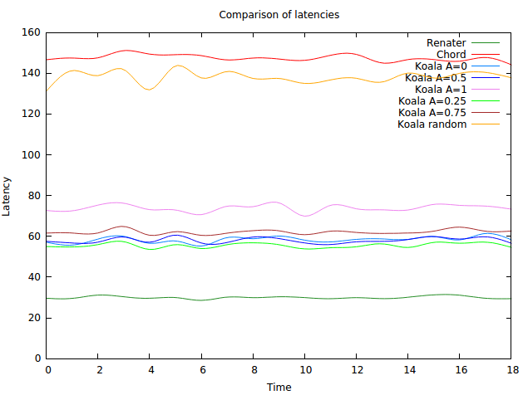
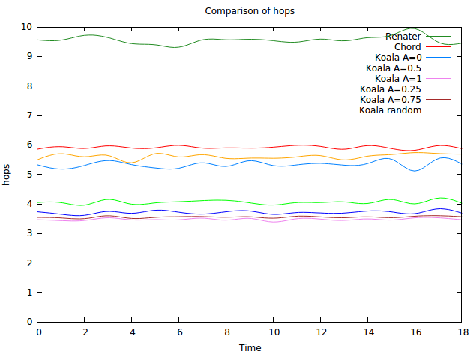

29 September

now use default latency but ask for update, k=20 (100000 cycles)
right now asking for update and not asking is giving me the same result
bug found

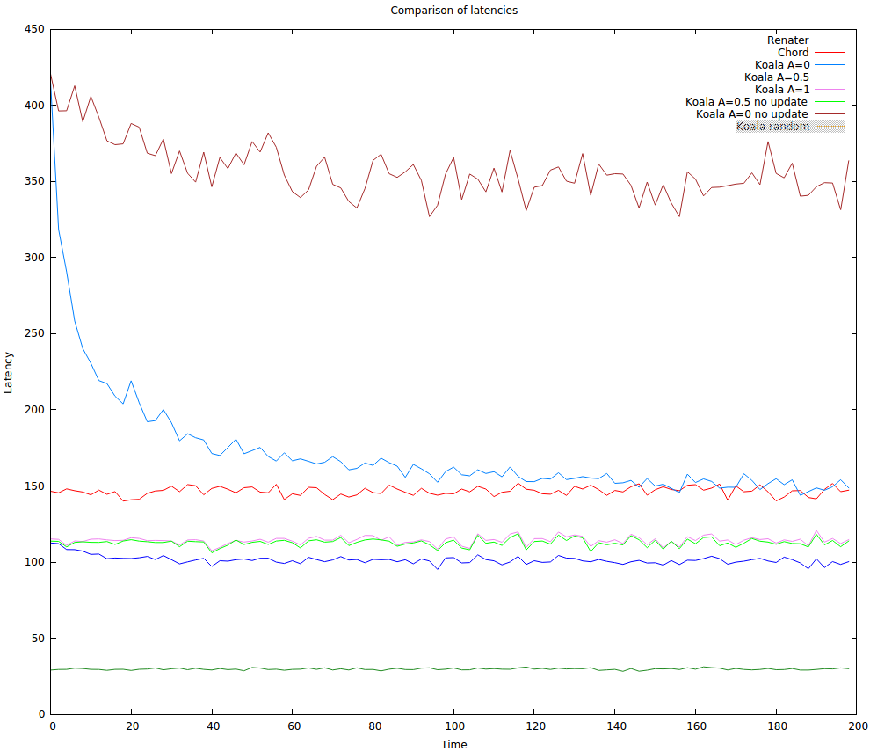
Now chose 20 equally distributed links and update latencies (100000 cycles)

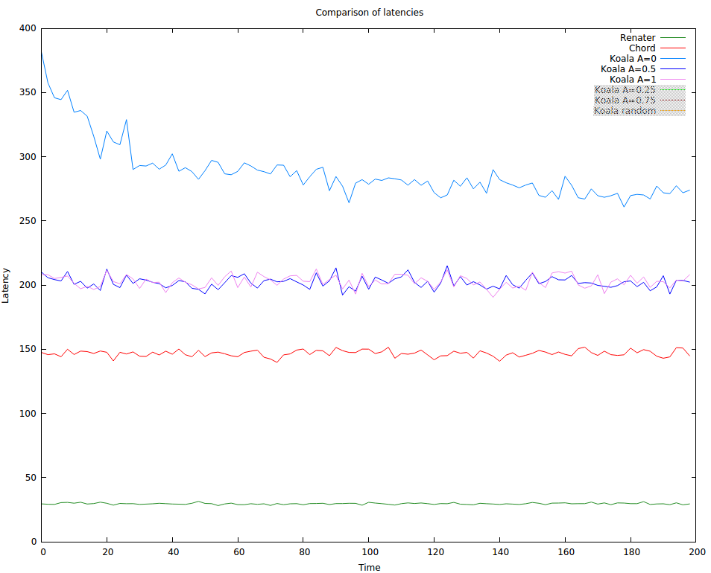

Now chose 50 equally distributed links and update latencies (100000 cycles)
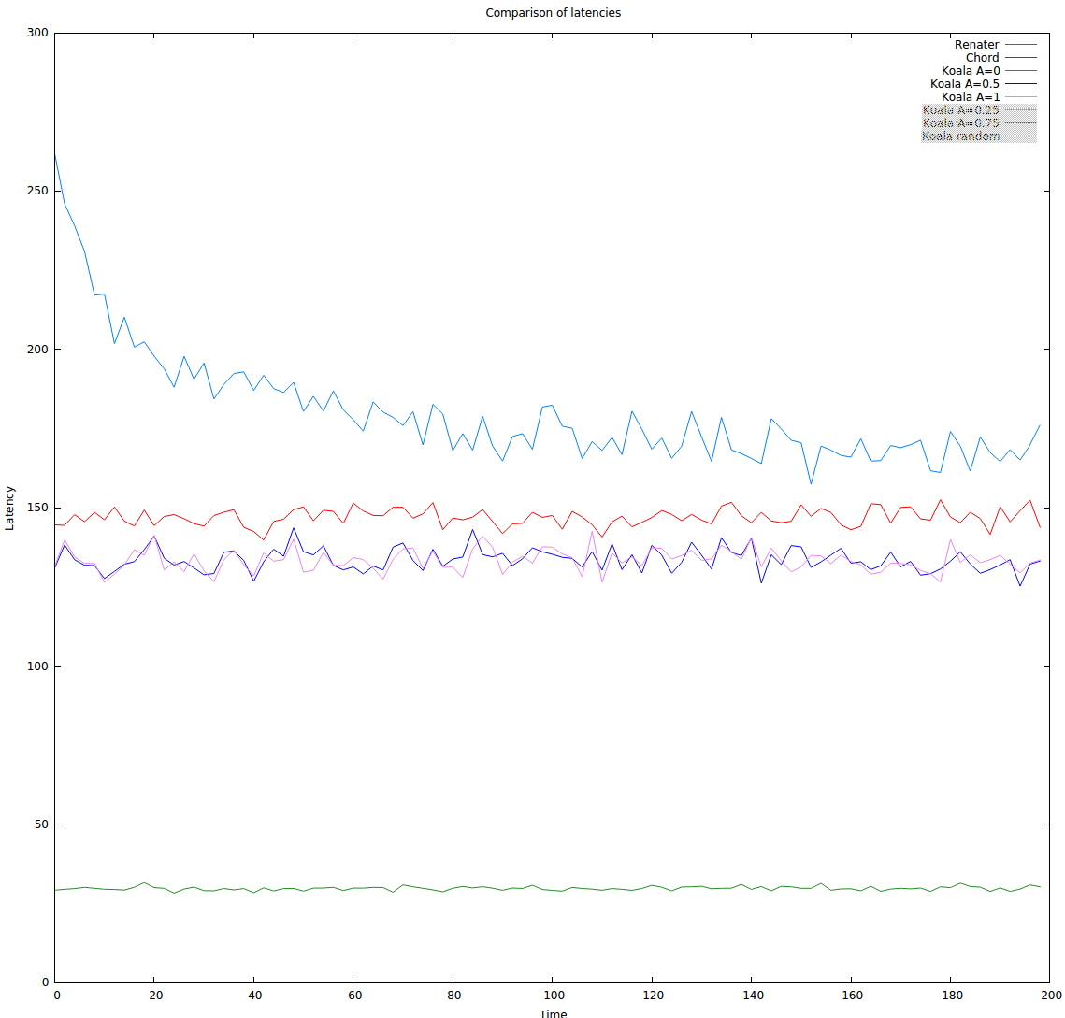
just a confirmation of what was said before (kleinberg vs random) both learning
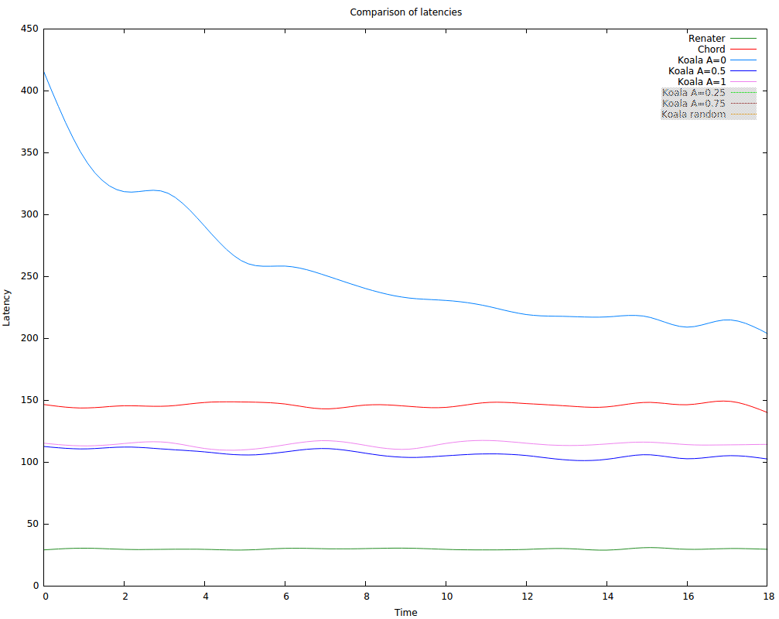

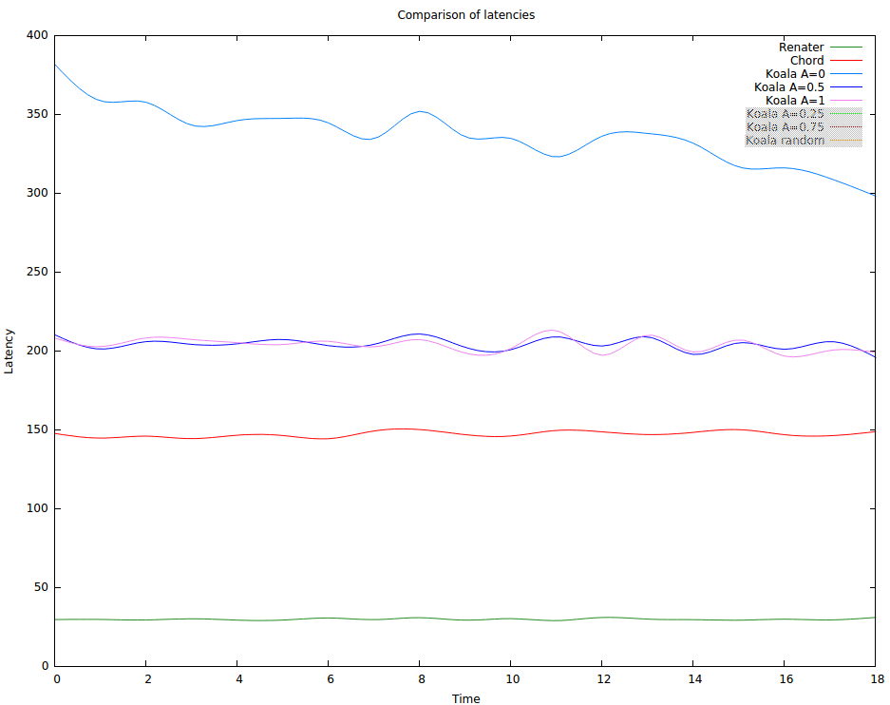

3 October

0.5 is clearly the fastest as long as there are not so many long links.

With the increasing of long links 0.5 , 0.25 , 0.75 and 1 get closer and closer.

However, 0.25 and 1 remain most of the time worse than 0.5, while 0.75 is very close and generally slightly faster.

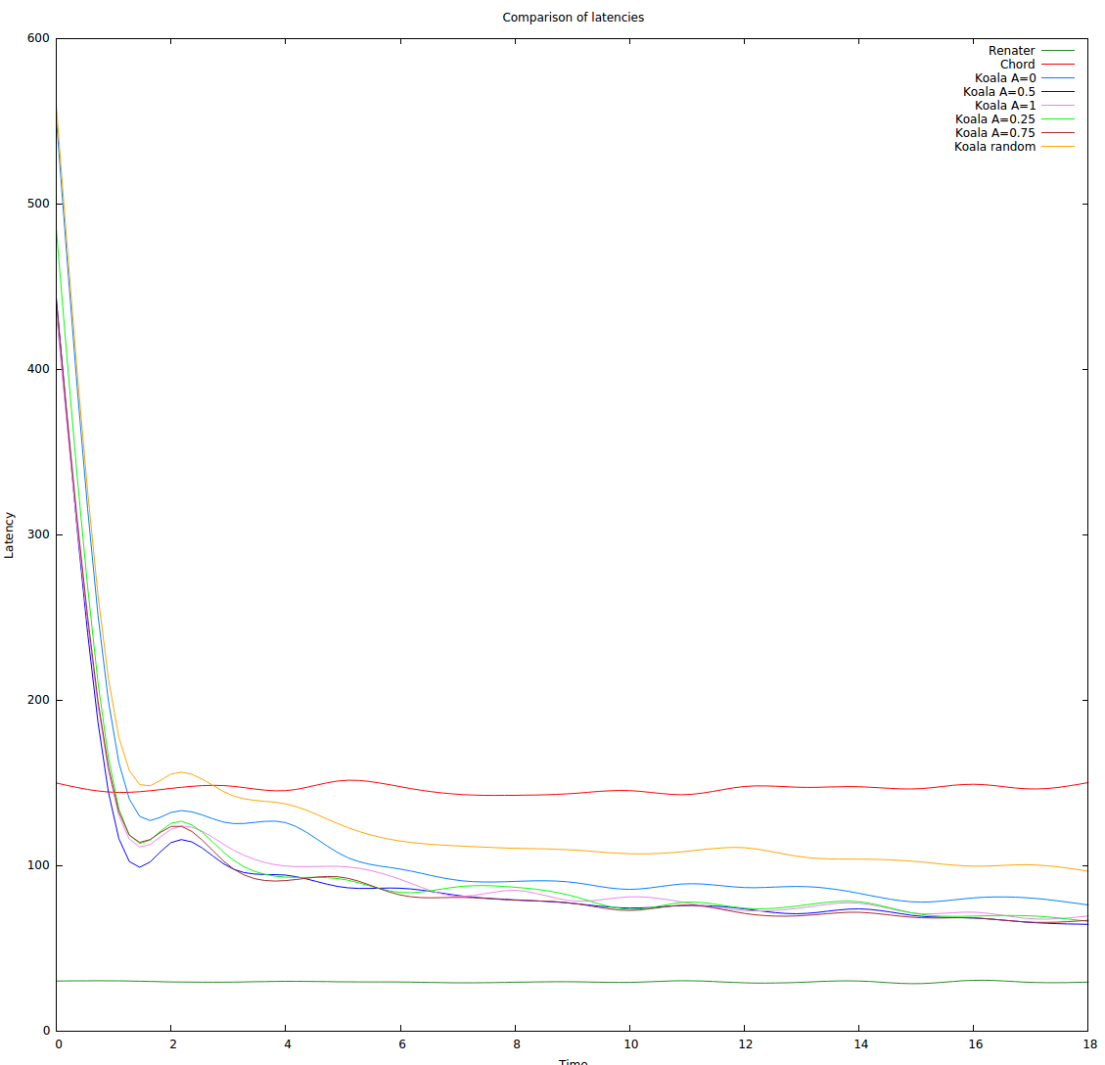

Hops-wise, they are pretty consistent.
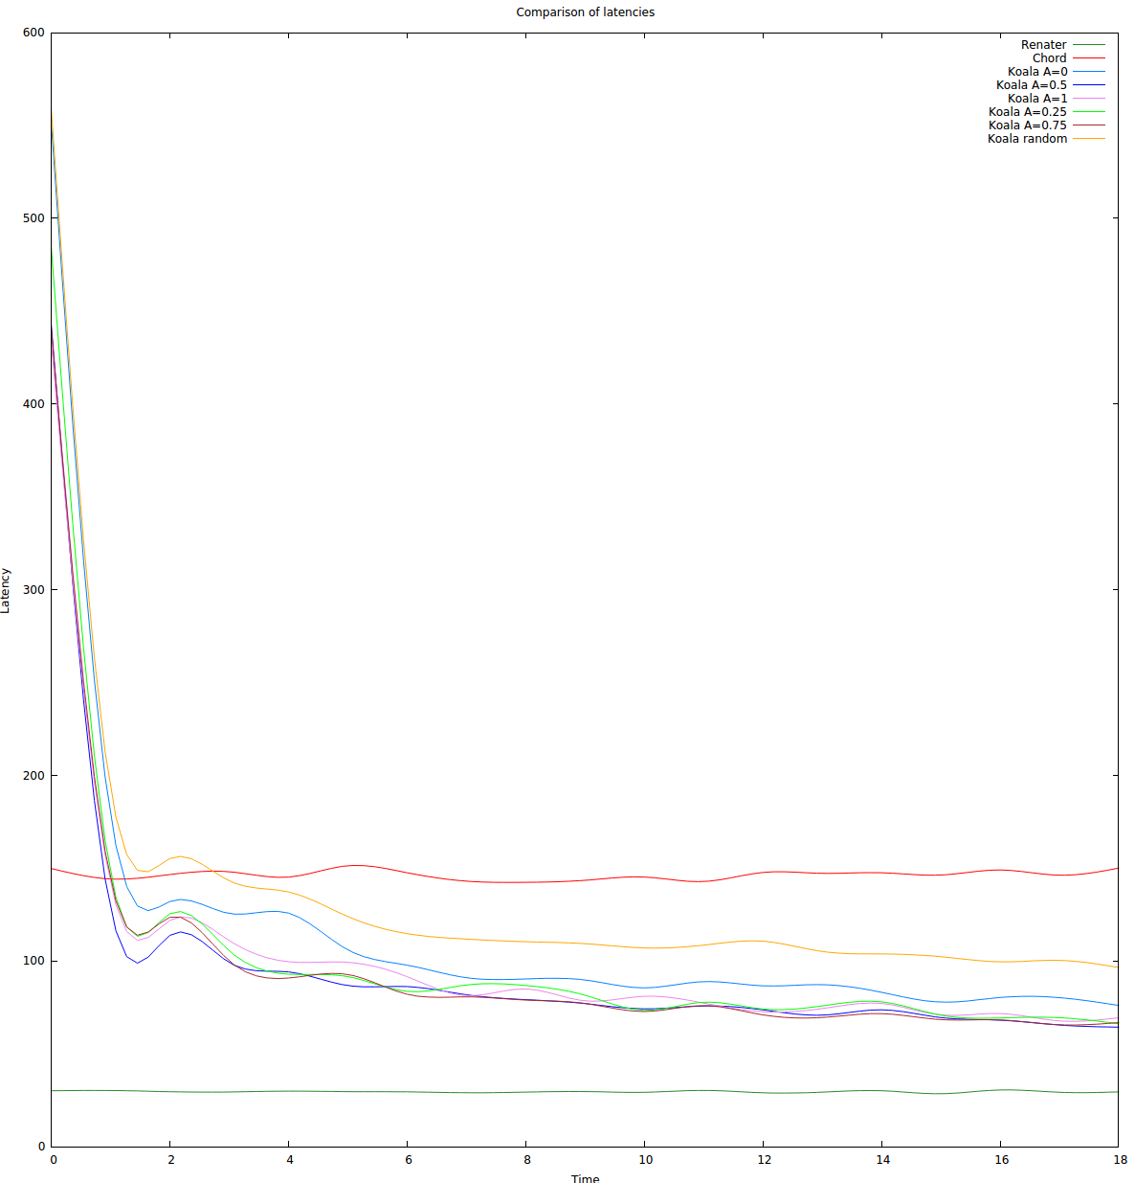
11 October

With k=20, msg piggyback=10, world size = 5, 1000 nodes

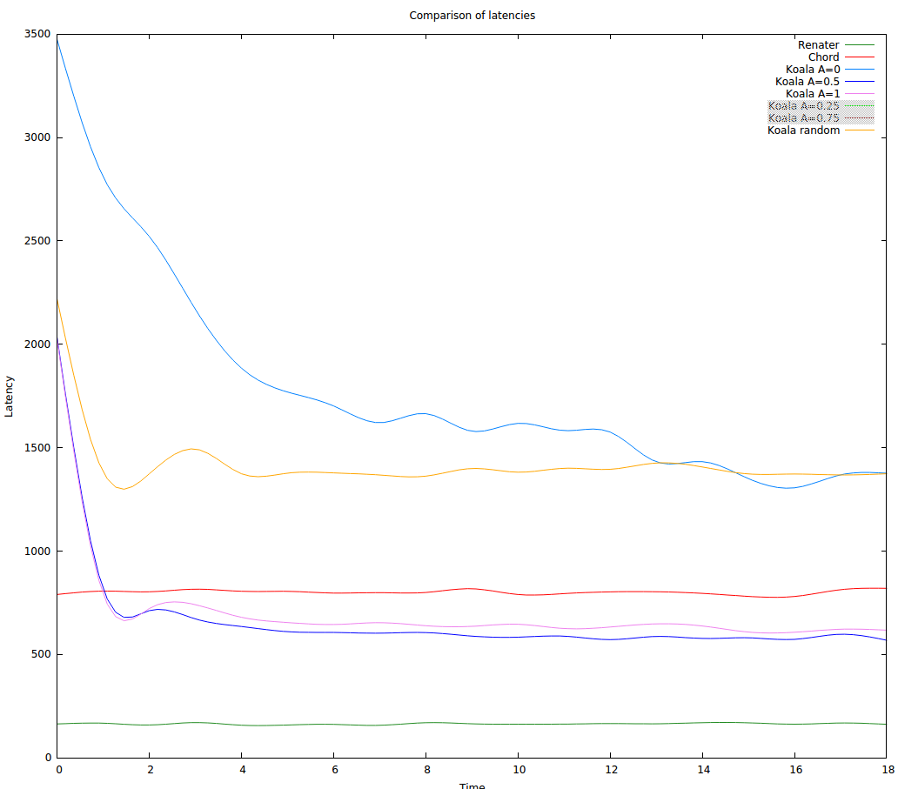
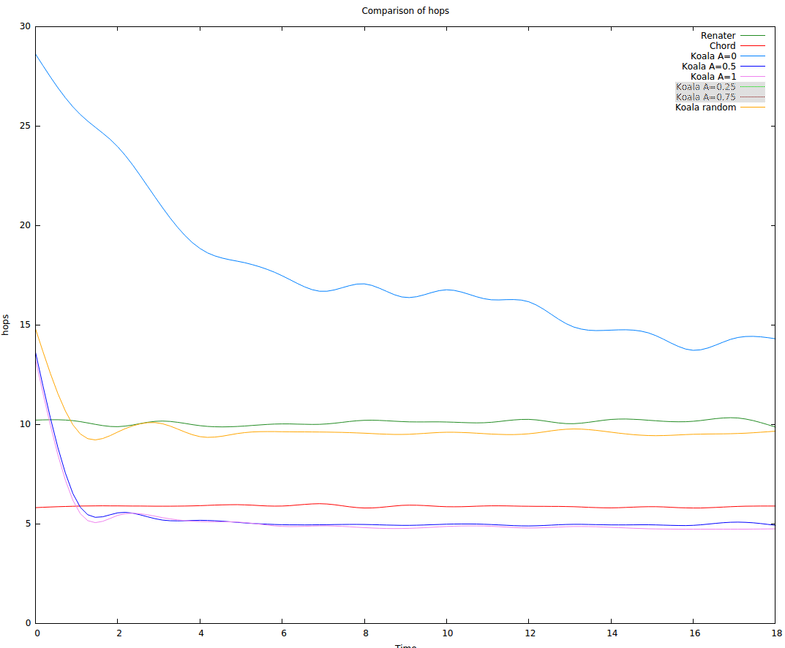

12 October
size= 10 000, cycles= 0, waxman, ws=5, k=20, piggyback=10, alpha=0.5
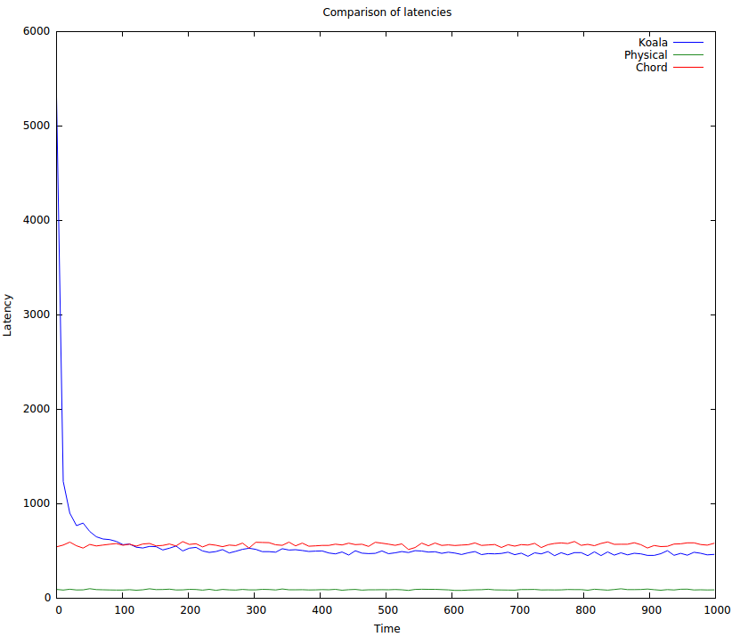

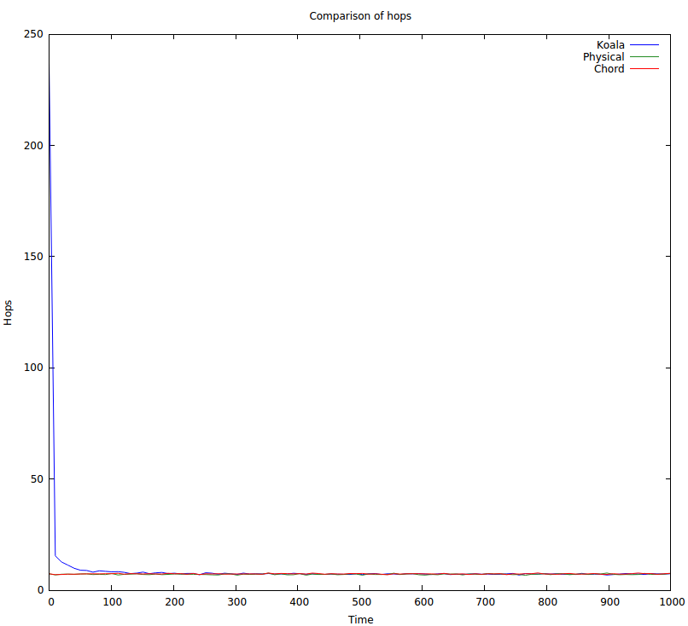
as before but piggyback=50
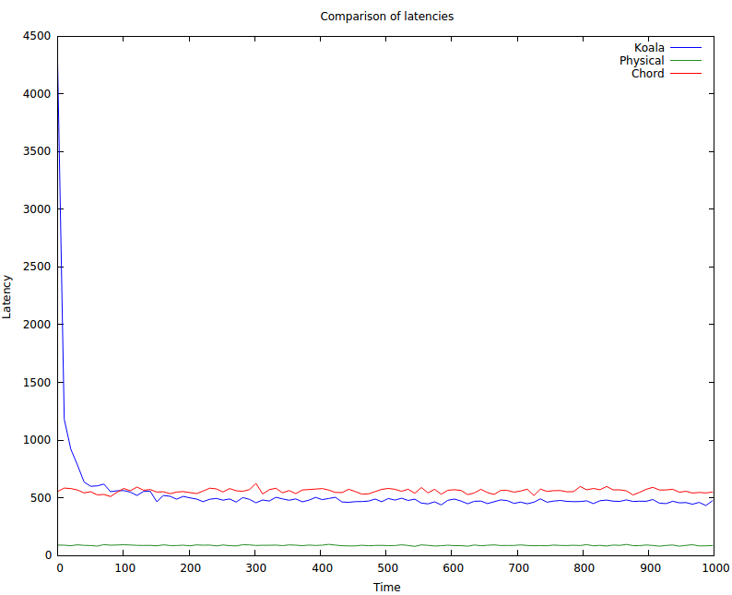

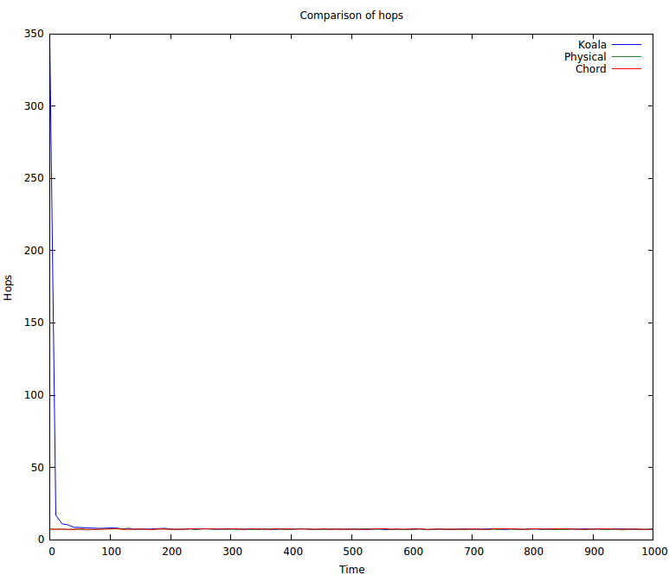

as before but piggyback=10 and k=50

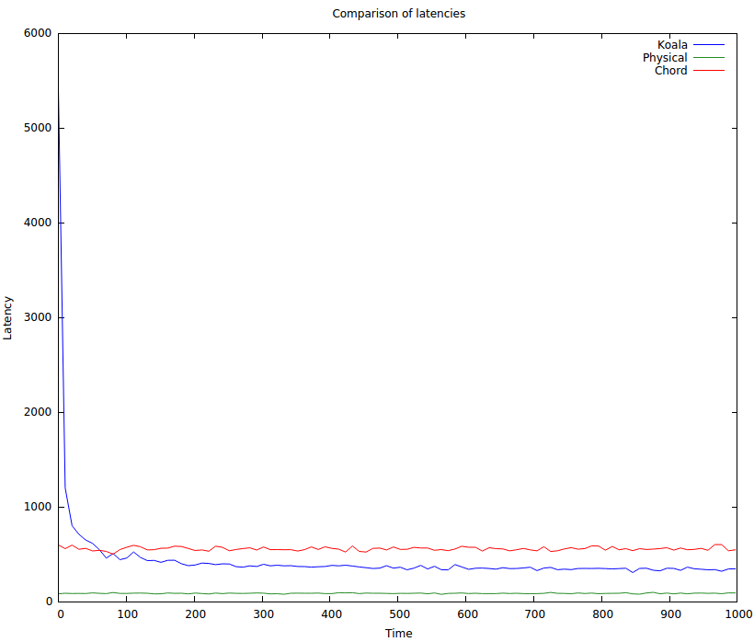

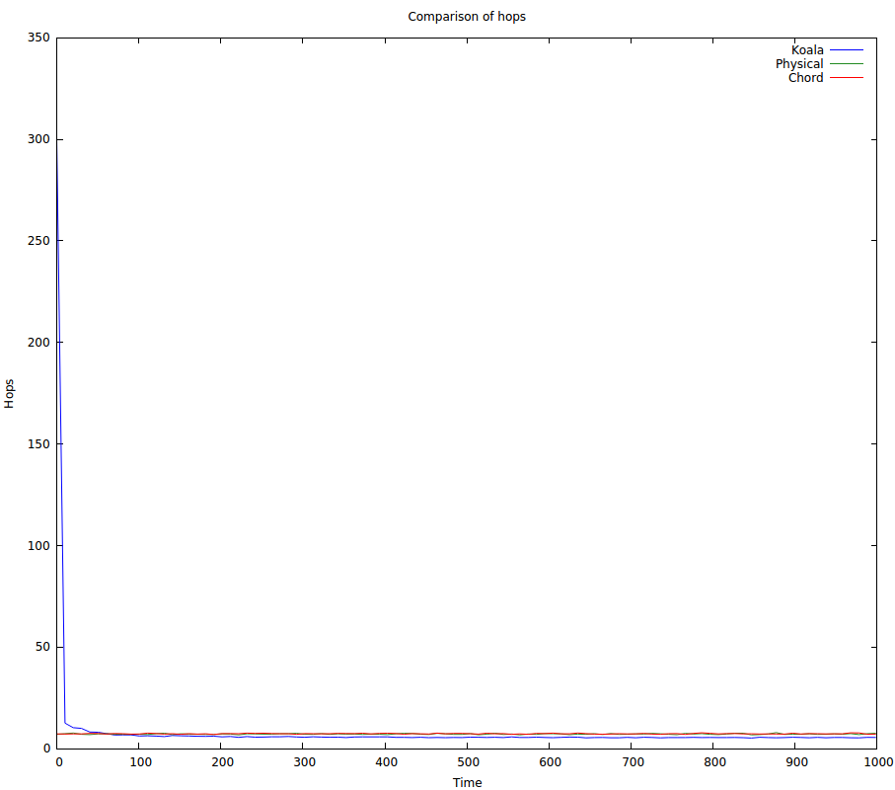

k=50, piggy=50
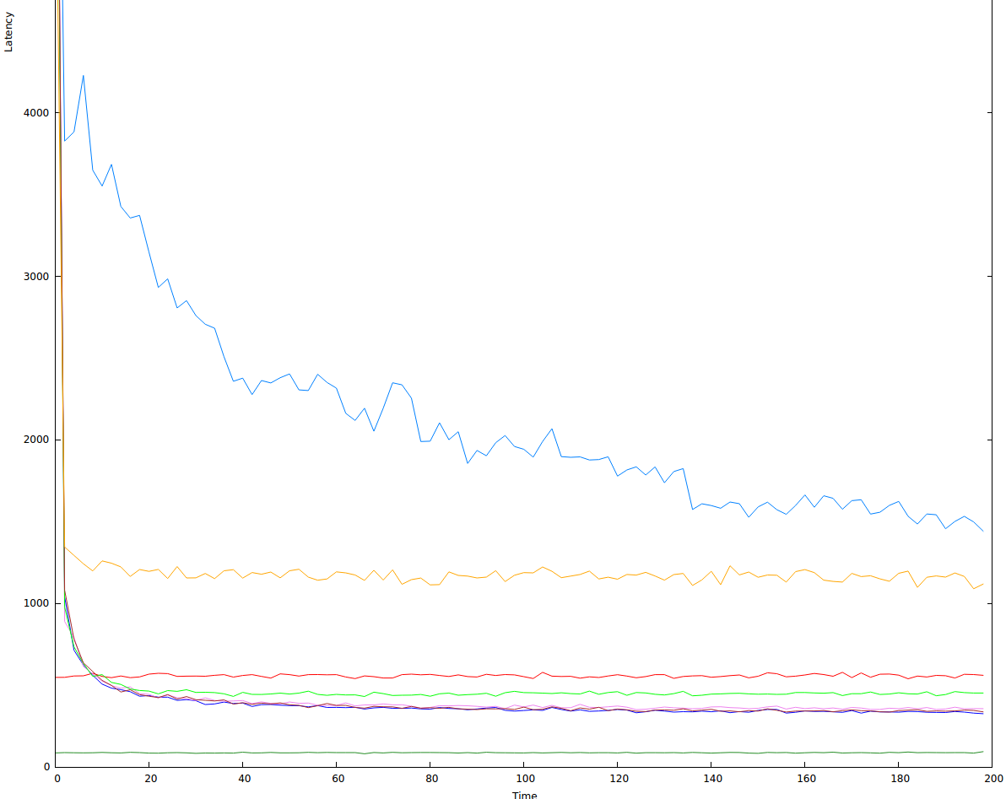
zoom
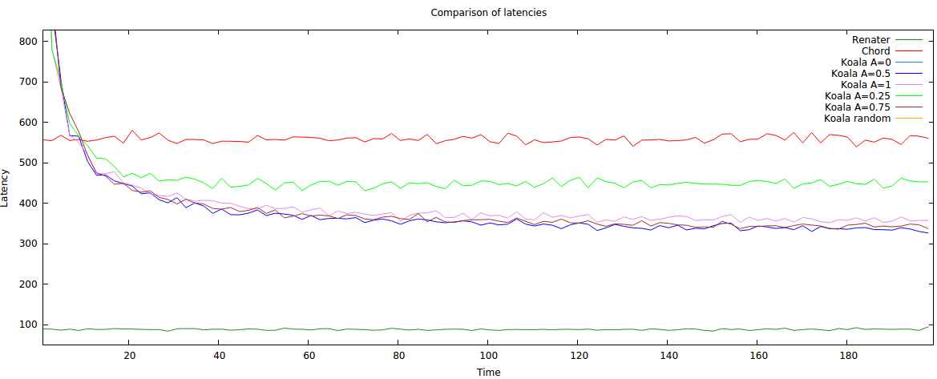
order: 0.5, 0.75, 1, 0.25, chord, rand, 0

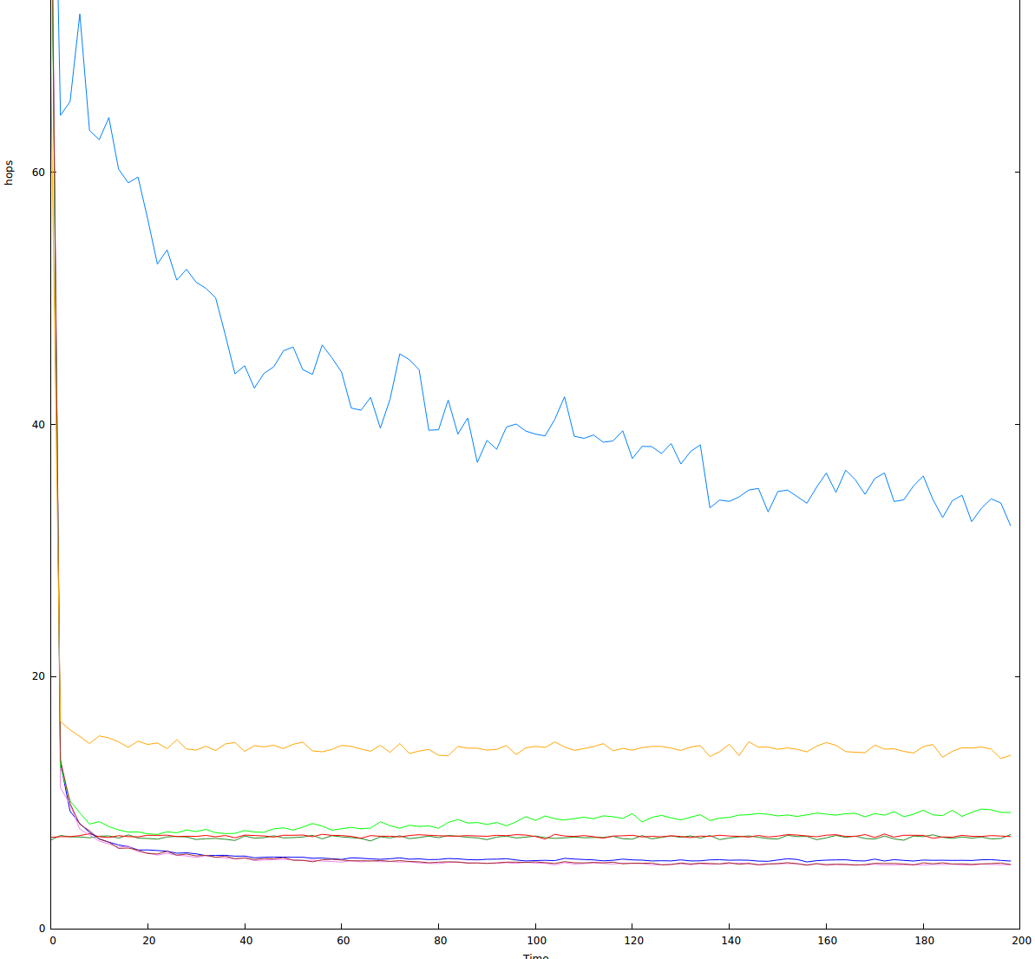
zoom

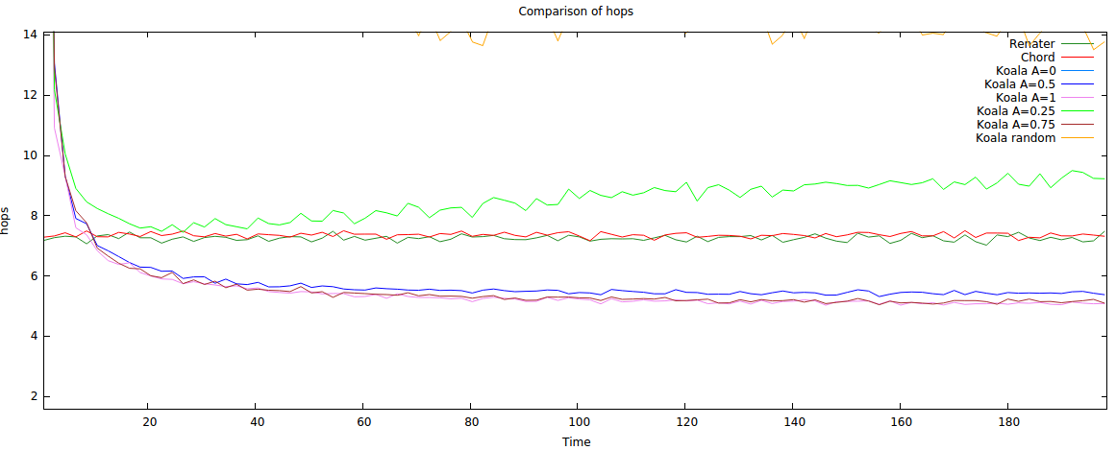
order: 1, 0.75, 0.5, chord, 0.25, rand, 0

new chord is annoying!! with 1 000 000 cycles and 10k nodes it still does not converge. C = 4

