ASSIGNMENT 4

Gillian Tatreau

2022-10-04

# Markdown Basics

## Favorite Foods

1. milk tea with boba
2. mac n cheese
3. popcorn

## Images

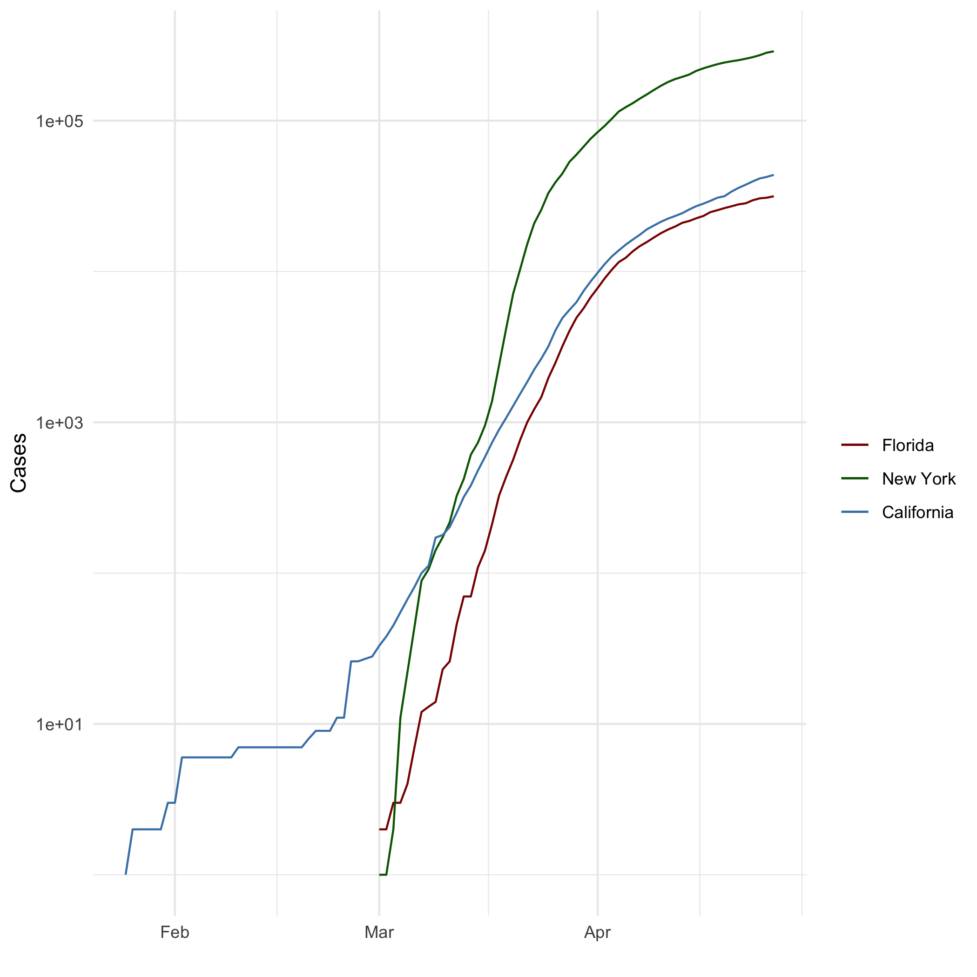

All Cases (Log Plot)

## Add a Quote

From Fyodor Dostoevsky’s *Crime and Punishment*:

Talking nonsense is man’s only privilege that distinguishes him from all other organisms… Talk nonsense in your own way. That’s almost better than talking sense in somebody else’s…Sense will always be there, but life can >be fenced in.

## Add an Equation

$E=mc^{2}$ $slope=\frac{y_{2}−y_{1}}{x_{2}−x_{1}}$

## Add a Footnote

This is a footnote[1]

## Add Citations

* R for Everyone (Lander 2014)
* Discovering Statistics Using R (Field, Miles, and Field 2012)

# Inline Code

## NY Times COVID-19 Data

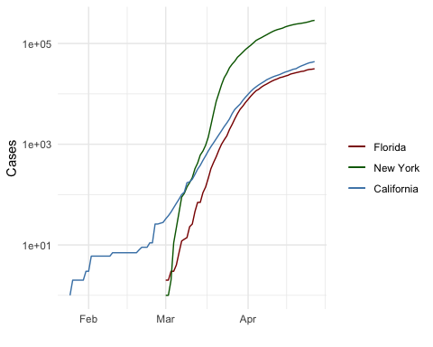

## R4DS Height vs Earnings

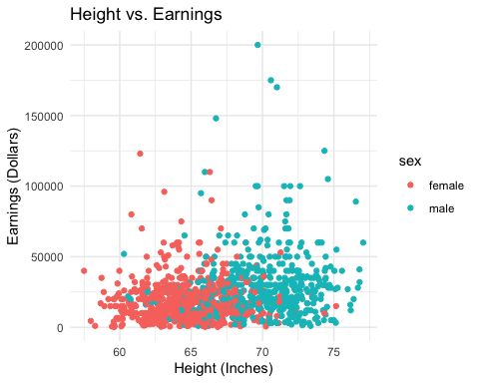

# Tables

## Knitr Table with Kable

One Ring to Rule Them All

| name | race | in_fellowship | ring_bearer | age |
| --- | --- | --- | --- | --- |
| Aragon | Men | TRUE | FALSE | 88 |
| Bilbo | Hobbit | FALSE | TRUE | 129 |
| Frodo | Hobbit | TRUE | TRUE | 51 |
| Galadriel | Elf | FALSE | FALSE | 7000 |
| Sam | Hobbit | TRUE | TRUE | 36 |
| Gandalf | Maia | TRUE | TRUE | 2019 |
| Legolas | Elf | TRUE | FALSE | 2931 |
| Sauron | Maia | FALSE | TRUE | 7052 |
| Gollum | Hobbit | FALSE | TRUE | 589 |

## Pandoc Table

| Name | Race | In Fellowship? | Is Ring Bearer? | Age |
| --- | --- | --- | --- | --- |
| Aragon | Men | Yes | No | 88 |
| Bilbo | Hobbit | No | Yes | 129 |
| Frodo | Hobbit | Yes | Yes | 51 |
| Sam | Hobbit | Yes | Yes | 36 |
| Sauron | Maia | No | Yes | 7052 |

# References

Field, A., J. Miles, and Z. Field. 2012. *Discovering Statistics Using r*. SAGE Publications. <https://books.google.com/books?id=wd2K2zC3swIC>.

Lander, J. P. 2014. *R for Everyone: Advanced Analytics and Graphics*. Addison-Wesley Data and Analytics Series. Addison-Wesley. <https://books.google.com/books?id=3eBVAgAAQBAJ>.

1. This is a footnote for **this** section