**LV Model Questions:**

**What can you say about the “role” of each parameter?**

a: Intraspecific competition coefficient, or predator attack rate

-lower values of a lead to an increase in prey and predator values by ten-fold. This also makes sense because a is the predator attack rate, so while this rate is small, there are more prey that survive.

b = Prey birth rate

-higher values of b increase the amount of prey by a significant amount. The predator value spikes and the prey value drives to 0 immediately. The prey life cycle is extremely short which makes sense because they are all typically born around the same time. The predator life cycles extend longer which makes sense because there is more prey available and predators will survive longer.

e = Conversion efficiency of prey to predators

-higher values of e lead to much smaller amounts of prey, which makes sense because e stands for the rate of conversion of prey to predators. The more efficient the rate is, lower the value of prey there is, and therefore higher value of predators that were converted from prey. There are more life cycles when e is higher as well. In addition, when e is low, the predator cycle slope is constant and stays relatively flat, whereas a higher e leads to a more dramatic life cycle slope.

s = Predator death rate

-lower s leads to much longer life cycles for predators compared to higher values of s. This makes sense because as s increases, this signifies that the predator death rate is increasing. In addition, when s is higher, the value of prey increases significantly. This makes sense because with more predators dying, this allows for prey populations to increase.

**What can you say about the role of predators in the simulation?**

The role of predators in this simulation serves as a driving force for how the whole model acts. Prey values depend on the different parameters explained above. All of the parameters relate to predators except prey birth rate. In testing parameter values, it can be seen that predators are the dominant force in this simulation. This is consistent with the role of predators in relation to prey in their rankings along the food chain.

**What is the relationship between parameter values and predator-prey cycle length?**

a: Lower a leads to shorter prey life cycles and longer predator life cycles. Lower values of a also lead to a lower frequency of life cycles. This all makes sense because with lower intraspecific competition between predators, more will survive and their life cycles will be longer.

b: Lower b leads to a longer life cycle for prey and shorter for predators. The life cycle frequency also increases a bit for higher values of b.

e: Higher values of e don’t change the frequency of the life cycles of predators and prey, but the higher e value shortens the cycle length of predators.

s: Higher s values increases the frequency of life cycles of both predators and prey. The length of each of the life cycles for the predator and prey also both increase.

**RM Questions**

**How dynamics different from Lotka-Volterra**

The Lotka Volterra and Rosenweig MacArthur models are different because the Rosenweig-Macarthur model includes a carrying capacity for the predators and limits the amount of prey that the predators can kill per unit time. The positive factor of prey growth is represented by bH(1- αH), rather than simply bH in the Lotka-Volterra. In the Rosenweig-Macarthur model, the birth rate is multiplied by the prey population, times one minus the current prey population divided by the carrying capacity. The RW model also replaces the simple attack calculation “a*H” in the LV model with w(H/d+H). “w” replaces “a” and (H/d+H) replaces H. As H becomes very large then this quotient increases closer and closer to 1.

**Role of each parameter, what causes different between L-V, R-M**

“b” is the birth rate for the herbivores. A high birth rate allows prey growth to outpace prey death from predators immediately, a low birth rate causes prey to decrease before rebounding when predators become low enough. “b”’s effect is not limited by carrying capacity in the LV model. “b*H” is multiplied by zero when H = k in the RM model.

“e” is the conversion efficiency from herbivores to predators. High “e” allows the predator population to recover cyclically as herbivore population increases in the RM model, vs. low “e” causes decrease to 0. “e”’s effect is limited by the limit of predator response via (H/d+H)

“s” is the predator death rate. It functions identically in both models, having a negative effect on predator growth rate.

“w” is the substitute for the “a” predator attack rate. Unlike in the LV model, the “w” is also affected by the (H/d+H) factors, which approaches 1 as H gets very large

“d” modifies the predator attack rate along with the prey population.

“α” is 1/k, or the inverse of the carrying capacity. Α limits the growth caused by prey birth rate. When H = α, bH(1-αH) = 0. This carrying capacity factor does not exist in the LV model.

**Relationship between parameter values and predator abundance**

High “b” is beneficial for predator abundance, increasing the amount of prey available for the conversion expression or prey to predator.

High “e” is beneficial for predator abundance, controlling how well predators able to grow given a certain number of prey

High “S” is harmful for predator abundance, increasing the rate at which they die off.

High “w” is beneficial for predator abundance, increasing attack frequency, allowing predators to grow and recover when prey increase

High “d” is harmful for predator abundance. As “d” gets larger, it reduces the conversion of prey to predators associated with attack frequency

Low “a” is beneficial for predator abundance. “a” is the inverse of carrying capacity, and a high carrying capacity allows enough prey growth to allow to conversion to predator population

**Paradox of Enrichment Questions:**

**What happens as carrying capacity increases?**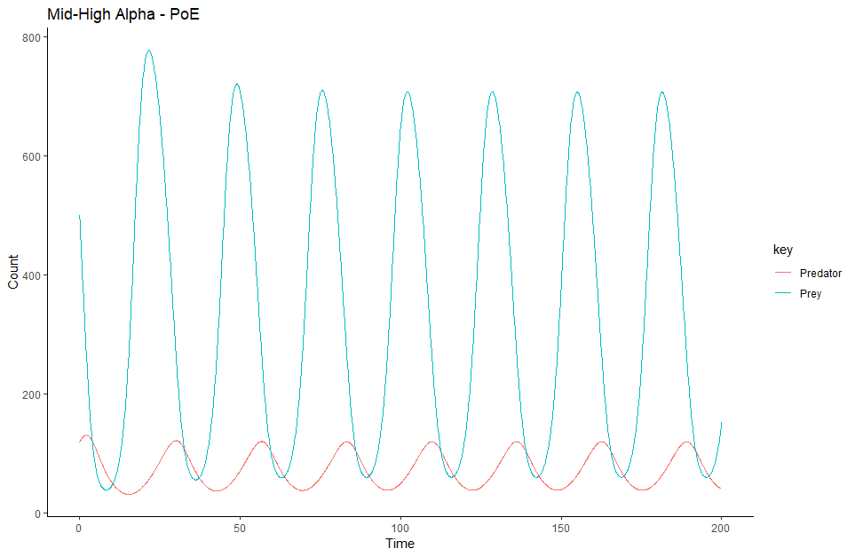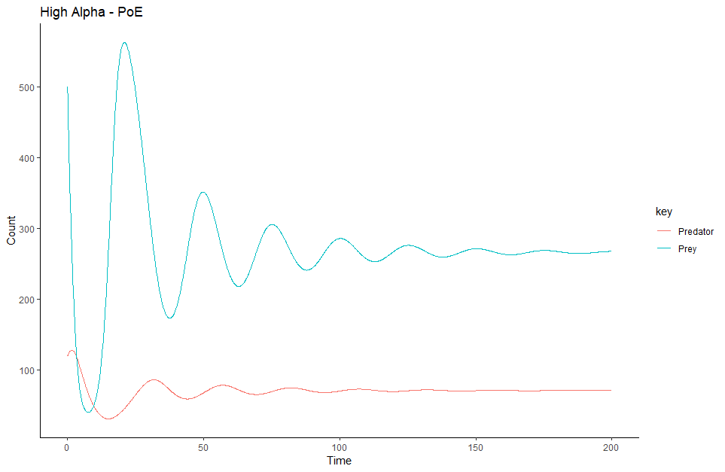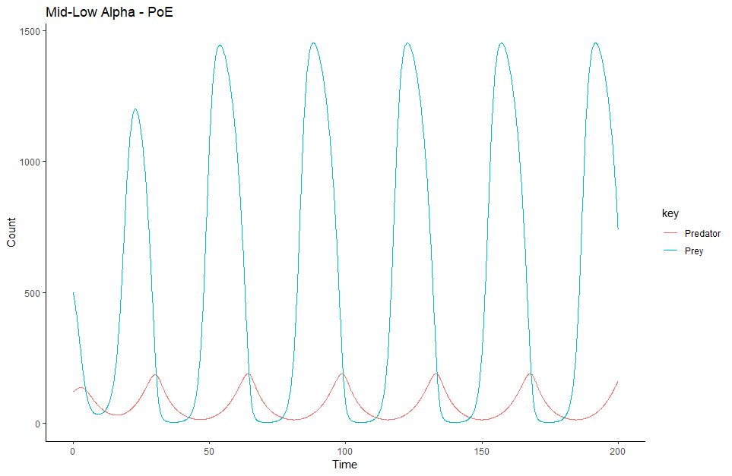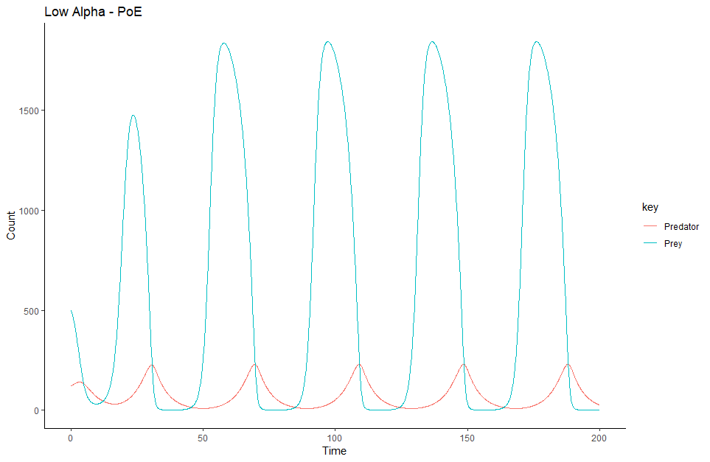

As carrying capacity increases (with a decrease in the alpha variable of the RM model), the prey population grows incredibly rapidly. However, as a result, the predator population also experiences unbounded growth until it reaches its maximum density. This causes both the upper bound of the prey population and the time between each cycle (wavelength) to increase.

**Why do you think we see the Paradox of Enrichment**

An increase in carrying capacity for prey simply allows for predators to gain greater resources. If the prey population is allowed to grow unchecked, the predator population is essentially given free reign to attack and eat, knowing that they have an overabundance of available prey. One predator can take down way more than a single prey (essentially unlimited), so increasing the amount of prey doesn’t affect their “appetite.”