Running the Square and Neon Dashboards

**Open RStudio**

RStudio should be located in your dock, if not, you can find it under Launchpad. You can also try Command + Spacebar to bring up Spotlight search and search for RStudio that way.

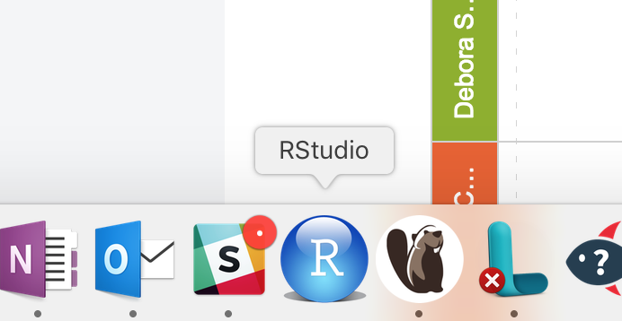

**Running via command**

This is the quickest way to run the apps.

In the RStudio console window type either **runApp(‘square/vis’)** or **runApp(‘neon/shiny’)**.

Depending on the RStudio configuration, your app will either launch in the Viewer panel of RStudio or launch in Chrome/Safari. If the app launches in the viewer panel, you can launch it a full window by clicking the ‘Show in New Window’ button.

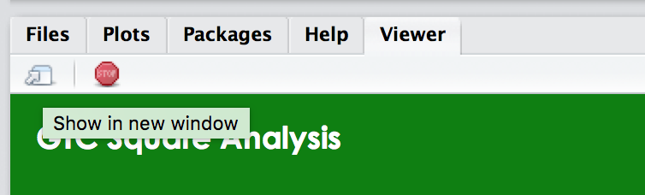

**Stopping the dashboard**

To stop the dashboard from running, click the ‘Stop’ button in either the R console or the Viewer panel.