# **Saving sales data from Square**

**Notes**

Each year of sales data should be downloaded from the Square website and stored in the dashboard data directory as a CSV. There should never be more than one CSV file for each year. When downloaded new data for a particular year, be sure to replace the previous file (if one already exists).

Start by navigating to the Square website <https://squareup.com/dashboard>

Once logged into the dashboard, navigate to the **Sales** section

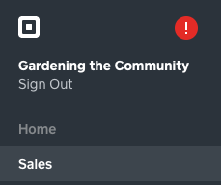

Then navigate to the **Transactions** tab

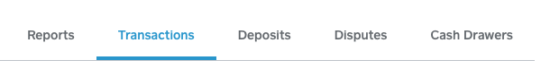

Ensure that you have to correct year selected

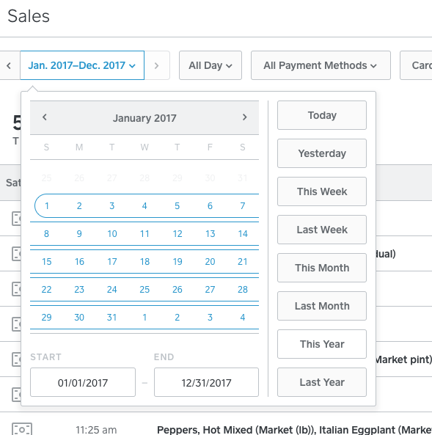

Click the **Export** button, highlight **Item Detail CSV**, then right-click and click **Save Link As…**

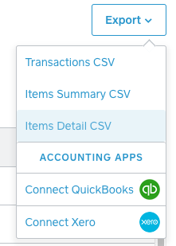 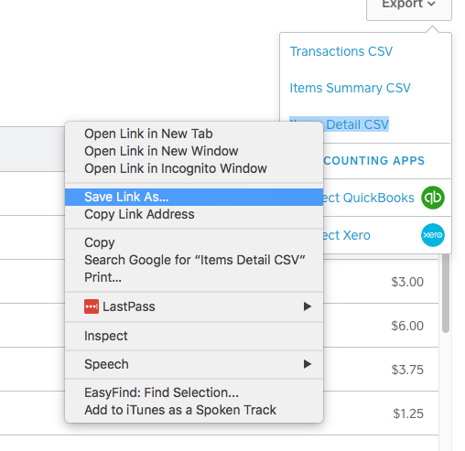

Within the **Save As** window, navigate to the Square dashboard data directory located within at **gtc/square/vis/data/items**. The gtc folder should be located within your home directory.

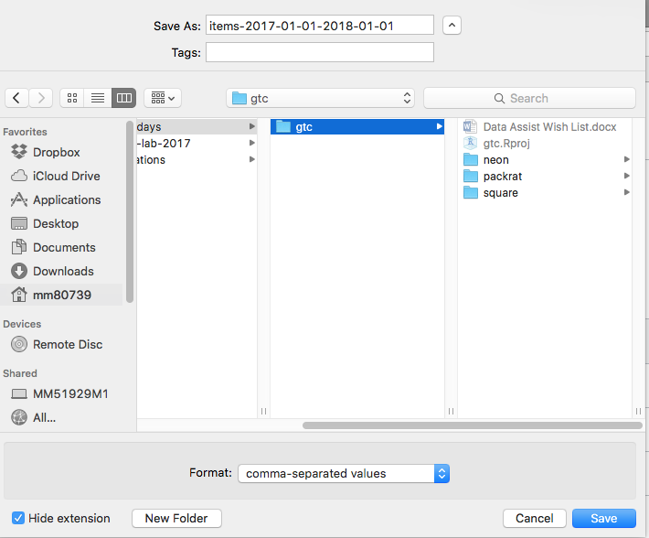 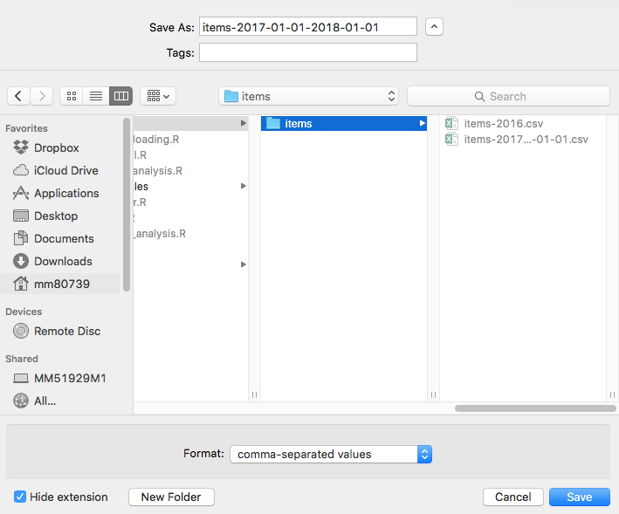

Once you are within the items directory, click **Save.** If you have an older file for that year, be sure to click **Replace** if this dialog appears.

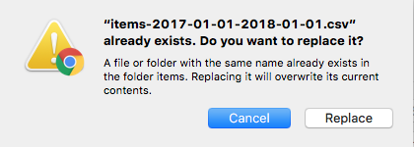

Follow this process to download new or updated sales data.

If you have trouble, please contact Matt Girard at [mgirard59@massmutual.com](mailto:mgirard59@massmutual.com)