ELEC 2110

Electric Circuit Analysis

Gabriel Emerson

Jake Bryson

August 27, 2019

Section 002

Electrical Measurements: Breadboarding, NI Elvis, Multimeter, Lab Reporting

Introduction

This lab is to introduce the student to primary equipment that will be used in lab for the rest of the semester. Students will learn how to make basic electronic measurements and highlight various features of a technical lab report.

Exercise 1

This exercise was about measuring resistance and reading the lines on resistors to determine their resistance without measuring.

(1)

This is Table 2 when figuring out what theoretical value of a resistor is based on the colored lines, compared to the actual measured value. The measured value does fall in the correct range of theoretical values for R1, R2, and R3.

(2)

This Is the measured value of R1 resistor listed in Table 2.

The next Table (Table 3) asked to Calculate certain resistors in series and in parallel, and then measure them to find the theoretic and calculated value.

(3)

This is Table 3 which asks to measure and calculate the resistance in series and in parallel.

(4)

This is a measurement of Req in Table 3.

(5)

This is a measurement of Rtot from Table 3.

Since the measured results of in series and parallel resistors came within .001 of the theoretical value for both, the formulas appear to be very close if not exact to the measured resistance values.

Exercise 2

Exercise 2 asked the student to measure certain voltages in a circuit and input these values in Table 4. Students are given two separate circuits to analyze and measure different points and these are the points labeled in Table 4.

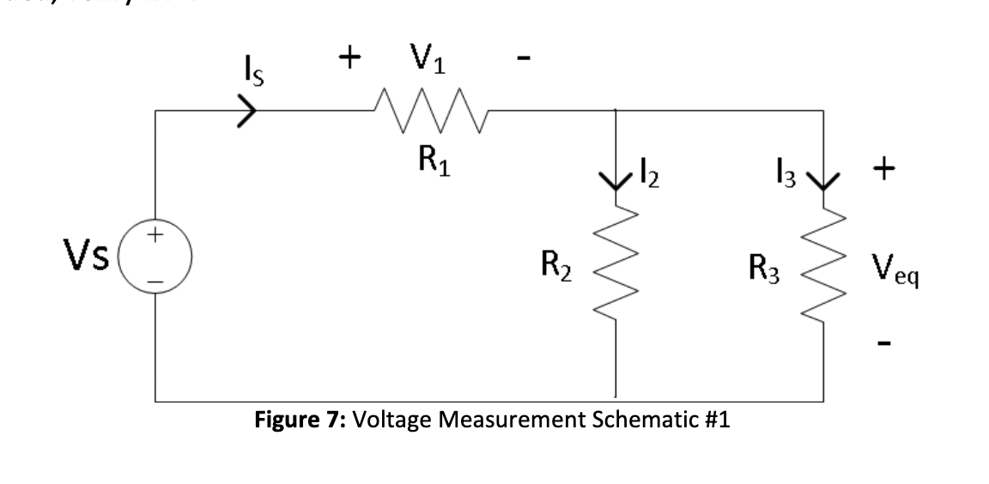

(6)

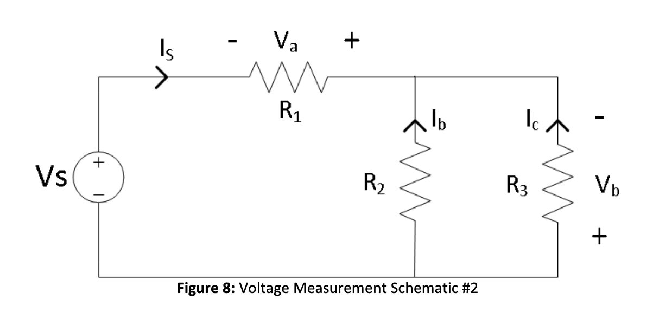

(7)

These are the two circuits that the student is asked to analyze and measure for Table 4.

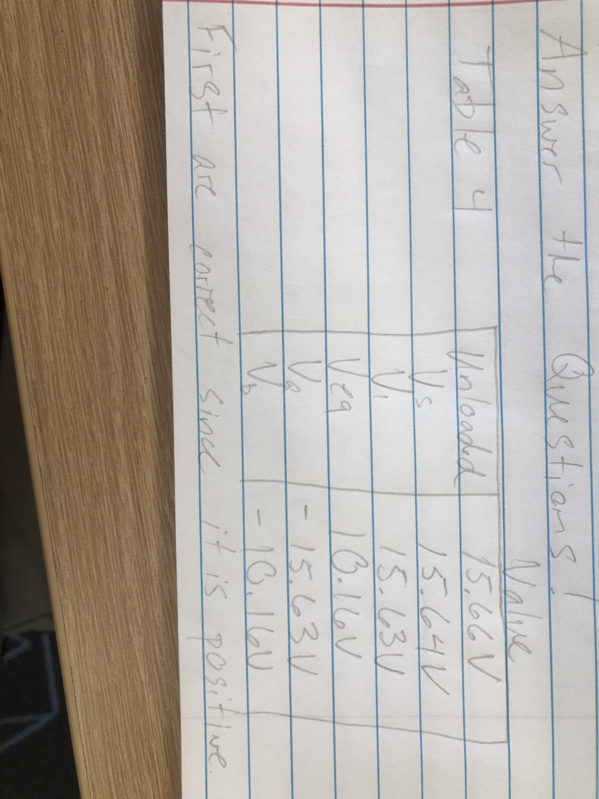

(8)

This is table 4, each value can be found in the circuits above, and the measured value found in this Table.

KVL

|  |  |
| --- | --- |
| Vs - V1 | Veq + Vb = 0 |
| 15.64 - 15.63 = .01 | 10.16 – 10.16 = 0 |

(9)

This is the measuring of Vs in circuit 1.

Exercise 3

Exercise 3 asks the student to do almost identical measurements to the same circuits, except the student is looking for current instead of voltage. The student is given the same circuits as before when looking for voltage.

(10)

Calculations from Table 5 show that I2 = -Ib and I3 = -Ic. KCL is verified by showing I2+I3=Is.

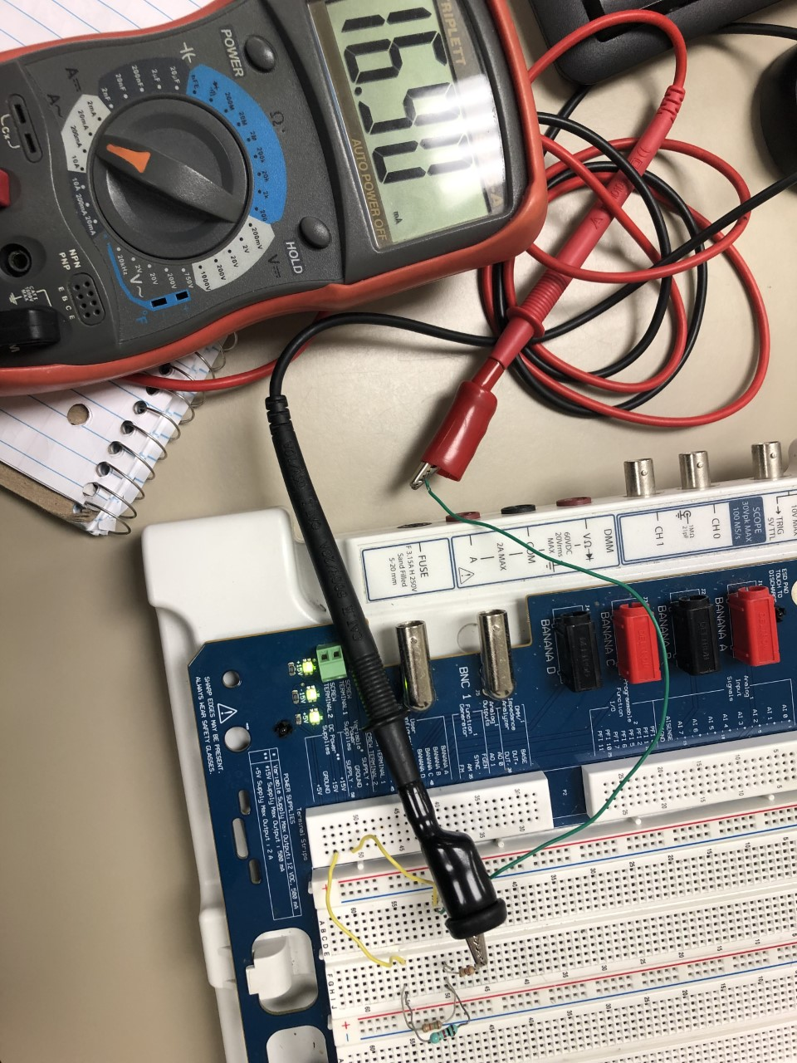

(11)

Measuring of Is for Table 5.

The correct direction of the current is the current that is positive. This means that I2 and I3 are the correct direction for the current on that node.

KCL

|  |
| --- |
| Is + Ib + Ic = 0 (Is = -Ib – Ic) |
| 16.90 – 6.81 – 10.16 = ~ -0.07 |

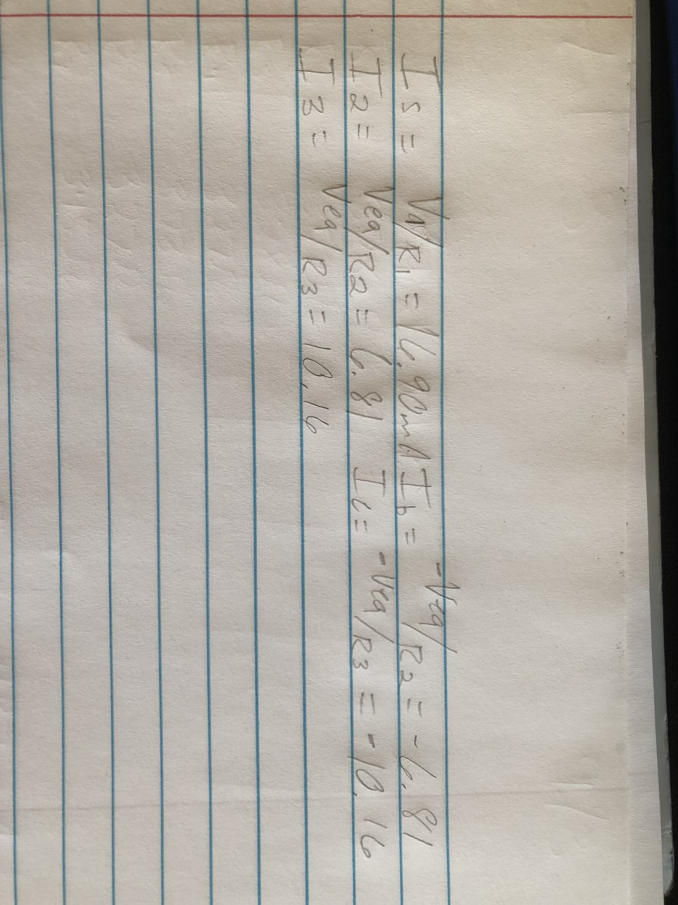

(12)

Verify Values using Ohm’s Law.

Exercise 4

Exercise 4 the student is to take no measurement but use previous measurements and formulas from this lab to learn how to use the voltage and current divider rules.

(13)

Use Voltage divider formula to rederive previous measurements.

(14)

Use Current divider formula to rederive previous measurements.

Summary Table

|  |  |
| --- | --- |
| V1=(Vs*R1)/(R1+Req) | = 15.63V |
| Veq=(Vs*Req)/(R1+Req) | = 10.16V |
| I2=Is*(R3/(R2+R3)) | = 6.78mA |
| I3=Is*(R2/(R2+R3)) | =10.14mA |

Conclusion

Lab 2 was much more complex than Lab 1. Lab 2 focused on physical measurements and how to use instruments in the lab. It covered a wide range of everything in DC circuits, from resistance to current divider laws. This lab is crucial to student learning since the student must use physical tools that all Electrical Engineers must use in an everyday job.

Bibliography

1. Table of measurements R1, R2, and R3
2. Photo of measured value R1
3. Table of measurements Req and Rtot
4. Photo of measured Req
5. Photo of measured Rtot
6. Circuit given to analyze in exercise 2 which can be found in lab manual/lab2
7. Circuit given to analyze in exercise 2 which can be found in lab manual/lab2
8. Table of measurements of voltages taken for exercise 2
9. Photo of measured Vs found in exercise 2
10. Table of measurements of current taken for exercise 3
11. Photo of measurement Is in exercise 3
12. Photo of verification of Ohm’s law for currents in exercise 3
13. Photo of using voltage divider formula to rederive previously found measurements
14. Photo of using current divider formula to rederive previously found measurements