ELEC 2110

Electric Circuit Analysis

Gabriel Emerson

Jake Bryson

September 24, 2019

Section 002

Thevenin Equivalent Circuits

Introduction

The student will begin to take Electrical Measurements of circuits, in order to understand more Thevenin equivalent circuits. The student will also become more familiar with the formulas to derive certain Thevenin circuits and use a potentiometer to find solutions.

Exercise 1

Show the mathematical derivation to show Voc/2 = the voltage at two nodes when Rload = Rth.

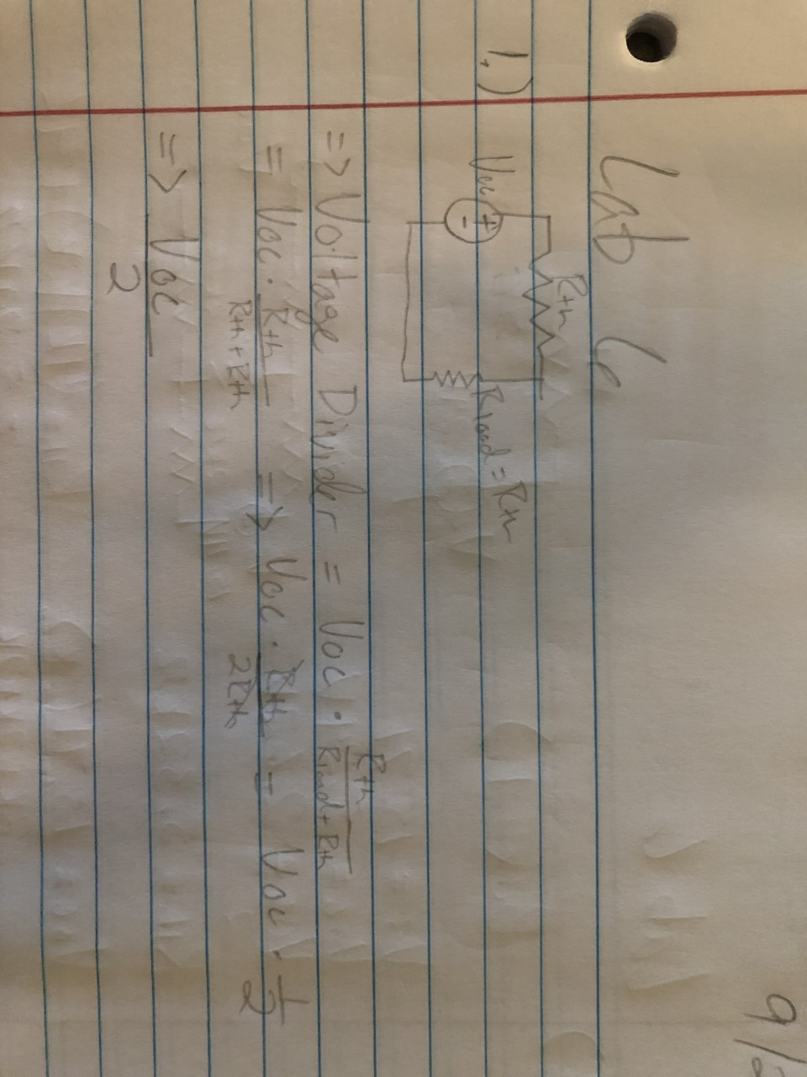

(1)

Exercise 2

Measure and record the resistance between pin1-pin2 and pin2-pin3. Then check if pin1-pin3 is the same as pin1-pin2+pin2-pin3.

Summary Table

|  |  |
| --- | --- |
| Pin1-Pin2 | 0.5 Ohm |
| Pin2-Pin3 | 9.86k Ohm |
| Pin1-Pin3 | 9.86k Ohm |

Exercise 3&4

Experimentally determine the Thevenin equivalent circuit for the black box. Measure Vs, Voc, and calculate Voc/2. Then measure resistance at the point Voc = Voc/2. Then draw the Thevenin equivalent using Rth and Voc, and lastly calculate Isc. Then remove the cover on the black box and draw a schematic of the circuit inside. Then draw a new Thevenin circuit, and measure to compare to previous steps.

Box 1

(2)

Summary Table

|  |  |
| --- | --- |
| Vs | 15.71V |
| Voc | 5.24V |
| Voc/2 | 2.62V |
| Rth | 5.32k Ohm |
| Voc (Thevenin) | (15.71*2k/(2k+2k+2k)) = 5.24V |
| Rth (Thevenin) | ((2+2||2)+4) = 5.29k Ohm |
| Isc | (5.24/5.29) = 0.991mA |

Box 3

(3)

Summary Table

|  |  |
| --- | --- |
| Vs | 15.71V |
| Voc | -3.13V |
| Voc/2 | -1.57V |
| Rth | 1.22k Ohm |
| Is | (Vs/Rtot) = 4.72mA |
| Ib2-b1 | ((Is*2k)/6k) = 1.57mA |
| Voc (Thevenin) | (-Ib2-b1*2k) = -3.14V |
| Rth (Thevenin) | (([2k||2k]+2k)+2k) = 1.2k Ohm |
| Isc | 4.72mA |

Exercise 5

Answer the Question: Now knowing what you do about this specific black box, is it possible to measure the Thevenin resistance at B1-B2 directly from the black box? If so, explain how you would do it? If not, why not?

Yes, you can measure resistance of the black box by measuring directly outside where the power supply is connected to the black box. This is possible since there is only one power source, and the source sees the total resistance of the black box.

Conclusion

Thevenin circuits are a very important solution to learn. It is one of the more known ways for electrical engineers to solve certain circuits. This method is crucial to learning more about how circuits work and especially how to solve complex circuits.

Bibliography

1. Equations with Thevenin circuit for exercise 1
2. Equations with Thevenin and Norton circuit for box 1 exercise 3&4
3. Equations with Thevenin and Norton circuit for box 3 exercise 3&4