**Gabriel Emerson**

**Lab 11: Complex Numbers TIMS Answer Sheet**

Pre-lab Exercise) Express each vector in Polar form and graph.

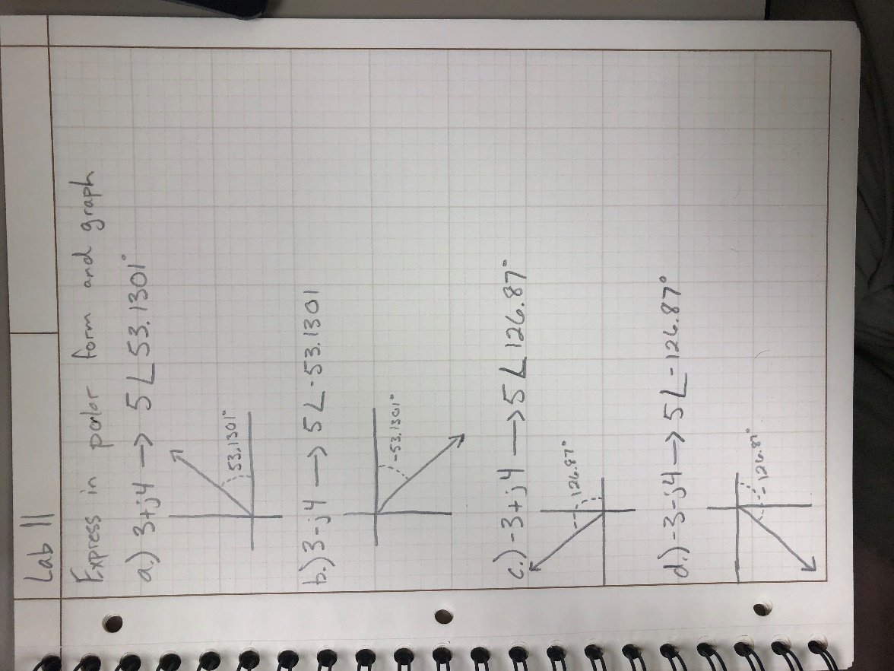

1. Sum = ARB1+ARB2 =

* 1+j1 or sqrt(2) /_ 45 degrees

1. Change the ARB2 phase to -90◦, press “Load ARB”, and record the complex number for the summed value. Record the complex number in both rectangular and polar form.

* 1-j1 or sqrt(2) /_ -45 degrees

1. Explain why the XY plot displays a circle.

* It displays a perfect circle centered at 0,0. This is because at 0 our ARB2 is a sin wave out to 1V (same as our perfect circle). I presume it is creating this plot in polar form and that is why it is a circle.

1. How does this correspond to what you see on the PicoScope?

* It makes sense it is written as 0+j1 because this means we do not go left and right (on the real axis) but we only go up and down (imaginary axis) which does go up exactly 1V.

1. How does this correspond to what you see on the PicoScope?

* This also makes sense because 1+j0 would give us a 1 on the real axis and 0 on the imaginary, thus it should not go up and down but only side to side.

1. Write the equation for signals at ARB1 and ARB2 as a function of time in the form: Acos(t + )

* ARB1: 1cos(wt-15)
* ARB2: 1.2cos(wt+75)

1. Create the functions described in B.1 and B.2. Include both Matlab “.m” files in your submission.
2. Use the MATLAB functions that you created to add the two phasors.

* These two forms add to equal 1.2765+0.9003j or 1.562050 /_ 35.1944

1. Comparing the output sum signals from steps 3 and 4, are the results as expected? Explain.

* Yes they are the same because when you lag by 180 it is the same distance from 0 just which direction (either left or right ie. Positive or negative). Since cos and sin are similar waves, just at different lags, this will make the sin wave in front or behind the cos wave by the same distance. This is why when you look at the scope the signals look the exact same.

1. Record the ChB amplitude in Table 1. The first one is done for you.

Table 1

|  |  |
| --- | --- |
| Phase (degrees) | Output signal amplitude (V) |
| 0 | 2.0 |
| 30 | 1.711 |
| 60 | 1.147 |
| 90 | 164.8mV |
| 120 | 1.129 |
| 150 | 1.729 |
| 180 | 2.162 |
| 210 | 1.729 |
| 240 | 1.147 |
| 270 | 166.5mV |
| 300 | 1.112 |
| 330 | 1.711 |
| 360 | 2.118 |

1. Use Matlab to plot your results. Include a title, label the axes, and turn on the grid.



F.1.) What did you enjoy about this lab?

* + I enjoy bringing MATLAB and the scope together

F.2.) What didn’t go well in this lab?

* + I wish MATLAB things were explained more in detail since this is the first time a lot of us will use some of these specific functions.

F.3.) How would you improve the lab experiment for future classes?

* + I would try to explain the MATLAB part a little more in depth.