**Lab 4: Special Signals TIMS Answer Sheet**

A.1.5. Measure and record the duration of one pulse width and one clock cycle (in milliseconds).

* + 487.7 uS
  + $Clock Cycle=$ 954.8 uS

A.2.5. Record the minimum interval of the digital signal

* + Almost exactly 1ms long

A.2.5. How does the minimum digital interval compare to the clock cycle duration?

* + It rises on the first rising edge of clock, and falls on the next rising edge of clock

A.2.5. Convert the displayed portion of the digital signal to binary code.

* + 1011110110
  + Show previous exercises to GTA

A.3.5. Complete Table 1 below.

Table 1: Delay and Transition Times for Sequence Data

|  |  |  |  |
| --- | --- | --- | --- |
|  | BBLPF2 | BBLPF3 | BBLPF4 |
|  | 1 kHz | 1 kHz | 1 kHz |
| Delay | 258.6uS | 254.4uS | 839.3uS |
| Rise time  (10%-90%) | 215.2uS | 305.1uS | 182.7uS |
| Fall time  (90%-10%) | 218.2uS | 309.3uS | 176.8uS |

A.3.8. At what frequency are you no longer able to accurately discern the digital signal when using BBLPF 4?

* + Beginning at 2.5kHz it begins to get difficult to read which singles go with which clock edge. After 3.5kHz the signal overlaps the next clock signal, making it too difficult to say which signal goes with which clock edge.
  + Show to GTA

B.4. Complete Table 2 below.

Table 2: Step Response for Various Filter Systems (low f setting)

|  |  |  |  |
| --- | --- | --- | --- |
|  | BBLPF2 | BBLPF3 | BBLPF4 |
| **Delay time** | 258.0uS | 279.1uS | 856.6uS |
| **Rise time** | 208.4uS | 275.2uS | 153.4uS |

C.4. Complete Table 3 and graph the values in Figure 1. If completing this task digitally, Matlab can be used for graphing or the student can use some combination of screen capture and photo editing software.

Table 3 – Pulse Width Data

|  |  |
| --- | --- |
| f (cycles per second) | Pulse Width (us) |
| 500 | 1,959uS |
| 1000 | 954uS |
| 1500 | 599.2uS |
| 2000 | 482.0uS |
| 3000 | 325.1uS |
| 4000 | 248.2uS |
| 6000 | 165.4uS |
| 8000 | 124.2uS |
| 10,000 | 99.95uS |

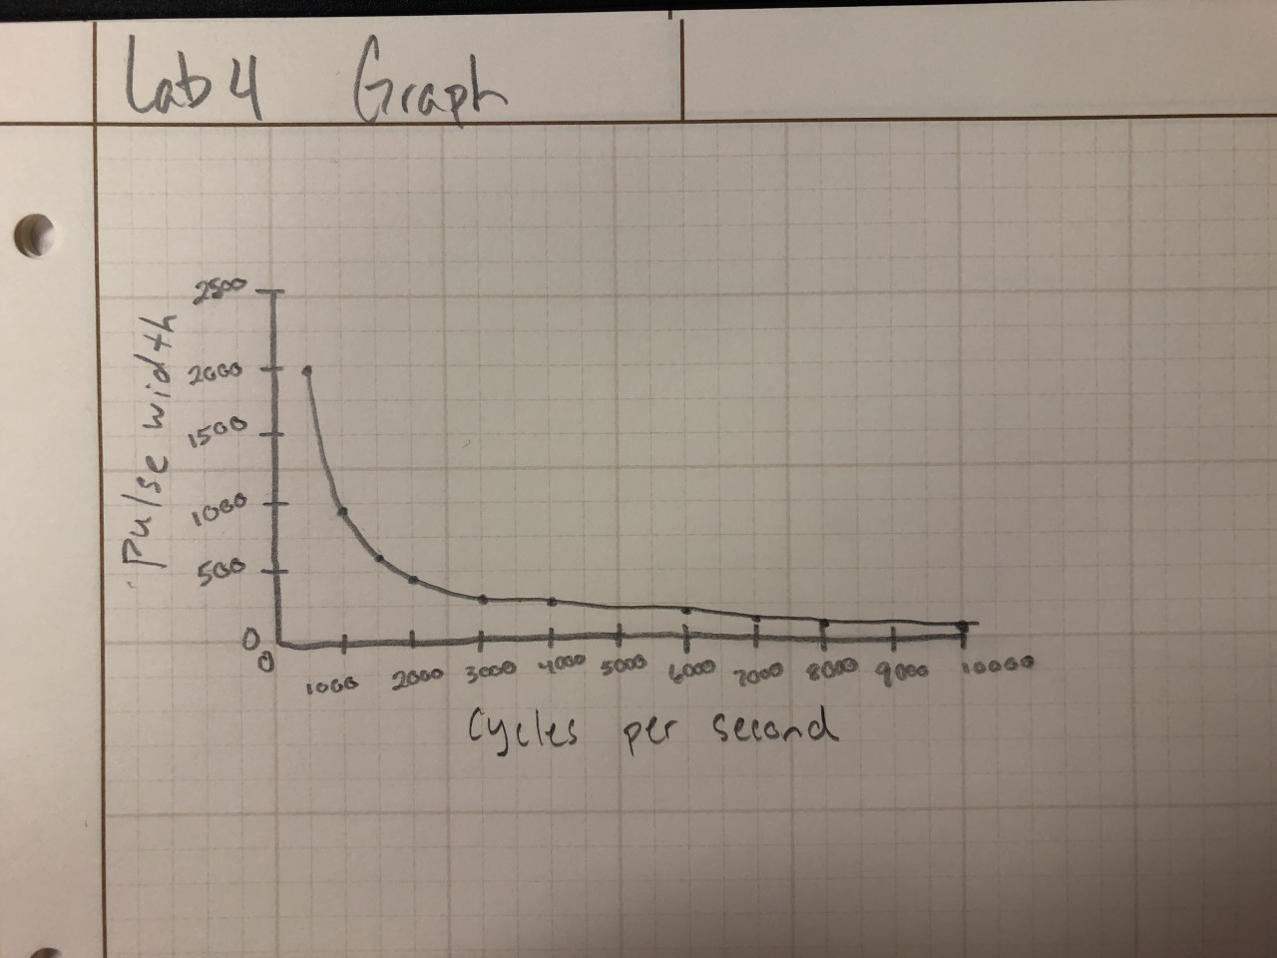

C.9. Why does the amplitude change with continued decrease in pulse width?

* + It changes because as the pulse width decreases (frequency increases), the flat top of the signal gets shorter and shorter until it does not exist, then the amplitude itself begins to decrease as well since amplitude and frequency are inversely related. This is due to the wavelengths of the signal.

D.1.7. Comment on how the signal quality changes with the change in frequency.

* + The signal gets lower voltage peak-to-peak as the frequency gets higher.

D.1.7. Complete Table 4 Measurements.

Table 4

|  |  |  |  |
| --- | --- | --- | --- |
| Frequency  Hz | BBLPF2  Vpp | BBLPF3  Vpp | BBLPF4  Vpp |
| 300 | 6.397 Vpp | 6.132 Vpp | 6.485 Vpp |
| 1000 | 6.309 Vpp | 4.901 Vpp | 6.751 Vpp |
| 2000 | 4.544 Vpp | 1.941 Vpp | 5.559 Vpp |
| 3000 | 431.2 mVpp | 385.8 mVpp | 591 mVpp |
| 4000 | 74.5 mVpp | 81.52 mVpp | 76.55 mVpp |
| 5000 | 31.12 mVpp | 33.31 mVpp | 53.52 mVpp |

D.2.5. Describe how the signal changes.

* + The signal does not look so square. It looks much more like a sin wave, but still has a little bit of a square shape.

D.2.6. Describe how the signal changes.

* + It develops a square shape the stronger the Vpp is. As the amplitude goes down it loses that square shape, but it comes back when you raise the input amplitude.

E.5. Convert input and output signals to their digital (sequence of 1s and 0s) equivalents.

Table 5

|  |  |  |
| --- | --- | --- |
| f (kHz) | Input  digital signal | Output  digital signal |
| 4 | 11011101 | 00100010 |
| 5 | 10100010 | 01011101 |
| 7 | 01110010 | 10001101 |

F.1. What did you enjoy about this lab?

* + It was interesting to be able to play with the different signals and manipulate them to what you want.

F.2. What didn’t go well in this lab?

* + There is a lot of material in this lab that takes a while to get through.

F.3. How would you improve the lab experiment for future classes?

* + Maybe not as long of a lab, all the steps are good, but could be broken up in to two labs.

**Gabriel Emerson**