**Gabriel Emerson**

**Lab 6: System Linearity TIMS Answer Sheet**

A.1.4. Complete the chart of the comparator output voltage response to changing input peak to peak voltage.

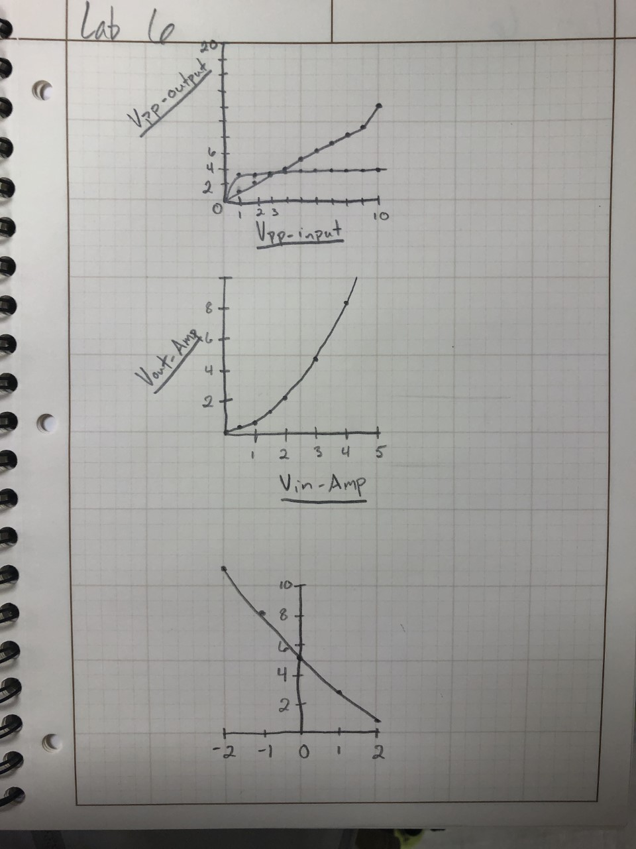

A.1.4. Is the Comparator system output linear or nonlinear? Why?

* + It is linear, as the vin goes up, vout goes up as well and will not curve back down

A.2.2. Add the Rectifier output results to the previous chart.

A.2.3. State whether you believe the rectifier output is either linear or nonlinear and why.

* + I think It is also linear since it never has signs of going down as Vin increases

A.3.8. Complete Table 1 below.

Table 1: Output Amplitude

|  |  |
| --- | --- |
| Input  Amplitude | Output  Amplitude |
| 0.5 | 133.4mV |
| 1.0 | 546.9mV |
| 1.5 | 1.129V |
| 2.0 | 2.20V |
| 3.0 | 4.853V |
| 4.0 | 8.426V |

A.3.8. Plot the results of table 1 in the following figure or with Matlab.



A.3.8. Is the system linear?

* + No, the way this graph runs makes me think this graph is a squared function but how quickly it jumps up the graph

A.3.8. Do your results demonstrate the half angle formula described in the introduction to this section? If not, why not?

* + Yes, because these values for Vout are approx. equal to the half angle formula to Vin

B.1.6. Complete Table 2 below.

Table 2

|  |  |
| --- | --- |
| DC value (V) | Signal frequency (Hz) |
| -2 | **11.28KHz** |
| -1 | **8.36KHz** |
| 0 | **5.66KHz** |
| 1 | **2.89KHz** |
| 2 | **0.87KHz** |

B.1.7. Plot the results in the figure below.



B.1.7. Is this system linear?

* + Yes

B.2.6. What is an obvious application of a system that behaves this way?

* + I think if dc IC chips and how they have input signals (ie. Clear) that stays high and when it goes low, this clears the data of the chip. Other systems that need to be turned off before a certain function is called are also good examples of this.

C.1.6 Describe how the scope display demonstrates operation of the integrator.

* + It looks like at a certain time, both signals go high, however the input is a ramp function, while the output is a window (step) function.

C.2.10. On the scope, measure and record the time taken for the exponential curve to decrease to e-1 of its top value. This is the time constant.

* + Vtop*e^-1= 1.345V
  + Time constant = 80.27uS

F.1. What did you enjoy about this lab?

* + It will more straightforward than the last lab

F.2. What didn’t go well in this lab?

* + Some of the add-ons for the scope machine were a little touchy, leading to us having to try multiple ones to get something to work

F.3. How would you improve the lab experiment for future classes?

* + I have no way to improve this lab