**Gabriel Emerson**

**Lab 9: Convolution TIMS Week 2 Answer Sheet**

1. Explain in detail the output of the system in Figures 1 and 2.

* The output appears to be in a superposition state. If you disconnect b0, b1, or b2, one third of the signal will disappear either from the beginning, middle of end respectively. This shows that the signal could have more to do with delaying the energy.

1. What electrical circuit component creates the presence of ‘delayed energy’?

* The capacitor creates the ability to “lead” or “lag” which can create ‘delayed energy’.

1. Explain the superposition sum in your lab notebook in your own words.

* This means the input signal is delayed and caught at different times for the output. When it gets caught three different times (b0, b1, b2) then it makes the signal add up at these times and create one signal that is 3 times larger than the original input signal.

1. Based on your findings from Week 1, explain what you would expect the system output to be if the input was four pulses back to back instead of one or two?

* I would expect that the frequency would be approximately 250Hz (since that is 500Hz/2) because halving the frequency seems to make the input signal smaller and the output becomes more of what the input is. I also think it would be made of 4 different superposition signals to be able to view the entire signal.

1. How could you adjust the current TIMS setup to simulate this?

* I could take the current 500Hz input signal and divide it again in the digital utilities module. This would give me approximately 250Hz.

1. Follow the instructions in the lab to complete the handout.
   1. Label where x[0], x[1], …, x[7] show up on each of the plots. Set x[0] as the first pulse of the positive sin wave on the input.
   2. Record the voltages of the first 3 time steps in each plot and compare to the output voltage in that time step
   3. Record any error found in the previous step

* Error y[0] = 20.3mV
* Error y[1] = 124.7mV
* Error y[2] = 576.7mV
  1. Include all of this in your submission

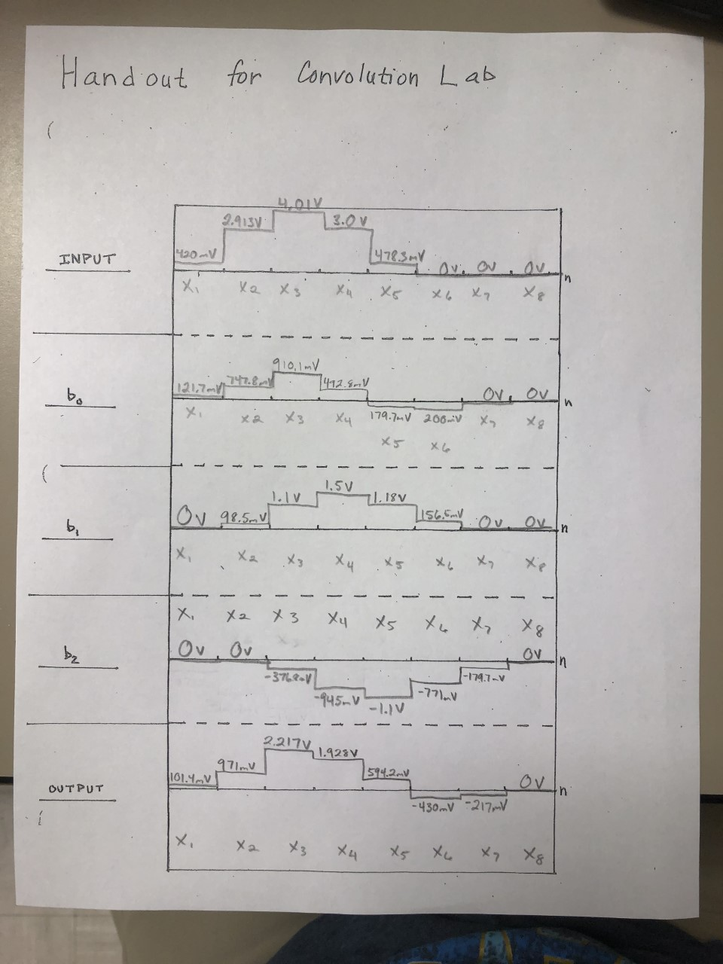

1. Write equations for y[1], y[2], and y[6].

* y[1] = h[0]*x[1]+h[1]*x[6]+h[2]*x[5]
* y[2] = h[0]*x[2]+h[1]*x[1]+h[2]*x[6]
* y[6] = h[0]*x[6]+h[1]*x[5]+h[2]*x[4]

F.1.) What did you enjoy about this lab?

* + The superposition involved in the adder signals is cool to play with and see firsthand how these signals are put together to get the output signal.

F.2.) What didn’t go well in this lab?

* + It took a moment to get the equations together but after talking to the TA we got it figured out.

F.3.) How would you improve the lab experiment for future classes?

* + I have no way to improve this lab