Gabriel Emerson

ELEC 2210 – T 11:00

Experiment #6: Diodes and Rectifiers

02/23/2021

**Introduction:**

The goal of this lab is for the student to gain experience using diodes and rectifiers. They will use LED’s, resistors, diodes, and capacitors to create the circuits that have been discussed so far in Digital Electronics. Constructing these circuits should help the students gain a better, real world understanding of the circuits and how they can be implemented.

**Step 1: LED Bridge**

Using the diagram from the lab manual, a full wave bridge rectifier was constructed using six LEDs and a resistor. When a positive voltage was applied to the circuit, the green and yellow LEDs turned on while the red LEDs remained off. When a negative voltage was applied, the red and yellow LEDs turned on and the green LEDS remained off. This is due to forward and reverse bias. I forward bias, no current would flow through the red LEDs, thus leaving them off. The same was true for the green LEDs in reverse mode. However, yellow stayed on in both cases because the output polarity is not affected by the input polarity. A screenshot of the circuit schematic can be seen below.

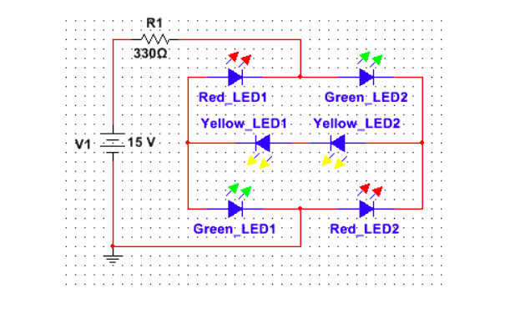

Figure 1: LED Bridge Circuit

**Step 2: Diode I-V Characteristics**

Using the schematic provided in the lab manual, the diode circuits was assembled and connected to the required inputs. The Digital Multimeter’s COM and A connections were connected to the Banana B and A respectively. Banana B then connected to a 1N4733A diode and to ground while Banana A was connected to the variable power source. The voltage and current plot was generated in forward and reverse mode using the LabView software.

Table 1: Forward IV data

Figure 2: Forward IV Characteristics

Table 2: Reverse IV data

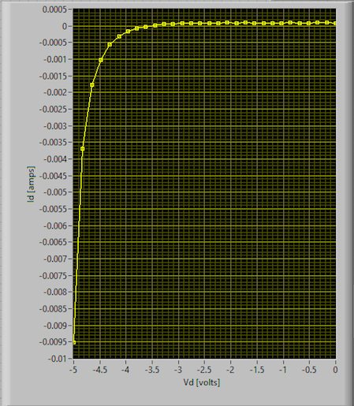

Figure 3: Reverse IV Characteristics

One can deduce whether or not the 60mV rule holds by looking at Figure 2. Two blue bars are used to approximate points where the current is 10x apart. This shows that the values are about 70-75mV apart which is comparatively close to the 60mV rule.

**Step 3: Bridge Rectifier**

Bridge Rectifier:

The circuit shown in Figure 6 was constructed and tested using 1N914 diodes. To realize the 7.6F capacitance, two 3.3 F and one 1F capacitors were connected together in parallel. Also a total of 20kΩ of resistance was connected in parallel with the capacitors. The function generator was set to 10 volts peak-to-peak. As the function generator was grounded, a differential measurement of the output voltage across the output was made. The output voltage was measured by the difference of AI1+ and AI1- connected at opposite sides of the resistor.

The results of the bridge rectifier output are shown in the figure.

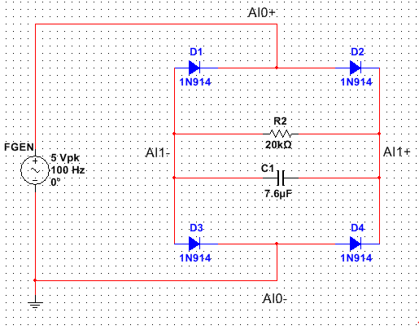

Figure 4: Bridge rectifier schematic

Figure 5: Bridge rectifier output

The output of the bridge rectifier is smaller than the output of a half-wave rectifier because there are two diode voltage losses rather than one diode voltage loss. Then, one of the 3.3F capacitors was removed, resulting in a total capacitance of 4.3 F. The results of the new bridge rectifier output are shown in Figure 8. When capacitor value is reduced to 4.3F the output Vripple will increase because now there is less capacitance therefore less energy can be stored.

Figure 6: Bridge rectifier with less capacitance

Later, the AI+ and AI- input terminals were connected across D2 to measure the voltage across the diode. The output voltage is shown in Figure 9. The scope cursor was used to find the point when the inverse voltage across the diode D2 reached its peak.

Figure 7: Diode D2 voltage

**Conclusion:**

After completing this lab, I think I achieved a better understanding of the physical layout of diodes and rectifiers. The advantage of this circuit over the rectifier circuits built previously is that the output due to the diode is removed, thus the output voltage of the rectifier is the same as the input voltage during the positive half cycle. Also, when the capacitor is added we can gain voltage of the negative half cycle. Another advantage is that we can analyze signals with very low voltages that have less voltage than the diode voltage loss.

