**5220/6220 Lab 5 – Wireless Channel State Information**

**Prerequisites:** MATLAB (2018 or higher), sampled channel state information data, and the MATLAB code for reading, **Windows System (Some code used in the project only works for Windows.)**

**Installing MATLAB 2020a (You could also use the any MATLAB installed on Windows):**

Auburn University now has a Campus-Wide License for MATLAB, Simulink, and add-on products. Faculty, researchers, and students may use these products for teaching, research, and learning. The license allows individuals to install the products on university-owned equipment, as well as personally owned computers. The product is available for Windows, Mac and Linux platforms and also has an online edition for running in a web browser.

Go to Auburn University’s Portal to download:

<https://www.mathworks.com/academia/tah-portal/auburn-university-31487067.html>

You may need to create a MathWorks account before downloading the software.

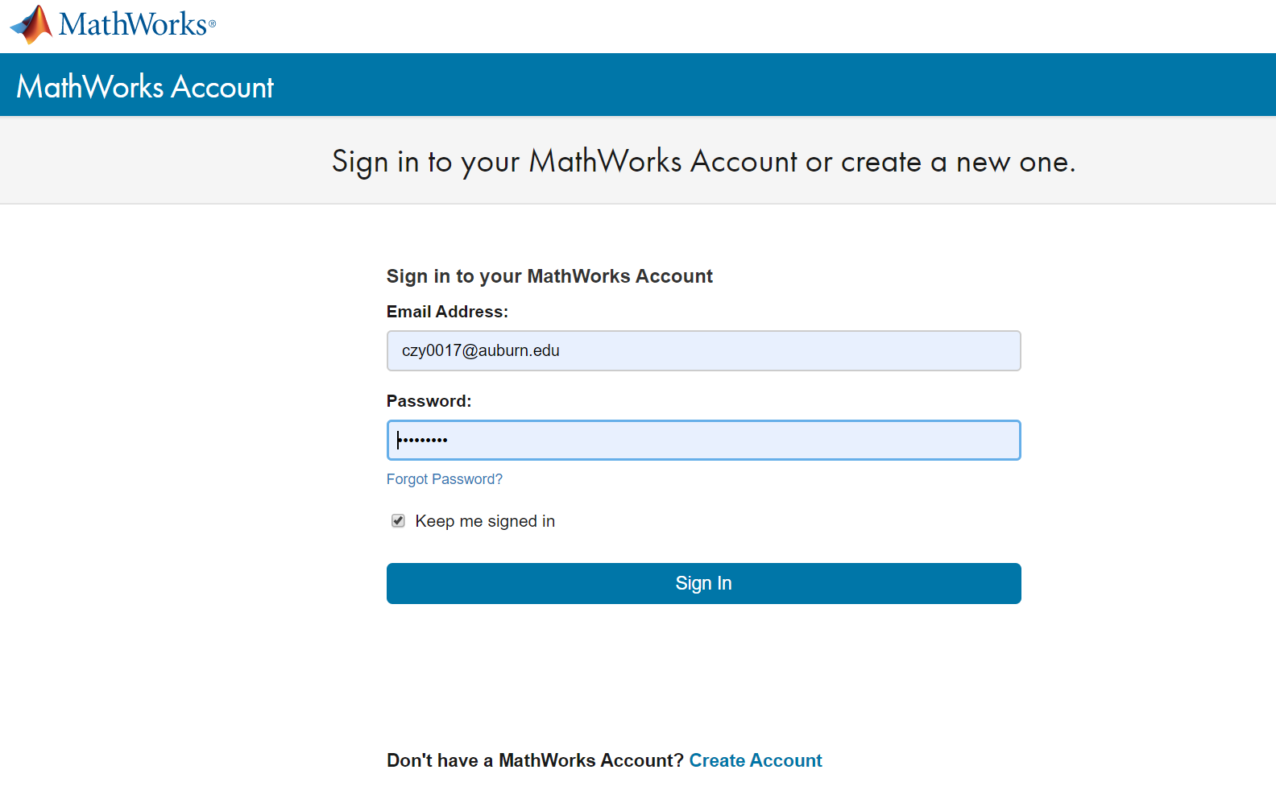

After you sign in with the newly created account, you will see the download page as follows:

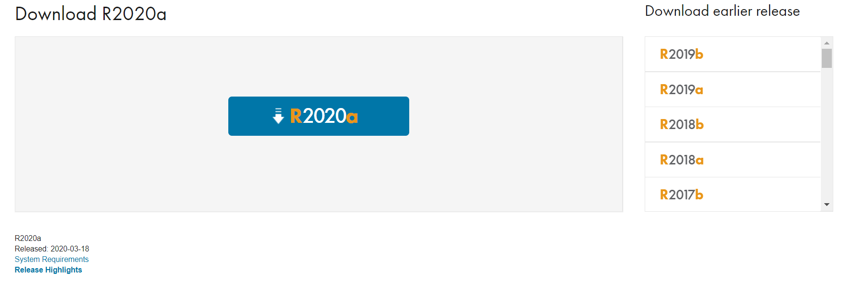

Choose the version R2020a (the latest version) and download the installation program.

Open the downloaded installation program and start to install MATLAB R2020a.

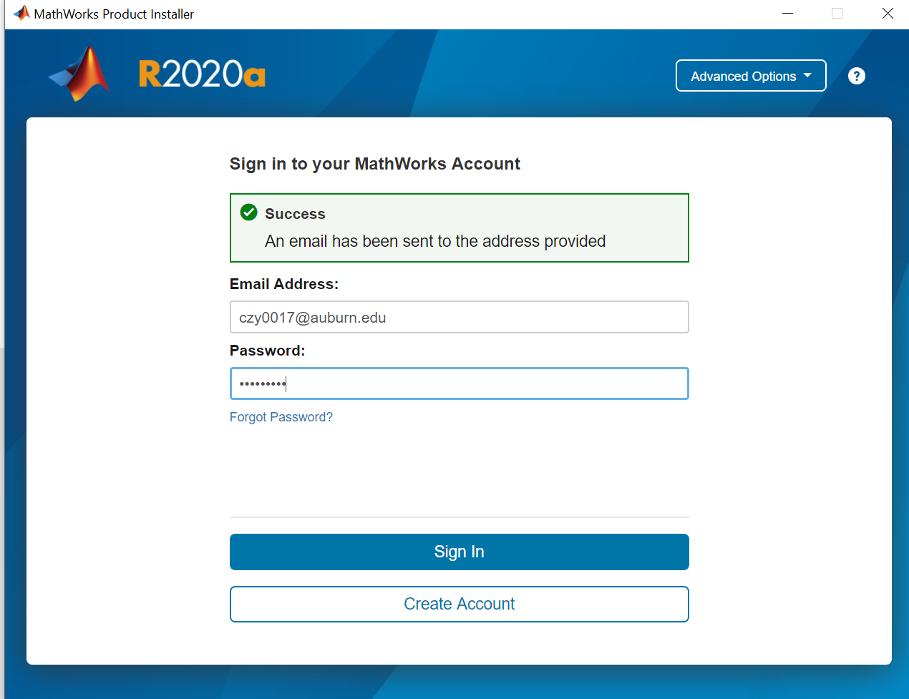

You may need to sign in the MathWorks account created by you before the installation process.

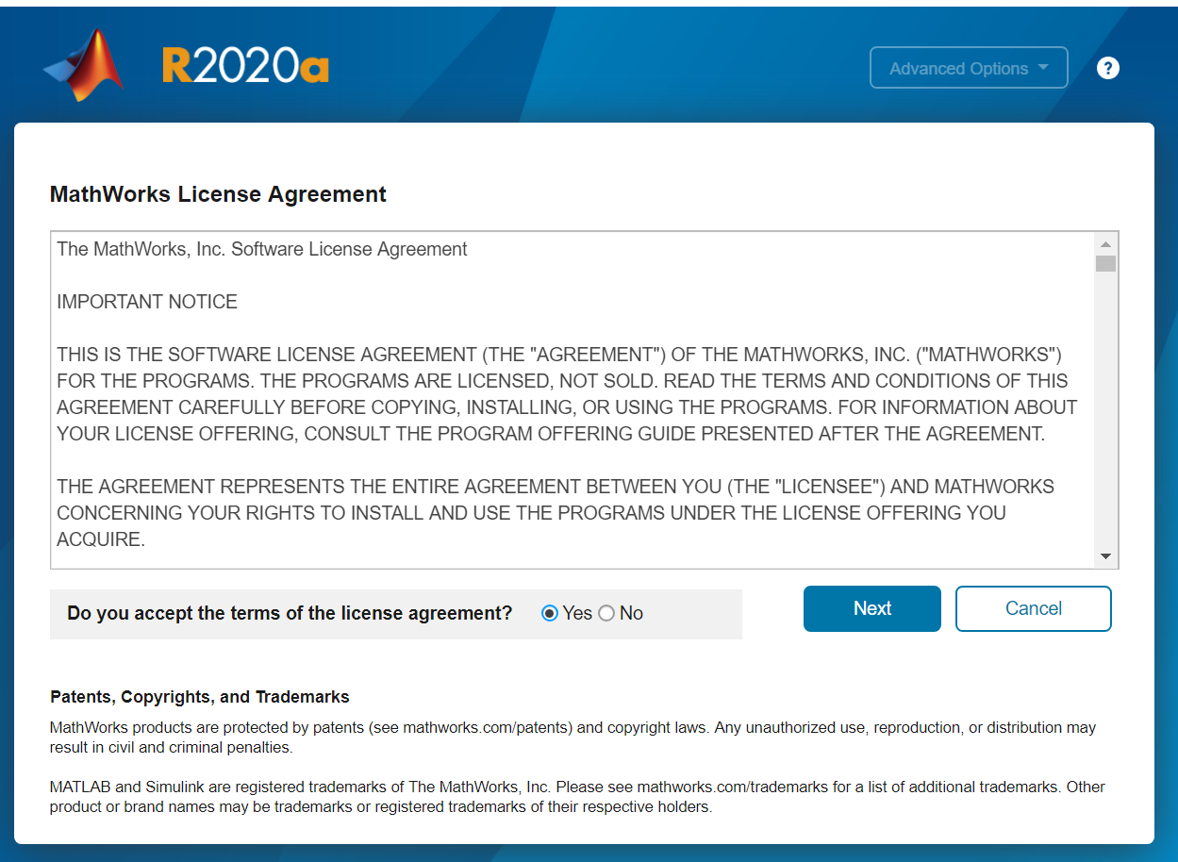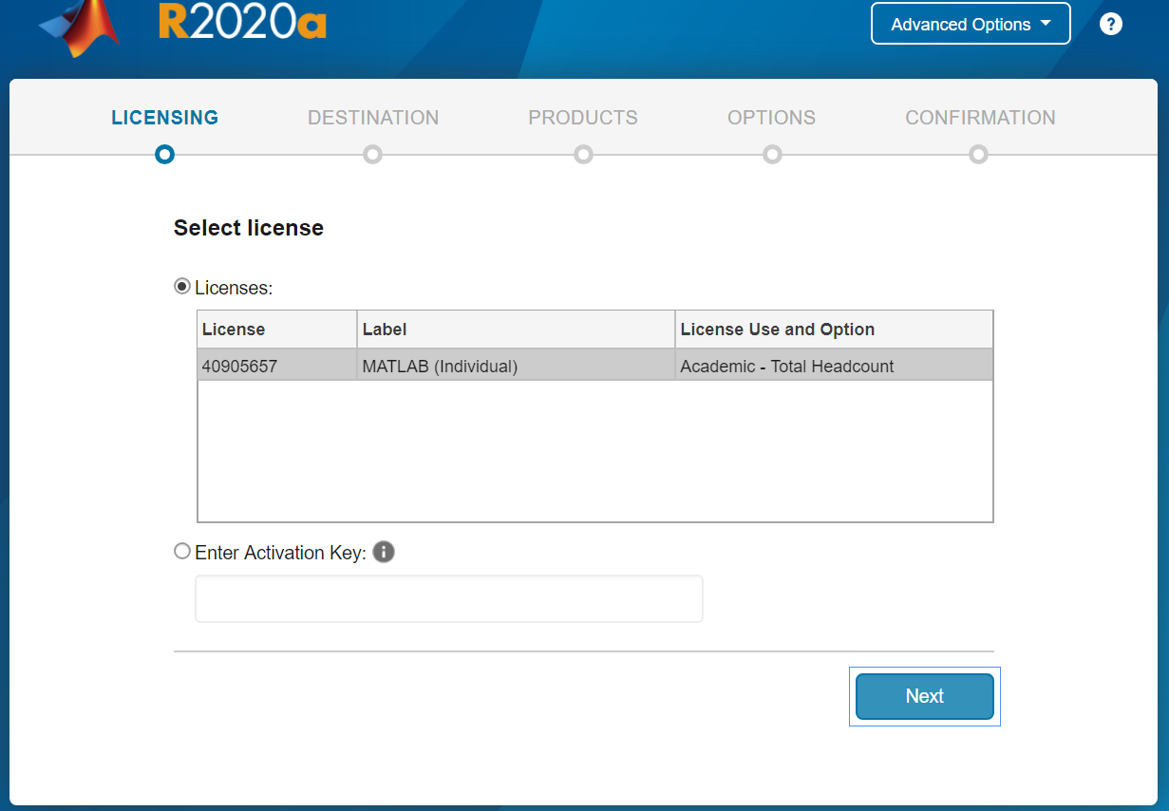

After you logged in, you may need to accept the license agreement and confirm the MATLAB license. Then, choose **the default setting** and keep kick the “next” button until the installation starts. The software requires about 10G, so choose the appropriate disk before the installation. The entire installation process takes about 20~50 minutes depends on the network speed.

**Download the required files from canvas, including the extracted CSI and the reading program.**

**Brief introduction of Channel State Information (CSI):**

In wireless communications, channel state information (CSI) refers to known channel properties of a communication link. This information describes how a signal propagates from the transmitter to the receiver and represents the combined effect of, for example, scattering, fading, and power decay with distance.

The method to estimate CSI is called Channel estimation.

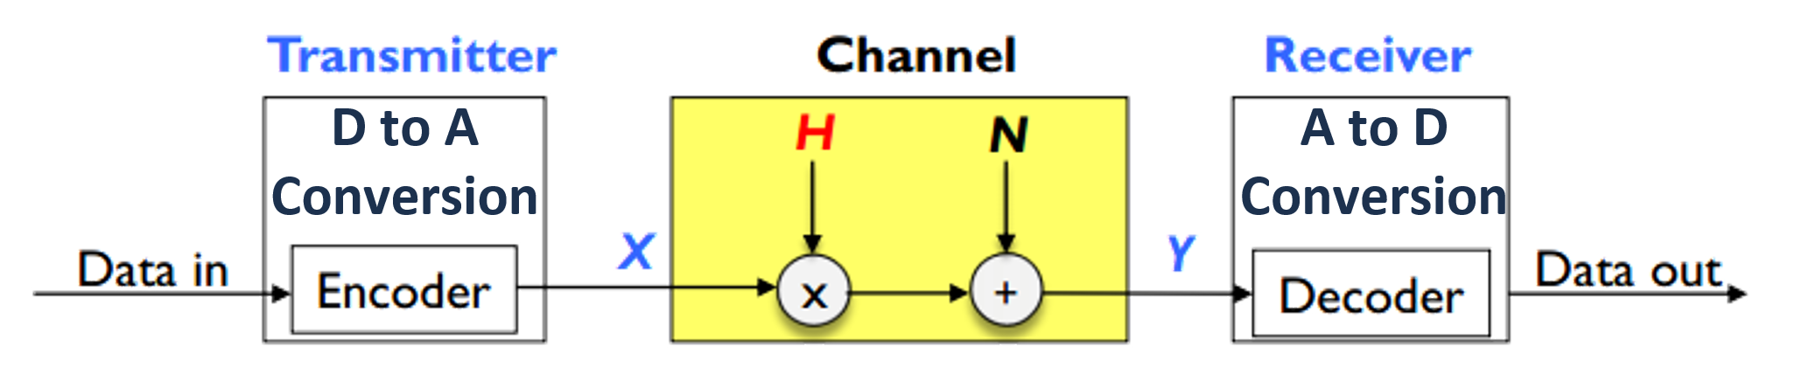

As the Figure shows, for the received signal over multiple subcarriers (channels), the received signal Y could be represented as:

Y=CSI X+N

where CSI could be estimated by Y/X, which is a **complex value.**

The CSI makes it possible to adapt transmissions to current channel conditions, which is crucial for achieving reliable communication with high data rates in multiantenna systems.

**Exercise 1: Observe the real CSI data captured by the commodity WiFi device.**

In WiFi transmission, the packet is transmitted through different subcarriers simultaneously. In this part, we could observe the estimated CSI for one packet in different wireless subcarriers.

1. Open the MATLAB and click the button showed in the following figure. Find the folder of the downloaded lab files (matlab_lab). Open the downloaded file called CSI_lab.m

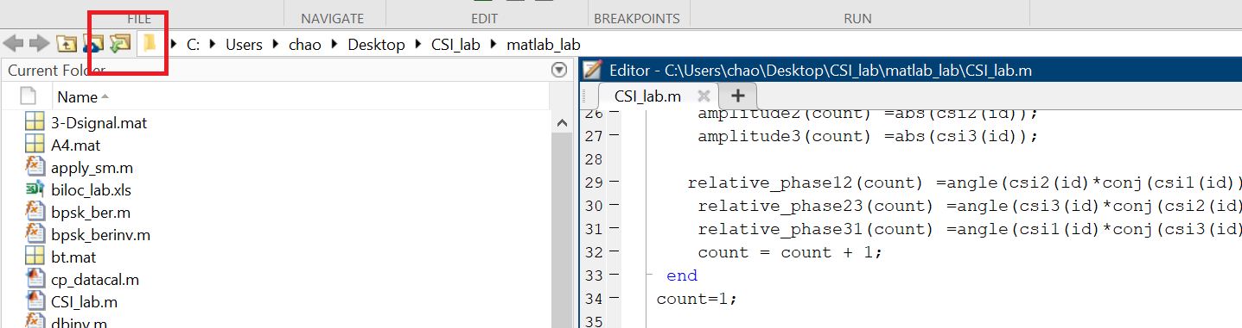

1. Run the code with “EDITOR”🡪 “Run” showing as the following figure

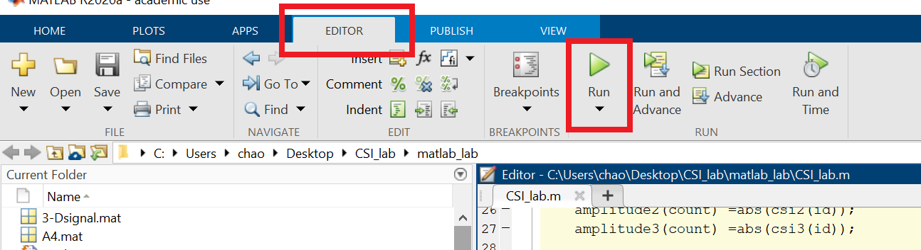

1. You will get the CSI for one packet for all 30 subcarriers in the first plot, which is shown in the polar coordinates.
2. **Take a screenshot** of the plot and attach it to your lab report.

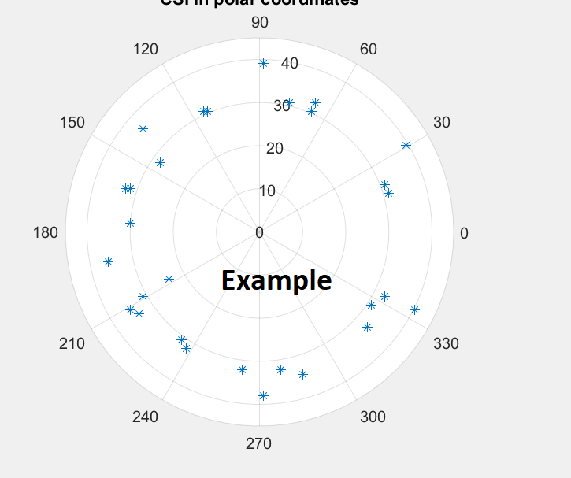

**Exercise 2: Observe the wireless channel variation from captured CSI of continuously received packets**

The exercise will plot the CSI variations for continuously received packets (800 packets in total). Both the amplitude and phase of CSI can reflect the variation of the wireless channels. Run the same code to obtain the second plot for CSI phase variation.

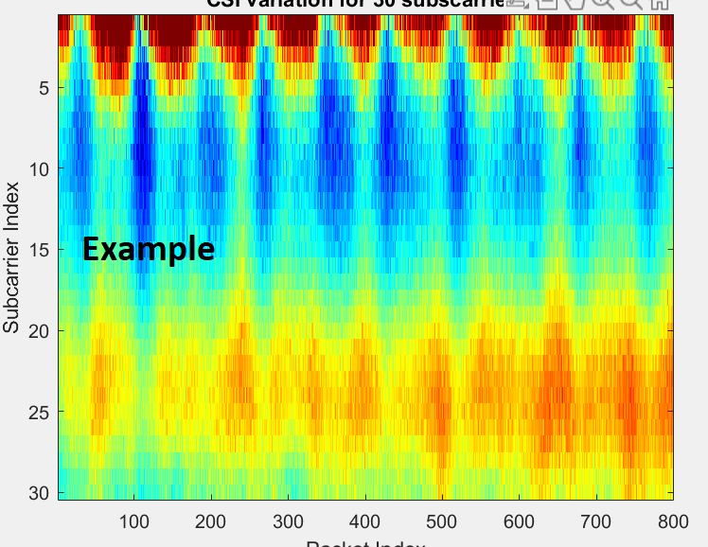

1. Read the comment of the code and change the parameter to plot CSI amplitude variations.



1. **Take the screenshots** of the **two plots (phase and amplitude)** and attach to your lab report.

