ELEC 2110

Electric Circuit Analysis

Gabriel Emerson

Jake Bryson

August 20, 2019

Section 002

Introduction to Multisim: DC Analysis
Introduction

This lab is to introduce the student to the National Instruments Multisim Stimulation Program with Integrated Circuit Emphasis. Students walk through five exercises to learn how to use the program to build various circuits.

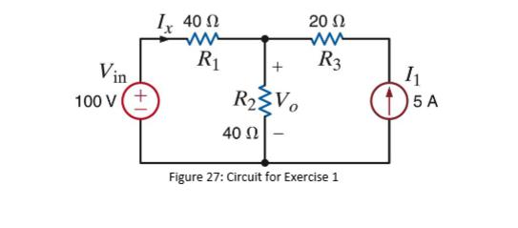
Exercise 1

(1)

This exercise is for use of getting started with Multisim. Setting up circuits and where to find specific pieces that students will get more familiar with this semester. Students found each part of the circuit and made a working, while also finding the correct testing pieces for Voltage, Resistance, and Current.

Summary Table for Exercise 1
Vo | Io
150V | -1.25A

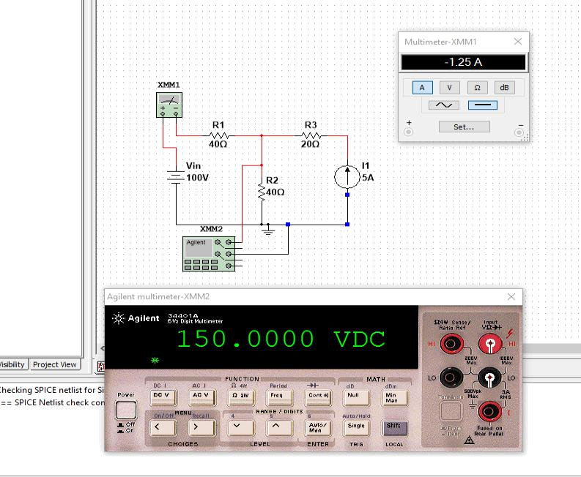

This circuit is the result from exercise 1, with one multimeter measuring Current, and the other measuring voltage.

Exercise 2
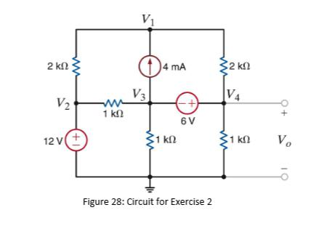

(2)

Exercise 2 was a continued experiment, learning how to see a schematic and make the circuit. Students were given this schematic and were told to create a circuit and find Vo, given the rest of the circuit.
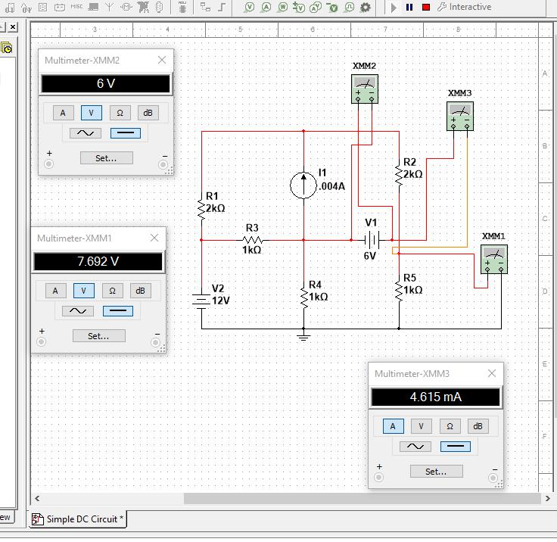

This is the result of exercise 2, finding Vo to be 7.692V, when given 6V and 4.615 Amps.

Summary Table for Exercise 2
Vo | Vs | Io | Power supplied by Source
7.692 | 6V (given) | 4.615mA | 6V*Io == 6V * 4.615mA  = 27.65mW

Exercise 3

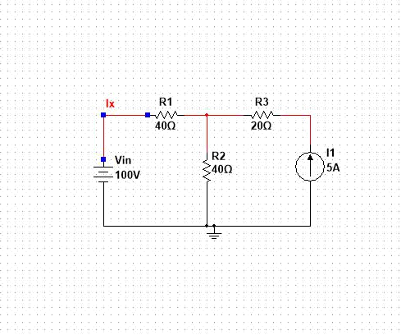
Exercise 3 was getting used to the DC sweep feature in Multisim. Students are to plot Vo as the voltage Vin is varied between 50 V and 150 V in steps of 10 V in the circuit. Then calculate results. Students then set up the experiment with current. Setting Ix as I1 varied from -5A to 5A in steps of 1A.

This is the schematic from the DC sweep in order to run the sweep for both Voltage and Current.

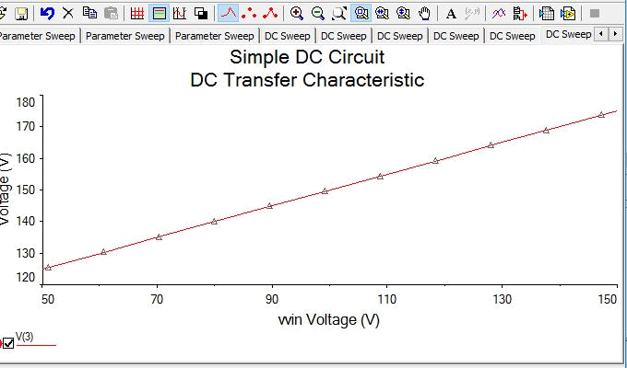

This is the result from Voltage sweep finding this steady rise.
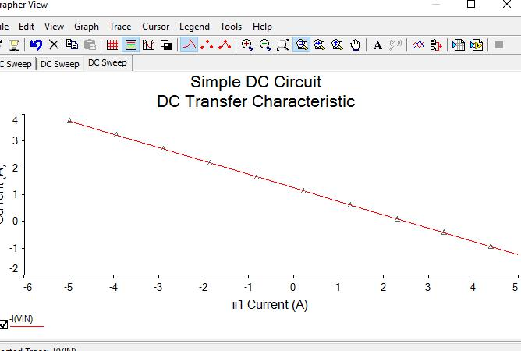

This is the result from the Current sweep, finding a steady decline.
Exercise 4

Exercise 4 introduced resistance controlling voltage and current. Students used Multisim to solve for voltage as R varies from 250 Ohm to 3k Ohm. Then make a sweep graph.
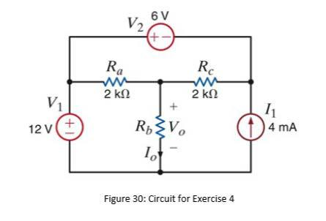

(3)

This is the schematic of the circuit used in exercise 4 to vary resistance and find Vo.
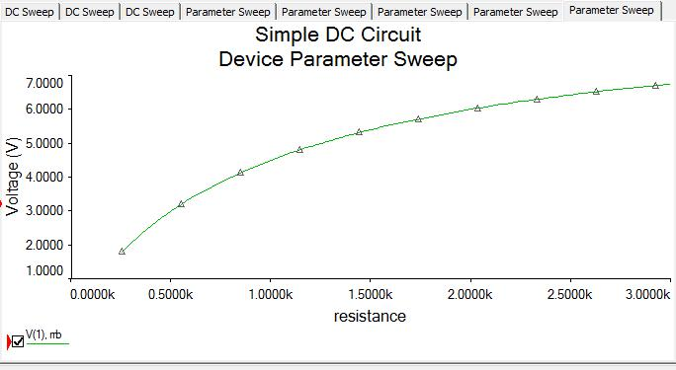

This is the first sweep for exercise 4.

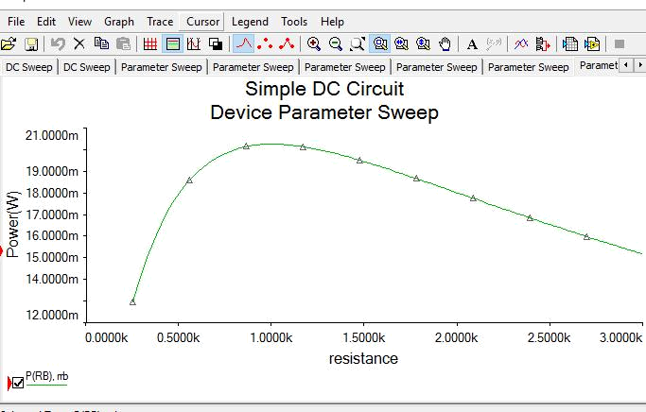

This is the second parameter sweep for exercise 4.
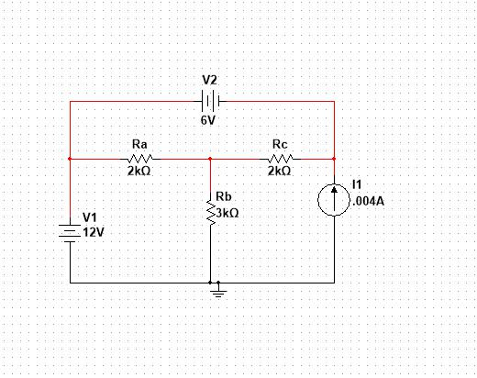

This is the circuit drawn for exercise 4 to perform parameter sweeps.
Exercise 5

This exercise is to become more familiar with Multisim. Given a larger and more complex schematic, draw a circuit to find Io.
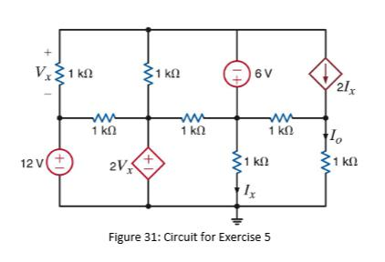

(4)

This is the schematic given to find Io.

Screenshots of exercise 5 could not be found.
Conclusion

Lab 1 was a relatively simple lab that was more focused on familiarity than complexity. This lab was given to help students learn to use Multisim; a program largely used in Electrical Engineering. It is helpful to easily put together a new circuit and test it, since it is all done on a computer program.

Bibliography
- Picture of Circuit figure 27 used in Exercise 1 is from Lab Manual/Lab1: Introuduction to MultiSim.

- Picture of Circuit figure 28 used in Exercise 2 and 3 is from Lab Manual/Lab1: Introuduction to MultiSim.

- Picture of Circuit figure 30 used in Exercise 4 is from Lab Manual/Lab1: Introuduction to MultiSim.

- Picture of Circuit figure 31 used in Exercise 5 is from Lab Manual/Lab1: Introuduction to MultiSim.

