Gabriel Emerson
Lab 12: Poles and Zeros Matlab Answer Sheet

- For the differential equation: $$\frac{d^{2}y}{dt^{2}}+4\frac{dy}{dt}+3y\left(t\right)=\frac{dx}{dt}+3x(t)$$

- Find the corresponding transfer function

- (S+3)/(s^2+4s+3)

- Find the poles and zeros

- P = s=-3, s=-1
- Z = s=-3

- Plot and include the pole-zero map

- Define if the system is asymptotically stable, stable, or unstable. Explain using both poles and zeros of the system and with the impulse response of the system.

- Asymptotically since the impulse goes to 0 as time progresses, you can also tell since the poles of the system are in the left side of the plane

- For the differential equation: $$\frac{d^{3}y}{dt^{3}}+3\frac{d^{2}y}{dt^{2}}+\frac{dy}{dt}-5y\left(t\right)=\frac{d^{2}x}{dt^{2}}-7\frac{dx}{dt}+12x(t)$$
- Find the corresponding transfer function

- = (s^2-7s+12)/(s^3+3s^2+s-5)

- Find the poles and zeros

- P = s=-2+i, s=-2-i, s=1
- Z = s=4, s=3

- Plot and include the pole-zero map

- Define if the system is asymptotically stable, stable, or unstable. Explain using both poles and zeros of the system and with the impulse response of the system.

- Unstable since it goes to infinity as time progresses. You can also tell since the poles of this system do exist on the right side of the plane

- For the differential equation: $$\frac{d^{4}y}{dt^{4}}+5\frac{d^{3}y}{dt^{3}}+9\frac{d^{2}y}{dt^{2}}+5\frac{dy}{dt}=\frac{d^{2}x}{dt^{2}}-10\frac{dx}{dt}+21x(t)$$
- Find the corresponding transfer function

- (s^2-10s+21)/(s^4+5s^3+9s^2+5s)

- Find the poles and zeros

- P = s=0, s=-1, s=-2+i, s=-2-i
- Z = s=7, s=3

- Plot and include the pole-zero map

- Define if the system is asymptotically stable, stable, or unstable. Explain using both poles and zeros of the system and with the impulse response of the system.

- This system is stable since it does not go to infinity or zero as time progresses. You can also tell since there are no poles on the right side of the plan, but there is a zero.

- Design a third order transfer function that produces a stable impulse response. The function should have two zeros.

- Define your transfer function

- (s^3+s^2+s+1)/( s^3+s^2+s)

- Plot and include Impulse Response

- Plot and include Pole-Zero Map

- Explain why the response is stable.

- Because there is a 0 pole and no other poles on the right side of the plane.

- Design a third order transfer function that produces an asymptotically stable impulse response. The function should have two zeros.

- Define your transfer function

- (s^3+s^2+s+1)/( s^3+s^2+s+1)

- Plot and include Impulse Response

- Plot and include Pole-Zero Map

- Explain why the response is asymptotically stable.

- Because there are no poles on the right side of the graph and there is not a pole exactly on 0

- Design a third order transfer function that produces an unstable impulse response. The function should have two zeros.

- Define your transfer function

- (s^3+s^2+s+1)/( s^3+s^2+s-1)

- Plot and include Impulse Response

- Plot and include Pole-Zero Map

- Explain why the response is unstable.

- It is unstable because there is a pole (s=0.544) on the right side of the plane

- Find the transfer function of the circuit in variables. (Don’t plug in any values for the R,L, and C components yet.) Include the transfer function below. Because this formula can be used for any component values, we call this the general form.

- 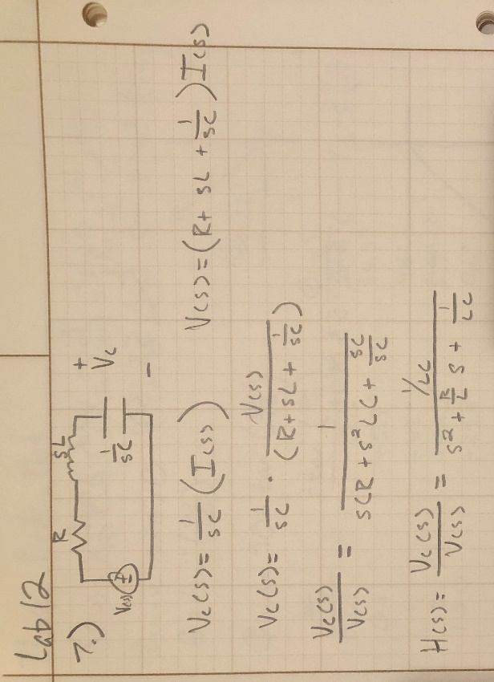

- For $R=40Ω$, $L=3 mH$ and $C=5 μF$, find the impulse response. Using step(H), find the step response of the system.

- Plot and include Impulse Response

- Plot and include step response

- Find the poles, zeros, and pole-zero map of the system. Is the system asymptotically stable, stable, or unstable? Why?

- Include the poles and zeros found

- P = s=-6.6667+4.7140i, s=-6.6667-4.7140i
- Z = There are no zeros

- Plot and include pole-zero map

- Is the system asymptotically stable, stable, or unstable? Why?

- This system is asymptotically stable since there are no poles on the right side of the graph or anything at 0. You can also look at the graph and see that it goes to 0 as time progresses.

- Maintain the values of $L$ and $C$ as $L=3 mH$ and $C=5 μF$. Set the resistance value are to $R=1Ω$, $R=2Ω$, $R=3Ω$, and $R=10Ω$. What happens to the impulse response in terms of oscillations as the resistance varies? How does the pole magnitude vary as $R$ is varied?

- Oscillations go down as resistance goes up.

- Demonstrate that H(s) is unstable by finding the poles and plotting the impulse response. $H\left(s\right)=\frac{s^{2}-7s+12}{s^{3}+s^{2}-2}$

- Include the poles and zeros found

- P = s=-1+i, s=-1-i, s+1
- Z = s=3, s=4

- Plot and include pole-zero map

- Write $H(s)$ in the form described in Equation (3).

- ((s-3)(s-4))/((s-1)(s+1+i)(s+1-i))

- Perform pole-zero cancelation to get rid of the unstable pole and plot the impulse response of the new system).

- Pole-Zero cancellation in the form of Equation 3.

- ((s-3)(s-4)(s-1))/((s-1)(s+1+i)(s+1-i))

- Pole-Zero cancellation in transfer function form (multiplied out as seen in #11).

- (s^2-7s+12)/(s^2+2s+2)

- Plot and include the impulse response of the new system.

- Now, is the system asymptotically stable, stable, or unstable? Is this what you expected to see?

- This system is asymptotically stable. This is what I expected since there were no other poles on 0 in the first equation. Then removing the pole that made it unstable only made it no longer unstable which then resulted in it being asymptotically stable.

F.1.) What did you enjoy about this lab?

  - The oscillations exercise was cool to see how circuits apply to this function of poles and zeros

F.2.) What didn’t go well in this lab?

  - Nothing. This lab was one of the best ones this year.

F.3.) How would you improve the lab experiment for future classes?

  - I do not have anything to add to this lab. It was fun and insightful at the same time.

