# Certificate Import Wizard

VPN Configuration Steps:

1. Install by running "InstallVPN-Signed.ps1" via right-click “Run with PowerShell”

2. If an Execution Policy change prompt appears, make sure to enter "Y" for Yes and press Enter

3. Your p12 private cert password is your mobile number in reverse converted to hexadecimal uppercase

4. "ThirdSight" VPN shortcut will be created on your desktop and it uses the rasdial.exe command to initiate the VPN connection

5. Next install the 2nd VPN shortcut “Add-3S-VPN.ps1” via right-click “Run with PowerShell”

6. There should now be two separate VPN shortcuts on your desktop, one “ThirdSight” VPN and another “3S VPN”

7. Set the VPN metrics to take priority over your Wifi/LAN interfaces:

<https://thirdsight.net/3s/?xmail-id=263973ab-4e58-44c0-ae5c-e220bf50d095&wkspc-id=522>

### Password

**33350B31**

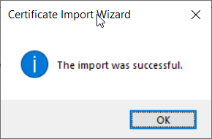

### Welcome

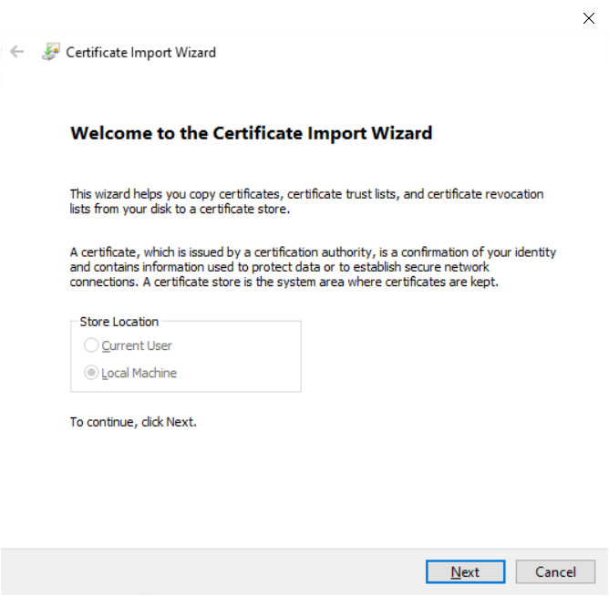

### Next

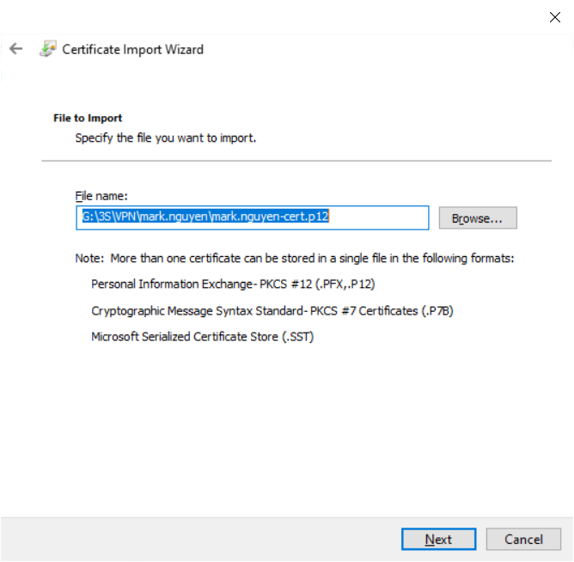

### Next

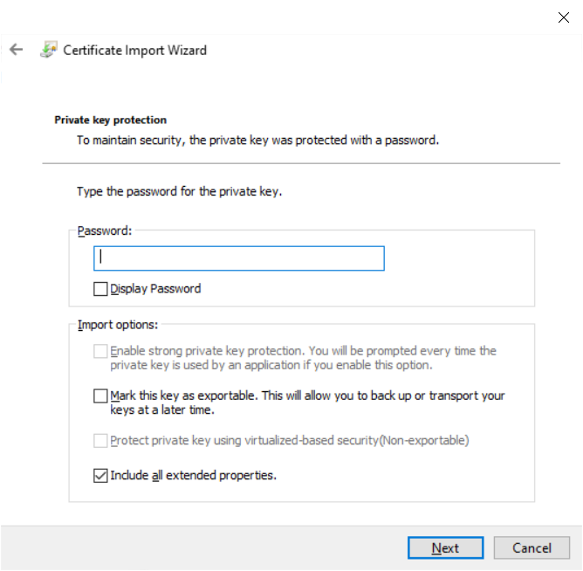

# Manually importing the client certificate - Windows 10

1. The manual import can be completed using Microsoft Management Console (MMC).

Open Command Prompt and type *mmc* and hit **Enter** to open MMC.

Go to File menu, click **Add/Remove Snap In**, and add the **Certificates** snap-in for **Local Computer**.

Once added, right-click in the middle window and select **All Tasks > Import**.

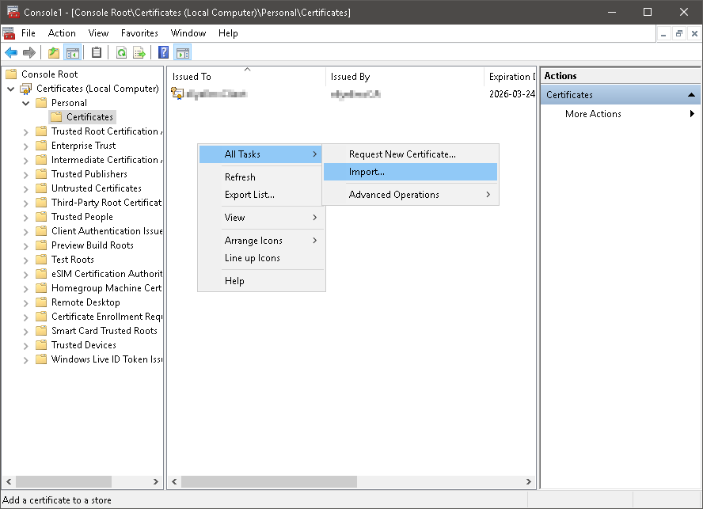

1. Once imported, the certificate should show up under **Local Computer** and not **Current User**.

Export the FortiAuthenticator certificate and import it under **Trusted Root Certification Authorities**, again under **Certificates (Local Computer)**.