Nokia SBC Auto Deploy Web User Guide

D-SBC CE

Version 1.0

Last Updated: 2017-01-30
Table of Contents
1 Preface 3
1.1 Legal Statements 3
1.2 Additional Resources 3
1.2.1 WEB Sites 3
1.2.2 Mailing Lists 4
2 Introduction 5
2.1 Intended Audience 5
3 Installation Requirements 5
3.1 Supported Browsers 5
4 Quick User Guide 7
Step1. Open Home Page of the Web 7
Step2. Register a New User if First Login 8
Step3. Modify Personal Settings and save the change 8
Step4. Start CE Deployment 8

Preface

Legal Statements
Copyright 2016 – 2026, Xu Xiao, All Rights Reserved.

Additional Resources
Other documentation includes:
Nokia SBC Auto Deployment Dev Guide

WEB Sites
- Source Code
  - https://github.com/gter1216/mgw7510-web

Mailing Lists
- Mail:
  - Xiao.A.Xu@alcatel-sbell.com.cn
  - Peng.e.Zhao@alcatel-sbell.com.cn
  - Darcy.Ling@alcatel-lucent.com

Introduction
Nokia SBC Auto Deployment Web is developed for easier to do auto deployment for various edition of SBC product.
Currently, D-SBC CE is released for use. Other edition is under construction, but we need more volunteers to do this
huge work.

Intended Audience
This document is intended for users to do cloud edition deployment work..

Requirements
The following requirements must be met.

Supported Browsers
The following browsers are supported and have been tested.
- Google Chrome version 55 and above
- Mozilla Firefox version 49 and above

Quick User Guide
This section describes how to use this web.

Step1. Open Home Page of the Web
Open http://135.251.216.181, then you will see the following page.

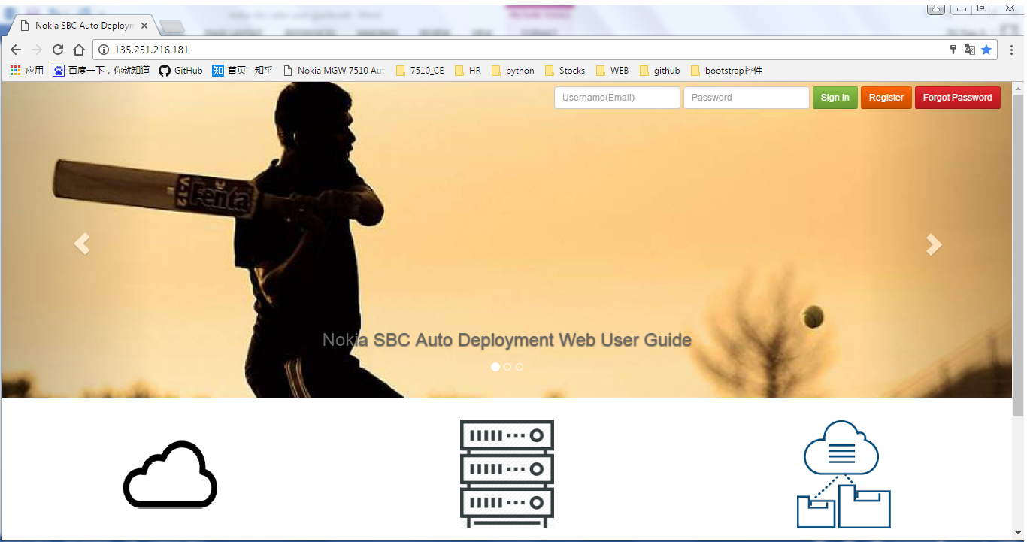

Step2. Register a new user if first login
Next, click register button to redirect to register page.
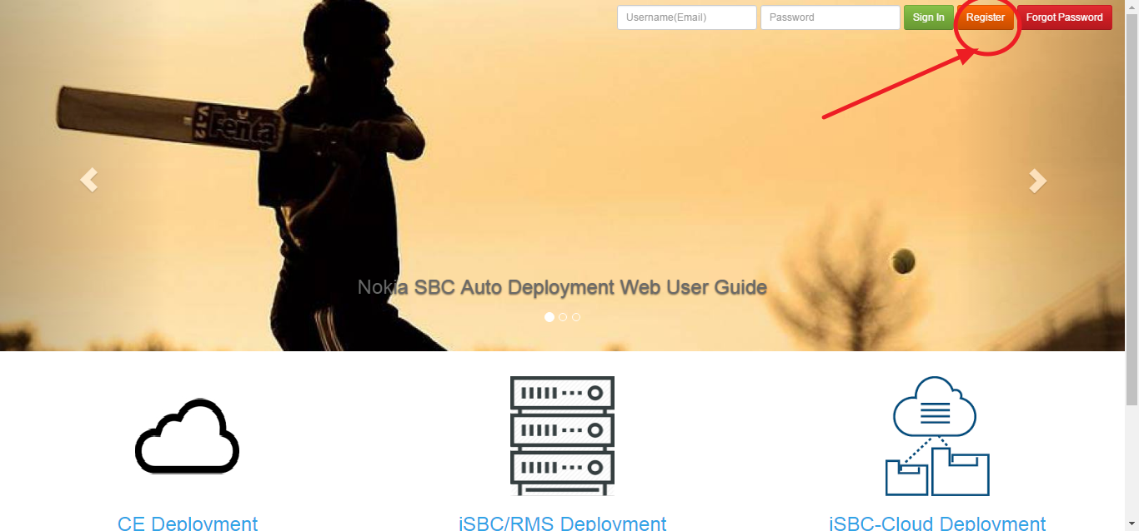
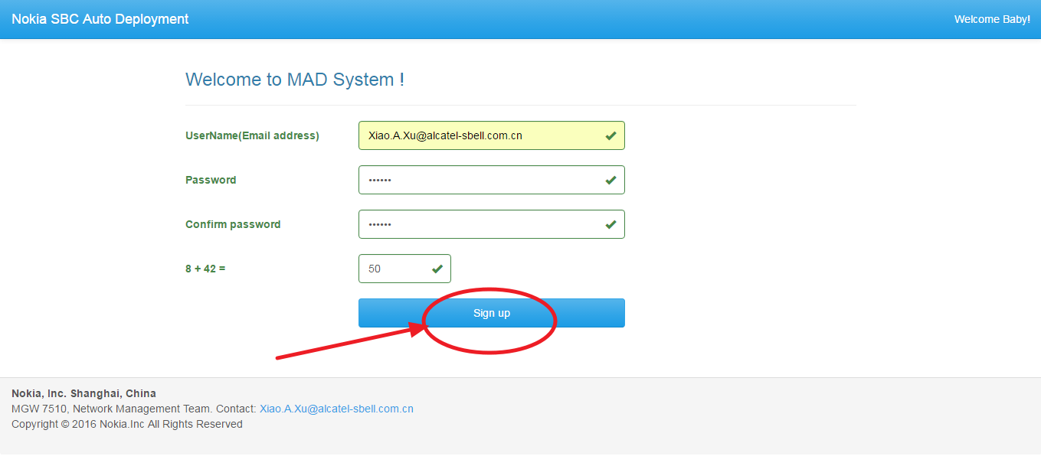
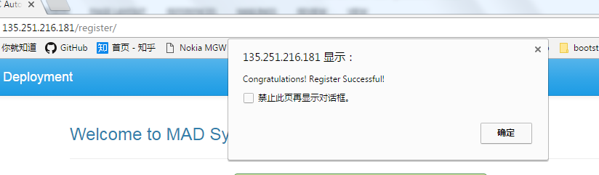

Please use work email to register.

Step3. Modify personal settings and save the change
Next, click right-top navigator button and then click settigns.

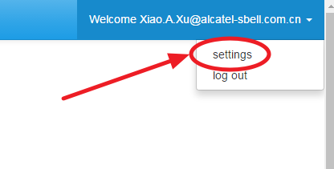

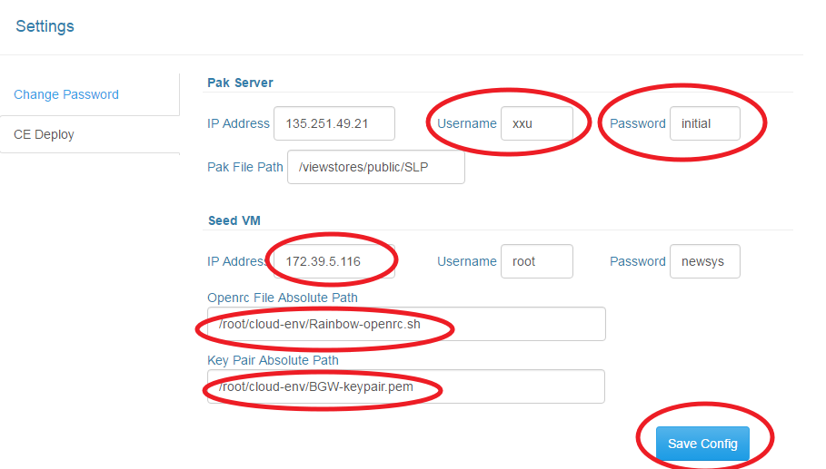

Please use your own pak server username and password.
And user your team’s seed vm to do CE deployment. 172.39.5.116 belongs to NM/RAINBOW team, do not use this IP address only if you are member of NM/RAINBOW team.

Finally, click save to save the changes.

Step4. Start CE Deployment
Next, click CE Deployment icon.

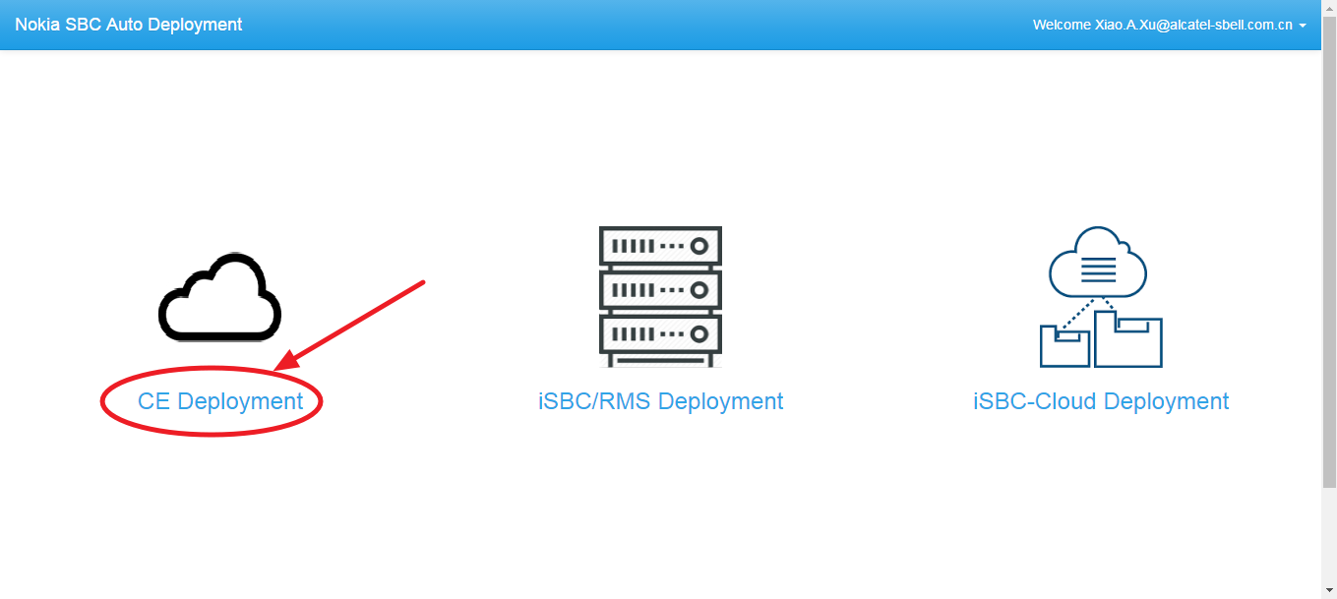

Firstly, select the qcow2 version you want to deploy. And then upload your own user input file.
Finally, click start button to trigger the auto deployment.

You could check log file if there is problem during deployment. If you met some problems during
deploy, please send the log file to Xiao.A.Xu@alcatel-sbell.com.cn

