Final Project Report

For Use in CS6603
  - Mark P Abbott, Michael Countouris, Soon Ryu
mabbott7, mcountouris3, sryu71@gatech.edu

STEP 1: Dataset Selection

Dataset Information
- Dataset Selected: WA_Fn-UseC_-HR-Employee-Attrition.csv
- Dataset Link: https://www.kaggle.com/datasets/patelprashant/employee-attrition

Regulated Domain
- Employment regulated domain, as it contains human resources data including employee demographics, job characteristics, performance ratings, and turnover decisions.

Number of Observations
- 1,470 observations (employee records).

Number of Variables
- 35 variables covering employee demographics, job characteristics, satisfaction metrics, and outcome measures.

Dependent/Outcome Variables Selected
Two dependent variables were selected for this analysis:
Table 1-Dependent/Outcome Variables
Variable | Type | Description | Distribution
Attrition | Primary | Employee turnover | No: 1,233 (83.9%),  Yes: 237 (16.1%)
PerformanceRating | Secondary | Performance evaluation score | Rating 3: 1,244 (84.6%),  Rating 4: 226 (15.4%)

Protected Class Variables
The dataset contains 3 variables associated with legally recognized protected classes:
Table 2-Protected Class Variables
Variable | Type | Range/Categories | Count
Age | Continuous | 18-60 years | 1,470
Gender | Categorical | Male, Female | Male: (882 employees, 60.0%),  Female: (588 employees, 40.0%)
MaritalStatus | Categorical | Married, Single, Divorced | Married (673, 45.8%), Single (470, 32.0%), Divorced (327, 22.2%)

Legal Precedence/Laws for Protected Classes
Age: Age Discrimination in Employment Act (ADEA)
- Protects workers aged 40 and older from employment discrimination
- Covers hiring, firing, promotion, compensation, and other employment terms
Gender: Title VII of the Civil Rights Act of 1964
- Prohibits employment discrimination based on sex/gender
- Applies to all aspects of employment including hiring, firing, pay, and working conditions
MaritalStatus: Fair Employment and Housing Act (state-level protection)
- Prohibits discrimination based on marital status in employment decisions
- Varies by state jurisdiction but widely recognized as protected characteristic

STEP 2: Dataset Exploration

Protected Class Subgroups
Table 3-Protected Classes and Corresponding Subgroups
Protected Class | Subgroups | Type
Age | 18-60 years (continuous) | Individual age values from 18-60 (43 unique values)
Gender | Female, Male | Binary categorical variable
MaritalStatus | Single, Married, Divorced | Three-category marital status

Discretized Subgroup Mappings
Table 4-Numerical Mapping for Categorical Variables
Variable | Subgroup/Value | Numerical Code
Gender | Male | 0
Gender | Female | 1
MaritalStatus | Single | 0
MaritalStatus | Married | 1
MaritalStatus | Divorced | 2
Attrition | No | 0
Attrition | Yes | 1
PerformanceRating | 3 | 0
PerformanceRating | 4 | 1

Selected Protected Classes
The following two protected classes were selected:
- Gender (Male/Female)
- MaritalStatus (Single/Married/Divorced)

Frequency Tables
Table 5-Gender vs Attrition
Gender | No | Yes
Female | 501 | 87
Male | 732 | 150

Table 6-MaritalStatus vs Attrition
MartialStatus | No | Yes
Divorced | 294 | 33
Married | 589 | 84
Single | 350 | 120

Table 7-Gender vs PerformanceRating
Gender | No | Yes
Female | 494 | 94
Male | 750 | 132

Table 8-MaritalStatus vs PerformanceRating
MartialStatus | 3 | 4
Divorced | 279 | 48
Married | 567 | 106
Single | 398 | 72

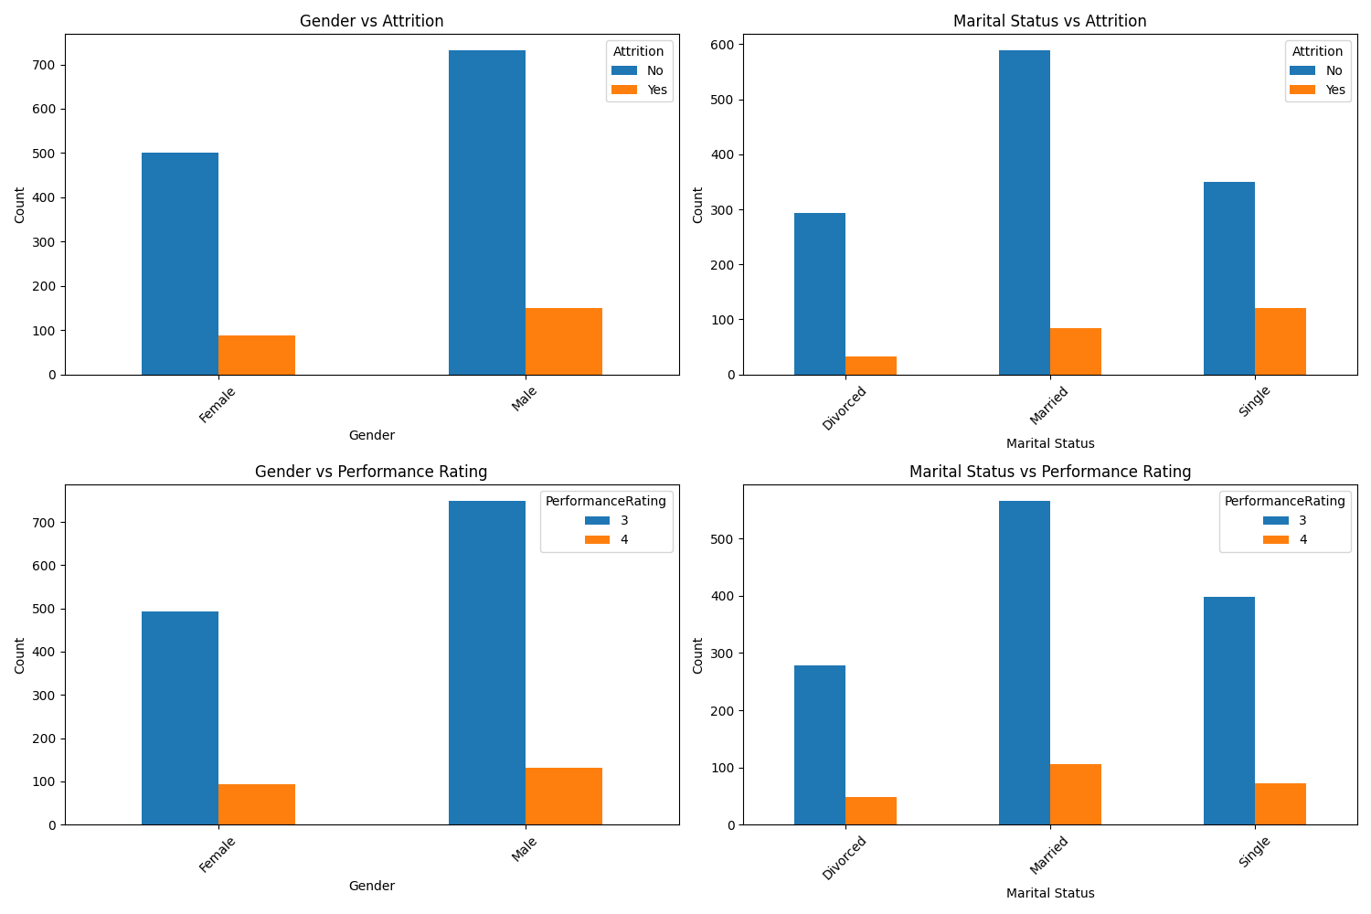
Bar Charts
The bar charts show the distribution patterns for each protected class against both outcome variables. Key observations:
- Gender vs Attrition: Males have higher attrition counts in both categories
- Gender vs Performance: Both genders show similar rating patterns with more employees receiving rating 3
- Marital Status vs Attrition: Single employees show highest attrition rates relative to their group size
- Marital Status vs Performance: All marital status groups follow similar performance rating distributions
The visualizations clearly demonstrate the frequency differences that will be analyzed for bias in subsequent steps.

STEP 3: Defining Creditworthiness and Preparing the Dataset

Selected Protected Classes

Selected Protected Classes

Selected Protected Classes

Selected Protected Classes

STEP 3: Defining Creditworthiness and Preparing the Dataset

Selected Protected Classes

Selected Protected Classes

Selected Protected Classes

Selected Protected Classes

STEP 3: Defining Creditworthiness and Preparing the Dataset

Team members
- Mark P Abbott, mabbott7@gatech.edu
- Michael Countouris, mcountouris3 @gatech.edu
- Soon Ryu, sryu71@gatech.edu

Selected Protected Classes
그래프 설명

Selected Protected Classes
Based on the analysis, Statistical Parity Difference (SPD) appears to be the better fairness metric for this dataset because:

- Interpretability: SPD values closer to 0 are easier to understand (perfect fairness = 0)
- Consistency: SPD shows more consistent improvement across all stages
- Sensitivity: SPD better captures the bias changes after transformation

For MaritalStatus, SPD improved from -0.067 to -0.021, showing clear bias reduction.
For Gender, SPD shows the bias direction more clearly than Disparate Impact.

Selected Protected Classes
PerformanceRating could also be used for classifier training by converting it to binary (3→0, 4→1), but the severe class imbalance (84.6% vs 15.4%) makes it less suitable for meaningful bias analysis.

Answer of question per team members

1. Did any of these approaches seem to work to mitigate bias (or increase fairness)? Explain your reasoning.
예시 답변: "Yes, the reweighting approach showed some effectiveness in reducing bias. For MaritalStatus, the Statistical Parity Difference improved from -0.067 to -0.021, moving closer to the ideal value of 0.0. This indicates that the bias against single/divorced employees was reduced after applying the preprocessing technique."
2. Did any group receive a positive advantage?
예시 답변: "Yes, the unprivileged groups (Female and Single/Divorced employees) received positive advantages. The reweighting technique increased their representation in the dataset, which helped reduce the disparity in outcomes compared to privileged groups."
3. Were any group disadvantaged by these approaches?
예시 답변: "The privileged groups (Male and Married employees) were relatively disadvantaged as their overrepresentation was reduced. However, this was the intended effect to create more balanced outcomes across all demographic groups."
4. What issues would arise if you used these methods to mitigate bias?
예시 답변: "Several issues could arise: First, reweighting might reduce overall model accuracy. Second, it may not address all types of bias present in the data. Third, the approach assumes that equal outcomes are always fair, which may not reflect real-world complexities or individual merit differences."

