1. **Log Structure**

**PAMB:**

**PROD_node1 : 10.166.62.66**

Runtime Log Path: /jboss/eap/domain/servers/rcs_prod_node1/log

Backup Log Path: /weblogs/eap/domain/rcs_prod_node1

**PROD_node2: 10.166.62.67**

Runtime Log Path: /jboss/eap/domain/servers/rcs_prod_node2/log

Backup Log Path: /weblogs/eap/domain/rcs_prod_node2

**PBTB:**

**10.166.66.221**

Runtime Log Path: /jboss/eap/standalone/log

/app/rcs/log

Backup Log Path: /weblogs/eap

**Structure:**

rcs.log -- SQL and some debug log. Due to the limited Hard Desk space, this part had been disabled, so no useful info in this log file now.

rcs_claims.log -- RCS main log file, all the processing detail.

rcs_performance.log – Prefilling log, for performance tuning.

server.log – some Jboss runtime log and the interface in/out XML detail message.

jvm.log – JVM GC detail log.

audit.log – ignore it.

1. **Performance issue analyze**

There are some step to help locate the performance issue when user report the system is slow.

**Step 1**: Use below command we can find out all the action which cost more than 10s.

grep '|Duration:[0-9]\{5,\}' rcs_claims.log |less

‘|Duration:’ is a key word in rcs_claims.log, ‘[0-9]\{5,\}’ means more than 5 digital what means more than 10s.

Result sample:

15:40:26,037 INFO [com.pca.claims.common.web.filter.HttpRequestLogFilter] (http-/10.166.62.66:8443-32) After handle the request|The requested uri:/claims/commonSearch.do|actionMethod=/claims/commonSearch.do.doShowDetail|remote address:10.166.62.65|Duration:301648

**Step 2**: Use the Thread Name as a key word, we can find out all the detail for this action via bellow command.

grep 'http-/10.166.62.66:8443-32' rcs_claims.log |less

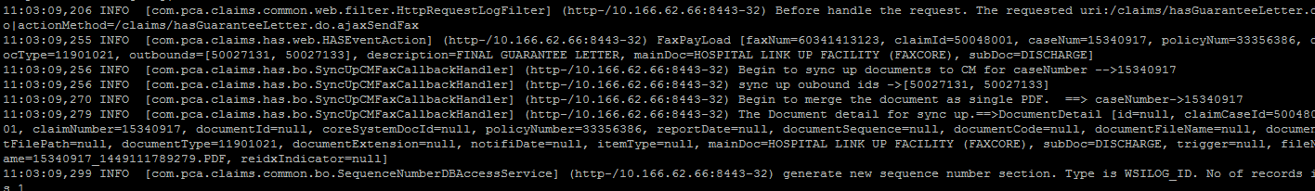

**Step 3:** Actually, we don’t need such more detail info but just want know which method cost most of time.

grep 'http-/10.166.62.66:8443-23.*|[0-9]\{5,\}$' rcs_performance.log* |less

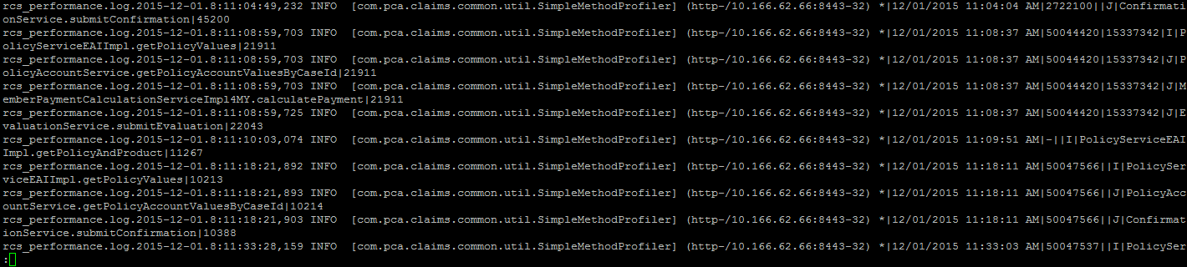

**Step 4:** For troubleshooting, we need to extract these info and provide to developer for future investigate.

grep 'http-/10.166.62.66:8443-23.*|[0-9]\{5,\}$' rcs_performance.log* >> /tmp/example.log

1. **Normal issue**

For this issue encountered while user doing task, we can get an Exception ID or some key word via alert message or error page. Such as ‘EAI1013002’/integration.err.interface. Then we can use it to locate the exception detail stack trace in rcs_claims.log.

Example:

Open the log file via less command

less rcs_claims.log

Then use ‘/’ to search down or ‘?’ to search up

Extract the stack trace log provide to the relate stream team for future investigate.

