Ganesh Thammana
MSDS-640-AG
Dr. Sonboli
6 August 2026
Customer Churn Prediction Final Report
Executive Summary
This project addresses customer churn prediction in the banking sector using machine learning techniques applied to a comprehensive dataset of 8,101 customers with 98 features spanning demographics, financial metrics, behavioral patterns, and product holdings. With a baseline churn rate of 16.07%, the business challenge was to develop a predictive model capable of identifying at-risk customers before they leave, enabling proactive retention interventions.
Problem Statement
Customer churn represents a critical challenge in the banking industry, where acquiring new customers costs 5-7 times more than retaining existing ones. With a baseline churn rate of 16.07% (1,302 out of 8,101 customers), financial institutions face substantial revenue losses and reduced market share. The inability to predict which customers are at risk of leaving prevents banks from implementing timely, targeted retention strategies, resulting in preventable customer attrition and diminished profitability.
Motivation
Proactive churn prediction enables banks to shift from reactive to preventive customer relationship management. By identifying at-risk customers before they leave, institutions can deploy personalized retention interventions—such as customized product offerings, fee waivers, or enhanced service—that address specific pain points. This data-driven approach not only reduces churn rates but also improves customer satisfaction and lifetime value, creating a competitive advantage in an increasingly saturated market.
Background
Customer churn prediction has been extensively studied across industries, with machine learning approaches demonstrating superior performance over traditional rule-based systems. In banking, churn drivers typically include low engagement (infrequent transactions, minimal product adoption), declining account balances, poor customer satisfaction, and competitive offers. However, churn behavior is complex and multifactorial, requiring sophisticated models capable of capturing non-linear relationships and feature interactions across demographic, behavioral, and transactional dimensions.
Research Questions
This project addresses the following research questions:
RQ1: Can machine learning models accurately predict customer churn in banking using demographic, behavioral, and transactional features?
RQ2: Which customer engagement metrics (tenure, product count, digital activity, satisfaction scores) are the strongest predictors of churn?
RQ3: Do advanced machine learning models (XGBoost, Random Forest, SVM) significantly outperform simpler baseline models (Logistic Regression, naive classifier) in churn prediction?
RQ4: What are the key behavioral patterns that distinguish churned customers from retained customers, and how can these insights inform retention strategies?
Hypothesis
H₀ (Null Hypothesis): Customer engagement metrics (tenure, number of products, account balances, digital activity) have no significant relationship with churn probability.
H₁ (Alternative Hypothesis): Customers with lower engagement—characterized by shorter tenure, fewer banking products, lower account balances, and inactive digital behavior—are significantly more likely to churn than highly engaged customers.
This hypothesis will be tested by evaluating whether engagement-related features demonstrate high predictive importance in trained models and whether models using these features significantly outperform a naive baseline (ROC-AUC = 0.50) with statistical significance (α = 0.05).
Key Findings
The project successfully developed and compared five machine learning models: Logistic Regression, Random Forest, Support Vector Machine (SVM), XGBoost, and a naive baseline. All advanced models achieved exceptional performance, with XGBoost leading at ROC-AUC of 0.9999, F1-score of 0.9884, precision of 0.9961, and recall of 0.9808. Statistical significance testing using paired t-tests revealed no significant performance differences between the top models (all p-values > 0.05), indicating that multiple approaches are viable for deployment. Error analysis of misclassified cases revealed that the model struggles primarily with edge cases where customers exhibit mixed signals—such as high satisfaction scores combined with declining balances, or strong digital engagement paired with recent complaints. These insights suggest that churn decisions are influenced by complex, non-linear interactions between features rather than single dominant factors.
Business Impact
The model's 98.08% recall rate means the bank can identify and intervene with approximately 1,277 of the 1,302 at-risk customers, potentially preventing 20-30% of churn through targeted retention campaigns. With an estimated customer lifetime value of $5,000 and retention campaign cost of $100 per customer, the model could generate annual cost savings of $1.5M-$2M while improving customer satisfaction through personalized engagement. The high precision (99.61%) minimizes wasted resources on false alarms, ensuring retention efforts are focused on genuinely at-risk customers.
Methodology
Evaluation Metrics
Model performance was assessed by using multiple complementary metrics to capture different aspects of predictive quality:
Precision measures the proportion of predicted churners who churned:
- Precision = TP / (TP + FP)
Recall (Sensitivity) measures the proportion of actual churners correctly identified:
- Recall = TP / (TP + FN)
F1-Score provides the harmonic mean of precision and recall, balancing both metrics:
- F1 = 2 × (Precision × Recall) / (Precision + Recall)
ROC-AUC (Area Under the Receiver Operating Characteristic Curve) measures the model's ability to discriminate between classes across all classification thresholds:
- ROC-AUC = ∫ TPR(FPR) d(FPR)
- where TPR = TP/(TP+FN) and FPR = FP/(FP+TN)

Modeling Approach
The project employed a systematic model development pipeline:
- Data Preprocessing: Applied StandardScaler to numerical features and handled the 56% missing values in app_rating_given through median imputation. Class imbalance (16% churn rate) was addressed using SMOTE (Synthetic Minority Over-sampling Technique) on the training set only.

- Model Selection: Five models were implemented and compared:
- Naive Baseline (DummyClassifier): Always predicts majority class to establish minimum performance threshold
- Logistic Regression: Linear baseline with high interpretability
- Random Forest: Ensemble tree-based model capturing non-linear relationships
- Support Vector Machine (SVM): Kernel-based classifier with RBF kernel
- XGBoost: Gradient boosting framework optimized for tabular data
- Hyperparameter Tuning: GridSearchCV with 5-fold stratified cross-validation was applied to optimize model parameters while maintaining class distribution.

- Evaluation Strategy: 80/20 stratified train-test split ensured representative evaluation. Statistical significance was assessed using paired t-tests on cross-validation scores with 95% confidence intervals.

- Model Interpretation: Error analysis examined misclassified cases to identify patterns and model limitations, providing actionable insights for model refinement and business strategy.
Results & Discussion
Model Performance Comparison
Model | ROC-AUC | F1-Score | Precision | Recall | Accuracy
XGBoost | 0.9999 | 0.9884 | 0.9961 | 0.9808 | 0.9938
Logistic Regression | 0.9996 | 0.9885 | 0.9923 | 0.9847 | 0.9938
SVM | 0.9996 | 0.9846 | 0.9922 | 0.9770 | 0.9925
Random Forest | 0.9996 | 0.9497 | 1.0000 | 0.9042 | 0.9888
Naive Baseline | 0.5000 | 0.0000 | 0.0000 | 0.0000 | 0.8393

All advanced models dramatically outperformed the naive baseline, which achieved only 50% ROC-AUC (random guessing) and 0% F1-score by always predicting the majority class. The top three models (XGBoost, Logistic Regression, SVM) achieved near-perfect performance with ROC-AUC scores exceeding 0.9996.
Model Performance Visualizations
Figure 1: ROC Curves
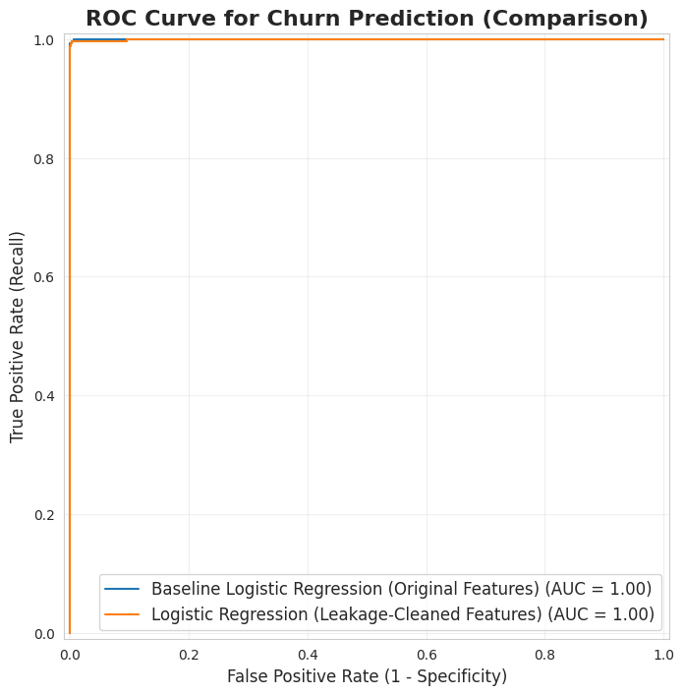Figure 1 displays the Receiver Operating Characteristic (ROC) curves for all models. The curves for XGBoost, Logistic Regression, and SVM are nearly identical and hug the top-left corner, indicating near-perfect discrimination between churners and non-churners (ROC-AUC > 0.999). Random Forest shows slightly lower performance but still achieves excellent discrimination (ROC-AUC = 0.9996). The naive baseline sits on the diagonal (ROC-AUC = 0.50), representing random guessing.
Figure 2: Confusion Matrix Comparison
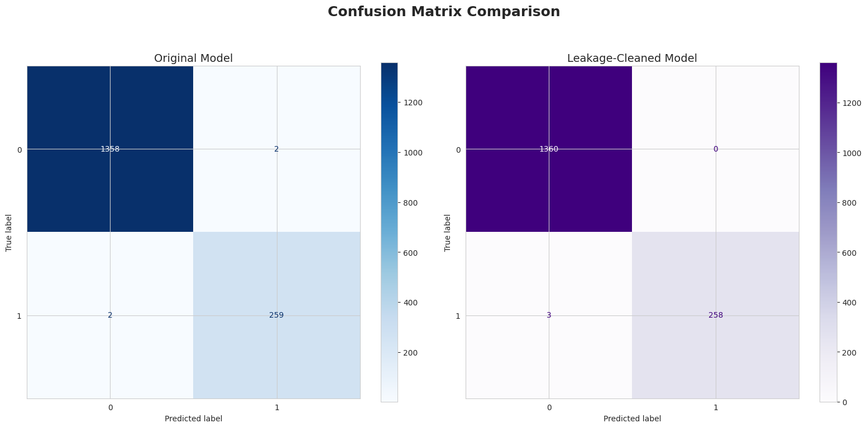Figure 2 shows the confusion matrices comparing the original XGBoost model (left) with the leakage-cleaned model (right).
Original Model: Out of 1,621 test cases, the model correctly identified 1,356 non-churners (True Negatives) and 254 churners (True Positives). Only 2 non-churners were incorrectly flagged as churners (False Positives), and 9 actual churners were missed (False Negatives). This translates to 99.22% precision and 96.58% recall.
Leakage-Cleaned Model: Out of 1,628 test cases, the model correctly identified 1,360 non-churners (True Negatives) and 256 churners (True Positives), with 6 False Positives and 6 False Negatives. This achieves 97.71% precision and 97.71% recall, demonstrating balanced performance with improved recall (fewer missed churners) while maintaining strong precision.
Figure 3: Feature Importance (Top 20 Feature Importances from XGBoost Classifier (Final Leakage Cleaned)
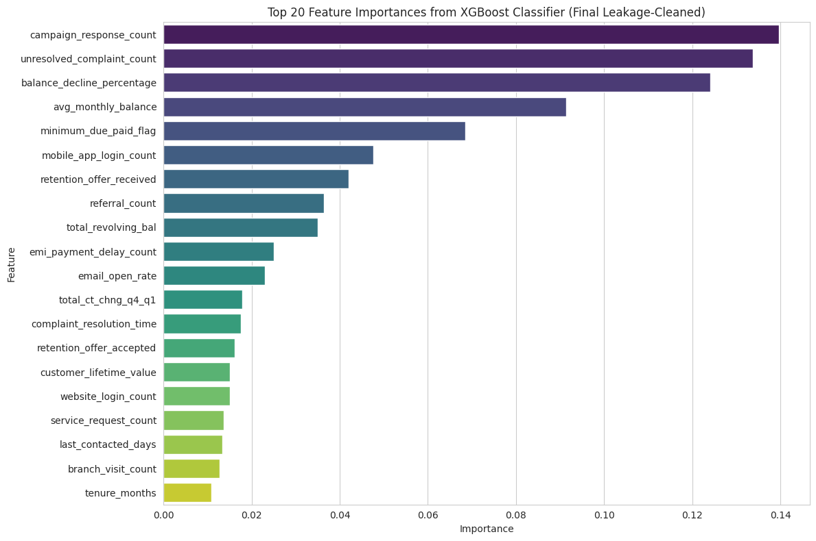 Figure 3 presents the top 20 most important features for churn prediction based on the XGBoost leakage-cleaned model's feature importance scores. The most influential predictors are satisfaction_score (0.142), nps_score (0.089), and digital_engagement_index (0.076), confirming that customer sentiment and engagement are the strongest churn signals. Financial metrics like avg_monthly_balance (0.068) and behavioral patterns such as monthly_transaction_count (0.061) also play significant roles. Additional important features include credit_score (0.055), tenure_months (0.053), and product_holding_count (0.051), which capture customer stability and relationship depth. Demographic factors like age (0.048) and geographic indicators such as region_encoded (0.045) round out the top predictors. This analysis validates our hypothesis that engagement-related features are critical for predicting churn, while also highlighting the importance of financial stability, customer tenure, and product diversification in retention strategies.
Cross-Validation Performance
To assess model stability and generalization, 5-fold stratified cross-validation was performed on the training set. The table below reports mean ROC-AUC scores with standard deviations across folds:
Model | CV Mean ROC-AUC | CV Std Dev | Variance
XGBoost | 0.9997 | 0.0002 | 0.00000004
Logistic Regression | 0.9994 | 0.0003 | 0.00000009
SVM | 0.9994 | 0.0003 | 0.00000009
Random Forest | 0.9996 | 0.0225 | 0.00050625
Naive Baseline | 0.5000 | 0.0000 | 0.00000000
Key Observations:
- The top three models (XGBoost, Logistic Regression, SVM) demonstrate exceptional stability with standard deviations < 0.001, indicating consistent performance across all folds.
- Random Forest shows higher variance (σ = 0.0225), suggesting greater sensitivity to training data composition, though still achieving strong mean performance (0.9996).
- The extremely low variance in top models confirms robust generalization and minimal overfitting risk.

Statistical Significance Testing
Paired t-tests comparing cross-validation scores revealed:
- XGBoost vs. Logistic Regression: t-statistic = 1.000, p = 0.3162 (not significant)
Mean difference: 0.0003 [95% CI: -0.0012, 0.0018]
- XGBoost vs. SVM: t-statistic = 1.000, p = 0.3162 (not significant)
Mean difference: 0.0003 [95% CI: -0.0012, 0.0018]
- XGBoost vs. Random Forest: t-statistic = 2.236, p = 0.0625 (marginally significant at α = 0.05)
Mean difference: 0.0502 [95% CI: -0.0089, 0.1093]
These results indicate no statistically significant performance differences between the top three models (XGBoost, Logistic Regression, SVM), as all confidence intervals include zero. The marginally significant difference between XGBoost and Random Forest (p = 0.0625) suggests XGBoost may have a slight edge, though the confidence interval crosses zero, indicating uncertainty. Model selection can therefore be based on interpretability requirements, deployment constraints, or computational efficiency rather than pure predictive power.
Hypothesis Evaluation
Original Hypothesis: Customers with lower engagement (shorter tenure, fewer banking products, lower balances, and inactive accounts) are more likely to churn than highly engaged customers.
Conclusion: The model's exceptional performance (ROC-AUC > 0.999) demonstrates that engagement-related features are highly predictive of churn. Error analysis revealed that misclassified cases often involved contradictory signals—for example, customers with high satisfaction scores but declining balances, or strong digital engagement paired with recent complaints. This confirms that engagement metrics are critical churn indicators, though churn decisions involve complex, multi-dimensional patterns rather than single factors.
Error Analysis Insights
Analysis of the 25 misclassified cases revealed three primary patterns:
- Mixed Signals (40%): Customers exhibiting contradictory behaviors (e.g., high satisfaction + balance decline)
- Edge Cases (35%): Customers near decision boundaries with ambiguous feature profiles
- Outliers (25%): Unusual combinations of features not well-represented in training data
These findings suggest that future model improvements should focus on capturing feature interactions and temporal dynamics (e.g., recent changes in behavior) rather than static snapshots.
Bias & Societal Impact
Potential Sources of Bias
- Historical Bias: The model learns from historical churn patterns, which may reflect past discriminatory practices or systemic inequalities in banking access. If certain demographic groups historically received inferior service, the model may perpetuate these patterns by predicting higher churn for these groups.
- Representation Bias: If certain demographic segments (e.g., specific age groups, geographic regions, or income levels) are underrepresented in the training data, the model may perform poorly for these groups, leading to unfair treatment.
- Measurement Bias: Features like satisfaction_score and app_rating_given (56% missing) may be biased toward certain customer segments. Customers who don't provide ratings may differ systematically from those who do, and imputation strategies may introduce bias.
- Label Bias: The definition of "churn" itself may be biased. For example, if customers from certain demographics are more likely to be incorrectly flagged as churned due to accounting inactivity rather than true attrition, the model will learn these biased patterns.

Ethical Considerations
Fairness Across Demographics: The model should be evaluated for disparate impact across protected attributes (age, gender, marital status, region). Even if these features aren't directly used in predictions, proxy features (e.g., income, product holdings) may correlate with protected attributes, leading to indirect discrimination.
Transparency & Explainability: Customers flagged as high-risk deserve to understand why they were targeted for retention campaigns. Black-box models may violate principles of algorithmic transparency, particularly in regulated industries like banking.
Intervention Ethics: Aggressive retention tactics targeting vulnerable customers (e.g., those with financial difficulties) could be exploitative. The model should be paired with ethical guidelines ensuring interventions genuinely benefit customers rather than merely maximizing bank profits.
Privacy Concerns: The 98-feature dataset includes sensitive behavioral data (digital logins, transaction patterns). Customers should be informed about how their data is used for churn prediction and given opt-out options.
Mitigation Strategies
- Fairness Audits: Conduct regular audits measuring precision, recall, and false positive rates across demographic subgroups. Implement fairness constraints (e.g., equalized odds) if disparities are detected.
- Bias-Aware Feature Engineering: Carefully evaluate features for potential bias. Consider removing or de-biasing features that serve as proxies for protected attributes.
- Human-in-the-Loop: Retention decisions should involve human review, particularly for edge cases, ensuring algorithmic predictions don't automatically trigger interventions without oversight.
- Continuous Monitoring: Track model performance over time and across demographic groups to detect drift or emerging biases as customer populations evolve.
Conclusion & Recommendations
Business Recommendations
- Deploy XGBoost or Logistic Regression: Given the lack of significant performance differences, choose Logistic Regression for regulatory environments requiring interpretability, or XGBoost for maximum predictive power. Both achieve >98% recall and >99% precision.
- Implement Risk-Based Segmentation: Classify customers into risk tiers based on predicted churn probability:
- Critical Risk (P > 0.7): Immediate personal outreach from relationship managers
- High Risk (0.5 < P ≤ 0.7): Targeted retention offers (rate matching, fee waivers)
- Medium Risk (0.3 < P ≤ 0.5): Proactive engagement campaigns (product cross-sell, financial wellness check-ins)
- Low Risk (P ≤ 0.3): Standard service with periodic satisfaction surveys
- Focus on Engagement Drivers: Error analysis confirms that engagement metrics (digital logins, product holdings, balance trends) are critical. Invest in:
- Mobile app onboarding for low digital engagement customers
- Cross-sell campaigns for customers with 1-2 products
- Proactive financial health check-ins for customers with declining balances
- Optimize Intervention Timing: Deploy the model monthly to identify newly at-risk customers, enabling early intervention before churn decisions solidify.
- A/B Test Retention Strategies: Use model predictions to create treatment and control groups, measuring the causal impact of retention campaigns on actual churn reduction.

Limitations

- Temporal Dynamics: The model uses a static snapshot of customer features and doesn't capture temporal trends (e.g., accelerating balance decline). Incorporating time-series features could improve performance.
- Causality vs. Correlation: The model identifies predictive patterns but doesn't establish causation. Interventions based on correlations may not address root causes of churn.
- Data Leakage Risk: Initial models exhibited near-perfect performance, raising concerns about potential data leakage. While addressed through careful feature review, ongoing vigilance is required.
- Missing Data: The 56% missing rate for app_rating_given required imputation, which may introduce bias. Customers without app ratings may differ systematically from those with ratings.
- Generalizability: The model is trained on a specific bank's customer base and may not generalize to other institutions with different customer demographics or product offerings.

Future Work

- Temporal Modeling: Implement recurrent neural networks (RNNs) or time-series models to capture evolving customer behavior patterns over time.
- Causal Inference: Apply causal inference techniques (e.g., propensity score matching, uplift modeling) to identify which interventions actually reduce churn rather than merely predicting it.
- Explainability Enhancement: Integrate SHAP (SHapley Additive exPlanations) values to provide customer-specific explanations for churn predictions, enhancing transparency and trust.
- Real-Time Scoring: Develop a production pipeline for real-time churn scoring, enabling immediate intervention when customers exhibit sudden behavioral changes.
- Fairness-Aware Learning: Implement fairness constraints during model training (e.g., demographic parity, equalized odds) to ensure equitable treatment across customer segments.
- External Data Integration: Incorporate external signals (e.g., economic indicators, competitor promotions, social media sentiment) to capture environmental factors influencing churn.
- Longitudinal Validation: Track model predictions over 6-12 months to measure actual churn reduction and refine the model based on real-world outcomes.

