Introduction

Parsing huge amount of data is required for practically any information retrieval which deals with vast amount of common-sense and domain specific knowledge. Initially we start building the tool for word relatedness visualizer, but the scope of the project changed as we discovered that exploiting presented technique is more efficient in other applications – such as reverse dictionary, words associations; whereas still preserving functionality to determine relatedness of two words. Assessing the relatedness of texts in
this space equals to comparing the corresponding
vectors using standard metrics. For that, we used a technique called Explicit Semantic Analysis. Compared with baseline, using ESA results shows improvement in correlation of computed relatedness scores with human
judgments. Extrinsic evaluation shows improvements in word sense disambiguation problem, due to human knowledge integration for relatedness score computing.

Semantic Relatedness Measures

Standard dictionary-based
measures of word pair similarity are based on
only a single path between those words. They capture similarity of the words, but not relatedness. Relatedness measure incorporates the notion of similarity, enhancing it with such concepts as antonymy and meronymy. Therefore, a models of relatedness that incorporates information from every explicit or implicit path connecting the two words in the entire graph are required.
One of the methods is described in [2],using a random walk over
nodes and edges derived from WordNet links
and corpus statistics. Authors used a novel divergence measure, ZKL, that
outperforms existing measures for computing semantic relatedness of pairs. In their experiments, they were able to achieve relatedness measure highly correlated with human similarity judgments by rank ordering.
In another approach, [3] authors used random walk over nodes and edges derived from WikiPedia itself. Using both Google PageRank and HITS algorithm implementations in their experiments, they show that Wikipedia
does not perform as well on the smaller datasets but
outperforms WordNet on big datasets by a large margin.

Using gloss overlap as semantic relatedness measure might seem to be very simple idea, however in [4], authors show through extrinsic evaluation that extended gloss overlap improves WSD task by as far as 89% in some cases.

Explicit Semantic Analysis

After careful literature survey, the idea of text representation with massive amounts of world knowledge was very inspirational for us.
There is no problem to get set of words of language; any dictionary packages can provide them; there are many test sets readily available on the web as well. However, retrieving the set of concept seems to be more of the problem, as there isn't self-sufficient structured information. Therefore, we
represented texts as a weighted mixture of a predetermined set
of natural concepts, which are defined by humans themselves
. As proposed in [1], for that we used concepts defined by Wikipedia articles.
Each Wikipedia concept is represented as weighted word vectors, where for each word TF-IDF [2] value is assigned. We build inverted-index of concepts, as it is more useful for implementation, where weighted vector of concepts is associated with each word. (Pic. 1)

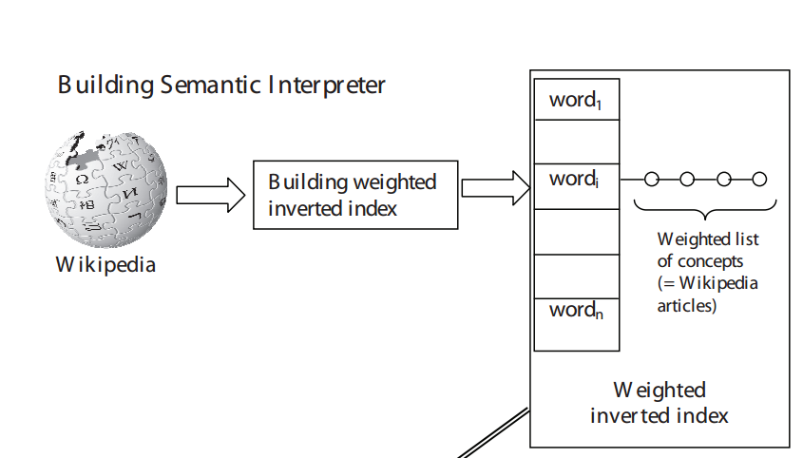

Pic. 1 Inverted-index for each of word in the word index

For example,Table 1 shows top 10 concepts for the words dog and medicine.

Equipment | Investment
1 Tool  2 Digital Equipment Corporation Angel investor  3 Military technology and equipment Stock trader  4 Camping Mutual fund  5 Engineering vehicle Margin (ﬁnance)  6 Weapon Modern portfolio theory  7 Original equipment manufacturer Equity investment  8 French Army Exchange-traded fund  9 Electronic test equipment Hedge fund  10 Distance Measuring Equipment | 1. Investment  2 Digital Equipment Corporation Angel investor  3 Military technology and equipment Stock trader  4 Camping Mutual fund  5 Engineering vehicle Margin (ﬁnance)  6 Weapon Modern portfolio theory  7 Original equipment manufacturer Equity investment  8 French Army Exchange-traded fund  9 Electronic test equipment Hedge fund  10 Distance Measuring Equipment Ponzi scheme
Table 1.

\Implementation

Implementation consisted of following stages:

- build an inverted index of a Wikipedia Database provided in the original MediaWiki database schema
- compute ESA vectors for any text
- compute Cosine Similarity of ESA vectors (which can be used as semantic similarity measure)

The main challenge was to parse an actual size of wikipedia dump.

Our initial approach was to split the wiki-dump into one plaintext ﬁle (ﬁle_<page_id>) per wiki-page. The title of
the page is considered as the wikipedia concept. We wrote perl scripts to parse

these ﬁles one at a time (a lot of disk activity) but less memory pressure. We

generated one ﬁle per word in the vocabulary that stores the term frequency of the

word with respect to several wiki-pages.
Format of this inverted-tf ﬁle :

ﬁle_<page_id> normalized term -frequency.

--In gabrilovich et al's terms, ﬁle_<page_id> is one wikipedia concept.

We computed idf parallely that stores idf values in a separate ﬁle. Then using this
per-word ﬁle and the idf ﬁle, we computed the tf-idf inverted index per word.

We used Amazon RDB service for high-performance query processing. However, it turns out that bottleneck was fetching the data from the storage to memory, not a query processing, and we ended up generated sqllite database with joint index on word identifiers and tfidf values.

Empirical Evaluation

Conclusion

References

1. Computing Semantic Relatedness using
Wikipedia-based Explicit Semantic Analysis
Evgeniy Gabrilovich and Shaul Markovitch
, Department of Computer Science
Technion—Israel Institute of Technology, 32000 Haifa, Israel

2. Lexical Semantic Relatedness with Random Graph Walks
Thad Hughes and Daniel Ramage

Computer Science Department
Stanford University
, Stanford, CA 94305

3. WikiRelate! Computing Semantic Relatedness Using Wikipedia
Michael Strube and Simone Paolo Ponzetto
EML Research gGmbH
Schloss-Wolfsbrunnenweg 33
69118 Heidelberg, Germany

4. Extended Gloss Overlaps as a Measure of Semantic Relatedness
Satanjeev Banerjee,
Carnegie Mellon University
Pittsburgh, PA 15213
, Ted Pedersen
University of Minnesota

5. Salton and McGill, 1983.

