**046326**

**Introduction to**

**Biological Signals & Systems**

Simulation Exercise

**Student:** Paz Peleg **ID:** 203827290

**Student:** Gilad Hecht **ID:** 206837007

**Part I**

1. **HH Model** (Assuming $I=0)$
2. There is a single equilibrium point of the system when $V_{K}<V<V_{Na}$ are:
$$V_{0}=-74.4 \left[mV\right]$$

$$n_{0}=0.31$$

$$m_{0}=0.052$$

$$h_{0}=0.596$$

3. The eigenvalues of the Jacobian in the single equilibrium point we found are:

$$λ=\left(\begin{aligned}\begin{matrix}-4.726 \\ -0.178+0.432i \\ -0.178-0.432i\end{matrix} \\ -0.12\end{aligned}\right)$$

We can notice that the Real part of all the eigenvalues is negative, so this is a stable equilibrium point. This makes sense as it is the Resting Potential.

1. Simulation of the system presenting the transient effects:

* At time $T_{0}=0.5697 [ms]$ the potential is decreasing and isn’t developing to an Action Potential.
* At Time $T_{1}=0.5707 [ms]$ the potential is increasing and developing to an Action Potential.

In the following graph we can how the state variables change in time, in response to different-length current pulses:

1. **2D HH Model** (Assuming $I=0$)
2. The equilibrium point of the 2D HH model, when $n_{0}=h_{0}=0.35+\frac{9}{90}$, is:

$$V_{0}=-62.8 \left[mV\right]$$

$$n_{0}=h_{0}=0.45$$

$$m_{0}=0.18$$

The eigenvalues of the Jacobian in the single equilibrium point we found are:

$$λ=\left(\begin{aligned}\begin{matrix}3.0325 \\ -7.7229\end{matrix}\end{aligned}\right)$$

We can notice that both eigenvalues are Real, and since one eigenvalue is positive and the other is negative, we can conclude that this equilibrium point is a saddle point.

In the following graph we can see the flow lines near the equilibrium point $\left(V_{0}=-62.8\left[mV\right] , m_{0}=0.18\right)$ in the state-space.

1. When using the 2D HH model, there is no threshold voltage that defines whether the membrane potential will develop to an Action Potential or not. This is due to that fact that this model is based on 2 variables – $V$ and $m$, and they both dictate the terms for an Action Potential to develop (terms = threshold curve).

As such, near the saddle point, we can define the threshold curve geometrically by the eigenvectors leading directly to the saddle point (including the saddle point itself).   
Away from the saddle point, we can define the threshold curve geometrically by the trajectories leading directly to the saddle point.

The threshold curve split the phase space in half – any trajectory starting from the upper-right half would enable an Action Potential to develop, while trajectories starting from the bottom-left half would get the membrane potential to decrease.

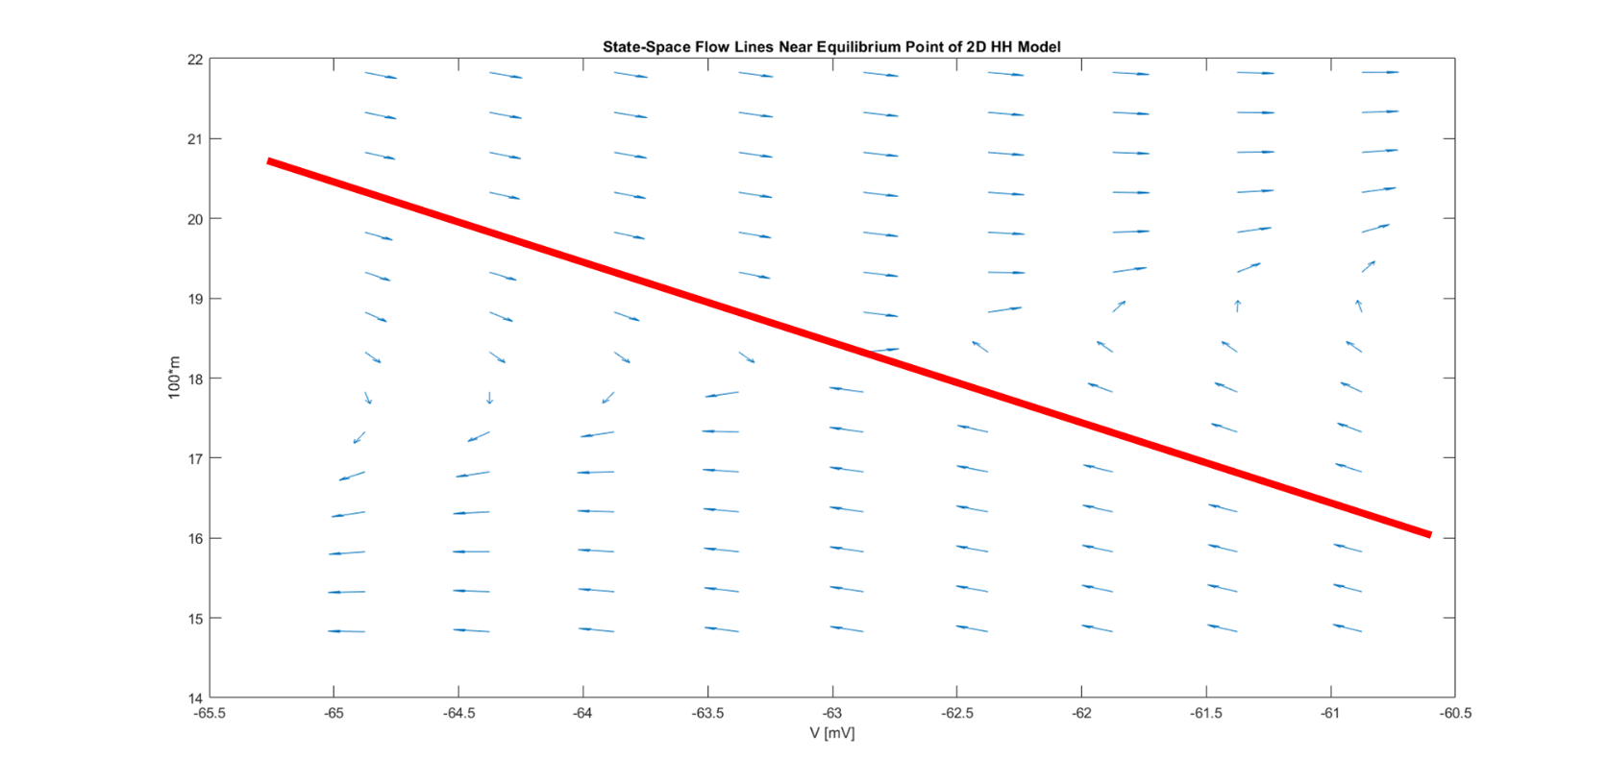Using the same graph from the previous section, we can present the threshold curve as the red line (notice that there is no “threshold voltage” because the line is not vertical):

1. **Comparison between full HH Model to 2D HH Model** (Assuming $I=0$)
2. Simulation of $t=0.2[ms]$, comparing the full HH model to the 2D HH model:

In the graph we can see how each model “develops” through time, while both start from the same exact starting points:

* Point 1 right of the equilibrium point – should lead to an increasing membrane potential and to an Action Potential.
* Point 2 ( $V_{0}-2\left[mV\right])$ left of the equilibrium point – should lead to a decreasing membrane potential.

We can see that for each starting point, both models behave similar and provide close results. It can be explained by the fact that the 2D HH model refers to the parameters $n$ and $h$ as constants, so their effect on the model is negligible.

When examining the full HH model, these parameters are not constant, but since this simulation is very short in time – we can say that the parameters $n$ and $h$ almost do not change, and that is why we get very similar results between the two models (the 2D HH approximation is good for short periods of time).

1. Simulation of $t=4[ms]$, comparing the full HH model to the 2D HH model:

In the graph we can see how each model “develops” through time, while both start from the same exact starting points:

* Point 1 right of the equilibrium point – should lead to an increasing membrane potential and to an Action Potential.
* Point 2 ( $V_{0}-2\left[mV\right])$ left of the equilibrium point – should lead to a decreasing membrane potential.

We can see that both models behave similarly when starting from Point 2 (left of equilibrium) – the values of $V$ and $m$ decrease and get away from the equilibrium point.

When starting from Point 1 (right of equilibrium) the two models behave entirely different:

* 2D HH model (purple line) – the values of $V$ and $m$ increase, causing an Action Potential, and keep on rising away from the equilibrium point until reaching another equilibrium.
* Full HH model (orange line) – the values of $V$ and $m$ increase, causing an Action Potential, and then the parameters $n$ and $h$ take their place in restraining the membrane potential, so the values of $V$ and $m$ fall back to the other side (left of equilibrium point).

This simulation demonstrates the differences between the models in longer time periods, in which the parameters $n$ and $h$ can no longer be referred to as constants, and they do change and affect the entire model through time (in contrary to the 2D HH approximation).