Local datasets for this course: Samba mounts

USF Seismology Computational Network
Here is a

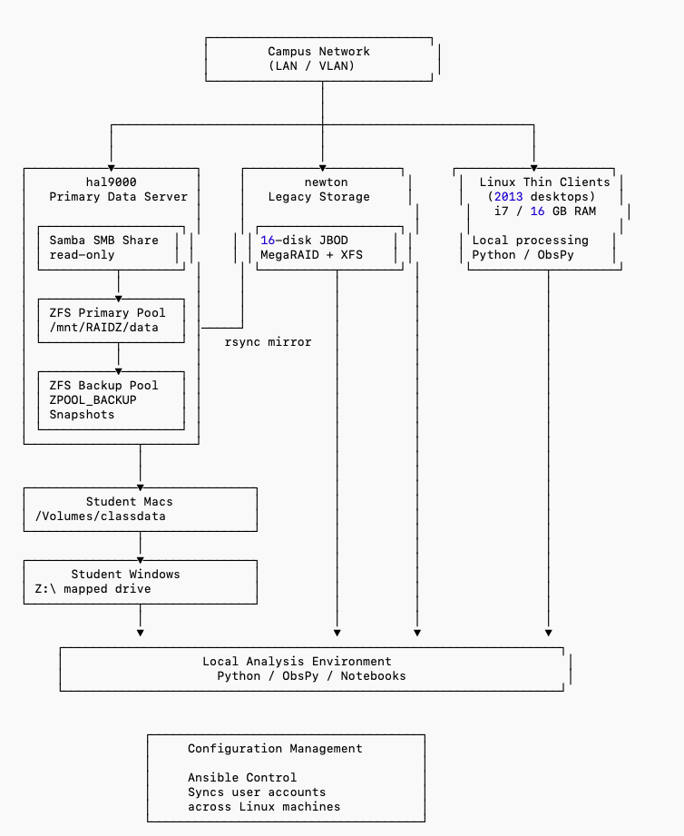

Current setup
You should already have the following tools setup for your Mac/Windows laptop/desktop:
- GitHub Desktop
- Miniconda (or Anaconda)
- Visual Studio Code
In addition, you should have a conda environment called ‘compsci’ or something similar, and this should already have obspy installed in it.

Further setup
We will now add the following, to set you up for remote access:
- USF VPN: follow instructions at https://vpn.usf.edu to install and configure Palo Alto Network’s Global Protect application. When you are offsite (not at USF), logging into the VPN (Virtual Private Network) makes your computer work as if you were already on campus.

Mount samba shares from the hal9000 server
I have various datasets installed on hal9000, which is an Ubuntu 22.04 (April 2022) server in the server room, SCA 219.
What follows are specific instructions for MacOS first, and then Windows second.
But then move on to section 5, to check that you can read and plot data from this samba mount, with ObsPy.

🍎 Connect to the class seismic datasets (Mac)
You will connect to the class data server using SMB.
The share is READ-ONLY, so you cannot accidentally modify or delete anything.

✅ Step-by-step instructions

Step 1 — Open Finder
Click the Finder icon in the Dock.

Step 2 — Open Connect to Server
You can do this either way:

Option A (fastest)
Press:
CMD + K

Option B
In the top menu bar click:
Go → Connect to Server
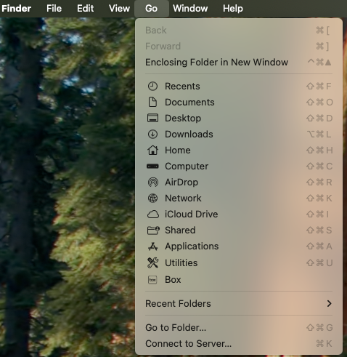

Step 3 — Enter the server address
In the Server Address box type:
smb://10.246.31.49/classdata

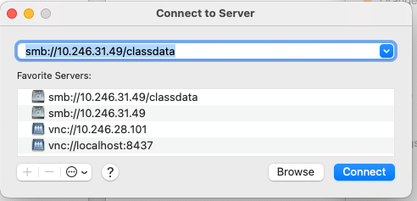
Then click Connect

Step 4 — Login
If prompted for authentication:
Select:
👉 Guest
Then click Connect

🎉 You are connected
A Finder window will open showing the dataset folders.
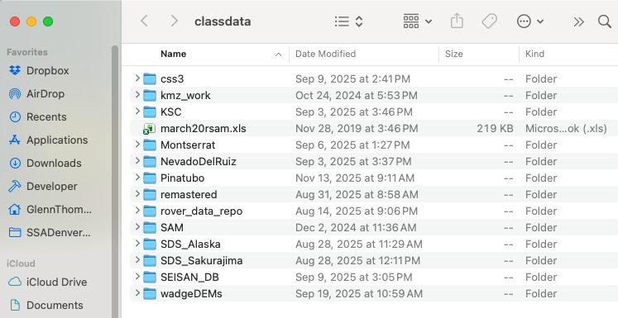
You should see folders like:
KSC
Pinatubo
Montserrat
SEISAN_DB
SDS_Alaska
SDS_Sakurajima

📂 Where the drive appears

In Finder sidebar
You will see:
classdata
under Locations

In Terminal
The share is mounted at:
/Volumes/classdata

💻 Example Terminal usage
cd /Volumes/classdata
ls
df -h

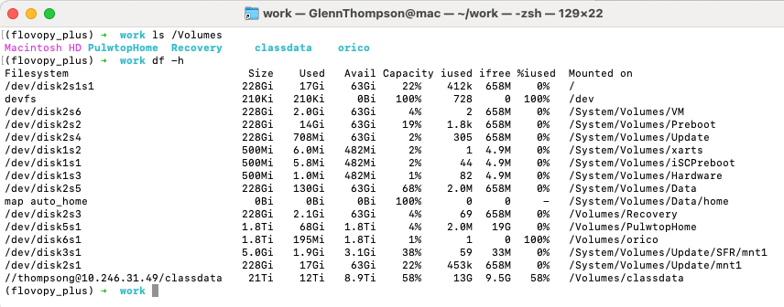

🖥️ Connect to the class seismic datasets (Windows)
We will connect to the class data server as a network drive so it behaves like a normal disk on your computer.
The drive will be read-only — you can browse and copy files but not modify anything.

✅ Step-by-step instructions

Step 1 — Open File Explorer
Press:
Windows key + E

Step 2 — Go to “This PC”
In the left sidebar click:
👉 This PC

Step 3 — Click “Map network drive”
At the top toolbar click:
👉 Map network drive

Step 4 — Enter connection details
Drive letter:
👉 Select Z:
Folder:
\\hal9000\classdata
Check the box:
✅ Reconnect at sign-in
Then click Finish

Step 5 — Login (if prompted)
Username:
guest
Password:
👉 Leave blank
Click OK

🎉 You are connected
You should now see a new drive:
Z: classdata (\\hal9000)

📂 What you should see
Opening the drive should show folders like:
KSC
Pinatubo
Montserrat
SEISAN_DB
SDS_Alaska
SDS_Sakurajima

Using the drive in Python / ObsPy
Example:
from obspy import read

# Mac
st = read('/Volumes/classdata/Pinatubo/WAVEFORMS/199112/9112010B.DMX')
# Windows
#st = read('Z/Pinatubo/WAVEFORMS/199112/9112010B.DMX')

print(st)
st.plot()

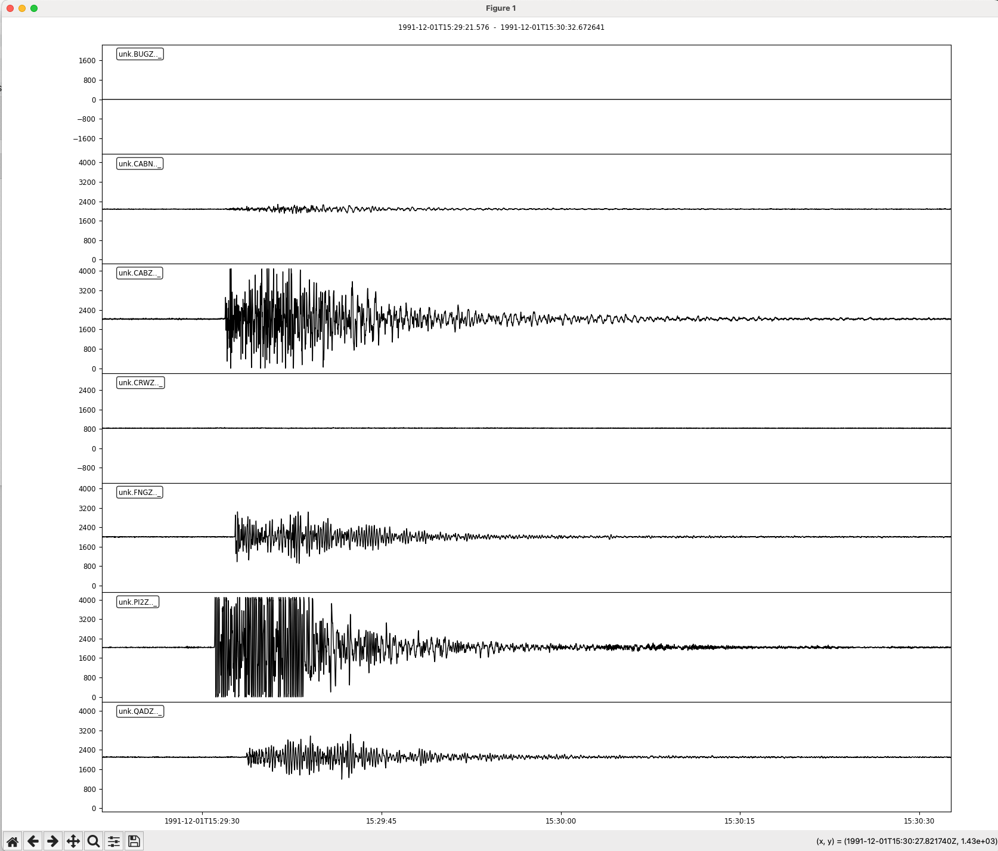

Note that you can use the buttons at the bottom left for some interactive plotting. Try zooming in:
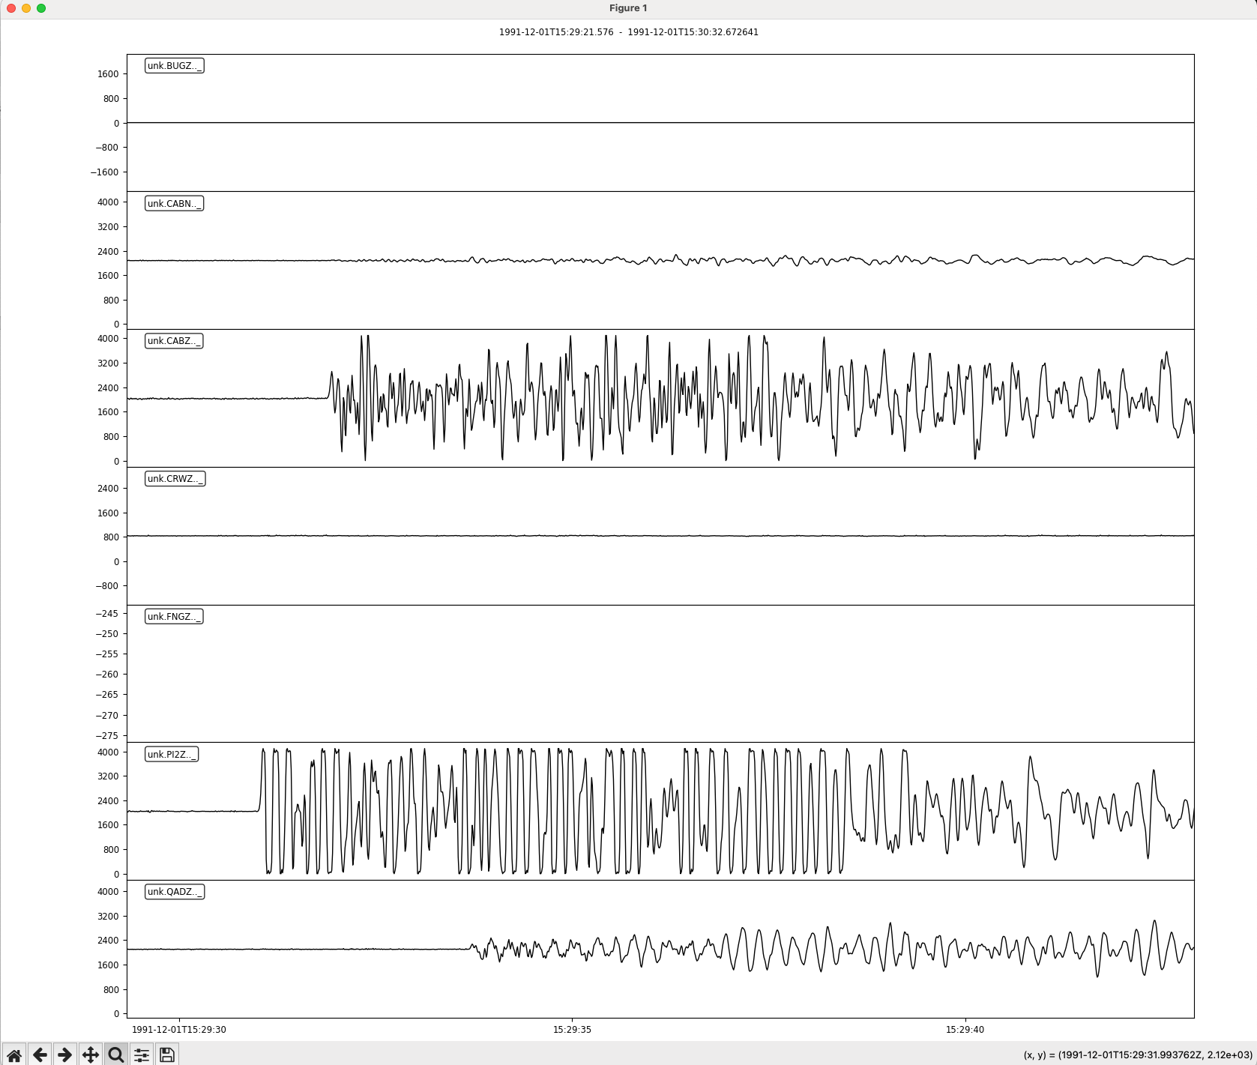

You have just read in a DMX file – this is a demultiplexed SUDS file. SUDS was the USGS system developed in the 1980s. Thanks to the IASPEI software library and the VDAP mobile monitoring system, many seismic networks and observatories around the world ran SUDS-based seismic monitoring systems from the 1980s-2010s, and some may still be doing so. Support for DMX files was only added recently in ObsPy, but it is not perfect, and sometimes the Win-SUDS Utilities library still needs to be used.

It is possible to write Python scripts that detect what operating system they are running on, so they can be generic:

from obspy import read
import platform
from pathlib import Path

# Detect OS and set data root
os_name = platform.system()

if os_name == "Windows":
DATA_ROOT = Path("Z:/")
elif os_name == "Darwin": # macOS
DATA_ROOT = Path("/Volumes/classdata/")
elif os_name == "Linux":
DATA_ROOT = Path("/mnt/classdata/")
else:
raise RuntimeError(f"Unsupported OS: {os_name}")

# Build file path
filepath = DATA_ROOT / "Pinatubo" / "WAVEFORMS" / "199112" / "9112010B.DMX"

print(f"Reading file from: {filepath}")

# Read waveform
st = read(str(filepath))

print(st)
st.plot()

