

Alaska Earthquake Information Center

University of Alaska Fairbanks

The iMac Earthquake Notification System: User Guide

AEIC Internal Report 2008-05

*by* Glenn Thompson

August, 2008

Suggested citation:

Thompson, G., 2008, The iMac Earthquake Notification System: User Guide, University of Alaska Fairbanks, AEIC Internal Report 2008-05.

This version was last revised: September 2nd, 2008

This document, any updates to it, and any additional information are available at:  
<http://www.aeic.alaska.edu/AEIC/internal/report/2008-05/>

The Alaska Earthquake Information Center is a cooperative program between the Geophysical Institute of the University of Alaska and the U. S. Geological Survey with support from the Earthquake Hazards Programme.

DISCLAIMER

This report has not been edited or reviewed for conformity with U. S. Geological Survey and State of Alaska standards and nomenclature. The data in this report are preliminary and subject to revision. This report is released on the condition that neither the U. S. Geological Survey, nor the Geophysical Institute, University of Alaska Fairbanks, may be held liable for damages resulting from its authorized or unauthorized use.

Table of Contents

[1 Introduction 1](#_Toc208727752)

[2 Hardware 1](#_Toc208727753)

[3 Software 2](#_Toc208727754)

[3.1 Antelope (the left monitor) 3](#_Toc208727755)

[3.2 CISN\_Display (the right monitor) 10](#_Toc208727756)

[4 Data download 11](#_Toc208727757)

[5 Troubleshooting 12](#_Toc208727758)

[6 Contact Information 16](#_Toc208727759)

[References 16](#_Toc208727760)

# Introduction

The Alaska Earthquake Information Center (AEIC), based at the Geophysical Institute, University of Alaska Fairbanks, has been funded by the Department of Homeland Security to develop a near-real-time notification system for earthquakes in Alaska, and to deploy this at seven regional emergency operations centers (EOCs) around the state of Alaska. As well as providing information such as the latitude, longitude, depth and magnitude of an earthquake, a goal is to provide a link to information about the intensity of ground shaking.

The solution the AEIC decided upon was to provide two separate notification systems, for reasons of redundancy and robustness. ***Antelope*** is a commercial real-time seismic data acquisition and analysis package which forms the backbone of the AEIC’s seismic monitoring programme. The Antelope program of most interest is ***dbevents\_aeic***, which displays recent earthquakes and announces them with a computerized voice if they are above magnitude 4.0 (this can be reconfigured). It also provides links to ground-shaking maps (ShakeMaps) and detailed maps of the event epicenter.

***CISN\_Display*** is a free program which allows emergency managers to view recent earthquake activity, and it is configured to display tsunami bulletins and ground-shaking maps (ShakeMaps) in a web browser.

# Hardware

Antelope does not run on Microsoft Windows, but it does run on MacOS, Linux and Solaris. The AEIC felt that of these, MacOS would be the easiest to configure and support at remote sites. The AEIC primarily uses Solaris in its offices, and while this is probably the most stable operating system of all, it requires specialist support. iMacs were the cheapest Apple Macintosh desktop computers capable of supporting two monitors. They are also visually impressive.

The iMac has the following specifications:

* 20 inch widescreen LCD display
* 2.16 Ghz Intel Duo Processor
* 4MB cache
* 1 GB of RAM
* 250 GB hard drive
* 128 MB graphics card
* built-in iSight web camera
* Ethernet card
* 2 firewire ports, 3 USB 2.0 ports
* wireless network (‘AirPort’) card
* integrated stereo speakers and microphone (required for audio announcements)

To this has been added a 3-button USB mouse, a mini-DVI to DVI adapter, and a 23 inch Cinema HD widescreen monitor.

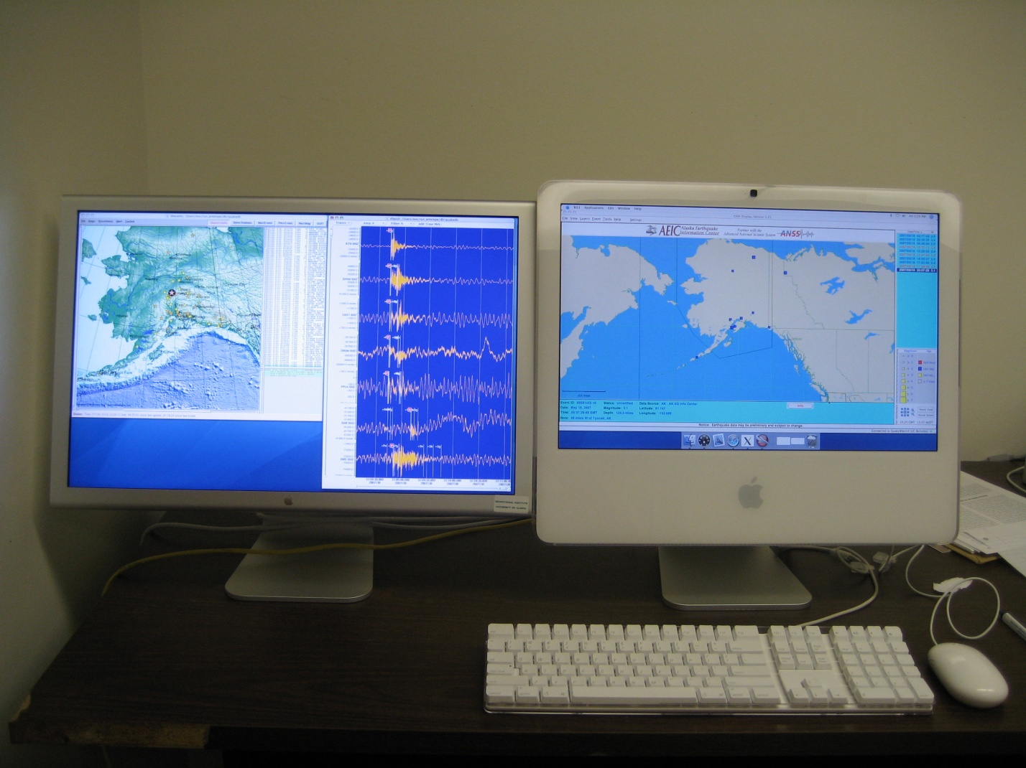

Figure 1: A photograph of the earthquake notification system. On the 23 inch monitor to the left the Antelope program dbevents\_aeic is running. CISN\_Display is running on the right monitor (this is actually the iMac computer with its integrated 20 inch monitor).

# Software

There two main applications are Antelope and CISN\_Display. While they operate very differently, they are designed to show very similar earthquake information. Both mainly consist of a map view, showing the location of earthquake events, and an earthquake event list view, showing all the earthquakes that have been detected in the last few days.

## Antelope (the left monitor)

Antelope is the software the AEIC uses to acquire data streaming from over 400 stations throughout Alaska, automatically detect earthquakes, calculate earthquake locations and magnitudes, and produce archive databases of all that information. It is commercial software produced by Boulder Real-Time Technologies (BRTT) and it is the most robust software available for transporting real-time seismic data over TCP:IP network connections. It comes with an extensive set of development tools which allow customers to build their own Antelope applications. AEIC’s goal with this project has been to give the EOC’s the same view of the near-real-time earthquake data that we have in our office at the University of Alaska Fairbanks.

The Antelope program AEIC has developed for viewing the data is called dbevents\_aeic [Figure 2]. A continuous TCP:IP connection is made to a server at the AEIC to download new earthquake origins (including latitude, longitude, depth and magnitude information) as soon as they are available. The first origin is usually computed and downloaded within 2 to 5 minutes of the earthquake occurring, and new origins are automatically recomputed and downloaded as data from more stations becomes available. Waveform data are also downloaded, as soon as they become available, but these take a few minutes longer. All these data go into a local database, and it is this database which is displayed by dbevents\_aeic.

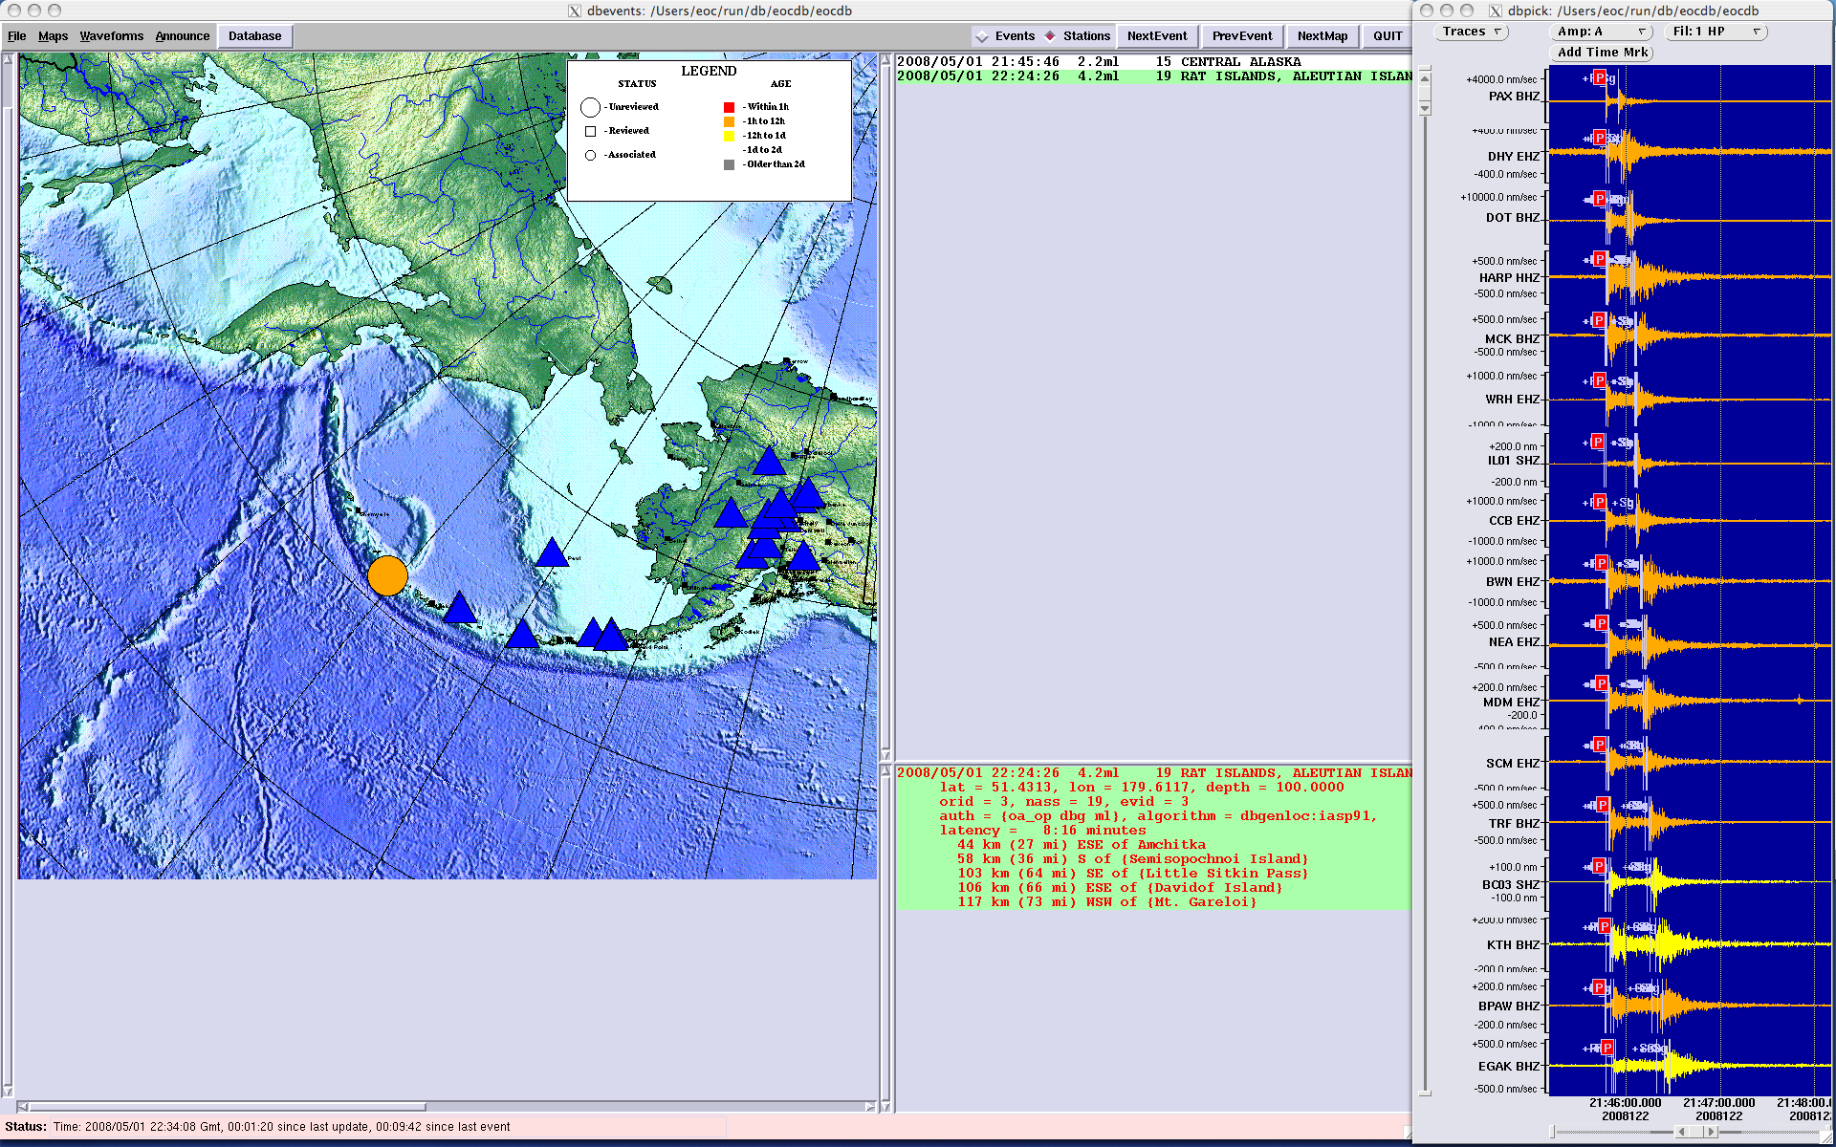

Figure 2: The Antelope program dbevents\_aeic. This consists of four panels. Left: a map of the selected earthquake event (circle) and the seismic stations the earthquake was detected on (triangles). Top-center: the earthquake event list shows just one event. Bottom-center: the origin list shows that two origins were computed for this event. Right: the waveforms are shown from each station on which the event was detected.

As the first origin for a new event is received, the earthquake magnitude and geographic area is announced by a computerized voice, if the earthquake is above a given threshold (the default is magnitude 4.0). AEIC can modify this parameter (and others) remotely, on request. Visually the dbevents\_aeic screen is divided into four areas:

4

Waveforms from the stations the selected earthquake event was detected on

2

List of all earthquake events in the database (with the selected earthquake highlighted)

1

Map of the selected earthquake location (circle) and the stations the event was detected on (triangles)

3

List of all origins computed for the selected earthquake event (with the selected origin highlighted)

These are now described in more detail:

1. **The event map [Figure 3]:** The circle indicates the earthquake epicenter (or 'origin'). The triangles indicate seismic stations on which the event was detected (a blue triangle for any station used for that origin, an orange triangle for any station that wasn't used). By right-clicking on a triangle, the station code will be shown along with its name and geographic co-ordinates. There may be more than one circle, meaning that more than one origin was computed for this event. As the seismic waves spread out, Antelope finds detections from additional stations, and re-computes the origin. If the event triggers our seismic alarm system, the Duty Seismologist will review the event within about 30 minutes, and compute a new origin, which will then overwrite all automatic origins. Right-clicking on an origin (a circle) on the map brings up a summary of that origin (including its geographical coordinates and magnitude), and options [Figure 4] to display a detailed map of that event, or a ShakeMap (these are only normally computed for earthquake origins with a magnitude of greater than about 5.0).

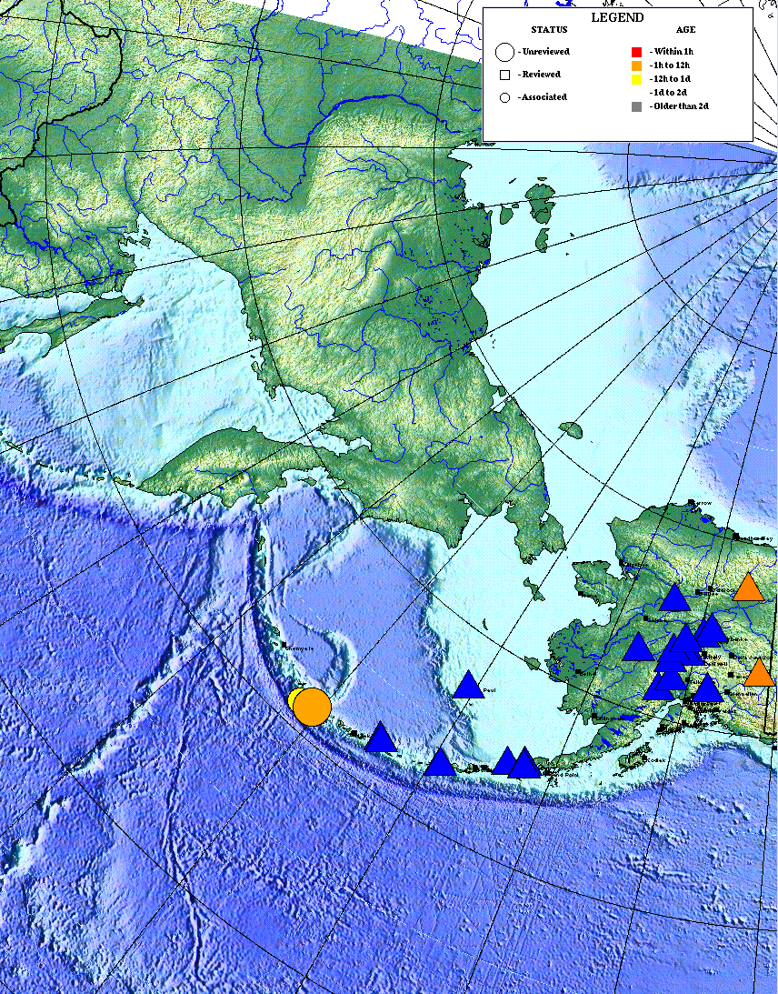

Figure 3: map panel from dbevents\_aeic. The big orange circle is the selected (or preferred) origin for this earthquake event. The smaller yellow circle behind it is an alternate origin for this event, and should normally be ignored. The blue triangles are the stations on which the selected origin was detected and were used in the computation. Orange triangles mark stations that were not used in computing this origin.

1. **The event list [Figure 5]:** The panel centre-top shows the list of events. The UTC (GMT) time of each event is shown, along with its magnitude, the number of stations it was detected on, and the Flinn-Endahl Region (geographic region) in which it occurred. The event shown in map view is highlighted in green (this will usually be the most recent event). Use the mouse to select events. The letter 'r' next to an event in this list indicates the event has been reviewed and re-located by the Duty Seismologist (either because it was an alarm event, or because it was mislocated by the automatic algorithms).

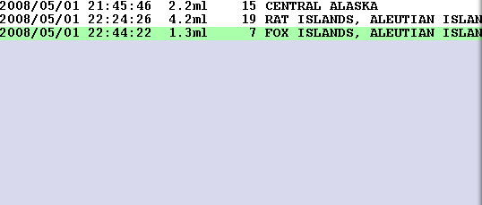

Figure 5: The event list in dbevents\_aeic. This shows the origin time of each event (in UTC), its magnitude, the number of stations the event was detected on, and the geographical region (Flinn-Engdahl region) in which the event was located.

1. **The origin list [Figure 6]:** The panel centre-bottom shows the list of all origins for the selected event. As explained above, there can be multiple origins for an event. The selected (‘preferred’) origin is highlighted in green. The information displayed includes (first line) origin time (UTC), magnitude, number of stations it was detected on, area of the world, (second line) latitude and longitude (in decimal degrees) and depth (in km), (fifth line) latency - i.e. the number of minutes between the event happening and the origin being computed, (additional lines) distances to various communities or landmarks around Alaska.

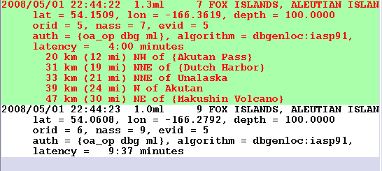

Figure 6: The origin list in dbevents\_aeic. This shows the origin time(in UTC), its magnitude, the number of stations the event was detected on, the geographical region (Flinn-Engdahl region) in which the event was located, the geographical coordinates, the latency of the data (the number of minutes between the earthquake occurring and the origin data being downloaded, and the distance to several nearby communities or geographical features.

1. **The waveform display [Figure 7]:** This shows the waveforms for the currently selected origin. When a new event comes in, it usually takes a few minutes for this to update as the waveform data has to be segmented and downloaded behind the scenes. During this time this panel may appear blank.

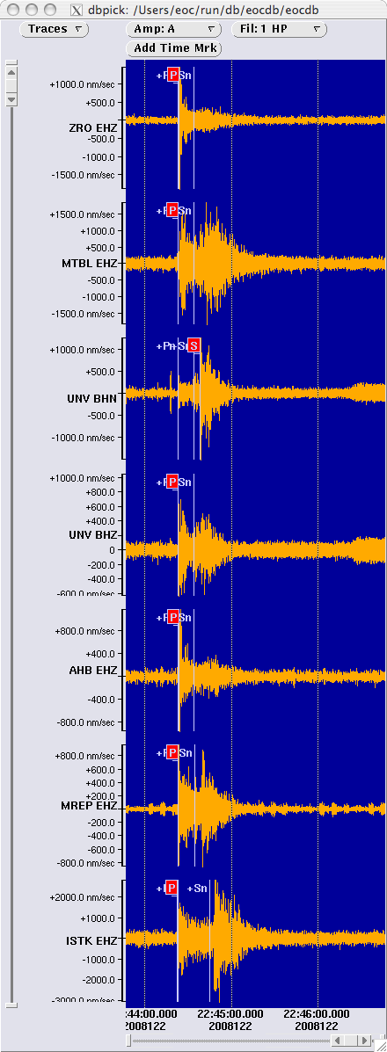

Figure 7: The waveform view. This shows the seismic waveform recorded on all the seismic stations used to compute this earthquake origin (in this example, there are 7). In red, the phase picks (‘P’ or ‘S’) are shown. The P picks should almost line up vertically. The S picks will be displaced vertically. The stations are listed in order of their distance from the epicenter. The delay between P and S increases with distance.

There is also a menu along the top [Figure 8]. It is generally best not to tamper with this. To the right-of-center there are radio buttons labeled ‘events’ and ‘stations’. The default is ‘stations’. If ‘events’ are selected, the map will show all the events currently in the database (and no stations), rather than all the origins and stations for a single event. This mode can be seen in Figure 9.

dbevents_menubar

Figure 8: The top menu for dbevents\_aeic.

dbevents\_aeic can hang when the database is cleaned off once a day, and for this reason, at the top of every hour, the dbevents\_aeic display will automatically close and be restarted. If any of the windows have been moved, they will be put back in their original position. The default settings will also be reloaded (e.g. ‘stations’ mode for map view).

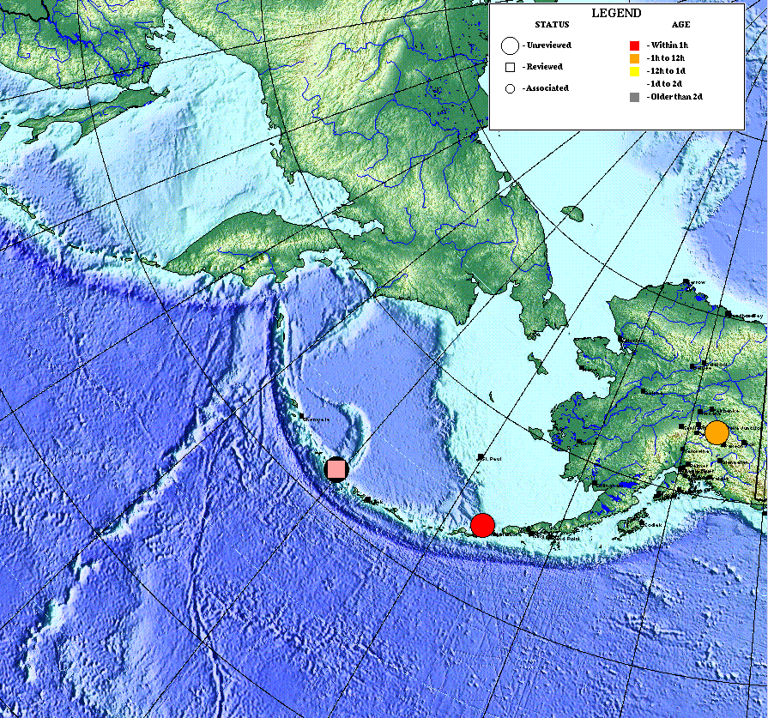

Figure 9: The map view in ‘events’ mode. Here there are just three events in the database, colored according to how long ago they happened (see legend).

## CISN\_Display (the right monitor)

On the right-hand-side monitor (which is the iMac computer itself), you will see CISN\_Display. This is not an AEIC product. It was developed by the California Integrated Seismic Network (CISN). However, most of the earthquake parameters for the state of Alaska are computed by the AEIC, and then sent to one of the CISN servers in California. *CISN\_Display* connects to one of these servers, and downloads new earthquake data as soon as they are available. The time delay for this system is longer because the data are received indirectly: it usually takes 10 – 20 minutes.

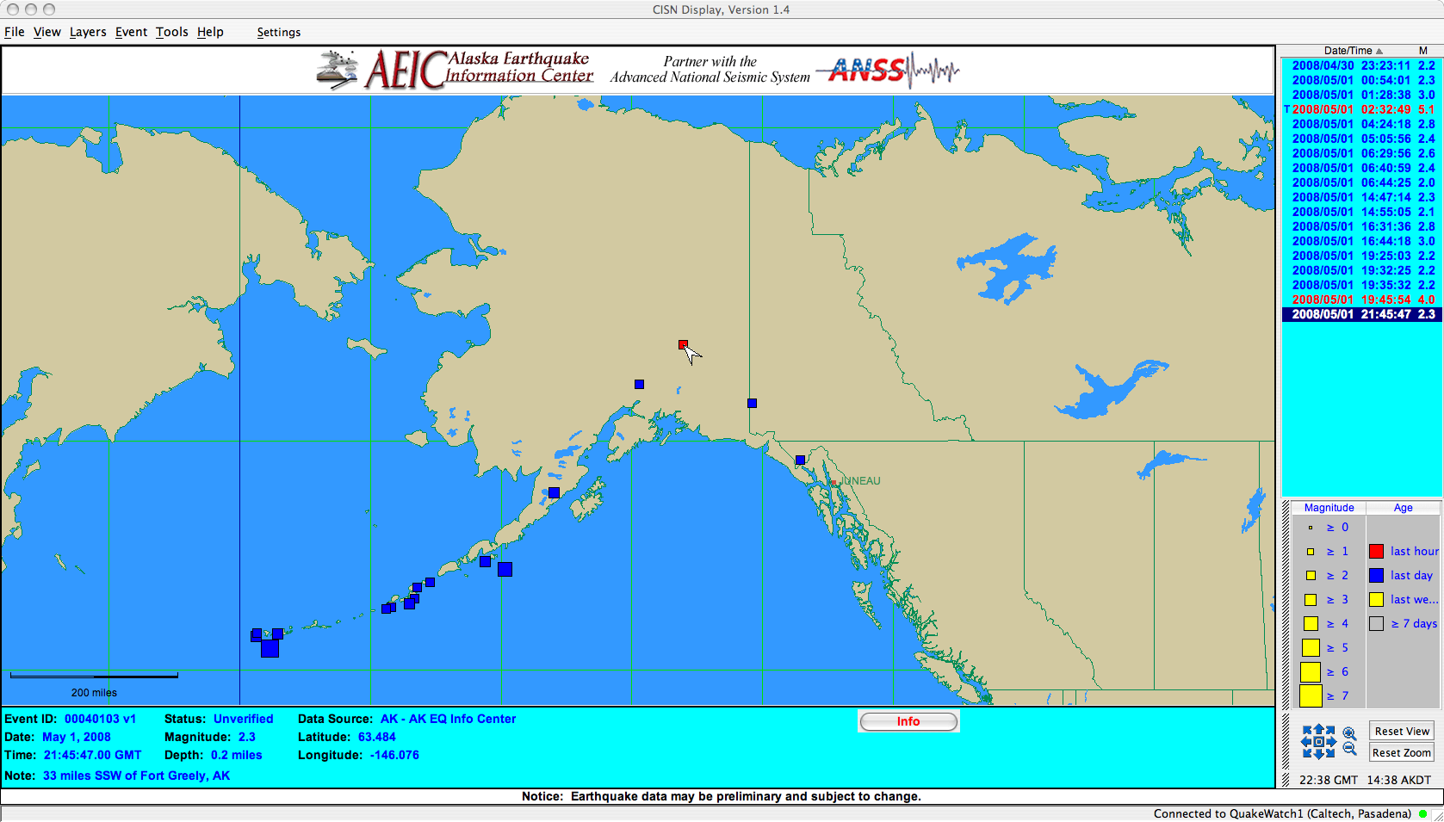

Figure 3: CISN\_Display. This consists of 4 panels. The main panel is the map, centred on South-Central Alaska. Below this is information about the currently selected event, which is marked with an arrow on the map view, and highlighted on the event list (top right). Bottom right is a legend and tools for zooming, scrolling and resetting the map view.

The application you should see on the right-hand side screen is CISN Display. It was created by the California Integrated Seismic Network. All regional earthquake monitoring organisations in the US (and some from elsewhere in the world) send their earthquake information in a format called QDDS to the USGS, and from this a near-real-time database is compiled which sits on a server in California. The CISN\_Display software is an program that downloads and plots events from that database. It also consists of 4 panels:

1) The main panel is the map. An arrowhead indicates the currently selected event (usually the most recent event). The size of the symbols indicates the magnitude of the event (see legend, bottom right). To reset the map view, click the 'Reset View' and 'Reset Zoom' buttons (bottom right).

2) The event list shows event time (UTC) and magnitude. The selected event (usually the most recent event) is highlighted in dark blue. Sometimes there will be an 'S' next to an event in this list, indicating that there is a ShakeMap available for this event. ShakeMaps should also be displayed automatically in a web browser (Safari). A 'T' next to an event indicates a tsunami bulletin has been issued.

3) The bottom panel gives more information about each event including Date, Time, Latitude, Longitude, Depth and Magnitude as well as the Data Source (usually the Alaska Earthquake Information Center). Clicking on the 'Info' button should show links to a ShakeMap or Tsunami Bulletin if one was associated with this event.

4) The fourth panel is a legend.

# Data download

AEIC's Antelope real-time monitoring system has to do many things such as acquiring hundreds of datastreams, running detection, association, location and magnitude determination algorithms on them, and merging these with earthquake metadata from other centers. Ultimately however, it produces an event database containing earthquake metadata and associated waveform data. The points relevant for transmitting this data to a remote EOC are:

* there is a data server at AEIC called 'inverse'. Its full domain name is inverse.giseis.alaska.edu. It has an Object Ring Buffer (ORB). An ORB is a circular buffer on disk. New earthquake origins and corresponding waveform data are written to this ORB by the programs dbsubset2orb and orbsegment, written specifically for this project.
* The iMac also has an ORB. Data is copied from the ORB on inverse to the ORB on the iMac using an Antelope program called orb2orb. This pulls data from port 6510 on inverse.giseis.alaska.edu to port 6510 on this iMac.
* To establish an ORB, the Antelope program 'orbserver' is used.
* dbevents\_aeic monitors a real-time database written from data on the orb. The Antelope programs orb2db and orb2dbt write this database.
* To stop the database growing without limit, and the accumulation of other files on the system, various scheduled tasks or 'cron jobs' are run.
* All these processes are managed by an Antelope program called 'rtexec'. It monitors programs and restarts them if they crash. Most programs have log files and parameter files.
* There is a graphical user interface called 'rtm' which provides a handy way to see what programs are running under rtexec. This is mainly used for configuration and troubleshooting.

CISN\_Display polls a QuakeWatch server (in California) every few seconds to see if new earthquake origins are available, and if so, it downloads and displays them. The earthquake origins from AEIC are derived from an Antelope database and custom AEIC scripts that produce CUBE files from these. The QDDS system, run by the USGS, polls the AEIC server for new CUBE files every few minutes. The QuakeWatch system, running at various centers that comprise the California Integrated Seismic Network, then has a mechanism for retrieving data from the QDDS servers and merging these with information about the availability of ShakeMaps and tsunami bulletins. It is these data that are downloaded when CISN\_Display polls the QuakeWatch servers. Because of the multiple steps involved, CISN\_Display is relatively slow to display new earthquakes, and typically takes 20 to 30 minutes.

# Troubleshooting

So far the AEIC has more than 30 computer-months of running these earthquake notification systems at various sites, and problems are rare. However, the AEIC has attempted to make troubleshooting the system as simple as possible, should it prove necessary.

The system is working if both applications have events in the last few hours (note the time of the events is given in Universal Time). However, if no new events have been received in one of the applications for more than 24 hours, there is almost certainly a problem. The simplest way to troubleshoot this is to contact AEIC using the information in the next section. AEIC staff can remote login to the iMac (using ssh on port 22), and hopefully restore the system. Its important to note which system (left or right monitor) has stopped working.

If you do wish to try and reset the system yourself, here is what to do:

Its preferable to stop Antelope prior to shutting down the computer, otherwise the ORB or the database could become corrupt, and no new events will be received. The most robust method is outlined below:

1. Start X11: There should be an icon on the panel on the bottom of the screen which looks like a big 'X'. Click on this.



1. You should then see the menu bar at the top of the window change to X11. It should have the menus 'Applications', 'Edit', 'Window' and 'Help'.
2. Click 'Applications' and then, in the drop-down menu that appears, 'Terminal'. This should bring up an xterminal (the Unix prompt).
3. In the terminal ("at the command line") type ‘stop\_antelope’ and hit return. This command may take anything from a few seconds to a few minutes to complete.
4. Again at the terminal, now type ‘clean\_orb.csh’. This will create a clean ORB and a clean database.
5. Now you need to restart the computer. Click on the apple icon on the top menu bar, and select 'Restart' from the drop-down menu.
6. The computer will now shutdown, reboot, autologin (as user 'eoc') and restart CISN\_Display and rtexec (the Antelope program that controls all other Antelope programs).
7. Start X11 again (see step 1) and bring up a terminal window (see step 2).
8. At the terminal type ‘start\_antelope’ and hit return. This gives rtexec permission to start other Antelope processes. Within 2-3 minutes, the dbevents\_aeic window should re-appear.

iii) ORB communication has been lost: In this case I will ask you to run 'rtm'. First get an X11 terminal window up (see section 4, step 1). Then type:

cd run

rtm &

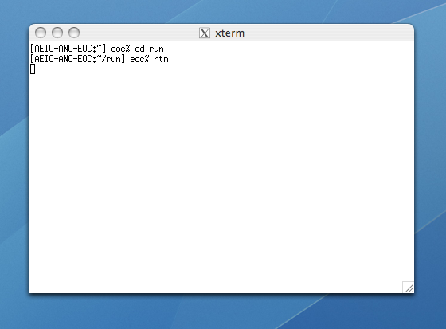

The graphical user interface 'rtm' should then appear.

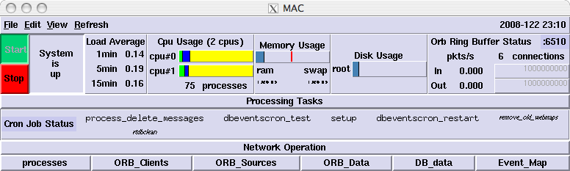

Click on the 'Processing Tasks' button.

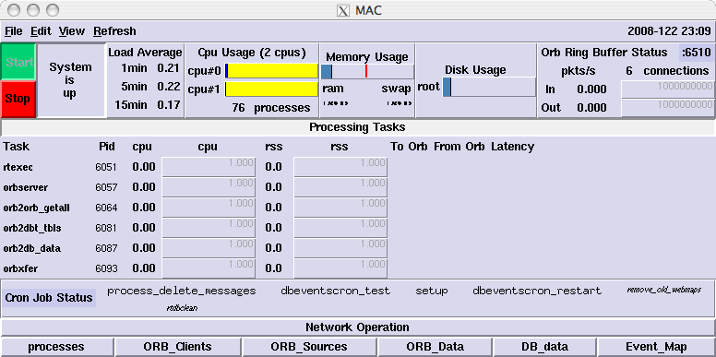

There are 6 processes listed:

- rtexec

- orbserver

- orb2orb\_getall

- orb2dbt\_tbls

- orb2db\_data

- orbxfer

The background around each of these should be gray. If it is yellow or orange, is the Pid field next to it -1? This indicates the process is dead.

To the right of the area marked 'Cron Job Status' there are 5 jobs listed:

- process\_delete\_messages

- dbeventscron\_test

- dbeventscron\_restart

- remove\_old\_webmaps

- rtdbclean

Its not important to know what these are. But again the background should be gray. If its orange, contact AEIC. The diagram below shows an example of what to look for – here 4 processes have an orange background. Under the Task column, the tasks orb2orb\_getall, orb2dbt\_tbls, orbd2db\_data and orbxfer each have a -1 in the PiD column (indicating the process is dead, as PiD should be a positive integer) and to highlight this rtm has orange out the PiD, cpu and rss columns. However, in this particular case, note the “System is starting” message. In this case those processes just have not been started yet – which takes about 1 minute. But if the message was “System is running” and processes were oranged out, that would indicate an error.

If a process died at some stage and was restarted by rtexec automatically, while the background will be gray rather than orange, the Task name itself will be highlighted in yellow. Its useful to make AEIC aware of any Task name which are highlighted yellow. If they are all gray, its OK.

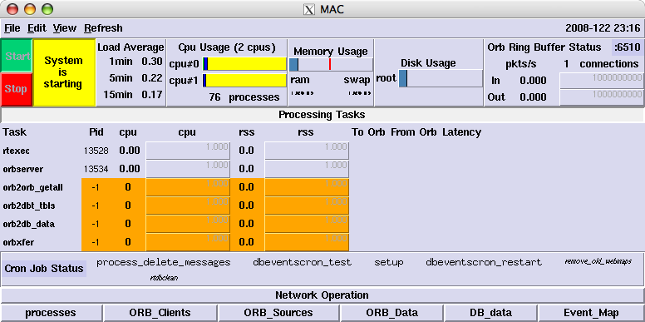

# Contact Information

In case of problems, please contact either

Glenn Thompson

Seismologist

Alaska Earthquake Information Center

907-474-7424

[glenn@giseis.alaska.edu](mailto:glenn@giseis.alaska.edu)

or

Roger Hansen

State Seismologist

907-474-5533

[roger@giseis.alaska.edu](mailto:roger@giseis.alaska.edu)

or find other contacts through our webpage:

<http://www.aeic.alaska.edu>

# 

# References

Wald, D. J., Worden, B. C., Quitoriano, V., Pankow, K. L, ShakeMap Manual: Technical Manual, User's Guide, and Software Guide, <http://pubs.usgs.gov/tm/2005/12A01/>.