

Alaska Earthquake Information Center
University of Alaska Fairbanks

The AEIC ShakeMap system: Technical Report

AEIC Internal Report 2008-02

by Glenn Thompson, Artak Martirosyan, Mitch Robinson & Roger Hansen

June 6, 2008

Suggested citation:
Thompson, G., Martirosyan, A., Robinson, M. and Hansen, R., 2008, The AEIC ShakeMap system: Technical Report. Alaska Earthquake Information Center, University of Alaska Fairbanks, AEIC Internal Report 2008-02.
This version was last revised: September 2nd, 2008
This document, any updates to it, and any additional information are available at:
http://www.aeic.alaska.edu/AEIC/internal/report/2008-02/

The Alaska Earthquake Information Center is a cooperative program between the Geophysical Institute of the University of Alaska and the U. S. Geological Survey with support from the Earthquake Hazards Programme.
DISCLAIMER
This report has not been edited or reviewed for conformity with U. S. Geological Survey and State of Alaska standards and nomenclature. The data in this report are preliminary and subject to revision. This report is released on the condition that neither the U. S. Geological Survey, nor the Geophysical Institute, University of Alaska Fairbanks, may be held liable for damages resulting from its authorized or unauthorized use.

Table of Contents
1 The AEIC ShakeMap system 1
1.1 Introduction 1
2 System Architecture 1
3 The Antelope-ShakeMap Interface 4
3.1 shake_watch 5
3.2 db2sm_xml 8
4 The (USGS) ShakeMap system 9
5 Databases 11
6 Accounts and Passwords 12
7 AEIC ShakeMap website 12
8 Generating a ShakeMap manually 15
9 Finite Faults 16
10 Cancelling a ShakeMap manually 16
11 Generating a Scenario 16
12 Cancelling a Scenario 18
13 Observations and Attenuation Models 19
14 Customized Content 21
15 Known Issues 22
16 Current settings and other info 23
17 Transfering ShakeMaps to the USGS ShakeMap servers 23
References 24

The AEIC ShakeMap system

Introduction
The ShakeMap software package was developed by the United States Geological Survey (USGS) for generating and distributing real-time ground-shaking maps in the aftermath of significant earthquakes. ShakeMap rapidly and automatically generates shaking and intensity maps, and combines instrumental measurements of shaking with information about local geology and earthquake location and magnitude to estimate shaking variations throughout a geographic area. The results are rapidly available via the Web through a variety of map formats, including Geographic Information System (GIS) shapefiles. These maps have become a valuable tool for emergency response, public information, loss estimation, earthquake planning, and post-earthquake engineering and scientific analyses.
The Alaska Earthquake Information Center (AEIC) has implemented the ShakeMap system for monitoring earthquake activity in Alaska. To make this possible, the AEIC has had to develop modules to get data from the its Antelope-based real-time data acquisition systems into the ShakeMap system. Thus there are two main components to the AEIC ShakeMap system:
- the Antelope-ShakeMap Interface, and
- the USGS ShakeMap modules (“ShakeMap”).
The ShakeMap configuration files, settings and libraries were also customised according to the regional specifics in Alaska.

System Architecture
The AEIC ShakeMap system is shown schematically in Figure 1. rtexec is a special Antelope program which controls other programs in a robust way. It continuously runs shake_watch, which monitors the summary event database for new candidate origins. It also continuously runs shake_version which monitors the MySQL database for new rows. The program rtm provides a convenient graphical user interface to help monitor that all processes under rtexec are running normally. This is shown in Figure 2.
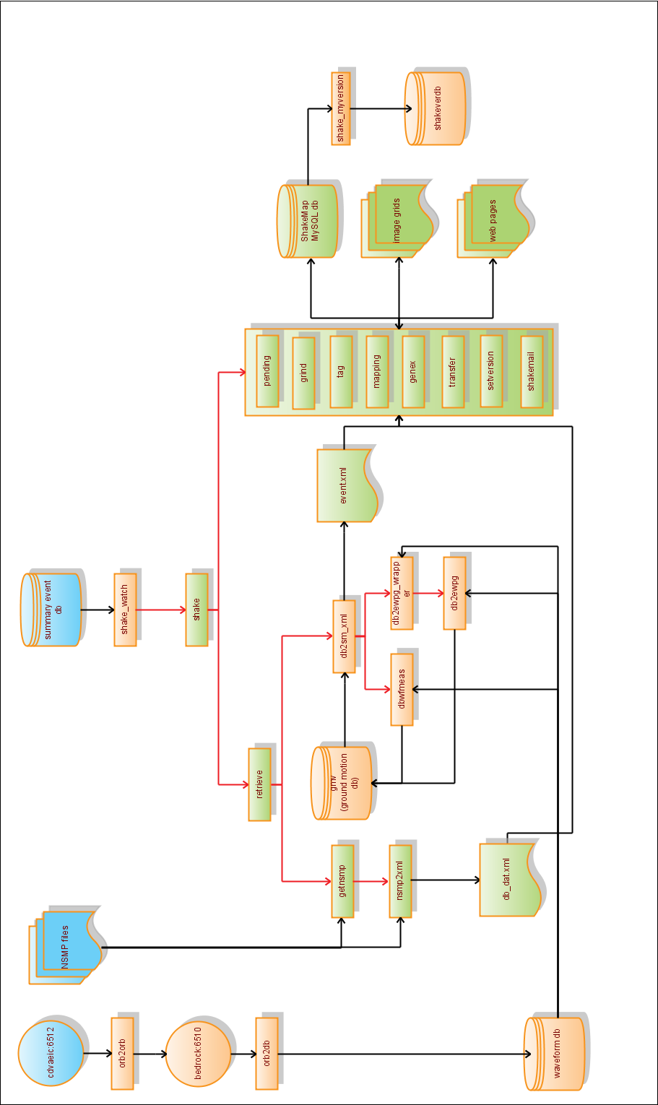

Figure 1. Schematic diagram of the AEIC ShakeMap system architecture. Rectangles represent programs. Cylinders represent databases. Red arrows represent how programs call other programs. Black arrows represent data flow. The yellow objects comprise the Antelope-ShakeMap Interface. Green objects represent components of the USGS ShakeMap system.

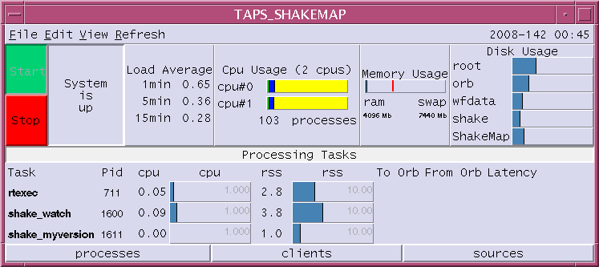
Figure 2: rtm, the graphical user interface which allows AEIC staff to monitor the Antelope-ShakeMap interface.
When a suitable origin is detected, shake_watch calls shake, which calls retrieve and other USGS ShakeMap programs. Retrieve calls getnsmp and nsmp2xml, which retrieve XML files for USGS stations in the area. Retrieve also calls db2sm_xml, which calls dbwfmeas to measure peak ground velocity and acceleration values. db2sm_xml also calls db2ewpg_wrapper which in turn calls db2ewpg. The aim of these programs is to make peak spectral ground displacement, velocity and acceleration measurements. All these peak ground motion measurements go into a customised Antelope database, from where db2sm_xml reads them, and writes relevant data out to XML files for consumption by the ShakeMap program grind. Other ShakeMap programs read from and write to the ShakeMap MySQL database, and generate web content. The details can be found in the ShakeMap manual, and are not shown in Figure 1.
All components of the AEIC ShakeMap system are located on bedrock except the summary event database (on kobuk) and a waveform orb (on cdvaeic) which feeds the waveform orb on bedrock.
The top level directories of relevance are:
 | Home directory (for user shake): | /home/shake (on bedrock)
 | Run directory for Antelope-ShakeMap Interface | /home/shake/run (on bedrock)
 | ShakeMap root directory: | /usr/local/ShakeMap (on bedrock)

The Antelope-ShakeMap Interface
The Antelope-ShakeMap Interface is a collection of programs and configuration files developed by the AEIC to implement the USGS ShakeMap system within the Antelope real-time data acquisition and processing environment that forms the backbone of AEIC operations. The main programs are listed in Table 1. The key directories are listed in Table 2. The key parameter files are described in Table 3.

Table 1: The Antelope-ShakeMap interface: main programs
program | configuration file | Description
shake_watch | shake_watch.pf | The main program that monitors the summary event database for new origins, checks origins for eligibility and initiates a ShakeMap generation (shake) or cancellation (cancel)
db2sm_xml | db2sm_xml.pf | Called by shake, this Perl program measures ground motion values and puts these into XML files. It calls the Antelope program dbwfmeas It also calls db2ewpg_wrapper. Both these calls results in rows being added to Antelope databases, and db2sm_xml reads these rows and appends data to a corresponding event.xml XML file. These XML files are used by grind for calculating ground motion estimation grids.
dbwfmeas | dbwfmeas.pf | Computes peak velocity and acceleration values for a station-channel for a given time range. These values are outputted to the gmv database.
db2ewpg_wrapper |  | Called by db2sm_xml, this Perl program reads calibration, instrument type, units and sampling rate from the waveform database, and then calls db2ewpg.
db2ewpg |  | Called by db2ewpg_wrapper, this C program reads waveform data for a station/channel, and calls a USGS subroutine which computes peak ground spectral displacement, velocity and acceleration values. These values are then inserted into an Antelope database.

Table 2: Important directories for the Antelope-ShakeMap Interface.
Directory | Comment
/home/shake/run | Main directory for Antelope-related files and programs used for ShakeMap generation.
/home/shake/run/bin | Contains programs.
/home/shake/run/db | Several ShakeMap-related Datascope databases.
/home/shake/run/dbdata | Contains the waveform database.
/home/shake/run/pf | Parameter files.
/home/shake/run/state | State files for several modules.

Table 3. Partial list of parameter files.
Configuration file | Settings
shake_watch.pf | Controls ShakeMap triggering and cancellation process
db2sm_xml.pf | Controls calculation of ground motion parameters
dbwfmeas.pf | Controls waveform measurements

shake_watch
This program monitors the summary database for new origins and checks these origins for ShakeMap eligibility. It is run from /home/run/rtexec.pf. The command line syntax is:
/home/shake/run/bin/shake_watch parameter_file
The parameter file (/home/shake/run/pf/shake_watch.pf) sets the eligibility criteria, which includes:
- geographical control: two polygons can be defined with different magnitude thresholds (Figure 3);
- minimum number of associated phases;
- calculated Modified Mercalli Intensity threshold.
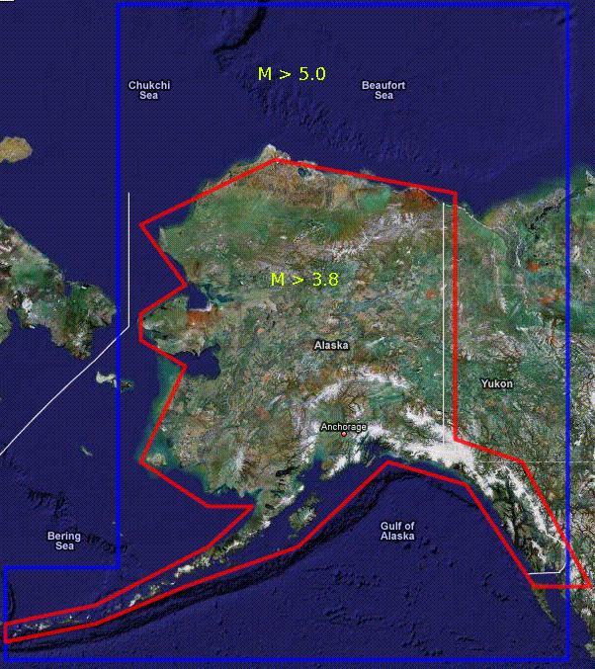
Figure 3: Shown here are the inner (red) and outer (blue) polygons and their associated magnitude thresholds (3.8 and 5.0 respectively).
Other parameters are:
- del_time - waiting time in seconds for new origins to be processed. This delay is necessary as magnitude data are not usually available until a few seconds after an origin has been determined.
- auto_cancel – for switching automatic cancellations on and off;
- prefor_ex – to bypass the prefor check for the specified author;
- norids_max – maximum number of records in the shake_watch state file (/home/shake/run/state/shake_watch.state). This file keeps one record for each ShakeMap in the following format (25124 25128 4), where the numbers are evid, orid and the source, respectively. Currently, the specified sources are:
          - AEIC automatic systems,
          - WCATWC,
          - NEIC,
          - AEIC analyst,
          - manual run, and
          - manual cancellation.
This is a listing of shake_watch.pf.
run_home /home/shake/run
bin_home /usr/local/ShakeMap/bin
database /iwrun/sum/run/dbsum/dbsum
second_polygon 1 # 1=yes, 0=no
del_time 60
auto_cancel 0 # automatic cancellation 1=yes, 0=no
prefor_ex #prefor exemption for this author

minmax &Arr{
nass_min 10
mmi_min 2.0
norids_max 200
}

ml_min 5.0
ak_polygon &Tbl{
55,-135
75,-135
75,-160
55,-160
}

ml_min2 3.5
ak_polygon2 &Tbl{
60,-143
71,-143
71,-153
60,-153
}

author_list &Arr{
oa_bk 1
oa_op 1
wcatwc 2
neic 3
UAF 4
manual 5
}

db2sm_xml
This module is called from retrieve.conf to perform waveform measurements, to establish an event’s input directory, and to create event.xml (event data) and db_dat.xml (observational data) files for the ShakeMap program grind. The command line syntax is:
db2sm_xml -event event_id
The program subsets the waveform database, calls dbwfmeas to calculate pga and pgv and writes these values in the data XML file. In addition, these values are first recorded in a temporary database table, then in the main ground motion database, gmv. The parameter file is db2sm_xml.pf, which contains the channel names, waveform window settings and other parameters. One of the parameters is ev_type, which enables (1) or disables (0) event type determination. If enabled, all events are classified into one of the three categories: crustal, intraplate and interface, by calling earthquake_type.pl. The algorithm is based on the position of the hypocenter with respect to the Alaska-Aleutian Megathrust. This is required for grind to utilize proper attenuation model.
Spectral maps are only created if the program grind is run with the –psa flag. By default, this flag is not included. Default behavior can be changed by setting up variable flags in shake.conf which indicate the magnitude range for which to apply a different behavior. While this isn’t part of the Antelope-ShakeMap Interface, its important to know about as it is one other place where there is a magnitude threshold. The line looks like:
variable_flags : grind 3.5 9.9 –psa
This indicates that grind will be run for all events with a magnitude between 3.5 and 9.9.

The (USGS) ShakeMap system
The ShakeMap package is open-source software written in Perl by the USGS. A detailed description is not attempted here. The installation instructions, user guide and technical guide are provided in the ShakeMap Manual [Wald et al.], available from http://pubs.usgs.gov/tm/2005/12A01/.
The ShakeMap modules are listed in Table 4. Each module generally has its own configuration file, which allows its behaviour to be customised. The main module is shake, which is a wrapper. Its configuration file lists the modules that will be run everytime a ShakeMap is initiated. Currently the order is: retrieve, pending, grind, tag, mapping, genex, transfer, setversion and shakemail.
The AEIC does not modify the USGS code (unless its absolutely necessary as a stop-gap measure), since any changes made will have to be remerged which each new release of the ShakeMap software by the USGS, creating a lot of overhead. Moreover, the AEIC wants to utilise the USGS code as-is, to keep in line with USGS best practice.
The key directories are listed in Table 5, and the main configuration files described in Table 6.

Table 4. Native ShakeMap programs. These are all in /usr/local/ShakeMap/bin.
Program | Configuration file | Comment
shake | shake.conf | The main ShakeMap program; a wrapper program that calls other ShakeMap programs.
retrieve | retrieve.conf | A wrapper code that calls other programs to retrieve data and produce data XML files
pending | pending.conf | Sends a new home page to the web site to indicate that an event is being processed.
grind | grind.conf | Reads the data files from the event’s input directory and generates grid files with interpolated ground motion values.
mapping | mapping.conf  colors.conf | Reads the grids generated by grind and makes PostScript maps of ground motion and shaking intensity.
genex | genex.conf  web.conf | Creates JPEG files from PostScripts, builds web pages, and generate GIS and other files for export via the web or FTP.
addon | addon.conf | Creates and copies a QDDS-formatted file to a local QDDS directory (currently not implemented).
transfer | transfer.conf | Transfers the output created by genex to the web and ftp sites.
setversion |  | Manipulates the version information for ShakeMaps and preserves versions as requested.
shakemail | shakemail.conf | Sends email notifications of ShakeMap generations and cancellations.
cancel | shake.conf | Undoes the effect of shake: it removes the event from data directory and the web. It can be called automatically by shake_watch if a revised origin for an earthquake event shows that it no longer is eligible for the ShakeMap system, or it can be called manually.
getnsmp |  | Associates NSMP station data with ShakeMap events and runs nsmp2xml.
nsmp2xml |  | Generates data XML file from NSMP XML files.

Table 5. Important ShakeMap directories.
Directory | Comment
/usr/local/ShakeMap/bin | All ShakeMap executables plus several third-party programs
/usr/local/ShakeMap/config | Configuration files of native ShakeMap programs
/usr/local/ShakeMap/lib | Contains Perl library modules for various ShakeMap programs, including site correction data and web page templates
/usr/local/ShakeMap/data | Repository of all event data and processed files. Each event has its own subdirectory such as data/12345 for event 12345.
/usr/local/ShakeMap/web | Contains ShakeMap web pages

Table 6. Partial list of configuration files.
Configuration file | Settings
shake.conf | Main ShakeMap configuration file. Contains the list of programs to run, default flags, magnitude dependent flags, magnitude thresholds for spectral response maps and saving versions, etc.
retrieve.conf | List of programs run before grind to generate observational data XML files. Currently contains two programs: db2ShakeMap_xml and getnShakeMapp
grind.conf | Controls generation of ground motion grids. Many settings including grid parameters, size, stations to ignore, attenuation models, etc.
mapping.conf | Controls the appearance of ShakeMaps, colors, sizes, markers, additional map features,etc.
genex.conf | Controls generation of web pages and various output files for third party software (GIS, Hazus, Google Earth)
shakemail.conf | Specifies formats and addressees of email and pager notifications

Databases
Table 7. Databases relevant to the AEIC ShakeMap system.
Path | Description
/iwrun/sum/run/dbsum/dbsum | Summary event database.
/home/shake/run/dbdata/archive | Waveform database for ShakeMap; contains only broadband and strong-motion channels.
/home/shake/run/db/gmv | Database containing ground motion measurements.
/home/shake/run/db/gmv_’evid’.wfmeas | Temporary database table for ground motion values.
/export/bedrock2/mysql/var/shakemap | The ShakeMap MySQL database.
/home/shake/run/dbshakeversion/shakeverdb | An Antelope copy of the MySQL table shake_version.MYD table of the MySQL database. Created by the shake_myversion process.

Accounts and Passwords
There are three separate accounts relevant to the ShakeMap system. There is a username and password needed to modify the software or its configuration. There is a username and password needed to access the ShakeMap website. There is also a username and password needed to access and/or modify the ShakeMap MySQL database (it should not normally be necessary to modify this database manually, although it was needed to remove old scenarios from the database: see section 10).

Table 8: Usernames and passwords relevant to the AEIC ShakeMap system.
Username | Password | Purpose
shake | (ask Mitch) | Solaris account to modify ShakeMap software and its configuration. There is no ssh access. There is ssh access for shake however, and su can be used from there.
shake | shake | Previously needed to access ShakeMap website, http://www.aeic.alaska.edu/~shake/shake. Now obsolete.
shake | (in the mydb.conf file) | MySQL account for the ShakeMap MySQL database: gives write access to create/modify/add/remove tables and records.
dlmon | dlmonquake | Needed to access the AEIC monitoring website http://www.aeic.alaska.edu/~dlmon/.

AEIC ShakeMap website
The URL for the ShakeMap website is given in Table 8. The website is password-protected. When logged on, the Home Page will be displayed, showing the most recent event, and recent significant events [Figure 4]. To see a full list of events, click the “Map Archive” link (upper left). The user is then presented with a table of events with columns: event id, name/epicenter, date, time, latitude, longitude and magnitude [Figure 5]. By clicking on any event in this list, a new page will show up with the instrument intensity map and links to other maps, and downloads. Returning to the archive web page, there is a menu along the top with links to archives from previous years, and also to earthquake scenarios. Clicking on the earthquake scenarios link will display scenario.htm, with a list of all the scenarios generated for this ShakeMap system [Figure 6]. By clicking on a scenario, the corresponding instrumental intensity map is displayed [Figure 7], along with links to the corresponding peak ground acceleration, peak ground velocity and spectral response maps. There is also a link to downloads, which includes jpg and postscript versions of the maps, other versions of the maps specifically for media purposes, raw grid files, GIS shapefiles for HAZUS, KML for display in GoogleEarth, and station lists [Figure 8].

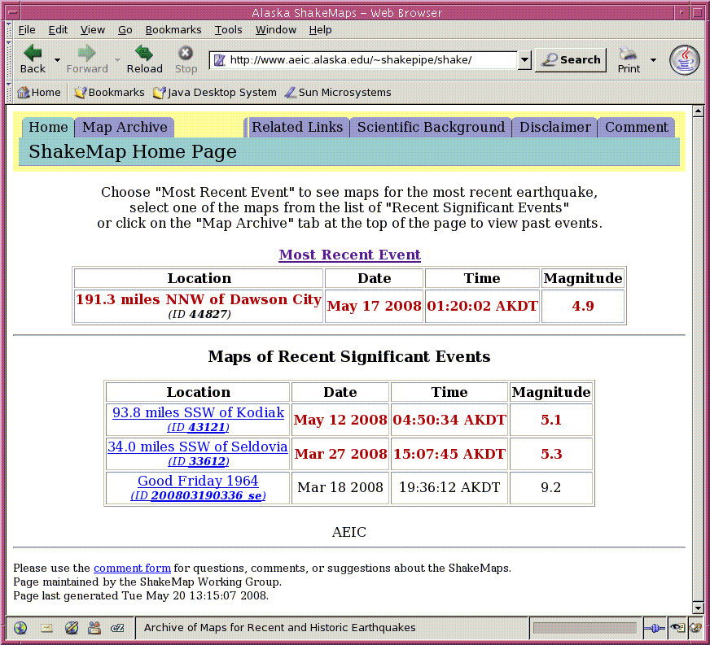
Figure 4: The AEIC ShakeMap website.

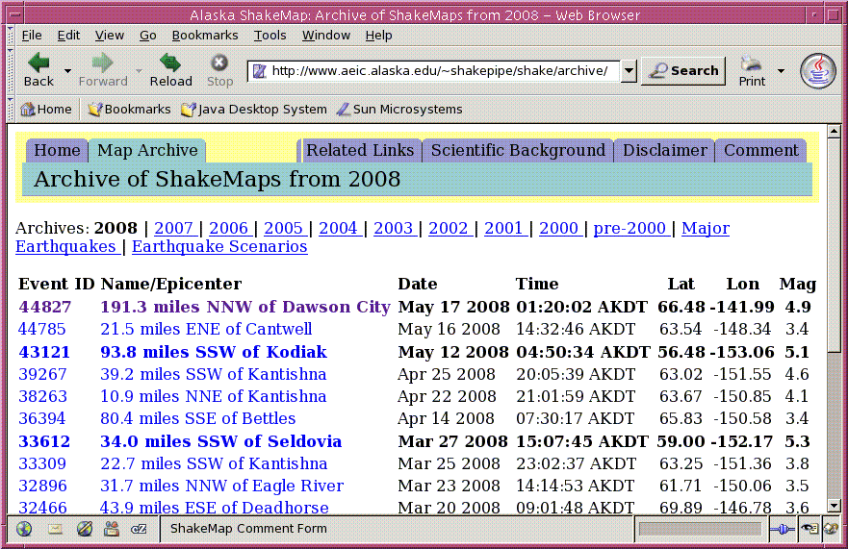
Figure 5: The AEIC ShakeMap archive webpage. This lists all the events a ShakeMap currently exists for, in the current year. It also has links previous years, as well as scenarios.

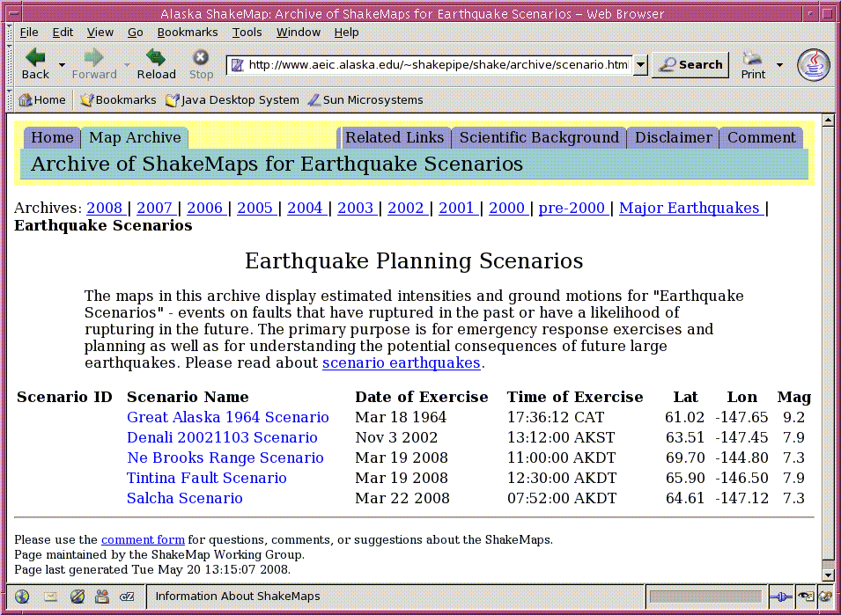
Figure 6: Scenarios index webpage.

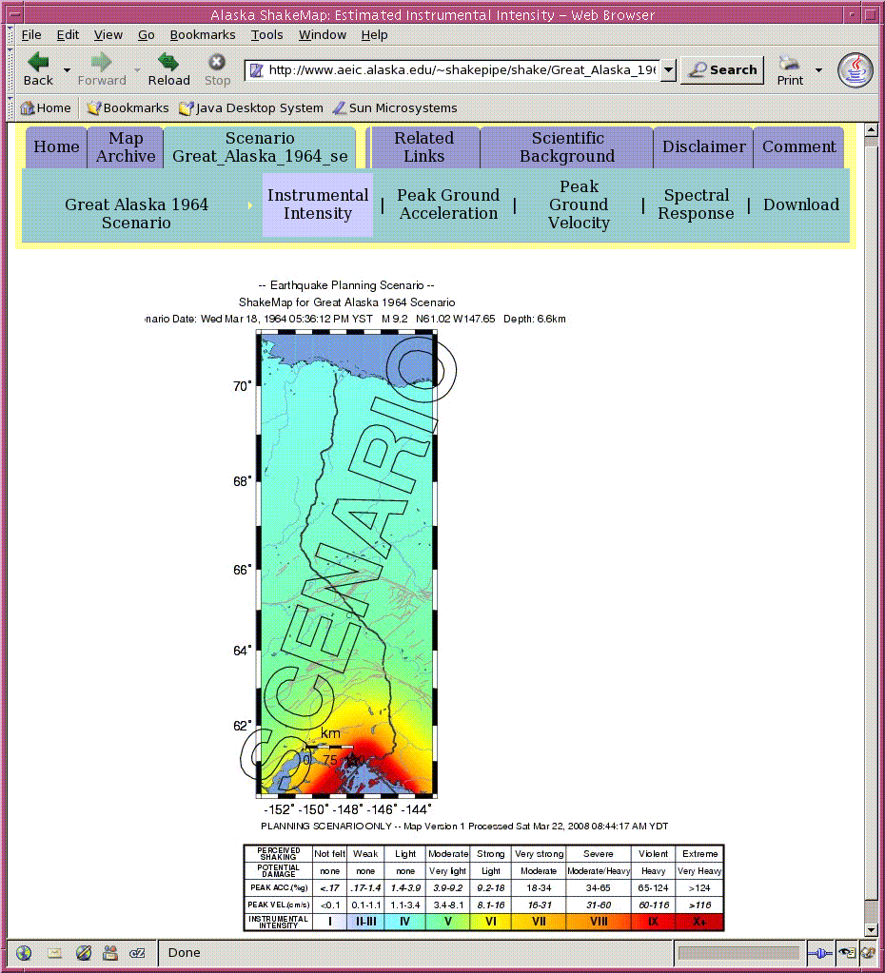
Figure 7: Instrumental intensity webpage for a particular scenario. An instrumental intensity webpage for an event is essentially identical to this.

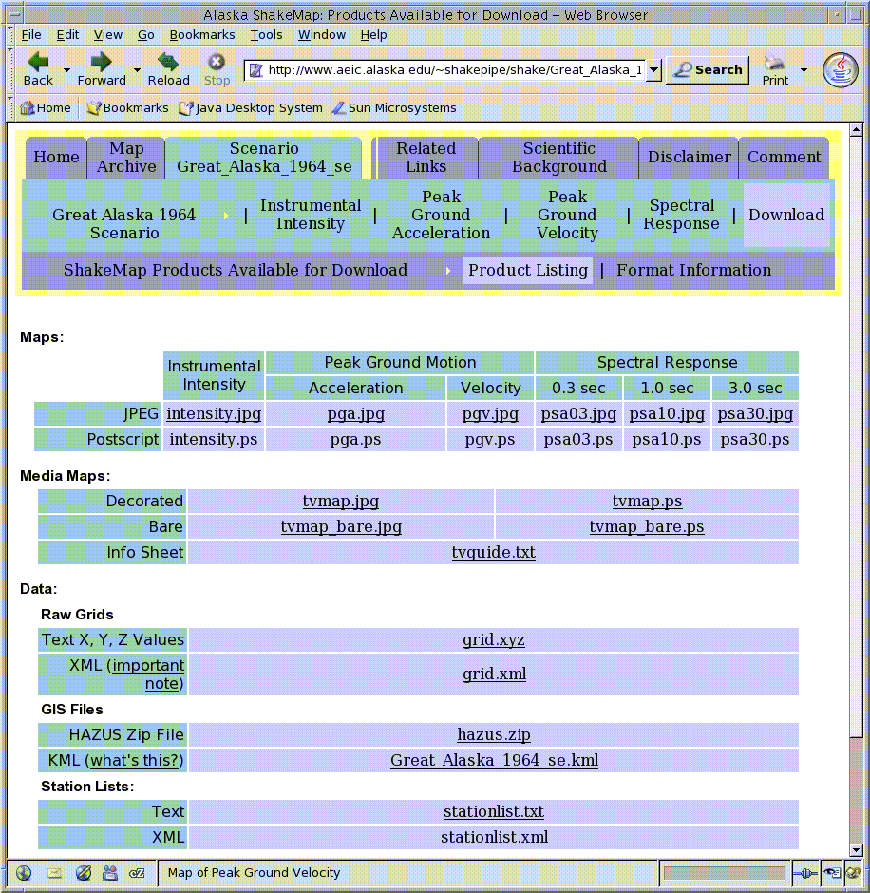
Figure 8: ShakeMap download webpage for a particular scenario. A download webpage for an event is essentially identical to this.

Generating a ShakeMap manually
Manual Run: In order to manually run a ShakeMap, it is necessary to login to bedrock (as user shake) and run the following command:
shake -event evid -once_only -default_fl
where evid is the event id. Use -help flag to get more information about the program:
shake -help
Flag -dryrun may be used to show the list the commands that will run without actually running them:
shake -event evid -once_only -default_fl -dryrun
In order to prevent manual runs from being overwritten, it is necessary to edit the shake_watch state file (/home/shake/run/state/shake_watch.state) by setting 5 for the manual run next to the evid and orid, for example (30234 30237 5) for evid=30234.

Finite Faults
By default, the earthquake source in ShakeMap calculations is assumed to be a point. However, it is possible to incorporate extended source geometry by placing an ASCII file with fault coordinates in the event’s input directory. The file must contain set of (latitude, longitude) points defining the surface rupture, and the filename must end in “_fault.txt”. See ShakeMap manual for more details.
This is a file which defines the lat/lon line segments of a particular fault. The > character is used to separate line segments. The name can be anything, but it must end with _fault.xml, e.g. example_scenario_fault.xml. A critical parameter used to determine the intensity of the shaking at each grid point is the distance from the source to that grid point. If there is no fault file, a point source is used for the earthquake, which is fine for small earthquakes but isn't going to give a very good representation for larger events.
If it is desired to translate one rupture (such as Denali 20021103) to another location, use the Matlab program load_faultfile.m in /home/glenn/PROJECTS/PIPELINE.
The fault rupture can be plotted on the map by modifying the configuration file mapping.conf.

Cancelling a ShakeMap manually
To manually cancel a ShakeMap:
/usr/local/ShakeMap/bin/cancel -event evid
In order to prevent a manual cancellation from being overwritten, it is necessary to edit the shake_watch state file (/home/shake/run/state/shake_watch.state) by setting 6 cancellation next to the evid and orid, for example (30234 30237 6) for evid=30234.

Generating a Scenario
In general, the scenario earthquakes should be a replication of a historical strong event or a hypothetical event consistent with the Alaska seismic hazard assessments (Wesson et al. 1999). The scenario settings are controlled by several configuration files, including shake.conf, grind.conf, and mapping.conf. While a description of scenario generation is given in the main ShakeMap Manual, those instructions do not work, and the following procedure has been developed.
Configuring a scenario consists of the following steps:
- Make a name for the new scenario event, ending in '_se' to indicate it is a scenario. For the sake of these instructions, call this example_scenario_se.
- Under the directory data, create a directory called example_scenario_se.
- cd to that directory, and create a directory called input.
- cd to that directory and create an event.xml and a db_dat.xml file. Examples can be copied from other events/scenarios in the data directory. The db_dat.xml file probably will not need altering. The event.xml file will. Make sure it has the id set to the scenario name (example_scenario_se). Give it the appropriate coordinates, origin time, magntude, description, creation time etc.
- Optionally create a fault file (see section 9).
- Optionally create an estimates.xml file. This contains real data values if they are available. Its simply a way to allow real data to be used as part of the ShakeMap model generated for this scenario.
Now a scenario has been configured, it must be run. This ShakeMap manual states the following command should work:
shake -event example_scenario_se
However, this causes shake to crash, complaining that the retrieve program needs to be run. The problem is that shake is not correctly interpreting the shake.conf file in the config directory. This file tells shake to ignore the program retrieve (and others) when it is running a scenario as opposed to a real event (for a scenario, there is no real data available, unless it is provided via the optional estimates.xml file). USGS suggested the following possible solutions:
1. Make a local copy of the config directory in each scenario directory, and place the appropriate version of shake.conf there. This was tried and did not work.
- Modify the shake.conf file so that retrieve can be ignored. However, this would then prevent real events being processed (they wouldn't get any data).
A workaround based on the latter is a tolerable solution. A script, run_scenario.csh in /usr/local/ShakeMap was written which temporarily moves a copy of a shake.conf file configured for scenarios (shake.conf.scenario) into the (main) config directory any time a scenario is run. When the scenario has finished running, it moves back a copy of the shake.conf file configured for real events (shake.conf.real) immediately afterwards. This is how to call it:
run_scenario.csh example_scenario_se
To run multiple scenarios a batch script can be written. The script scenario_wrapper.csh does this. It is also in /usr/local/ShakeMap.
If everything worked, all scenarios should appear in /usr/local/ShakeMap/web/shake/archive/scenario.html.

Cancelling a Scenario
According to the ShakeMap manual, scenarios should be deleted in the same way as events, for example:
cancel -event example_scenario_se
Once again this did not work. Instead it must be done manually. There are two steps:
- delete the directory structure
- delete the scenario from the MySQL database.

Deleting the directory structure:
This is a trivial process. Simply change to the relevant directory (e.g. data/example_scenario_se). Then remove all subdirectories with the exception of the input directory (this allows you to rerun the scenario at a later date if you wish; all other subdirectories can safely be destroyed).

Deleting a scenario from the MySQL database:
- Login to MySQL:
mysql -u shake -p (enter password from mydb.conf file)
- You should now get the mysql prompt:
mysql>
- Change to the appropriate database (in this case, shakemap):
use shakemap;
- (Optional) Show the tables:
show tables;
(should list: earthquake, server, shake_lock, shake_runs, shake_version)
- (Optional) View the schema for the earthquake table:
describe earthquake;
- (Optional) View records that contain this scenario:
select * from shake_runs where evid = 'example_scenario_se';
select * from shake_version where evid = 'example_scenario_se';
select * from earthquake where evid = 'example_scenario_se';
- Delete those records!
delete from shake_runs where evid = 'example_scenario_se';
delete from shake_version where evid = 'example_scenario_se';
delete from earthquake where evid = 'example_scenario_se';
- Commit those changes:
commit;
- Exit MySQL
quit

Observations and Attenuation Models
The ground shaking grids for ShakeMaps are produced on the basis of observed ground motion values (maximum peak ground accelerations and velocities), complemented by calculated ones using empirical attenuation relationships. Only horizontal strong-motion (BNN, BNE, HNN, HNE) and horizontal broadband (BHN and BHE) channels are utilized for ShakeMap calculations. There are a number of settings in grind.conf that control which observations are included in calculations and how the grids are calculated. Figure 9 shows the distribution of strong-motion and broadband stations used in ShakeMap generation in Alaska.
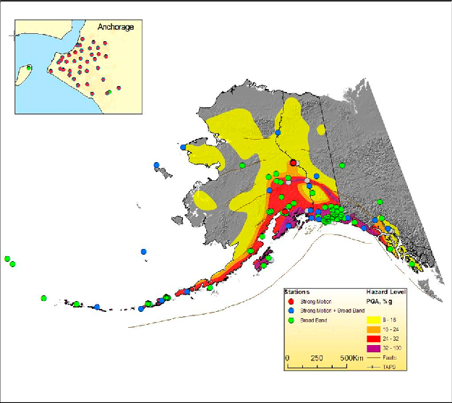
Figure 9. Map of strong-motion and broadband stations in Alaska on the background of Alaska seismic hazard map (pga, 10% in 50 years).

Peak ground values are calculated by dbwfmeas. The settings are controlled by /home/shake/run/pf/dbwfmeas.pf. The spectral calculations for periods 0.3, 1.0 and 3.0 sec are done by /usr/local/ShakeMap/bin/db2ewpg. The corresponding waveforms are preliminarily filtered by 5th order high-pass filter with 0.1 Hz corner frequency.
The velocity time series are differentiated in order to obtain accelerations and the acceleration time series are integrated in order to obtain velocities. Only the maximum of two horizontal components are utilized in grid computations. For sites, where the strong-motion and broadband sensors are collocated, the velocity data is used only for the velocity computations, and acceleration data only for accelerations.
The attenuation relationships for ground motion calculations are defined in grind.conf. The following models are currently used:
- Boore et al. (1997) model for the crustal events with M>5.3.
- Youngs et al. (1997) model for subduction-zone events.
- ShakeMap Small Regression model for shallow events with M<=5.3.

Customized Content
The most important regional characteristic for ShakeMap calculations is the uppermost 30m average shear-wave velocity (Vs30) grid for the whole state. The Vs30 values are required to correct the observed and computed ground motions according to the local geological conditions. We are currently using a vs30 grid derived from topography by correlating the Vs30 values with the gradient of the surface. This grid is compiled by the USGS.
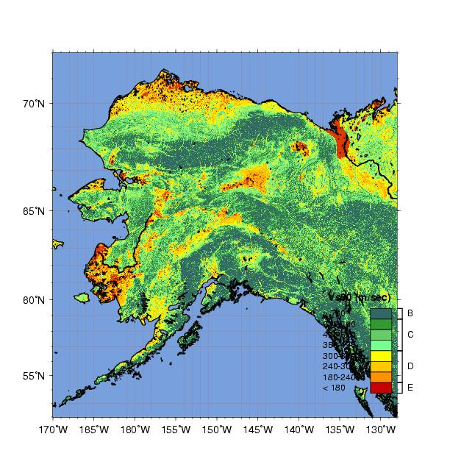
Figure 10. Vs30 map, currently used in ShakeMap calculations.

ShakeMap requires the binary version of this file (/usr/local/ShakeMap/lib/sitecorr/ak_vsgrid.bin), which can be obtained by converting the ASCII version to binary by using /usr/local/ShakeMap/bin/qtmlatlon2bin. A color-coded map of Vs30 is shown in Figure 10.
Vs30 values are used to determine site coefficients. Ideally, these numbers should be customized according to the regional characteristics; right now, however, we are using the coefficients derived from California earthquake data. They are set in /usr/local/ShakeMap/lib/sitecorr/site_corr_cdmg.dat.
There are numerous settings in the ShakeMap configuration files that are customized according to the regional specifics, including ground motion calculation settings in grind.conf. In addition, several auxiliary region-specific files are used for mapping, such as Alaska roads, faults, etc.

Known Issues
The following list contains certain problems in the ShakeMap software and related programs, and other potential problems that the ShakeMap system may encounter in the future:
- ShakeMap doesn’t work without observational data, i.e. without the *_dat.xml file. Therefore, when no observations are available, db2sm_xml copies the following blank data file (/home/shake/run/pf/dummy_dat.xml) to the event’s input directory.
- ShakeMap archival web page doesn’t automatically create a new link for the new year. In order to create this link, it is necessary to manually introduce the new year in the archival page template: /usr/local/ShakeMap/lib/genex/web/config/archivepages.xml.
- At high latitudes (~70N) the scalebar of ShakeMap doesn’t fit into the map frame. In order to fix this, line 921 in program mapping was modified from “my $sb_offset = 1.0;” to “my $sb_offset = 1.5;”. This is the only change done in the native ShakeMap codes.
- Contrary to the ShakeMap manual instructions, adding “_se” at the end of the event id doesn’t automatically add –scenario flags in the ShakeMap programs.
- When a scenario is generated, shake calls retrieve even though it is configured not to do so, with the result that no scenario is created. A workaround is to temporarily introduce a new shake.conf file, which is semi-automated by using the script create_scenario.csh, as described under section 11 “Generating a Scenario”.
- When a scenario is cancelled, it is not automatically removed from the MySQL database as it should be. Follow instructions under section 12 “Cancelling a Scenario”.
- The spectral calculation algorithm has not been comprehensively tested, for example, in case of a strong event with large number of observations, or when there are problems with waveforms such as spikes, missing or late samples, etc. Also, it is necessary to check the reliability of spectral calculations by comparing the results from collocated broadband and strong motion channels.
- There is no mechanism to identify if the broadband channels are clipped, so ShakeMap in such cases will be based on amplitudes.
- While running ShakeMap over ssh connection, grind doesn’t properly interpret the vs30 grid file. It is necessary, before running the ShakeMap programs, to run the following command:
setenv LC_ALL
- Currently, both ShakeMap and Antelope software support the same Perl version. In future releases, however, these versions may be different (at least for certain time period), which can create problems in Perl libraries and influence ShakeMap operations.
- All attenuation models are based on Mw magnitude while mostly Ml is used in ShakeMap calculations. Ml and Mw may differ considerably at larger magnitudes.

Current settings and other info
  - Current ShakeMap version: 3.2
  - Triggering parameters to generate a ShakeMap:
    - Number of associated arrivals (nass) > = 10
    - MMI >= 2.0
    - magnitude >= 3.5 for an event inside the rectangle from (-153,60) to (-143,71), or
    - magnitude >= 5.0 for an event inside the rectangle from (-160,55) to (-135,75).
  - Magnitude threshold for saving all ShakeMap versions: M>=5.0
  - Magnitude threshold for spectral calculations: M>=3.8
  - Delay time (number of seconds shake_watch will wait for a magnitude calculation) 60.
  - Automatic cancellation OFF (ShakeMaps are never automatically cancelled)

Transfering ShakeMaps to the USGS ShakeMap servers
In July 2008 AEIC became the official source of ShakeMaps on the USGS ShakeMap website (http://earthquake.usgs.gov/eqcenter/shakemap/list.php?y=2008&n=ak). To configure this, the following steps were necessary:
  - USGS created accounts on horst.wr.usgs.gov, graben.er.usgs.gov and mesa.cr.usgs.gov with username akshake (password smAnch02).
  - From bedrock.giseis.alaska.edu, log into graben, cd to .ssh and create an ssh pair (rsa) using ssh-keygen.
  - Cat the host key (/home/akshake/.ssh/id_rsa.pub) to .ssh/authorized_keys (and authorized_keys2 ?).
  - Copy the client key to /home/shake/.ssh/id_rsa.pub on bedrock (use scp).
  - Copy the host key to /home/akshake/.ssh on horst and mesa also, using scp.
  - Log into each of those machines and cat .ssh/ida_rsa.pub to .ssh/authorized_keys.
  - Modify the configuration file for transfer (transfer.conf) so that it includes the following lines in the destination section:
destination: horst.wr.usgs.gov
ttype: www
method: scp akshake
destdir: /home/html/earthquake/eqcenter/shakemap/ak
list: weblist

destination: graben.er.usgs.gov
ttype: www
method: scp akshake
destdir: /home/html/earthquake/eqcenter/shakemap/ak
list: weblist

destination: mesa.cr.usgs.gov
ttype: www
method: scp akshake
destdir: /home/html/earthquake/eqcenter/shakemap/ak
list: weblist

References
Boore, D. M., W. B. Joyner, and T. E. Fumal (1997). Equations for estimating horizontal response spectral and peak acceleration from western North American earthquakes: A summary of recent work, Seism. Res. Lett., 68, 128-153.
Youngs, R. R., S.-J. Chiou, W. J. Silva, and J. R. Humphrey (1997). Strong ground- motion relationships for subduction zones, Seism. Res. Letters, 68, 58-73.
Wesson, R., Frankel, A., Mueller, C., and Harmsen, S. (1999) Probabilistic seismic Hazard Maps of Alaska, USGS Open-File Report 99-36.
Wald, D. J., Worden, B. C., Quitoriano, V., Pankow, K. L, ShakeMap Manual: Technical Manual, User's Guide, and Software Guide, http://pubs.usgs.gov/tm/2005/12A01/.

