Locating pyroclastic flows from the Soufriere Hills Volcano, Montserrat, using 24-bit seismic amplitude data

Art Jolly, University of Leeds

Glenn Thompson, Montserrat Volcano Observatory & British Geological Survey

Gill Norton, British Geological Survey

Venus Bass, Montserrat Volcano Observatory

David “Patch” Silcott, Montserrat Volcano Observatory

ROCKFALL LOCATION SYSTEM

Locating pyroclastic flows on Montserrat using high-dynamic-range seismic amplitude data
Glenn Thompson, Montserrat Volcano Observatory
Arthur Jolly and Gill Norton, University of Leeds, UK
Pyroclastic flows from the Soufriere Hills Volcano, Montserrat, present a hazard to populated areas if they travel down the northern or western sides of the volcano. However, due to persistent low-cloud and winds from the east, it is frequently impossible to observe in which direction the dome is failing. What is needed is some method of determining the direction of dome failure based on continuous near-real-time data.
Our method is to use seismic amplitude data from 8 high-dynamic-range seismic stations in order to determine the trajectories of rockfall and pyroclastic flow signals. A grid search algorithm is used. At each grid position the reduced displacement (corrected for attenuation) for each station is calculated. The final location is chosen as the one which has the smallest standard deviation of reduced displacement. There is a good agreement between trajectories determined using this method and visual observations.
The products of this method will include hazard maps and estimates of run-out distance and collapse volume. Our ultimate goal is to be able to determine pyroclastic flow trajectories in near-real-time, which could be linked directly to an alarm system.

Concept:

- Locate rockfalls using seismic amplitude data.

Motivations:

- Ability to locate rockfalls/pyroclastic flows in near-real-time would improve safety of persons working in the exclusion zone.

- Difficult to observe changes in direction of dome growth (volcano covered in cloud most of the year). A switch to the north/west increases the risk to populated areas.

- Pager alarms of size / direction of rockfalls would improve safety of Montserrat population.

AMPMAP
(Jolly et al., submitted to JVGR)

Concept:

- GUI driven program used for manual processing of rockfall events

- Sliding 1024-sample window (13.6 s), with an overlap of 256-samples (3.4 s).

- Grid-search algorithm, minimizing the standard deviation of D_{R}, which is computed for each station from:

geometric speading
attenuation

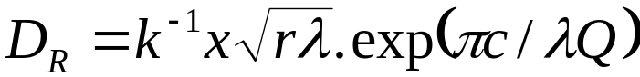

x = displacement at seismometer at frequency f
r = distance from trial location to seismometer
c = surface wave speed
Q = seismic quality factor
K = site amplification

Products:

- Trajectory of rockfall event

- D_{R} vs. time

Tuning:

- Frequency (8 Hz)

- Q (23)

- Site amplifications (by comparing observed rockfalls with ampmap results)

- Surface wave speed
From: Arthur Jolly [aj@earth.leeds.ac.uk]
Sent: Tuesday, August 28, 2001 10:35 AM
To: Glenn Thomson
Subject: Re: talk

Hi Glenn,

Here are some jpegs for the dome collapse rept.

They show Dr vs. time and locations for the three phases shown in figure
1. You could use these in your talk.

I think that they show collapse of the dome and not really deposition
down slope (ie pfs signals masked)

Cheers

Art

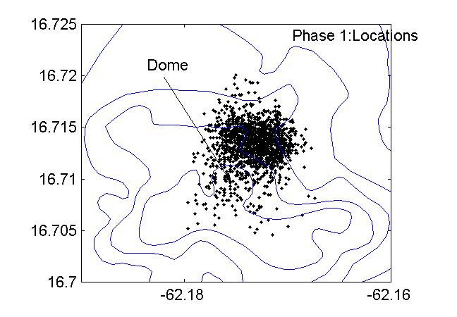

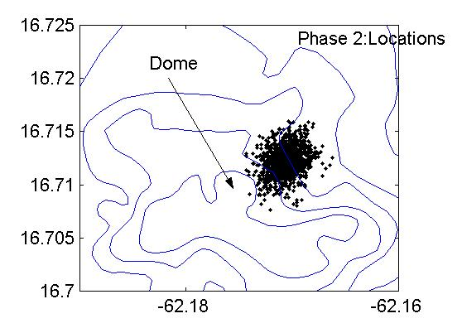

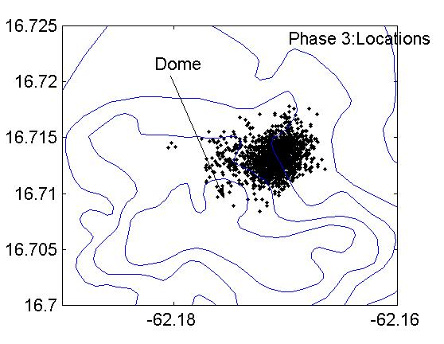

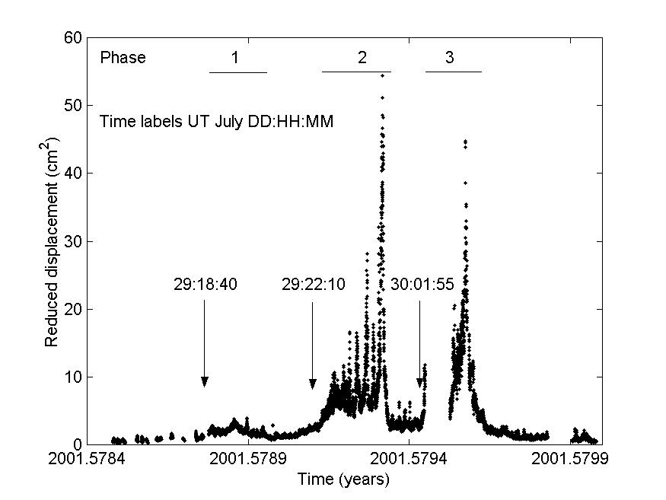
Ampmap (Matlab)
Event data
(rf, lp, vt)
Continuous data
Event classification (manual)
Rockfall triggering 1
Locate ssam data
Alarm system
Compute ssam data
(1 minute mean)
Rockfall triggering 2
Deposit volume / hazard maps (Matlab)
PROPOSED ROCKFALL LOCATION SYSTEM
proof of concept
Ampmap
Event data
(rf, lp, vt)
Continuous data
Event classification
Rockfall triggering 1
Locate ssam data
Alarm system
Compute ssam data
(1 minute mean)
Rockfall triggering 2
Deposit volume / hazard maps
PROPOSED ROCKFALL LOCATION SYSTEM: real-time implementation
Location algorithm & real-time maps (Earthworm modules)
Event data
(rf, lp, vt)
Continuous data
Event classification
(neural network)
Rockfall triggering 1
Locate ssam data
Alarm system
Compute ssam data
(1 minute mean)
Rockfall triggering 2
Deposit volume / hazard maps (Matlab)

