GARRY HAWTHORNE
Instructional Designer | Technical Writer | E-Learning Developer | L&D Leader

Portfolio

ABOUT ME

Garry Hawthorne is a multi-disciplinary Learning and Development practitioner with 19 years of experience spanning instructional design, technical writing, e-learning development, and enterprise software training. He translates complex systems and business workflows into scalable learning experiences that measurably improve performance across automotive, real estate, healthcare, and customer service industries. Skilled in ADDIE and SAM methodologies, Synthesia AI, SaaS LMS administration, technical documentation, and virtual facilitation, Garry brings both strategic vision and hands-on execution to every engagement. Proficient in generative AI platforms including Claude, ChatGPT, Google NotebookLM, Microsoft Copilot, and Perplexity AI, he accelerates content development and builds learner-centered materials at scale. He is a versatile L&D partner for organizations ready to build, scale, or modernize how their people learn.
DISCIPLINES & INDUSTRIES

Instructional Design | Technical Writing | E-Learning Development | Virtual Facilitation
Automotive / DMS | Real Estate / Homebuilding | Healthcare | Customer Service

TOOLS & TECHNOLOGIES
Authoring & E-Learning | Synthesia AI, Camtasia, Articulate Storyline 360*, Adobe Captivate*
Documentation & Writing | Microsoft Word, SharePoint, Confluence, Snagit, Adobe Creative Suite
LMS / Platform Admin | Canvas, Moodle, Blackboard; SCORM/xAPI packaging and deployment
Facilitation & Delivery | Zoom, Microsoft Teams, WebEx, DialPad
AI-Assisted Production | Claude (Anthropic), ChatGPT, Google NotebookLM, Microsoft Copilot, Perplexity AI, GenSpark AI
Design & Visual Comms | Canva, Adobe Creative Suite, Snagit, NotebookLM Infographics
* Certifications in progress
PORTFOLIO CONTENTS
Section 1 | Software User Guides & Instruction Manuals | Automotive / DMS
Section 2 | Quick Reference Cards | Automotive / DMS
Section 3 | Process & Workflow Documentation | Automotive / DMS
Section 4 | Visual Job Aids & Infographics | Automotive / DMS
Section 5 | Training Manuals & Curriculum Design | Automotive / Customer Service
Section 6 | Role-Specific Reference Guides | Automotive / DMS
Section 7 | Knowledge Base & Learning Tools | Automotive / DMS

SECTION 1 | SOFTWARE USER GUIDES & INSTRUCTION MANUALS

Software User Guide | Automotive / DMS
Audience: | Dealership Sales Managers, F&I Managers, Salespeople | Tool: | Microsoft Word, Saturn DMS, AI-Assisted Drafting
Outcome: Reduced onboarding time by 30% through clear, role-specific content that accelerated system proficiency across all dealership departments.
Saturn DMS: Comprehensive Training Guide (SOP)

This multi-chapter software user guide serves as the authoritative reference document for the Saturn Dealership Management System. Structured as a formal Standard Operating Procedure (Document No. SAT-TRN-0100, Version 4.0), it covers system architecture, role-based interface behavior, deal identification and tracking, customer verification workflows, purchase figures entry, F&I menu presentation, Deal Jacket management, eContracting, F&I Admin review, and deal audit. The document is organized with a full table of contents, clearly numbered sections, defined abbreviations, compliance callout boxes, and consistent formatting conventions designed for both self-paced learning and facilitator-led instruction. Each section moves from conceptual overview to procedural step-by-step guidance with numbered action tables, ensuring learners understand the rationale before executing the process.
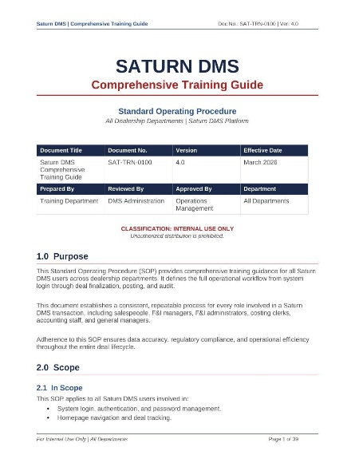

Instruction Manual | Automotive / DMS
Audience: | Sales Managers, Finance Managers | Tool: |  | Microsoft Word, Saturn DMS, Claude AI
Outcome: Provided dealership finance staff with a comprehensive reference that reduced data entry errors and improved deal submission accuracy.
Technical Writing Example: Purchase Figures Instruction Manual

This structured instruction manual guides finance professionals through the complete Purchase Figures workflow within Saturn DMS. It covers the three primary deal types (Cash, Finance, and Lease), the system's smart auto-population features, a nine-step data entry process with field-by-field guidance, lender selection logic, soft versus hard credit pull distinctions, credit application workflows, and rehashing fundamentals for declined deals. The manual includes a Best Practices section and a Key Takeaways summary, making it functional as both a training document and a day-to-day performance support tool. The document's information architecture mirrors the actual deal workflow, reducing cognitive load for new and experienced users alike.

Training Guide | Automotive / DMS
Audience: | Salespeople, Sales Managers, F&I Managers | Tool: | Microsoft Word, Saturn DMS
Outcome: Gave the dealership sales team a structured, step-by-step reference for completing registration and titling accurately, reducing submission errors and compliance delays.
Saturn DMS: Registration and Titling User Training Guide (Section 06)
This user training guide covers the Registration and Titling section of Saturn DMS, which sits between Trade-In entry and Insurance Information in the deal workflow. The document explains three vehicle delivery methods (Driven Off Lot, Shipping In State, and Shipping Out of State), six primary vehicle use categories, and two plate transaction types (Temporary and Transfer) with their required data entry fields. five-field address decision guide walks users through Mailing, Registration, and Garaging address distinctions using a clear Yes/No selection framework. The seven-step procedural section closes with a submission sequence that routes the completed record to the Sales Manager for approval. Eight key takeaways reinforce the critical accuracy standards required to prevent registration delays and deal reprocessing.
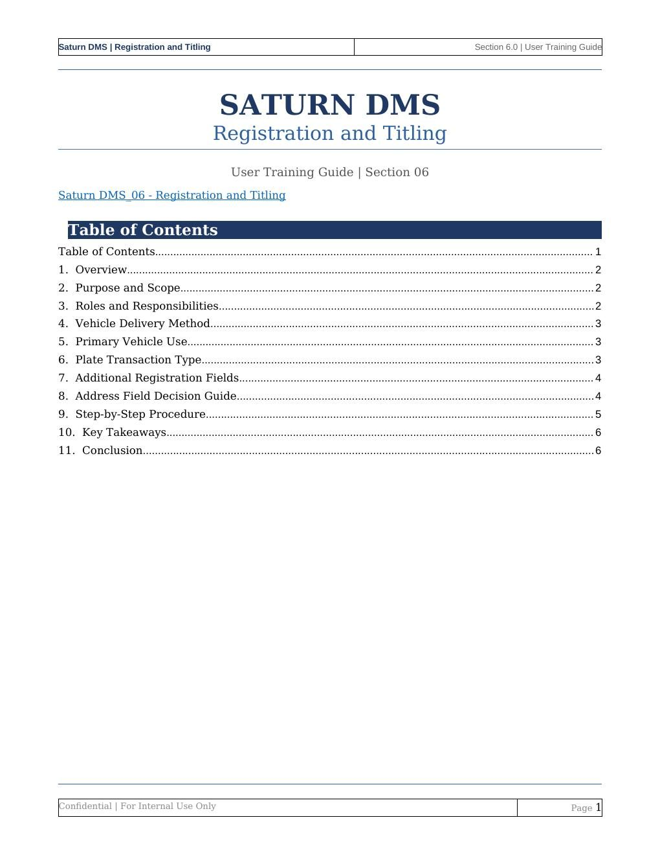

SECTION 2 | QUICK REFERENCE CARDS
Quick Reference Card | Automotive / DMS
Audience: | All Dealership Roles | Tool: | Microsoft Word, Saturn DMS
Outcome: Eliminated login support calls by giving every user a scannable, single-page guide covering all login steps, password rules, and troubleshooting paths.
Saturn DMS: Logging into Saturn Quick Reference Card

This single-page quick reference card delivers clear, numbered login instructions for all Saturn DMS user roles. It covers the seven-step login process including two-step authentication via Dialpad, first-login password update, and e-signature setup. A password requirements summary and a three-scenario troubleshooting table (verification code not received, account locked, and no reset email) are included in a compact, visually scannable format. The document is designed for posting at point of use or distributing digitally, and references the full SOP for users who need deeper procedural context.
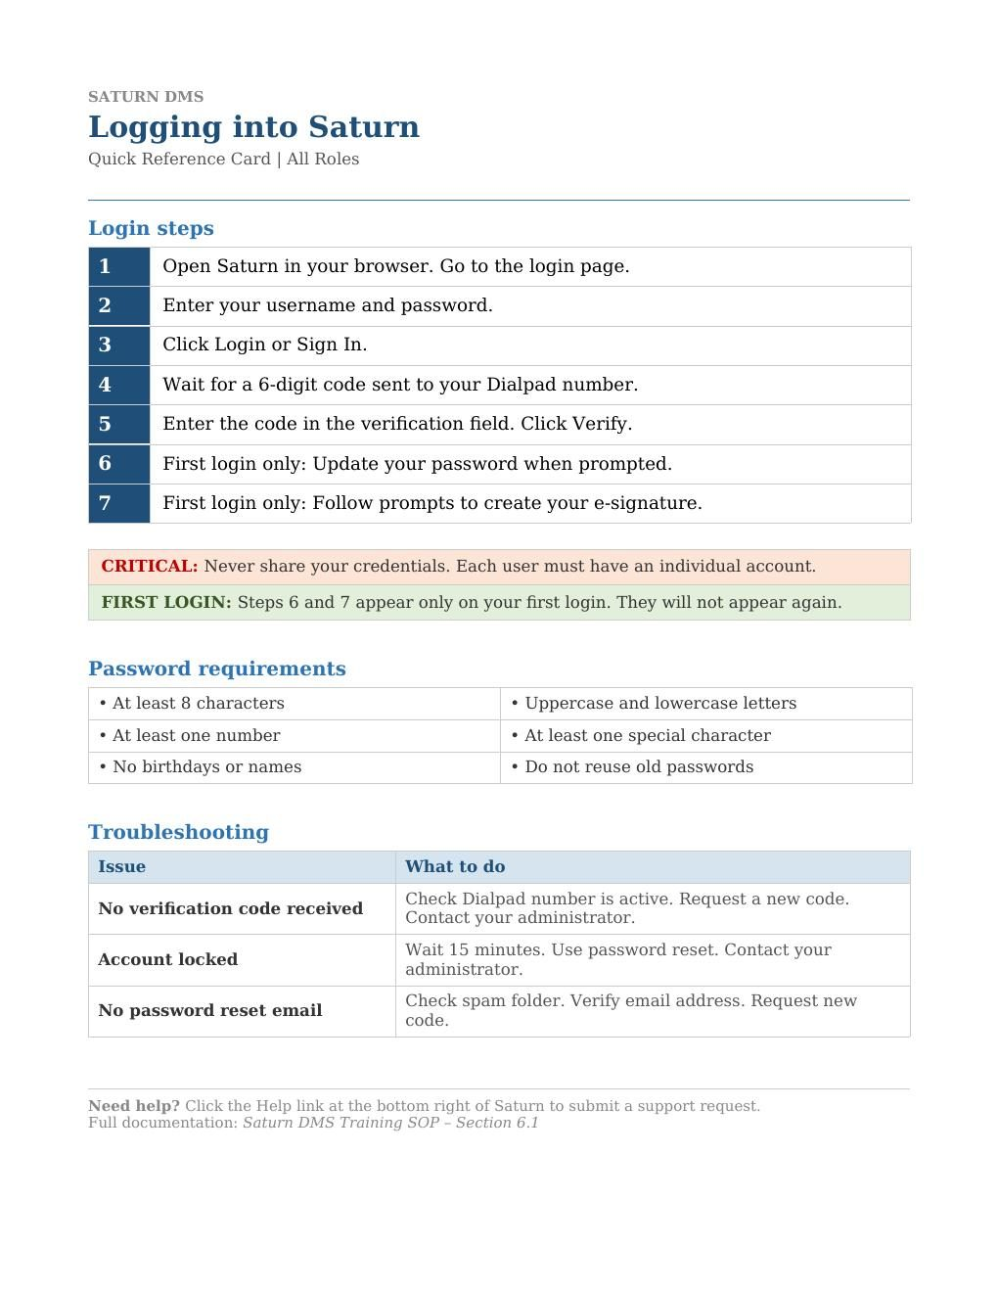

Quick Reference Card | Automotive / DMS
Audience: | All Dealership Roles | Tool: | Microsoft Word, Saturn DMS
Outcome: Prevented duplicate records and standardized the customer creation process across all dealership roles, improving data integrity and reducing verification failures.
Saturn DMS: Creating and Managing Customers Quick Reference Card

This single-page quick reference card guides all dealership roles through the seven-step customer setup workflow in Saturn DMS. It covers the search-before-create rule to prevent duplicate records, all required data entry fields (First Name, Last Name, Date of Birth, Primary Phone, Email, Full Address, and Language Preference), the verification trigger sequence, and the co-signer addition step. A search reference table identifies all four search methods (Name, Phone, Email, and Deal Number) with their corresponding input formats. Critical compliance notices are prominently placed to reinforce that no credit or purchase activity may begin until the customer's status shows Verified. Compact and role-agnostic, this card is designed for immediate point-of-use reference across the sales floor.
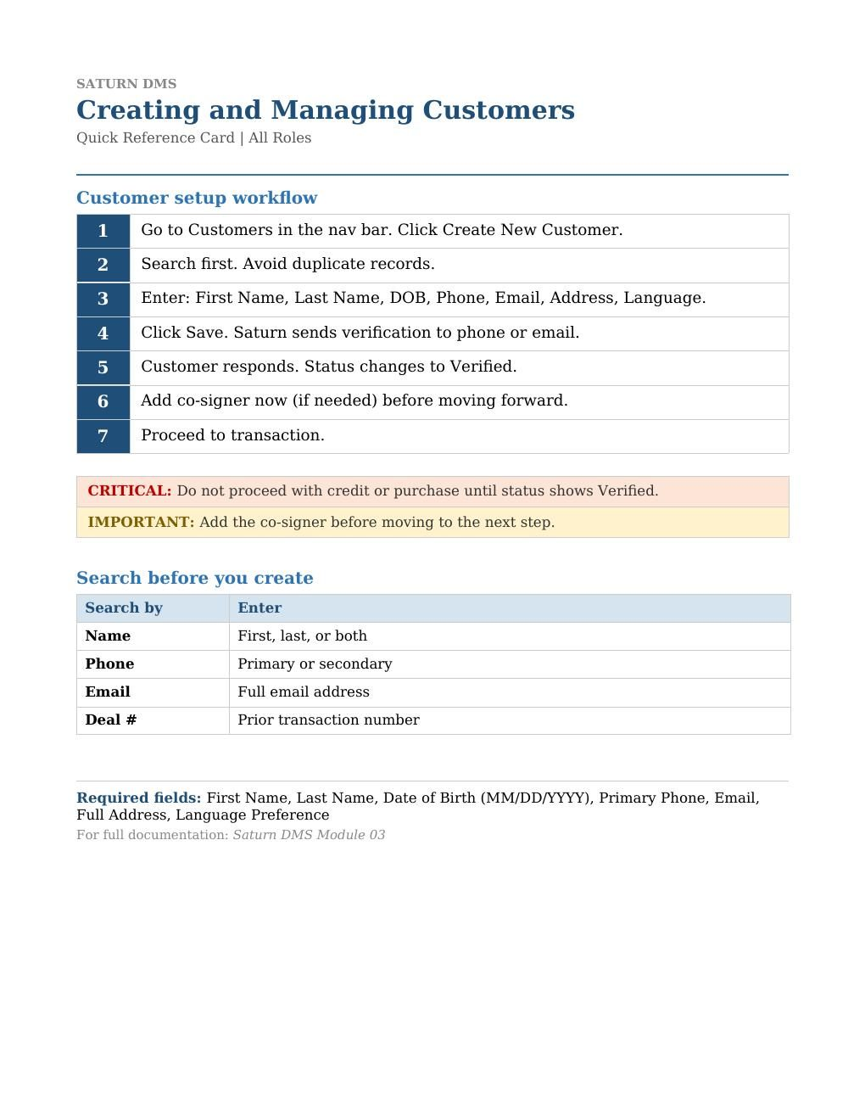

Quick Reference Guide | Automotive / DMS
Audience: | F&I Managers | Tool: | Microsoft Word, Saturn DMS, Claude AI
Outcome: Standardized the eContracting workflow across F&I staff, reducing deal closing errors, preventing lender submission failures, and cutting deal jacket routing time.
Saturn DMS: eContracting Quick Reference Guide (SAT-QRG-0042)
This eight-phase quick reference guide walks F&I Managers through the complete Saturn DMS eContracting workflow from deal review through lender funding. Phase 1 covers the nine-component Deal Recap verification checklist. Phase 2 addresses delivery status questions and the eContracting activation decision. Phase 3 details the Validate eContract process and error resolution protocol. Phase 4 covers the Get Paperwork sequence and automatic Deal Jacket navigation. Phase 5 guides customer e-signing via the Sign link. Phase 6 covers document distribution by category to the lender through RouteOne, including green checkmark verification. Phase 7 covers Required Items uploads and the 100% checklist completion rule. Phase 8 maps the full approval chain from F&I Manager to F&I Admin to Costing Clerk. A Quality Control Checklist and Workflow at a Glance summary table are included for use during live deal closings.
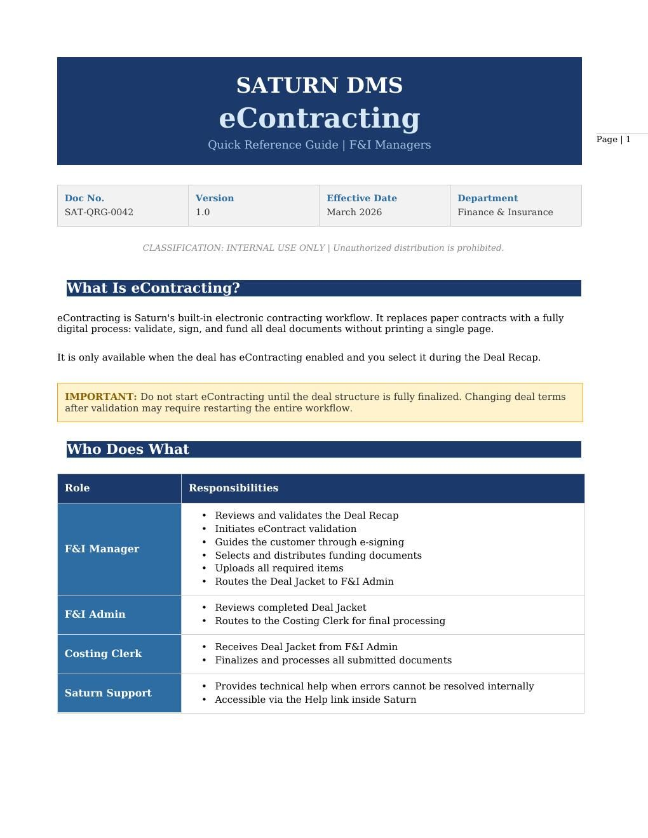

SECTION 3 | PROCESS & WORKFLOW DOCUMENTATION

Process & Workflow Doc | Automotive / DMS
Audience: | F&I Administrators (Rippers), F&I Managers | Tool: | Microsoft Word, Saturn DMS, Claude AI
Outcome: Established a standardized quality control process that reduced post-closing errors and protected dealerships from lender rejection and compliance violations.
Saturn DMS: F&I Admin Menu Guide

This procedural workflow document defines the F&I Admin section of Saturn DMS as the dealership's final quality control checkpoint before deal finalization. It outlines the distinct roles and responsibilities of the F&I Administrator (Ripper) and F&I Manager, maps where the review step fits within the larger deal lifecycle, and explains the consequences of bypassing it. The document uses a compliance-forward tone appropriate for a regulated environment, with callout boxes highlighting critical risk points. It covers the three-category review framework (Financials and Trade-Ins, Identity and Credit Compliance, and Vehicle and Product Details) alongside the Ripper Resolution Workflow: Checklist Protocol, Identify/Flag/Route, and Audit-Ready Final Approval. The writing demonstrates the ability to produce procedural content for subject matter experts while maintaining clarity and actionability for users at every experience level.

Process & Workflow Doc | Automotive / DMS
Audience: | Finance Managers, Sales Managers | Tool: | Microsoft Word, Saturn DMS, ChatGPT
Outcome: Equipped finance staff with a repeatable, step-by-step workflow for navigating declined deals, keeping more transactions active and improving close rates.
Saturn DMS: Mastering the Rehash

This workflow document guides finance professionals through the art and mechanics of deal rehashing within Saturn DMS. It opens with a strategic framing of rehashing as a customer advocacy tool, followed by a scenario reference table identifying five specific trigger conditions and their corresponding business opportunities. The centerpiece is a seven-step workflow for navigating the Saturn system to resubmit declined deals, select alternative lenders from the dropdown, and document outcomes. It explains the 14-to-45-day credit inquiry window and the single-impact rule for rehashing within that period. The document demonstrates the ability to blend conceptual framing with procedural precision, a combination particularly valuable in regulated, high-stakes environments where users need both context and exact steps.

SECTION 4 | VISUAL JOB AIDS & INFOGRAPHICS
Visual Job Aid / Infographic | Automotive / DMS
Audience: | Dealership Sales Staff, Service Advisors | Tool: | NotebookLM, AI-Assisted Design
Outcome: Provided a scannable, visually engaging quick reference that reduced support calls related to customer portal setup.
Saturn Customer Portal: 3-Step Customer Journey

This step-by-step visual job aid guides dealership staff through the Saturn Customer Portal shortcut setup process. Using numbered callouts, device mockups, and directional flow arrows, it communicates a three-step technical process without requiring written prerequisite knowledge: Step 1 (Scan and Verify via QR code), Step 2 (Install Shortcut to home screen without an app store), and Step 3 (Access and Login via the Saturn portal in full-screen native-app style). Designed for posting at point of use or embedding within a digital training module, this infographic demonstrates the ability to convert a multi-step software procedure into an at-a-glance performance support tool.
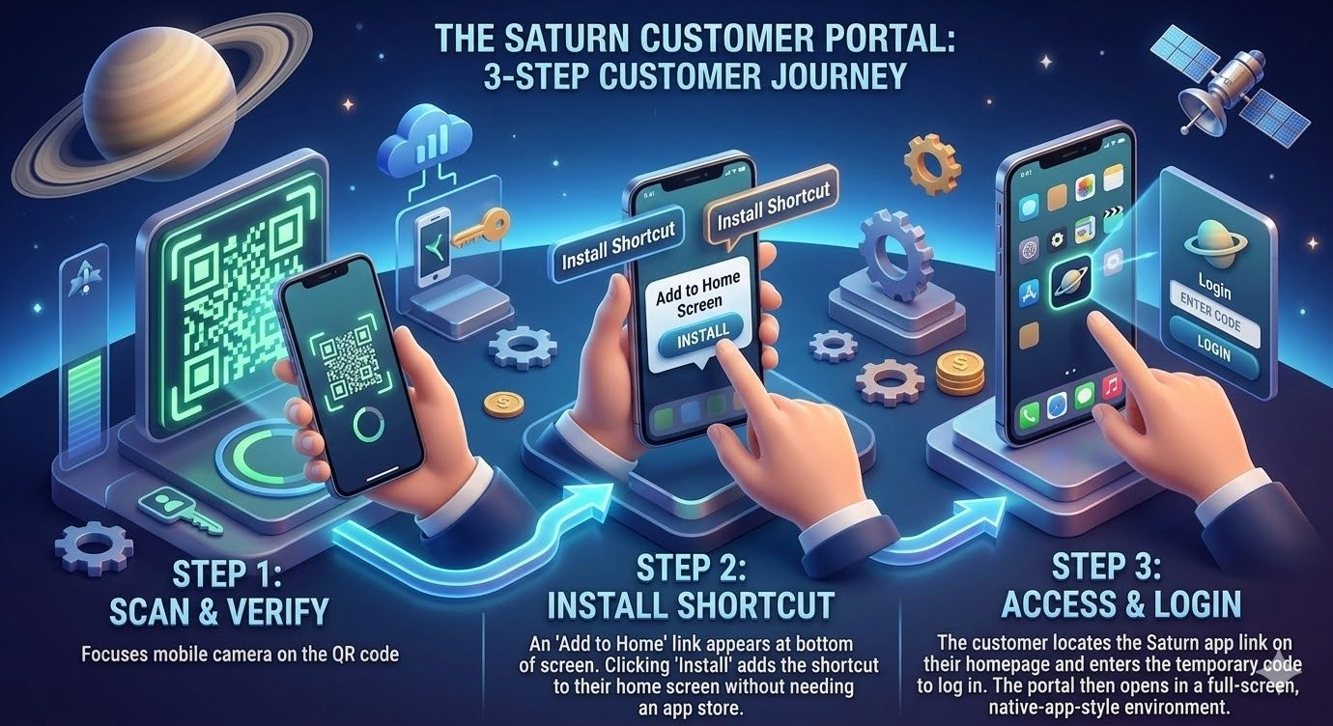

Visual Job Aid / Infographic | Automotive / DMS
Audience: | All Dealership Roles: GMs, Sales, Finance, Accounting | Tool: | NotebookLM, AI-Assisted Design
Outcome: Gave all dealership roles a single visual reference for understanding how Saturn integrates their workflows, accelerating cross-departmental alignment during onboarding.
Saturn DMS: The Integrated Dealership Lifecycle
This system architecture infographic maps the Saturn DMS Integrated Dealership Lifecycle across four departmental functions: General Management, Sales, Finance, and Accounting. It visually communicates the role-based navigation model, the Deal Identifying Number (DIN) structure (format YYMMDD###), real-time status indicators (Blue for completed actions, Red for immediate attention), secure identity verification via Plaid, the 17-point customer verification system, and automated compliance and credit check processes including OFAC/MLA Red Flag checks and multi-bureau credit reporting. The infographic exemplifies the ability to distill a complex, multi-role enterprise system into a single consumable visual.
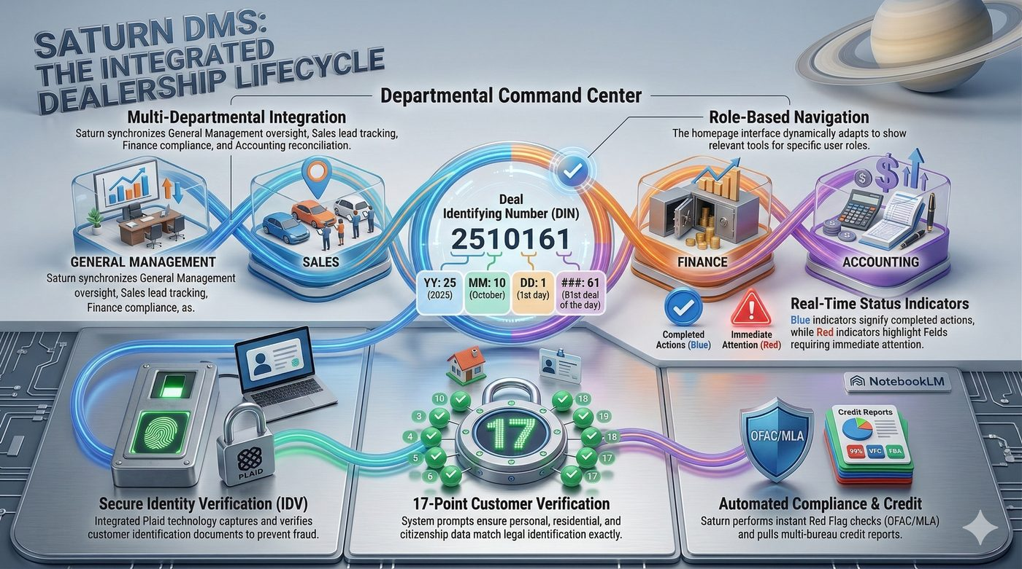

Visual Job Aid / Infographic | Automotive / DMS
Audience: | Finance Managers, F&I Staff | Tool: | NotebookLM, AI-Assisted Design
Outcome: Served as a visual companion to the Mastering the Rehash written manual, giving finance managers an at-a-glance workflow reference during live deal situations.
Saturn DMS: Mastering the Purchase Figures Workflow
This companion infographic presents the Purchase Figures workflow in a single visual across two panels. The left panel covers Deal Structure and Data Entry, showing the three distinct deal pathways (Cash, Finance, and Lease), smart auto-population of taxes, fees, and protection products, and the essential manual entries required of sales managers. The right panel covers Credit Integration and Submission, showing strategic lender rehashing, a soft versus hard credit pull comparison table, and the final finance submission pathway to the F&I menu. This piece demonstrates the ability to produce written documentation and its visual counterpart as an integrated content system.
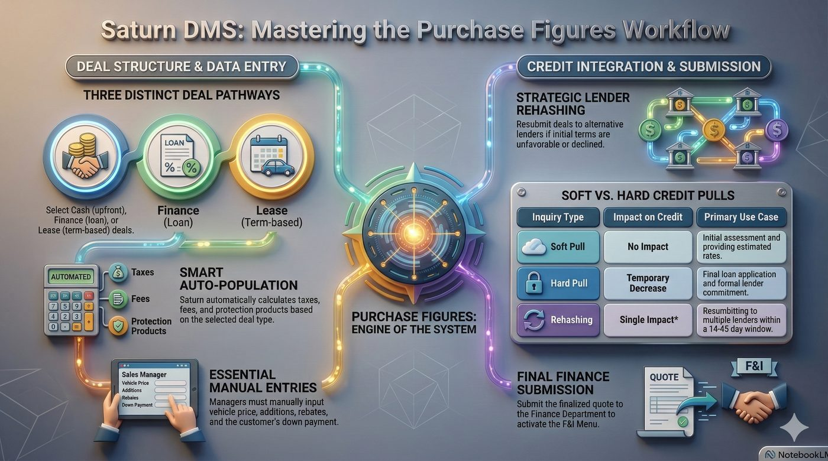

Visual Job Aid / Infographic | Automotive / DMS
Audience: | F&I Managers, Finance Staff, Sales Consultants | Tool: | NotebookLM, AI-Assisted Design
Outcome: Increased F&I product presentation confidence and improved customer-facing communication around protection plan value, supporting higher attachment rates.
360 Shield: The 4 Pillars of Automotive Protection
This four-quadrant infographic presents the 360 Shield automotive protection framework across its core value pillars: Performance and Asset Preservation (parts and labor coverage, NADA-level resale value via unlimited dent repairs and protective coatings), Lease-End Preservation (up to $5,000 in waived charges for worn tires, chipped paint, and interior stains), Mobility and Financial Security (rapid 32-minute roadside response, 14-minute average theft recovery via Kahu GPS, $800 key replacement), and Total Loss Protection (GAP coverage bridging the difference between insurance payout and loan balance after 35% first-year depreciation). Each quadrant uses data points, benefit statements, and supporting visuals to communicate product value in a format that works equally well as a training reference and a customer-facing conversation tool.
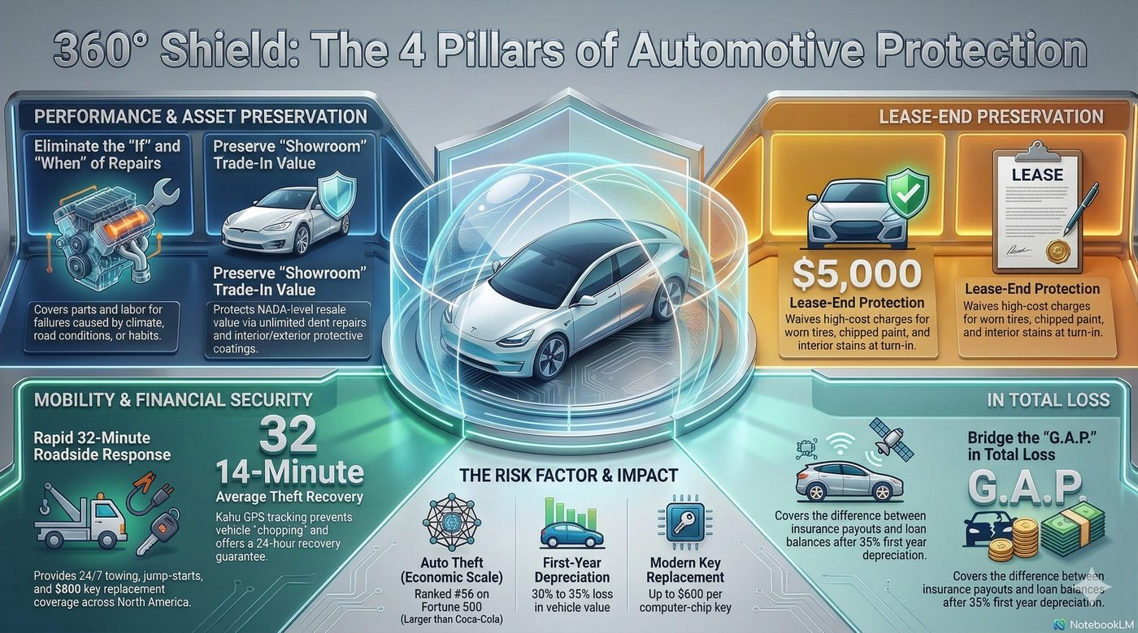

Visual Job Aid / Infographic | Automotive / DMS
Audience: | F&I Administrators, F&I Managers | Tool: | NotebookLM, AI-Assisted Design
Outcome: Standardized the F&I Admin review process visually, reducing documentation errors and improving audit-readiness across all dealership deal closings.
Saturn F&I Admin: The Last Line of Defense
This compliance-focused infographic frames the F&I Admin review as the dealership's last line of defense before deal finalization. The left panel presents the three-category review checklist: Financials and Trade-Ins (Buyer's Orders, Gross Profits, Lien Payoffs), Identity and Credit Compliance (OFAC, MLA, and IDV verification statuses), and Vehicle and Product Details (VIN accuracy, Carfax disclosures, F&I pricing). The right panel illustrates the Ripper Resolution Workflow across three stages: the Checklist Protocol, Identify/Flag/Route for discrepancies, and Audit-Ready Final Approval. The visual communicates high-stakes compliance requirements clearly to users under time pressure during live deal closings.

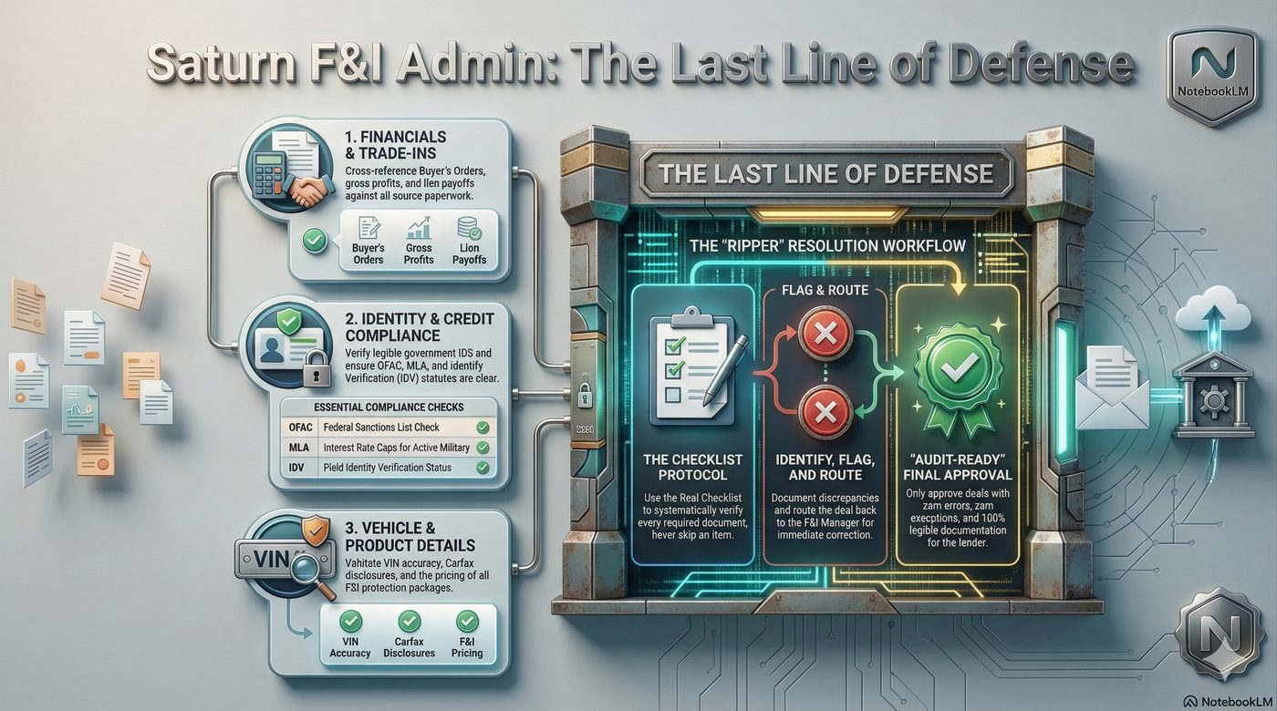

Visual Job Aid / Infographic | Automotive / DMS
Audience: | F&I Managers, Finance Staff | Tool: | NotebookLM, AI-Assisted Design
Outcome: Gave F&I teams a clear, process-oriented visual for managing the eContracting workflow from document preparation through successful lender funding.
Mastering the Saturn Deal Jacket: From Documentation to Funding
This process infographic maps the Saturn Deal Jacket system across two sections. The left panel covers the Foundation: the four folder types (Active for signing, voided for canceled items, Other for IDs and insurance, and eContracting for funding), the 100% Completion Rule requiring all three folder checklists to reach 100% before Saturn allows advancement to accounting, and the requirement to resolve all voided items before closing. The right panel maps the three-step eContracting workflow: Validate and Generate, Sign and Transmit (with signatures returning automatically to Saturn and transmitting to RouteOne), and Fund and Verify (select funding categories and send to bank, with document status reference for Successful Transmission and Transmission Failure resolution).
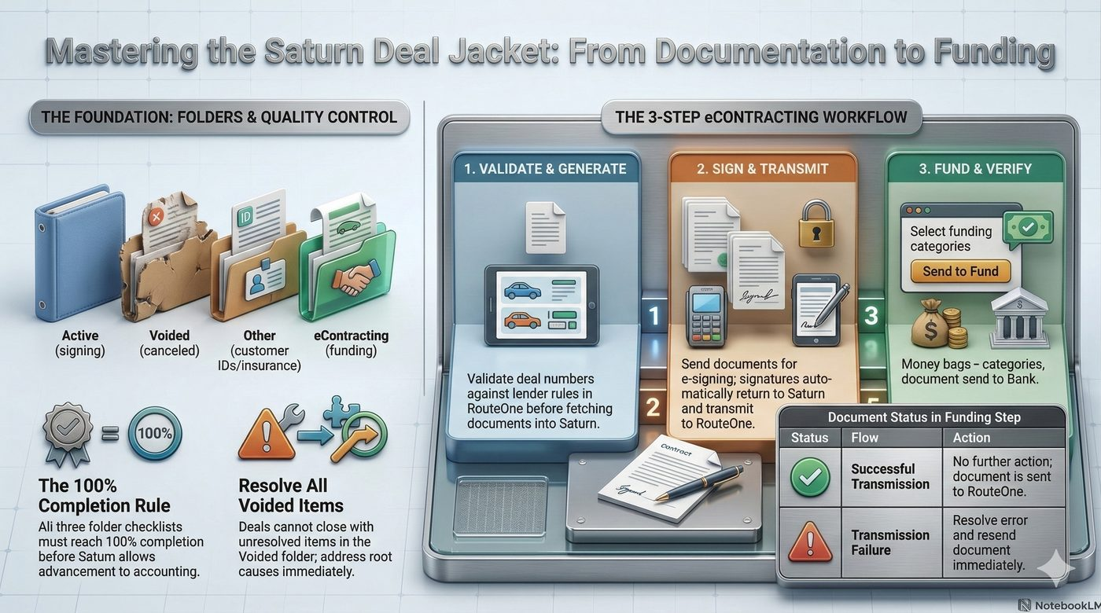

SECTION 5 | TRAINING MANUALS & CURRICULUM DESIGN

Training Manual | Automotive / DMS
Audience: | F&I Managers, Finance Staff | Tool: | Microsoft Word, NotebookLM
Outcome: Equipped F&I staff with a comprehensive product knowledge foundation that improved protection plan presentation skills and increased customer confidence in purchase decisions.
Saturn DMS: Comprehensive Automotive Protection and Service Plans Training Manual

This training manual develops F&I professionals' product knowledge and customer communication skills across four categories of automotive protection: mechanical failure coverage, lease-end preservation, mobility and financial security, and total loss protection. The document is structured to move learners from conceptual understanding to practical application, using the distinction between service contracts and maintenance schedules as a foundational framework. It incorporates customer-facing language models, objection framing techniques, and value articulation strategies alongside the technical product specifications. The writing demonstrates the ability to produce content that bridges technical documentation and instructional design for a specialized adult learner audience.

Curriculum / Syllabus | Customer Service / Call Center
Audience: | New Hire Sales Representatives, Call Center Trainers | Tool: | Microsoft Word
Outcome: Established a consistent, replicable new hire training experience that standardized sales call skills across the organization and reduced time to proficiency for new agents.
ADC Sales Training Syllabus

This structured training syllabus maps a full Day 1 new hire sales training program including timed agenda blocks, facilitator activities, required training materials, and role play scenarios. It covers business overview and department operations, the ADC sales call flow with verbatim scripting guidance, product knowledge, banking and closing procedures, legal disclosures, call control techniques, and structured role play with side-by-side observation. The document demonstrates curriculum architecture skills including session sequencing, time management, material alignment, and facilitation planning, all core competencies of an experienced instructional designer working across multiple disciplines.

SECTION 6 | ROLE-SPECIFIC REFERENCE GUIDES

Role-Specific Guide | Automotive / DMS
Audience: | Salespeople, Finance Managers, F&I Admins, General Managers, Accounting Staff | Tool: | Microsoft Word, Saturn DMS
Outcome: Provided every dealership role with a targeted, responsibility-specific reference that reduced cross-departmental confusion and improved task execution accuracy from day one.
Saturn DMS: Application Role-Specific Guide

This modular reference guide delivers role-tailored Saturn DMS guidance for each primary dealership function. The Salesperson module defines key responsibilities including customer engagement, deal initiation, quote generation, information accuracy, and follow-up, then provides task-level procedural guidance for creating customer records, generating quotes, and tracking deal progress through the system. Each module closes with a Best Practices section reinforcing the behaviors that prevent downstream issues. The document architecture demonstrates advanced information design expertise: the same system is documented from five distinct user perspectives, each scoped precisely to what that role needs to know without overwhelming them with information intended for other functions. This approach mirrors modern role-based access control in technical documentation.

SECTION 7 | KNOWLEDGE BASE & LEARNING TOOLS
Knowledge Base / Flashcards | Automotive / DMS
Audience: | All Saturn DMS Learners, Trainers, LMS Administrators | Tool: | CSV / Structured Data Format, Saturn DMS, Claude AI
Outcome: Created a reusable, LMS-deployable knowledge check tool that reinforced system comprehension and provided trainers with a ready-made assessment bank for Saturn onboarding programs.
Saturn DMS Flashcard Knowledge Base
This structured question-and-answer knowledge base was developed to reinforce Saturn DMS system comprehension across all dealership learner roles. Built in a standardized CSV format compatible with LMS flashcard and quiz deployment tools, the dataset covers core system functions including customer management, deal tracking, quote generation, service lookup, compliance workflows, and role-based navigation. Each entry pairs a precise question with a concise, accurate answer drawn directly from the Saturn system documentation. This deliverable demonstrates the ability to transform written documentation into interactive learning assets, a key competency at the intersection of technical writing and instructional design, and reflects a practitioner who thinks beyond static documents to build content ecosystems that support continuous learning.

THANK YOU
Thank you for reviewing this portfolio. Every document included represents real work produced for live organizational needs, not hypothetical samples. Each piece reflects the same standard Garry brings to every engagement: clarity of purpose, precision of language, and a commitment to making complex information accessible to the people who need it most.
Garry is available for full-time, contract, and consulting opportunities in instructional design, technical writing, e-learning development, and L&D leadership. Additional samples, references, and a video demonstration reel are available upon request.
Email  gthorne66@gmail.com | Phone  786-457-2133 | Location  Miami, FL | LinkedIn  linkedin.com/in/garry-hawthorne-9172b351

