
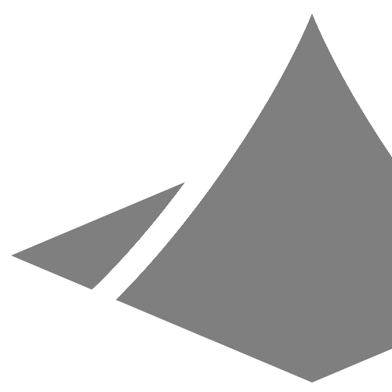

beginner tutorial

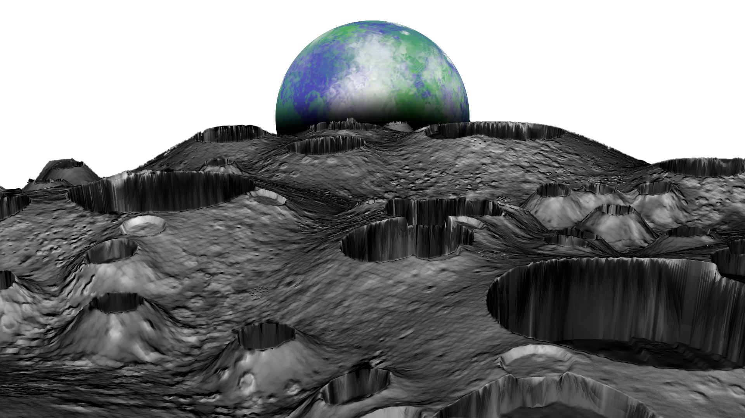
moonscape

George Tiersma
v1.0

table of contents

Introduction..............................................................................................................................
3

3

4

6

11

14

15

15

18

20

22

22

23

25

25

27

28

Preparations.................................................................................................................................................

Part I: Creating a Displacement Map.....................................................................................

Custom Brushes..........................................................................................................................................

Painting Craters...........................................................................................................................................

Using the Displacement Map................................................................................................................

Part II: Creating the Diffuse Map............................................................................................

Rocks, Holes and Small Details..............................................................................................................

Considering the Craters............................................................................................................................

Using the Diffuse Map..............................................................................................................................

Part III: Creating the Bump Map.............................................................................................

The Normal Map Filter..............................................................................................................................

Using the Bump Map................................................................................................................................

Part IV: Creating a Rendered Image.......................................................................................

Optimization.................................................................................................................................................

Positioning the Camera............................................................................................................................

Saving an Image..........................................................................................................................................

Part V: The Final Adjustments.................................................................................................
29

29

31

34

35

41

Smoothing the Crater Tips......................................................................................................................

Darkening the Crater Walls.....................................................................................................................

Adding Stars.................................................................................................................................................

Adding the Earth.........................................................................................................................................

Conclusion.................................................................................................................................

introduction

Welcome to the first tutorial for Sand Paper. This tutorial will demonstrate the basic functionality of Sand Paper. It is for users who know little or nothing about how to use Sand Paper and possibly little about image editing in general. Upon completion, the user will understand the basics of creating displacement maps, diffuse maps and bump maps for the creation of terrain in Sand Paper, as well as using Sand Paper to render an image of the terrain.

The tutorial will focus on creating an image of a lunar landscape, taking inspiration from some of NASA's famous photos from the moon.

Preparations

Before beginning this tutorial, ensure that the following software is ready for use:

- Sand Paper
- An image editor

GIMP (The GNU Image Manipulation Program) v2.10 will be used for the parts of this tutorial that involve image editing. For that reason, it is recommended that GIMP is used when following along. However, Adobe Photoshop should also be similar enough that it can be used as well. Other image-editing programs or apps may or may not have the necessary functionality.

3
part i: creating the displacement map

We will begin by creating the displacement map. The displacement map is an image that is used to change a 3D object's shape. In Sand Paper, it determines the entirety of the shape. It adjusts the position of each vertex (point) on the terrain based upon the color of a pixel in the map in the corresponding position. The terrain is the term used to refer to the main 3D object we will be working with in Sand Paper.

Most displacement maps used by 3D modeling software are colorless. However, Sand Paper uses all 3 color channels (red, green and blue).

To understand how a displacement map works in Sand Paper, look at Figures 1 and 2. Each colored square represents a vertex on the terrain. The color that we choose to make a square on the image will move the same area on the terrain. For example, if we change the color of the part of the image with the red square on the image, it will move the area with the same red square on the terrain.

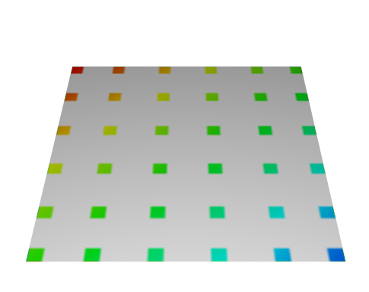
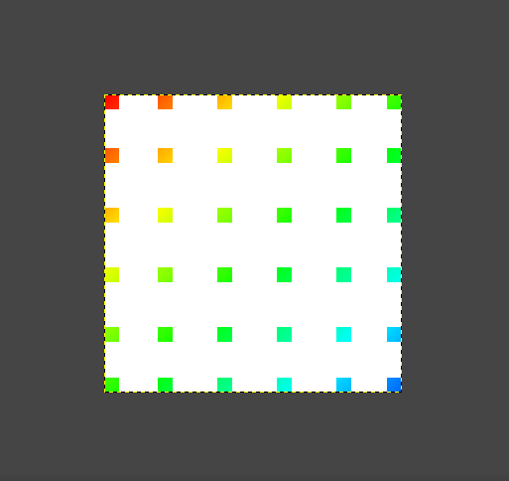

Figure 1: Vertex Positions on the terrain in Sand Paper
Figure 2: The Corresponding Pixels on the Displacement Map
4
If we want to shift a certain position of the terrain left or right, we would make the corresponding area on the displacement map either more red or less red (Figures 3 & 4).
Figure 3: Displacement Map for Shifting the Terrain's Corner to the Left
Figure 4: The Terrain Mesh Generated from the Displacement Map in Figure 3
part i: creating the displacement map
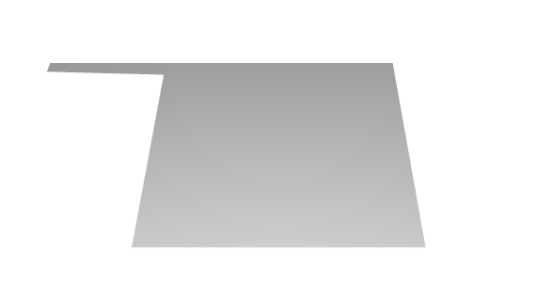
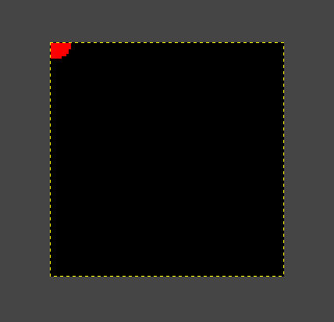

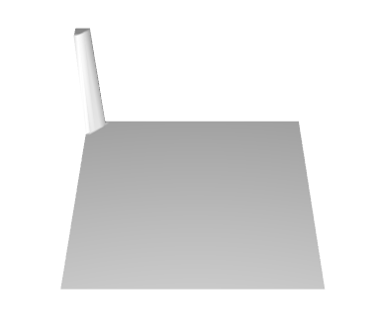
If we wanted to shift the same corner of the terrain up or down, we would use the color green (Figures 5 & 6).
Figure 5: Displacement Map for Shifting the Terrain's Corner Up
Figure 6: The Terrain Mesh Generated from the Displacement Map in Figure 5

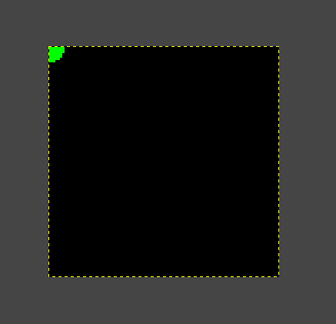

5
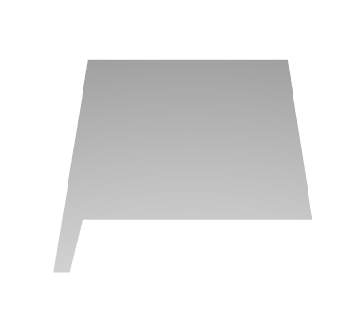
If we wanted to shift a corner forward, we would use the color blue (Figures 7 & 8).
Figure 7: Displacement Map for Shifting the Terrain's Corner Forward
Figure 8: The Terrain Mesh Generated from the Displacement Map in Figure 7
part i: creating the displacement map
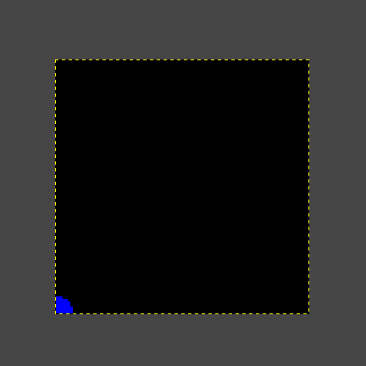

The more red a certain pixel is, the more that area of the terrain is shifted to the left. The less red a pixel is (producing a cyan color), the more it is shifted to the right. The more green a pixel is, the more it is shifted up. The less green it is (producing a magenta color), the more it is shifted down. The more blue a pixel is, the more it is shifted forward. The less blue it is (producing a yellow color), the more it is shifted backward.

Now that we understand how displacement maps are used, we will begin by creating a simple one. Our first displacement map will only use the color green, so it will only be shifted up in certain areas. When creating displacement maps for Sand Paper, green is most often the only color that needs to be used. Reds and blues are usually only needed for more advanced terrain generation with specific needs.

Custom Brushes

We will begin by creating 2 images: the displacement map and a custom brush for the displacement map.
6
- Launch GIMP (or a different image editor, if preferred).
part i: creating the displacement map
The screenshots taken of GIMP will be in single-window mode. If single-window mode is preferred, it can be activated by choosing Windows in the menu bar and then checking the option Single-Window Mode.

- To create the displacement map, on the menu bar, click File and then New... The Create a New Image dialog appears.
Set the width and height of the image to 800 pixels. Make sure the units are in pixels (px) and not inches (in) or centimeters (cm). Click OK.

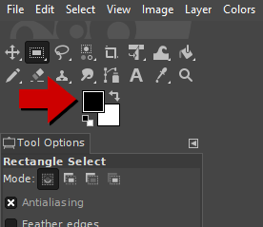
- The new image appears. Look at the active colors (Figure 9), and ensure that black is set as the foreground color.
If it is not, click the foreground color square to open the Change Foreground Color dialog, and
set the R, G and B values to 0.0. Then click OK to make the foreground color black.

- Click Edit on the menu bar, and then click Fill with FG Color. The entire image should now be black.
Figure 9: The Location of the Active Foreground Color Square
? Question: Why Black?

In the world of computer graphics, the absence of all color is black (Red: 0%, Green: 0%, Blue: 0%), and the existence of all color is white (Red: 100%, Green: 100%, Blue: 100%). Therefor, if we are to paint green (red: 0%, green: 100%, blue: 0%) on a black background, we would technically be adding green to the image, but if we were to paint green over a white background, we would technically not be adding green, but we would be subtracting red and blue from the image to make the white into green. This would cause the terrain to shift backward and to the right in the painted area, which is not what we want.

7
- Now lets create the image for a custom brush. The custom brush image that we create will be used as a pattern that will be painted over the displacement map.
part i: creating the displacement map
From the menu bar, click File and then New... The Create a New Image dialog appears.
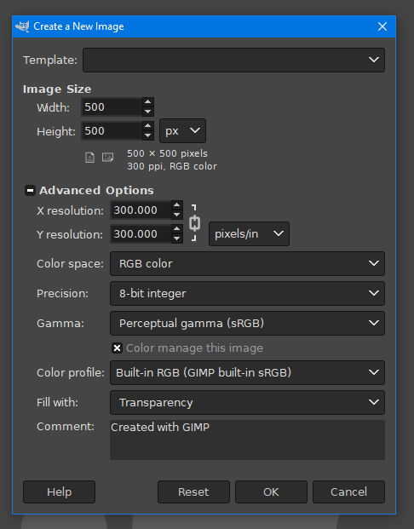
Set the width and the height to 500 px. Click Advanced Options.
Set Fill with to Transparency. The dialog should look like Figure 10.
Click OK. An empty new image appears in a new tab.

- Right click on the Rectangle Select Tool (Figure 11). Then click on the Ellipse Select Tool option that appears.
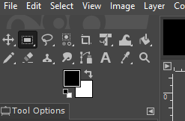
Figure 11: The Rectangle Select Tool
Figure 12: The Settings for Creating the Custom Brush Image
Figure 10: The Settings to Use When Creating the Image for the New Brush

? Question: Why is the image checkered?

Even though the new image may look like a chess board with different shades of gray in it, it is empty. It is fully transparent. Computer screens are obviously not capable of displaying a transparent color. If a screen used black to display transparency, how can we distinguish the color black from an empty pixel? The same question can be asked for white. Because of this, most graphic programs use the checkered design to represent an image that has nothing on it.

8
- Click and hold down the left mouse button while hovering the cursor over the image. While holding down the button, move the cursor to create a circle. Have the circle be about half the size of the image, and have it centered in the image. It should look like the circle in Figure 12.
part i: creating the displacement map

- Click on the active foreground color square
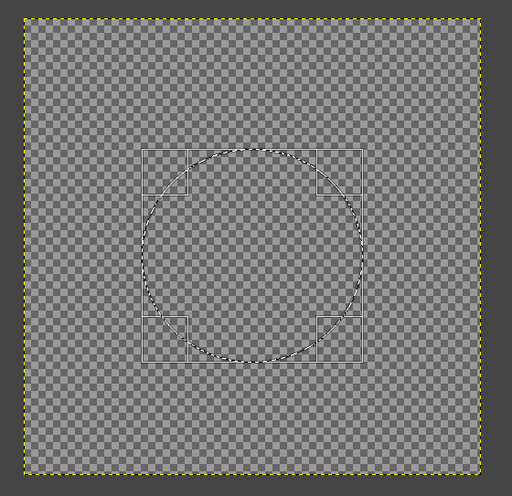
(Figure 9). The Change Foreground Color dialog appears.
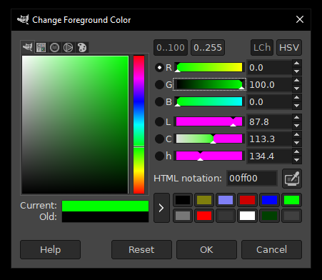
Set G (for green) to 100 and set R (for red) and B (for blue) to 0. Ensure that the settings look the same as Figure 13. Click OK.
Figure 13: Setting the Foreground Color to Green

Figure 12: Creating the Circle for the New Brush

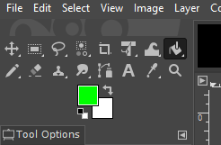

Figure 14: The Location of the Bucket Fill Tool

- Click on the Bucket Fill Tool (Figure 14), then click in the selection circle that we made on the image. We created a green circle. We are now going to make this circle into a shape that will be used to generate a crater in the terrain.
9
On the menu bar, click Filters > Blur > Gaussian Blur... The Gaussian Blur dialog appears.
part i: creating the displacement map
Set the Size X and Size Y to about 50. The circle should now be a blur. Click OK.

- Click on the active foreground color square (Figure 9) again. This time, set the foreground color to black. R, G and B should be set to 0. Click OK.

- Click on the Pencil Tool, and in the Tool Settings tab, set Size to about 150 (Figure 15). Now when we hover the cursor over the image, a circle should be seen around the cursor. This is the area that will be painted with the set foreground color whenever we click on the image.
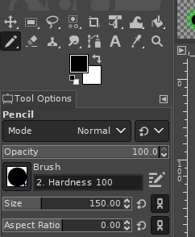
- Hover the cursor over the center of the green blur and click to create a black circle. The image should look like Figure 16.
Figure 15: Setting the Size of the Pencil Tool
Figure 16: The Finished Custom Brush
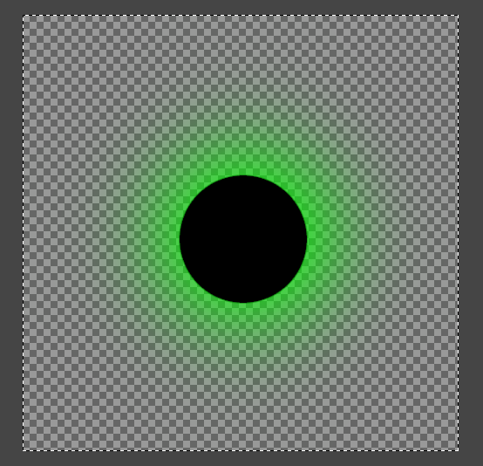

- We are now finished with the brush.
On the menu bar, click Select > All to select the entire image. Then click Edit > Copy. The copied image can now be used as a custom brush.
10
It might be difficult to envision, but this brush will be used on the displacement map to create a crater on the terrain. Remember that the more green a part of an image is, the higher it will be raised. Look at how the amount of green in the pixels changes from the image border to the image center. Notice that the green gradually increases until it drops off at the black circle. A crater's shape also gradually increases in elevation until it drops off at the hole. Thus, the brush that we made will create a crater.
part i: creating the displacement map

Painting Craters
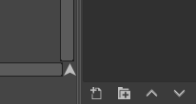
The custom brush will now be used on the map.

- Click on the tab with the small picture of the displacement map on it to change from the custom brush image if necessary.
Figure 17: The Location of the New Layer Button
Click on the New Layer button (Figure 17) which should be on the right side of GIMP (by default). The New Layer dialog box appears.
Set the name to Big Craters. The other settings can be left unchanged.
Click OK. A new layer named Big Craters appears in the list of layers (above the New Layer button).
? Question: What are Layers?

Layers are commonly used in many image-editing programs. They are used to divide the entire image into separate images, allowing the designer to work on one part of the image at a time. The best way to understand layers is to think about stickers in real life. The stickers are like separate layers, and the picture they are being put on is like the very back layer. Layers can also be thought of as a stack of picture cut-outs being arranged on top of each other. It might be difficult to see the important use of layers as a beginner, but after growing in experience, working in separate layers will prove to be a very valuable process.

11
- Right click on the Pencil Tool. A few options appear next to it.
part i: creating the displacement map
Choose the Paintbrush Tool.
On the Tool Options tab, there should be a picture of a black circle on a white square. Click that icon.
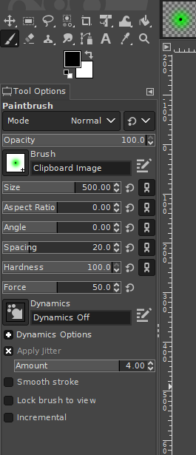
A box of different brush types appears. The brush in the top-left corner should be recognizable as the crater brush we made. Click that brush.
Set Size to about 500.
Check the box that reads Apply Jitter near the bottom of the settings. Jitter causes the paintbrush strokes to change from a smooth stroke, to spread-out speckles.
A box that reads Amount appears. Set it to 5.
Verify that the settings match what is circled in Figure 18.

- Click and drag the cursor across the image once or twice to speckle it with green circles. The image should look similar to Figure 19.
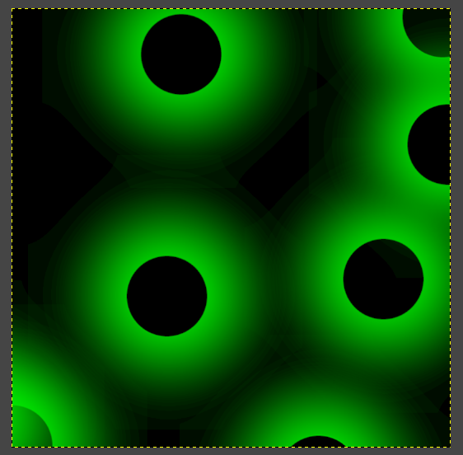
It may take a few tries. If it does not look right, click Edit > Undo on the menu bar and try again.

Figure 18: The Settings to Use When Painting Large Craters
Figure 19: The Displacement Map
12
- Repeat steps 1-3, except in step 1, name the new layer Medium Craters, and in step 2, set the Size to 300 and the Jitter Amount to 10.
part i: creating the displacement map

- Above the list of layers is the layer Opacity box. Set it to about 66 to make the Medium Craters layer 66% opaque.

- Repeat steps 1-3, except in step 1, name the new layer Small Craters, and in step 2, set the Size to 100 and the Jitter Amount to 15.
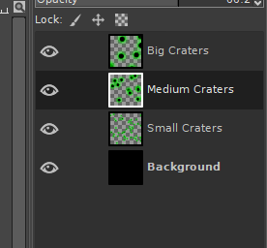
- Set the layer Opacity box to about 33 to make the Small Craters layer 33% opaque.

- Re-organize the layers in the list of layers to match Figure 20. We can move a layer further up or down the list by simply clicking and dragging a layer in the list.

- The final image should look similar to Figure 21.
Figure 20: The Final Order of Layers for the Displacement Map
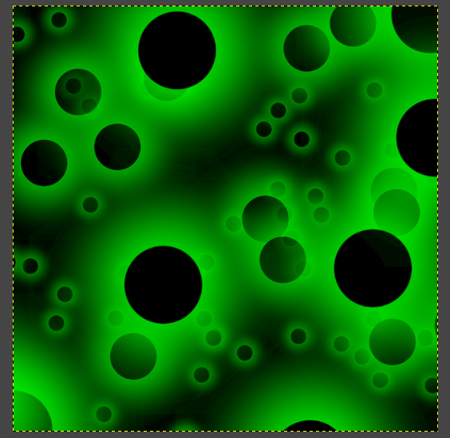
We can save the image to use with Sand Paper by clicking File > Export As... on the menu bar. In the Export Image dialog, give a memorable name and location to save it with.
Click Select File Type (By Extension) at the bottom of the dialog.
Choose PNG Image in the box that appears.
Click Export to save the image. Click Export again in the second dialog that appears.
Figure 21: The Completed Displacement Map
13
Using the Displacement Map
part i: creating the displacement map

We will now shift our focus to Sand Paper as we put the displacement map to use.

- Open Sand Paper.
On the Textures tab on the right side, there are two boxes. These boxes will contain the images we import. In this tutorial, we will only be importing colored textures, so we will only be using the top box.
Click the Add Image button in the Colored Textures box. An Open Texture dialog appears.
Choose the displacement map file and then click Open. The image appears in the Colored Textures box.

- Click on the Terrain tab. Click on the Displacement Map box and choose the displacement map. The terrain suddenly changes from being a flat surface to looking like a malformed model.

- The reason why it does not look correct is because the displacement strength is too strong. Use the Displacement Strength slider to lower the strength to almost the lowest setting. The terrain should now look similar to Figure 22.
Keep Sand Paper open for the next part of the tutorial.
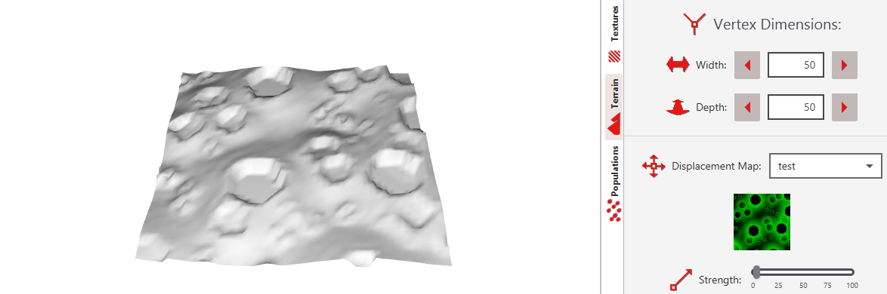
Figure 22: The Displacement Map Loaded into Sand Paper
14
part ii: creating the diffuse map

We will next create the diffuse map for the terrain so that it is not just one solid gray color.

A diffuse map is basically just a model's texture. It is the most simple type of map. It is the “wrapping paper” that covers the model. Where as other types of maps use shading and color to modify a model's appearance, the diffuse map is literally the model's appearance.

Rocks, Holes and Small Details

For our moonscape image, we will need a texture that looks similar to the rocky surface of the moon.

- Open GIMP.

- On the menu bar, click File > New... to create a new image. The Create a New Image dialog appears.
Set the width and height to 2000 pixels.

- Click the foreground color square (Figure 9). Set the Red, Green and Blue (R, G and B) each to 50 (Similar to what was done in Figure 13). This should make a gray color. Click OK.

- On the menu bar, click Edit > Fill with FG Color to make the image gray.

- Click the New Layer button (Figure 17). Name the new layer Rocks. Click OK.
15
- Click the foreground color square. Set R, G and B to 80. Click OK.
part ii: creating the diffuse map

- Choose the Paintbrush tool (the tool selected in Figure 18).
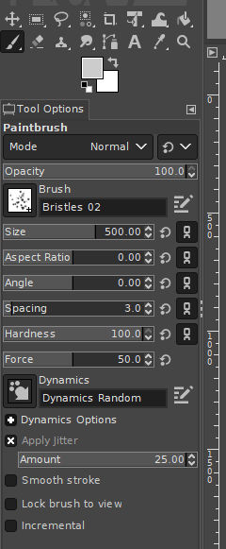
In the Tool Options tab, click the square button next to Brush. A box of options for different brushes appears. Choose a brush that would be good for painting rocks, such as the Bristles 02 brush.
Set the Size to 500.
Click the Paint Dynamics button (the square button with an arrow pointing down and to the right). In the list that appears, choose Dynamics Random. Dynamics control how the brush is to paint on the image. The Dynamics Random settings causes the brush to rapidly and randomly change size as we paint. This is useful for painting rocks since we want all the rocks to have a different shape, size and position.
Check the Apply Jitter check box and set the Amount to 25.
Ensure that the settings match Figure 23.
Figure 23: The Paintbrush Settings to Use When Painting the Rocks

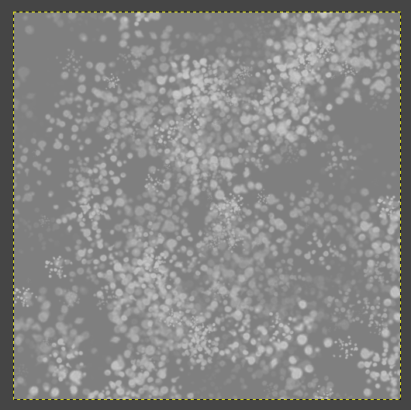
- Press and hold the left mouse button over the image and quickly
move the cursor all over the image. It should
now look similar to Figure 24. If it does not, feel free to undo and
Figure 24: A Rocky Texture
try again.
16
- Click the New Layer button to create another new layer. Name it Holes.
part ii: creating the diffuse map

- Click the foreground color square again. This time, set R, G, and B to 0 to make a black color.

- With the Paintbrush Tool selected, choose a brush that would be good for painting small holes, such as Bristles 03.
Ensure that the Size is still set to 500, as well as all of the other settings we changed in step 7.

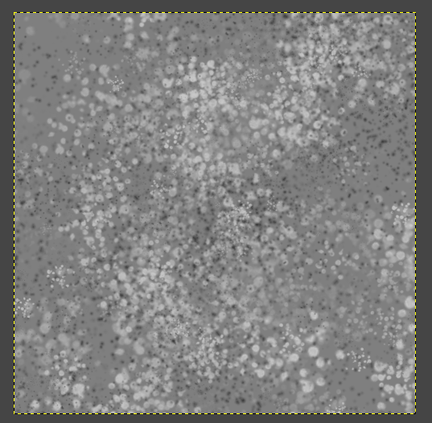
- Press and hold the left mouse button over the image and quickly move the cursor all over the image. It should now look similar to Figure 25.
If it does not, feel free to undo and try again.
Figure 25: The Texture of Rocks and Holes

- Click the New Layer button to create another new layer. Name it Small Details.

- Click the foreground color square again. This time, set R, G, and B to 20 to make a dark gray color.

- With the Paintbrush Tool selected, choose a brush that would work well for additional detail on the moon's surface.
Paint over the image.
Feel free to undo and experiment by adjusting the settings such as the Size and Jitter Amount to what seems to look best for the chosen brush.
17
- Re-organize the layers by clicking and dragging them into the order that looks the best. The image should now look like the moon's terrain (Figure 26).
part ii: creating the diffuse map

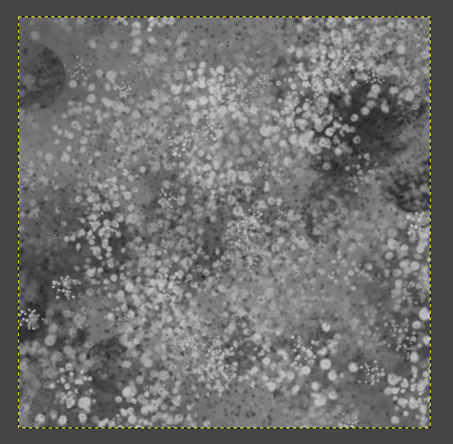
Considering the Craters

Our texture has one last issue that needs to addressed:
the craters.

Using the texture as it is right now, the high points of the craters will have just as much rock and holes as the low points on the moon. Try to envision a moonscape. It
Figure 26: The Moon Texture
would probably look better to have the tops of the craters void of this detail. Lets address this issue.

- On the menu bar, click File > Open... The Open Image dialog appears. Choose the displacement map that we created previously. Click OK. The map opens in a new tab.

- On the menu bar, click Image > Scale Image... to make the image bigger. Set the width and height to 2000 so that it will match the size of our diffuse map. Click Scale.

- On the menu bar, click Select > All and then Edit > Copy. The displacement map has been copied to the clipboard.

- Return to the diffuse map by clicking on its tab. On the menu bar, click Edit > Paste as > New Layer. The displacement map becomes a new layer that covers the image.

18
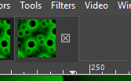
- We no longer need the original displacement map open. Click the tab for the displacement map. We can close it by clicking the small x that appears on the tab (Figure 27).
part ii: creating the diffuse map
After clicking that, a dialog appears asking if the changes should be saved. Click Discard Changes so that we do not needlessly save the displacement map as a larger image.
Figure 27: The Button to Close the Active Image

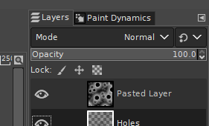
- Now that we are back to the diffuse map, on the menu bar, click on Colors > Saturation... In the dialog that appears, set Scale to 0. Click OK. The layer's green color now changes to a light gray.

- With the Pasted Layer layer selected, click the layer mode (Figure 28) and change it to Addition. The Addition layer mode causes the dark parts of the layer to become invisible.
Figure 28: The Location to Set the Layer Mode
? Question: What are Layer Modes?
A layer mode determines how a layer should cover the layers below it. Every single layer has its own layer mode. By default, a layer has a normal mode. The normal blending mode causes the layer to simply cover the layers below it with its own pixels. This is the only mode we have used so far, and it is the most common mode used. Other modes can have many different effects, such as darkening or lighting the layers below it, adding or removing color from the layers below it, changing the color from the layers below it, etc. How dark or light or how much color is at a certain part of the image determines the strength of the layer mode. Layer modes may sound complicated, but they are really easy to use. Simply experiment with different layer modes on different layers to see how it changes the image, then choose the best one. This is the easiest and best approach.

19
- The final image should now look similar to Figure 29. By looking at the texture, notice that the higher areas on the image (the craters) are now less detailed.
part ii: creating the diffuse map
On the menu bar, click File > Export As... to export the image. Give it a memorable name and ensure that it is exporting in PNG format, then click Export. When the second dialog appears, click Export again.
Figure 29: The Finished Diffuse Map
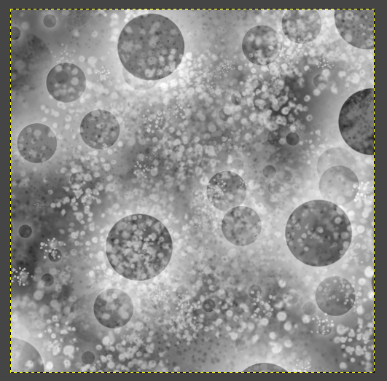

Using the Diffusion Map

Now that our diffusion map is finished, we can import it into Sand Paper.

- Back in Sand Paper, click on the Textures tab.

- Click on the Add Image button in the Color Textures box. The Open Texture dialog appears. Choose the diffuse map image and then click Open. The diffuse map appears in the Color Textures box.

- Click on the Terrain tab.
20
- Scroll down and click on the box next to Diffuse Map. Choose the name of the diffuse map. The map loads into the terrain. Sand Paper should look similar to Figure 30.
part ii: creating the diffuse map
Leave Sand Paper open for the later parts of this tutorial.
Figure 30: The Displacement and Diffuse Maps Loaded into the Terrain
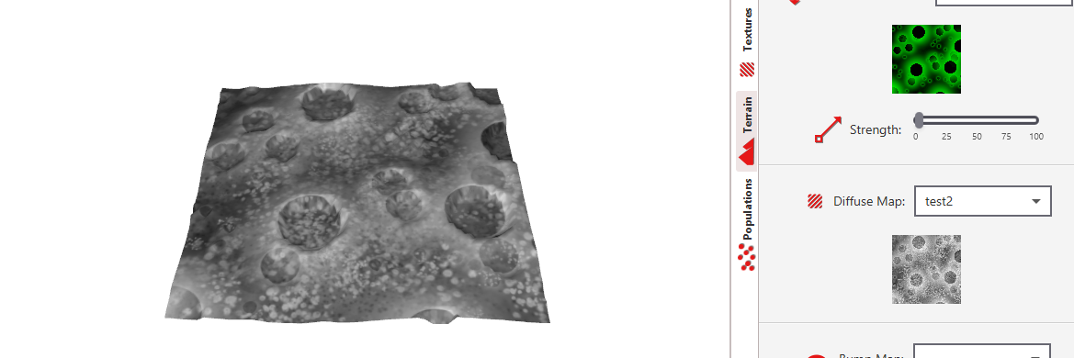

21
part iii: creating the bump map

The final map that we will design is known as a bump map. The map gets its name “bump” because it is used to cause small shifts in shape, useful for making bumps, as well as cracks, wrinkles or any other small details.

This sounds almost like the same purpose as a displacement map, but there is a difference. Displacement maps are used for large shifts in shape and bump maps are for small shifts in shape. (However, to be technically clear, bump maps do not shift the shape at all, but makes it appear as if the shape has been shifted.)

Bump maps are also interpreted differently than displacement maps. Some software use colorless bump maps, but Sand Paper use a type of bump map known as a normal map. Normal maps provide better quality detail than standard bump maps, but unfortunately, they are difficult to create (even by skilled graphics artists). Fortunately, GIMP provides a filter to automatically generate the map for us.

The Normal Map Filter

We will use our diffuse map to create our bump map. GIMP can use a filter on our diffuse map to create a bump map. If GIMP is not being used, there is also other free software available that is capable of generating normal maps.

- Open GIMP.

- On the menu bar, click File > Open... The Open Image dialog appears. Locate the diffuse map we made previously and then click Open.
22
- On the menu bar, click Filters > Generic > Normal Map... The Normal Map dialog appears.
part iii: creating the bump map
Set the Scale to 20 to make the map more intense.
The bump map should look similar to Figure 31.
Click OK.

- On the menu bar, click File > Export As... to export the image. Give it a memorable name and ensure that it is exporting in a PNG format, then click Export. When the second dialog appears, click Export again.
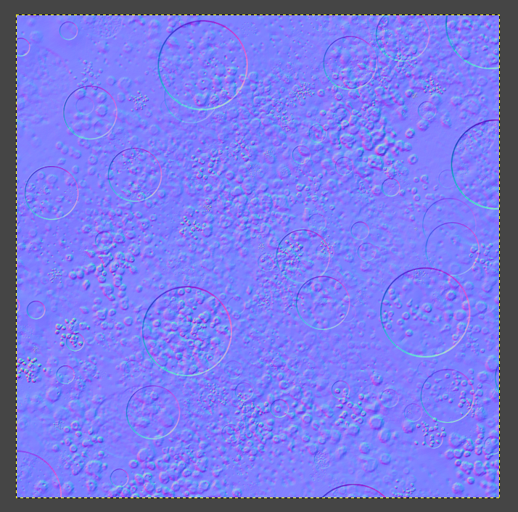
Figure 31: The Bump Map

Using the Bump Map

Bump maps are used in Sand Paper nearly the same way as diffuse maps.

- Back in Sand Paper, click the Textures tab.

23
- Click on the Add Image button in the Color Textures box. The Open Texture dialog appears. Locate the bump map and then click Open. The bump map appears in the Color Textures box.
part iii: creating the bump map

- Click on the Terrain tab.

- Scroll down to Bump Map. Click the box there and choose the name of the bump map. The bump map is loaded into the terrain.
Sand Paper should look similar to Figure 32.
Leave Sand Paper open for the next part of this tutorial.
Figure 32: Sand Paper with the Displacement, Diffuse and Bump Maps Loaded in the Terrain

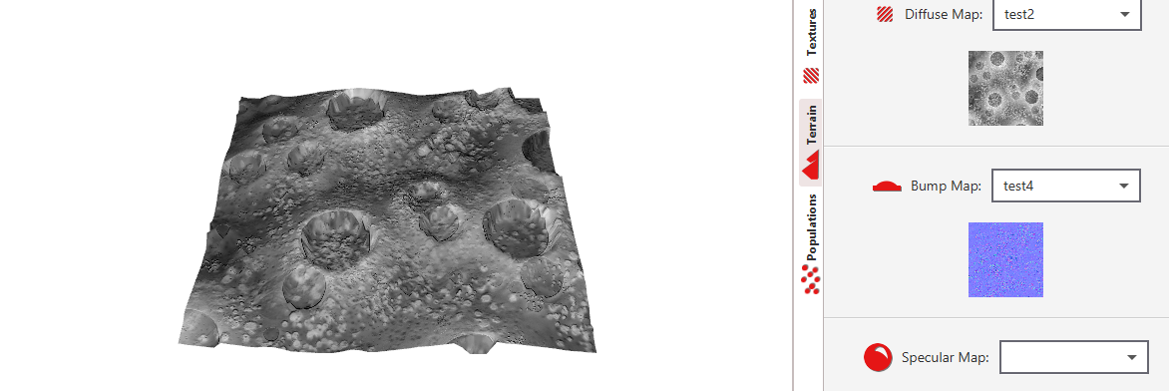

24
part iv: creating a rendered image

Our mesh of the moon's terrain is finished. We will now need to prepare Sand Paper for turning the moonscape into an image the way we want it.

Optimization

What we must now focus on is optimizing the terrain. In other words, we need to have the terrain look as good as it needs to, while still being feasible on the system's resources. Generating 3D models can be very power intensive (even on modern PCs).

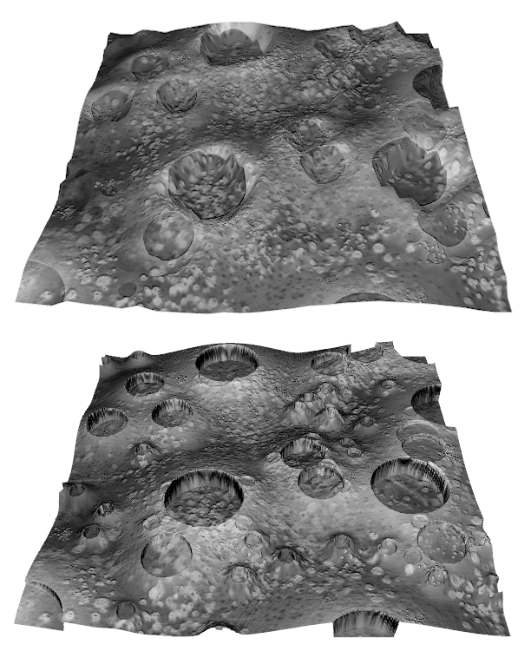
We will specifically be optimizing the terrain's vertex dimensions. The vertex dimensions are the number of vertices (or points in the terrain to which it is raised or lowered) deep and wide that are contained in the terrain. Figure 33 compares the moonscape with low vertex dimensions and high dimensions.

Notice that it looks like the craters on our terrain are jagged and do not line up perfectly with our textures. This is caused by low vertex dimensions
Figure 33: The Moonscape Terrain with Low Vertex Dimensions of 30x30 (top) verses High Vertex Dimensions of 500x500 (Bottom)
in the terrain. By default, the terrain in Sand Paper begins with vertex dimensions of only 50x50 (50 x 50 = 2500 total vertices). The reason for this is to allow Sand Paper to be able to make changes to the terrain quickly on any PC that is capable of running it. However, now that we are about to render an image from it, quality is much more important than time, so we will carefully increase the vertex dimensions to get the best quality we can, without pushing our PC to the point that it may hang.
25

- In Sand Paper, click the Terrain tab. We will incrementally increase the vertex dimensions to find out how much quality the PC can handle.

- Set both of the Vertex Dimensions Width and Depth to 250. After making the changes, if it pauses for a couple of seconds while the terrain refreshes, skip to step 6. Otherwise, continue to the next step.

- Set both of the Vertex Dimensions Width and Depth to 400. After making the changes, if it pauses for a couple of seconds while the terrain refreshes, skip to step 6. Otherwise, continue to the next step.

- Set both of the Vertex Dimensions Width and Depth to 500. After making the changes, if it pauses for a couple of seconds while the terrain refreshes, skip step 6. Otherwise, continue to the next step.

- Set both of the Vertex Dimensions Width and Depth to 600.
By now, the quality should be better than we even need it, so there is no need to make it higher. The quality technically would not get any better over 800 anyway, since that is the displacement map's dimension in pixels.

- The terrain's displacement map may appear to be getting weaker each time the vertex dimensions are increased. In reality, that is not the case. It just appears so much weaker because the terrain is so much bigger.
To fix this, re-adjust the Displacement Strength to what currently looks the best.
26
Positioning the Camera
part iv: creating a rendered image

Just like a camera in real life, the camera in Sand Paper (like most 3D modeling applications) can be moved and rotated around the 3D scene for the perfect shot.

Sand Paper has a camera that automatically centers itself on the terrain whenever the shape of terrain changes. However, this does not always work as we desire. The camera probably zoomed in further after completing the last section, so we will adjust that here as well.

- In Sand Paper, click on the Camera tab located on the bottom pane.

- Under Angle, use the slider next to Vertical to rotate the camera vertically around the terrain. Set it at an angle so that the camera is about eye-level (about 15 degrees).

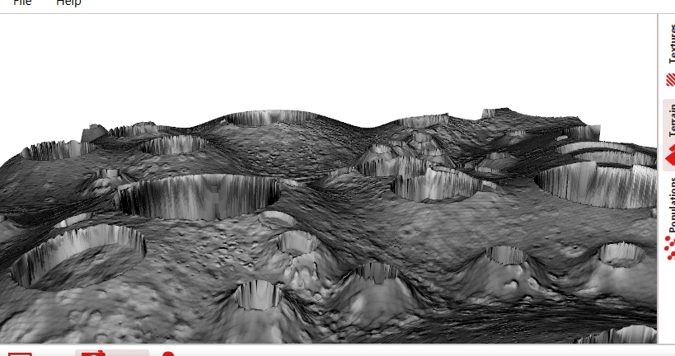
- Experiment with using the box next to Z (with the magnifying glass), to zoom the camera to the right amount. Higher, positive numbers will zoom the camera in, and lower, negative numbers will zoom out. Zoom the camera so that the front edge of the terrain is not visible, but the back 2 corners are visible (Similar to Figure 34).
Figure 34: The Moonscape Terrain at a Good Zoom for Rendering the Image
If the terrain has 600x600 vertex dimensions, setting the zoom to -800 is a good value. The value should be higher if the vertex dimensions are much less.

27
- Under Angle, use the slider next to Horizontal to rotate the camera horizontally around the terrain. Find an angle that aesthetically looks the best.
part iv: creating a rendered image

Saving an Image

Our moonscape terrain looks as good as we can make it look in Sand Paper, so it is time to render an image of it.

- In Sand Paper, click on the Render tab.

- Click the Background Color box and choose the black color.

- The Width and Height under Resolution will be the size of the rendered image (in pixels). Feel free to adjust these if desired, otherwise, leave them at 1920x1080.

- On the menu bar, click File > Save As... A Save Image Render dialog appears. Give the image a memorable name and location. Click Save.

28
part v: the final adjustments

Our work involved with Sand Paper is done for this tutorial. From Sand Paper, we will now return to GIMP to perform our finishing fixes and improvements.

Smoothing the Crater Tips

Looking at the image that Sand Paper generated for us, we can notice that some of the craters have unusual pointed edges. Thankfully, GIMP can patch it up fairly easy.

- Open GIMP.

- On the menu bar, click File > Open... The Open Image dialog appears.
Locate the image we exported from Sand Paper and then click Open. The moonscape image appears.

- Underneath the list of layers, click the New Layer button (Figure 17). The New Layer dialog appears. Set the name to Crater Edge Fix and click OK.

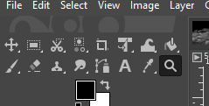
- Click on the Zoom Tool (Figure 35). In the Tool Options tab, make sure that Zoom in is selected.

- Click on a crater that has jagged edges in the image to zoom in on it.
Figure 35: The Zoom Tool
Keep clicking on it until the crater fills most of GIMP's screen.
29
- Right click on the Clone Tool (Figure 36). In the box that appears, select the Heal Tool.
part v: the final adjustments
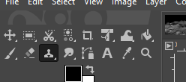
- On the Tool Options tab, set the Brush to Hardness 100.
Set the Size to 20. Feel free to adjust the size as needed while using the heal tool.
At the bottom of the options, check the Sample merged check box.
Figure 36: The Clone Tool
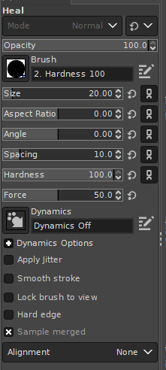
The settings should match Figure 37.

- To use the heal tool, hold the Control button and click an area of the moon's surface near the spike on the crater. Now click on and a little around the spike to remove the spike (Figure 38).
Technically, the spike is not being removed, but it is being covered. We are painting the first area we clicked on over the spike. The Crater Tip Fix layer is just covering the spike.

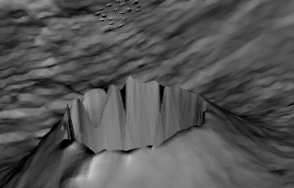
Figure 37: The Settings to Use for the Heal Tool
Figure 38: The Area to Click First Circled in Red with the Area to Paint Over Circled in Blue

30
- Remove all of the odd spikes on the crater.
part v: the final adjustments
Figure 39 shows what the crater should look like before the heal tool is used and after.
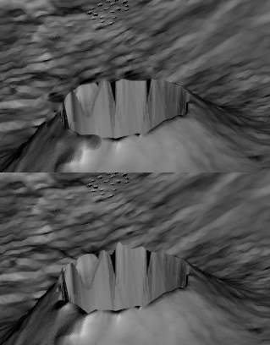
- Click the Zoom Tool (Figure 35). In the Tool Options tab, ensure that Zoom out is selected.

- Click anywhere in the image a few times to zoom out on the image. Zoom out until the entire image is visible.

- Repeat steps 5-11 only on a different crater with strange spikes on it. Repeat this until there are no longer any strange spikes on any craters.
Figure 39: The Crater Before the Heal Tool is Used on the Bottom and After on the Top

Darkening the Crater Walls

The other notable issue involving the craters is that they look too bright on the inside. Making them darker will make the craters appear more natural.

- Underneath the list of layers, click the New Layer button (Figure 17). The New Layer dialog appears. Set the name to Darken Craters and click OK.

- Click on the Zoom Tool (Figure 35). In the Tool Options tab, make sure that Zoom in is selected.

- Click on a crater in the image.
Keep clicking on it until the crater fills most of GIMP's screen.
31
- Right click the Free Select Tool (Figure 40), and then click the Scissors Tool.
part v: the final adjustments
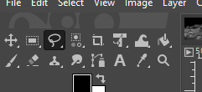
The Scissors Tool is used for choosing a piece of the picture to perform an action with (similar to how scissors in real life can be used to cut-out and separate a piece of a picture for a certain purpose).
Figure 40: The Free Select Tool

- On the Tool Options tab, check the box that reads Feather Edges and set Amount to 3.
Feather Edges will help blend the area that we will select with the Scissors Tool with its surroundings just a little bit. This will keep what we change from looking noticeably fake.

- Use the scissors tool to select the crater. How we go about doing that is kind of like playing connect-the-dots on a paper, except we place the dots and the computer connects them.
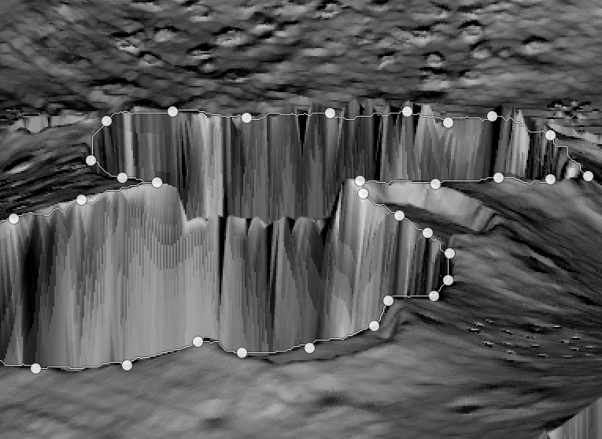
Click on the edge of the crater to create a dot. Click a little further on the edge to create another dot. The computer looks for a line in the image (in this case, the line is the edge of the crater) between the two dots and connects them.
Click a little further on the edge of the crater to create another dot. The computer connects the second dot to this third dot.
Figure 41: Using the Scissors Tool to Select a Couple of Craters
Keep clicking around the crater until the line is nearly all the way around the crater (Figure 41).
32
The lines do not need to be perfect, but if the computer creates a line that is too far off the edge, click and hold the left mouse button on the line to split the line with another dot, and drag it to where it should go.
part v: the final adjustments
Once there is a line completely around the crater, click the first dot to complete the shape.
Press Enter. The shape becomes our selection.

- Ensure that the foreground color square (Figure 9) is set to black (R: 0, G: 0, B: 0).

- On the menu bar, click Edit > Fill with FG Color. The crater is covered with black.

- Click the Zoom Tool (Figure 35). In the Tool Options tab, ensure that Zoom out is selected.

- Click anywhere in the image a few times to zoom out on the image. Zoom out until the entire image is visible.

- Repeat steps 2-10 with a different crater. Keep repeating those steps until all of the craters are covered with black. Very short craters can be skipped.

- Above the list of layers, click the box that Mode can be read on it and choose Overlay to change the blending mode to overlay.
A blending mode determines how the layer should change the layer below it. Blending modes may darken, lighten, change colors or cause various other changes.
The black covering the craters is now used to darken the craters that it is covering.

33
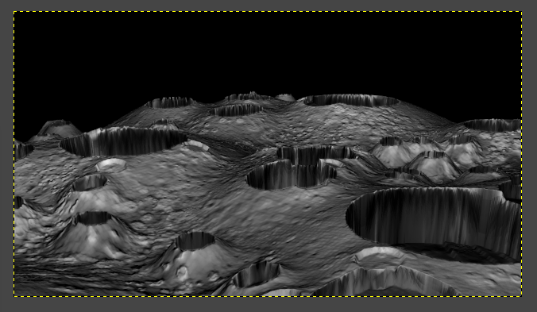
- Underneath the blending modes box, set the layer's Opacity to 90 to make the craters a little lighter.
part v: the final adjustments
The craters should look similar to the craters in Figure 42.

Figure 42: The Moonscape with Darkened Craters
Adding Stars
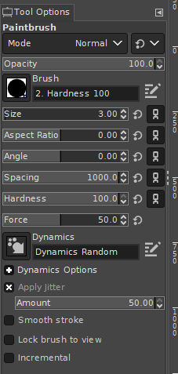
Now that our issues are fixed, lets add a few things to further enhance the image. We will first place some stars in the background to further give the appearance of being in space.

- Underneath the list of layers, click the New Layer button (Figure 17). The New Layer dialog appears. Set the name to Stars and click OK.

- Select the Paintbrush Tool.
On the Tool Options tab, set the brush to Hardness 100.
Set the Size to 3.
Set the Spacing to 1000.
Set the Dynamics to Dynamics Random.
Check the Apply Jitter check box. The Amount box appears below it.
Set Amount to 50.
Figure 43: The Settings to Use for Painting the Stars
The Tool Options tab should look like Figure 43.
34
- By clicking and dragging the left mouse button, paint back and forth along the black background on the image until a realistic amount of stars cover the background.
part v: the final adjustments
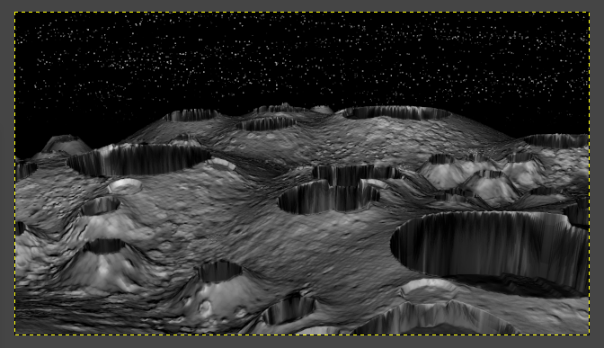
The image should now look similar to Figure 44.
Figure 44: The Moonscape with Stars in the Background

Adding the Earth

Even with the stars, the background of our picture feels a little empty. Lets give it a planet.

- On the menu bar, click File > New... The Create a New Image dialog appears.
Set the Width and Height to 500 pixels (px). Click OK.

- Click on the foreground color square (Figure 9). The Change Foreground Color dialog appears.
Set the color to a dull blue color (R: 30, G: 30, B: 70). Click OK.

- On the menu bar, click Edit > Fill with FG Color. The image is filled with the blue color.

- Click the foreground color square (Figure 9). The Change Foreground Color dialog appears.
35
Set the color to a dull green color (R: 30, G: 70, B: 30). Click OK.
part v: the final adjustments

- Click the Paintbrush tool.
Under the Tool Options tab, change the brush to one that would be useful for painting land, such as Grunge 01.
Set Size to 250.
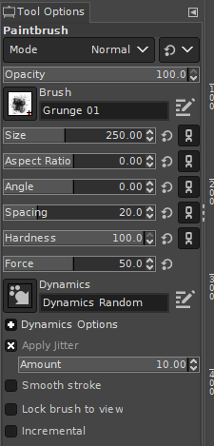
Set Dynamics to Dynamics Random.
Check the Apply Jitter check box. An Amount box appears underneath it.
Set the Amount to 10.
The tool options should look like Figure 45.

- Click and drag the cursor over the image to paint land. The image should look similar to Figure 46.
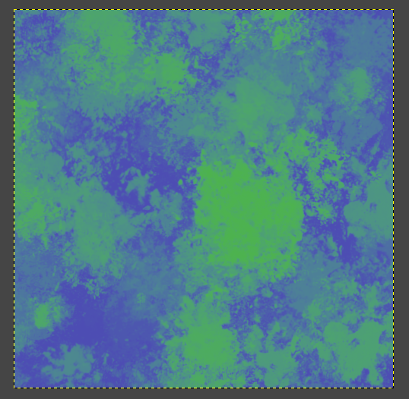
If the land does not look good, on the menu bar, click Edit > Undo and try again.
Figure 45: The Tool Options to Use when Painting the Land on the Earth
Figure 46: The Water and Land for Creating the Earth

36
- Click the foreground color square (Figure 9). The Change Foreground Color dialog appears.
part v: the final adjustments
Set the color to white (R: 100, G: 100, B: 100). Click OK.

- On the Tool Options tab, choose a brush that would be good for painting clouds, such as Texture 01.

- Click and drag the cursor over the image to paint some clouds.
If the clouds do not look good, on the menu bar, click Edit > Undo and try again.

- On the menu bar, click Filters > Distorts > Apply Lens... The Apply Lens dialog appears.
Leave the Lens refraction index at 1.7 and click OK. The image should look like there is a sphere on it.

- Right click the Rectangle Select Tool (Figure 11) and click the Ellipse Select Tool.

- On the Tool Options tab, uncheck the Feather edges check box if it is checked.

- Click and hold the left mouse button on one of the corners of the image, and drag the cursor to the opposite corner. There should now be a dotted-line selection circle perfectly surrounding the Earth.

- On the menu bar, click Edit > Copy to copy everything in the selection circle.

- Click on the tab with the picture of our moonscape on it to return to our moonscape image.
37
- Click the New Layer button (Figure 17). The New Layer dialog appears.
part v: the final adjustments
Set the name to Earth. Click OK. A layer named Earth appears in the list of layers.

- On the menu bar, click Edit > Paste. The Earth appears over our image.

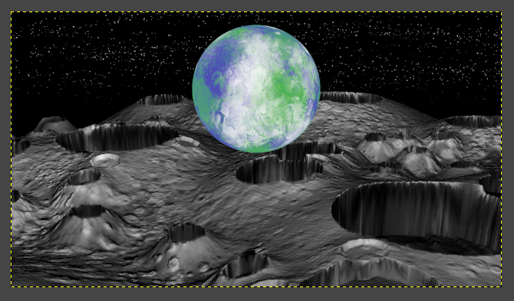
- Move the Earth by clicking and dragging it, so that it is positioned similar to how it is in Figure 47.
Figure 47: The Earth Positioned over the Moonscape


- Underneath the list of layers, click the Add Mask button (Figure 48). The Add Layer Mask dialog appears.
Choose White (full opacity) and click Add. A white square appears next to the Earth layer. This is a miniature picture of the mask. Since it is completely white, the Earth is completely visible.
Figure 48: The Add Mask
? Question: What are Layer Masks?

A layer mask is an invisible black & white image that is used with a layer to hide parts of the layer. Think of how (in real life) a mask hides a part of someone's face. In GIMP, masks work the same way. The black portion of the mask works to hide that part of a layer making it transparent, while the white keeps it visible. Gray areas are partially opaque, depending on how light they are.
38
Notice that the border around the image is now a green dotted line instead of yellow. Whenever the border is green, this means that a mask is currently being edited
part v: the final adjustments
and not the actual layer.

- Click the foreground color square (Figure 9). The Change Foreground Color dialog appears. Set the color to black (R: 0, G: 0, B: 0).
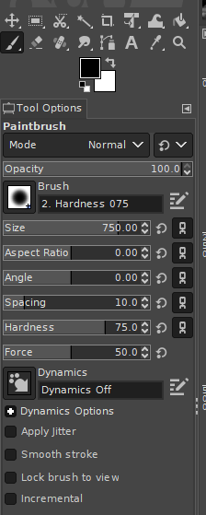
- Select the Paintbrush Tool.
On the Tool Options tab, set the Brush to Hardness 075.
Set the Size to 750.
The Tool Options tab should look like Figure 49.

- Click on the image and drag the cursor over the bottom half of the Earth to paint over the portion of the Earth that covers the moon.
That portion of the Earth is hidden, giving the appearance that the Earth is in the distance.
Notice that the miniature preview of the mask on the layer list next to the Earth layer now has a black spot. That is what we just painted, causing that part of the Earth to disappear.
If too much of the Earth disappeared, change the foreground color to white and paint with that color to make part of the Earth reappear.

Figure 49: The Options to Use when Painting on the Earth's Mask
39
- The image should look similar to Figure 50.
part v: the final adjustments
To save the image, on the menu bar, click File > Export... The Export Image dialog appears.
Give the image a name and then click Export. Click the Export button again in the next dialog that appears.
We can also save the project file so that we can return to this and edit it further. Unlike the PNG image we exported, the project file will contain all of the separate layers along with their settings.
To save the project, on the menu bar, click File > Save. The Save Image dialog appears.
Give the image a name and then click Save.
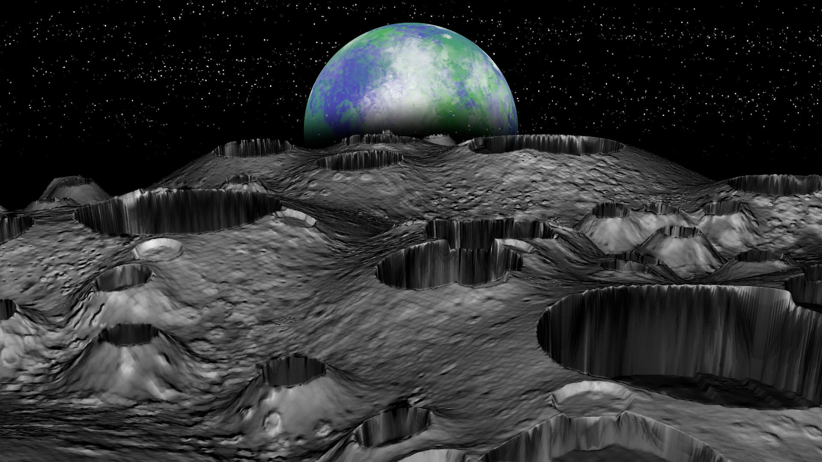
Figure 50: The Finished Moonscape Image

40
conclusion

Congratulations with completing this tutorial. Through completion, we should now have a basic understanding of how to use both GIMP and Sand Paper. More specifically, we know how to accomplish the following:

- Create a simple displacement map utilizing the green color channel
- Create a brush
- Utilize multiple layers to create an image
- Paint various texture patterns
- Create a normals bump map
- Use displacement, diffuse and bump maps to create the terrain
- Optimize the terrain's vertex dimensions for the ideal balance of quality and performance
- Set the camera position
- Set the camera zoom
- Fix small abnormalities in an image
- Utilize layer masks

Enjoy Sand Paper, and thank you for participating in this tutorial.
41

