Class Diagram & Modules Subdivision

# Modules Subdivision

Game

This is the main module of the application. It contains the whole game and is used to initialize, loop and finalize the application.

Graphics

This module will deal with the Graphics Engine (Ogre), and will be in charge of initialize, configure and finalize it.

Input

The Input module deals with User Input. It is in charge of receiving Input events from input devices (mouse, keyboard, joystick(s)) and send them to all registered listeners. The InputManager is the sub-module that manages all this. A class that wants to receive user input events will have to implement the InputListener interface and register itself to the InputManager.

Audio

The Audio manager is the module that abstracts the audio layer.

Data

The Data manager will be in charge of loading/saving resources from disk. It will offer a common interface to data and resources.

Physics

The physics engine will be implemented and controlled by the Physics module. A PhysicsManager will offer a standard interface to the underlying physics engine. A ParticleSystemsManager will manage all particle systems we will add.

Camera

This module will deal with cameras. Since a lot of different cameras will be handled in the game, a Camera Manager will be used to manage them all.

GUI

The GUI module will help dealing with the GUI, not only

Logic

The Logic module wil deal with game’s logic, enemies AI, and in a general way will manage scripts.

Entity

The Entity module will manage all entities (players, enemies, items) in the game.

States

States are managed by a StatesManager, that will listen to user input, and accordingly to game’s logic will change the current state.

## Game Loop

The Big Picture

Initialization

The Loop

Finalize

# Class Diagram

## The StatesManager and the game states



## The EntityManager and its subclasses

The Entity Manager is the base class used to manage all the ‘entities’ in the game. With the term entity we refer to all the things a player can interact with, and that can change their internal status, and that can receive user input, or follow some kind of logic, physics, AI. For instance, a Wyvern is an entity (controlled by the player, subject to physics, can change its status…), just like an enemy (soldier, wizard) or an item (power up).

An object in the scene is an item if and only if the player can interact with it (a rock that can be destroyed, a house that can be destroyed, a tree that can be destroyed… well the game is about destroying stuff). If an object is just part of the scenery, it does not need to be managed by this kind of manager (the ground, the sky, background hills and mountains).

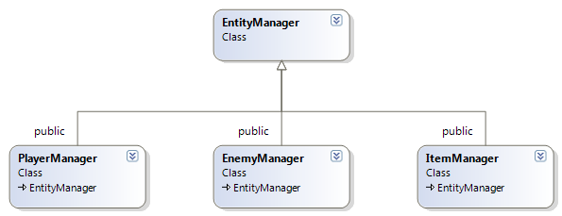

## GraphicsManager



## InputManager

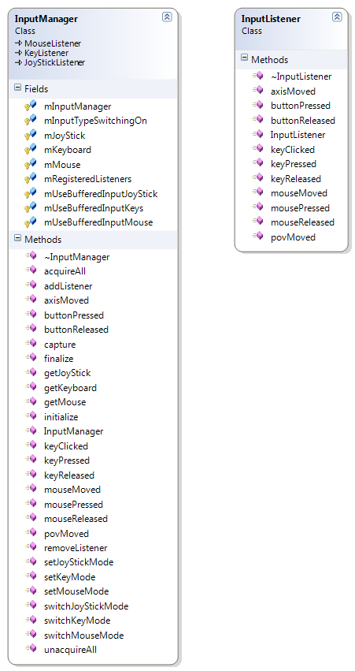

## The SceneLoader and the XML Parser

