**Checkmate u8**

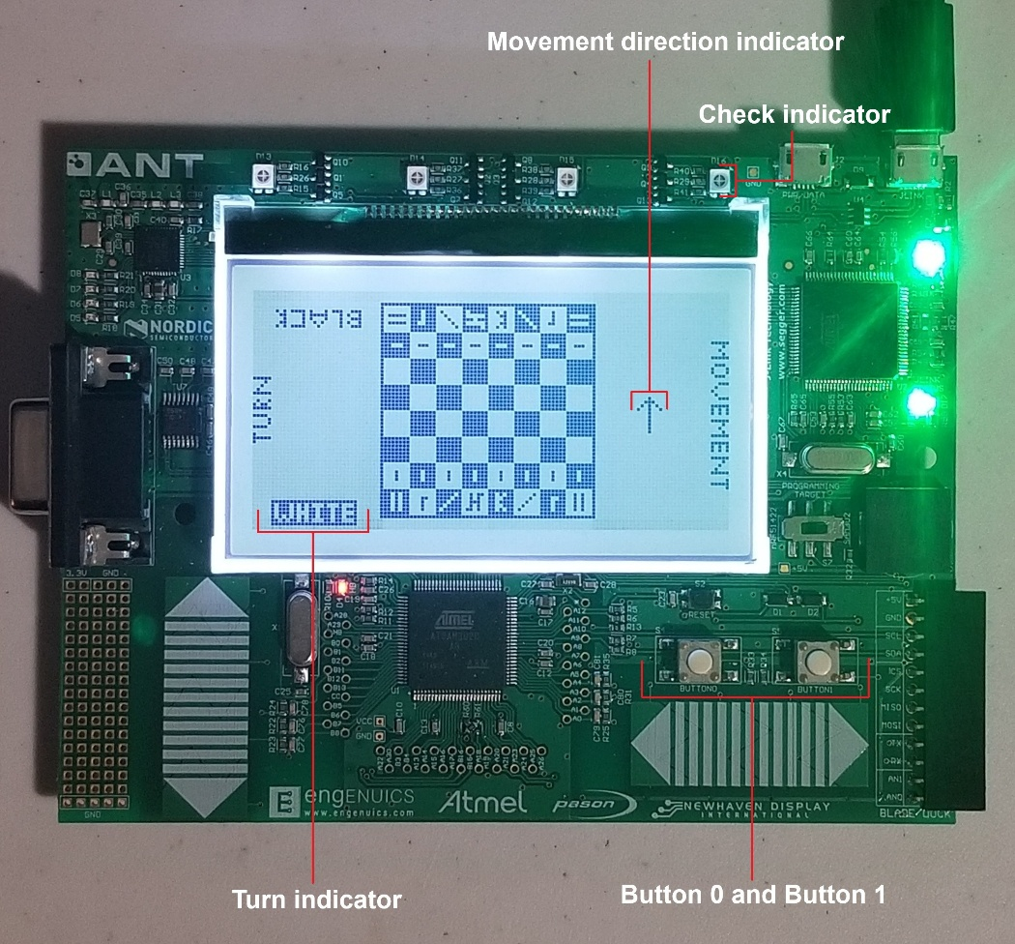 **Pieces Interface**

|  |  |  |
| --- | --- | --- |
|  | White | Black |
| Pawn |  |  |
| Knight |  |  |
| Bishop |  |  |
| Rook |  |  |
| Queen |  |  |
| King |  |  |

**Controls**

**Movement direction selection**

Open direction selection menu ––– hold button 0 for a half second

Cycle through direction options ––– button 0

Select direction / close direction selection menu ––– button 1

**Making moves**

Move highlighted square ––– button 0

Select highlighted square ––– button 1

Cycle through pawn promotion options ––– button 0

Select pawn promotion option ––– button 1

Resign ––– hold button 0 for five seconds