

Resource Assessment Economic Filter (RAEF)—A Graphical User Interface supporting implementation of simple engineering mine cost analyses of quantitative mineral resource assessment simulations

By Jason L. Shapiro and Gilpin R. Robinson Jr.

Chapter XX of

Section C, Computer Programs

Book 7, Automated Data Processing and Computations

Software support for probability calculations in three-part mineral resource assessments

Techniques and Methods X-XXX

U.S. Department of the Interior

U.S. Geological Survey

U.S. Department of the Interior

RYAN K. ZINKE, Secretary

U.S. Geological Survey

James F. Reilly, Director

U.S. Geological Survey, Reston, Virginia: 2018

For more information on the USGS—the Federal source for science about the Earth,  
its natural and living resources, natural hazards, and the environment—visit  
<https://www.usgs.gov>/ or call 1–888–ASK–USGS (1–888–275–8747).

For an overview of USGS information products, including maps, imagery, and publications,  
visit <https://store.usgs.gov>/.

Any use of trade, firm, or product names is for descriptive purposes only and does not imply  
endorsement by the U.S. Government.

Although this information product, for the most part, is in the public domain, it also may  
contain copyrighted materials as noted in the text. Permission to reproduce copyrighted items  
must be secured from the copyright owner.

Contents

Contents 3

Tables 5

Abbreviations 5

Abstract 6

Introduction 7

Background 8

Mining and Mill Cost Models 9

Commodity Values and Cost Updating 9

RAEF Summary 11

RAEF Parameters 12

RAEF Economic Filter Process 19

RAEF ZIP File 20

RAEF Package 21

Installation Comments 22

Required Software 22

Required Packages 23

Inputs to RAEF 24

GUI Option vs. Batch Run Option 25

GUI Option 26

Input Files Dialog 27

Deposit Information 28

Mine and Mill Methods 29

Days of Operation 30

Waste Management 30

Change Default Parameters 31

Run RAEF Process 32

Batch Run Option 32

RAEF Start Up Dialog 36

Economic Filter Results 37

Grade Tonnage Plots 42

Empirical Mode 44

References Cited 45

Figures

**Figure 1.** Customize Mill Option Dialog 17

**Figure 2.** Example of the User Define dialog for the commodity Copper 18

**Figure 3.** Example of a filled out RAEF GUI dialog, using a case study of an Open Pit and Block Caving mine type study with a 3-Product Flotation mill option (omitting the lowest value commodity). 27

**Figure 4.** Example of the depth profile interval dialog for three intervals. 29

**Figure 5.** Example of the Batch Run status dialog 36

**Figure 6.** Example of the RAEF startup dialog 37

**Figure 7.** Example Grade Tonnage plot of cutoff grade vs. ore tonnage 43

**Figure 8.** Example Grade Tonnage plot of cutoff ore value vs. ore tonnage 44

Tables

**Table 1.** List of available batch input parameter options 33

**Table 2.** Example of a filled out batch input file, using open pit and block caving mine types 34

**Table 3.** Example of the aggregated deposit results 38

**Table 4.** Example of the statistics for the in-ground contained resources and the recovered resources. 39

**Table 5.** Example of statistics on the depth results of the economic filter by interval group for a Porphyry model 40

**Table 6.** Example of statistics on the depth results of the economic filter by 10 equal interval groups for a Porphyry model 41

Abbreviations

CRAN Comprehensive R Archive Network

CSV comma-separated values

EPS encapsulated PostScript

GTM grade and tonnage model

GUI graphical user interface

JPEG Joint Photographic Experts Group

PDF probability density function

PMF probability mass function

USGS U.S. Geological Survey

**Resource Assessment Economic Filter (RAEF)—A Graphical User Interface supporting implementation of simple engineering mine cost analyses of quantitative mineral resource assessment simulations**

By Jason L. Shapiro and Gilpin R. Robinson Jr.

# Abstract

Economic evaluation of quantitative mineral resource assessments is important when considering the location, amount, and availability of undiscovered mineral resources that might be economic to extract. This analysis is accomplished using a simple engineering cost model approach developed by the US Bureau of Mines that applies a set of mine and mill engineering cost equations to simulations of undiscovered deposits. The simulated undiscovered deposits are developed using probabilistic estimates of undiscovered deposits that might occur in a study area and a tonnage-grade model defined for a specific deposit type. Resource Assessment Economic Filter (RAEF) is an analysis script built using the open-source statistical programming language R. It provides an easy-to-use method to apply a variety of mine and mill engineering cost equations to simulated deposits with estimated tonnage and grade characteristics to estimate undiscovered resources that might be economic to extract. RAEF provides a workflow to evaluate the economic potential of a package of simulated undiscovered mineral deposits, applying user-defined mine, mill, and study area option parameters to estimate in-ground and potentially-recoverable resource estimates. In addition, RAEF provides a series of graphical, tabular, and statistical summaries that document the results of the economic filter analysis.

# Introduction

Resource Assessment Economic Filter (RAEF) is a tool that uses mine engineering cost models and assessment tract features to provide an analysis of potentially recoverable resource estimates applied to USGS and other quantitative mineral resource assessment methods. RAEF allows for the implementation of a set of engineering mine cost equations to be applied to quantitative mineral resource assessments simulations. Economic filter analysis is important for assessing the location, amount, and availability of mineral supplies that might be economic to extract. The economic filter analysis is similar to a prefeasibility mineral property evaluation accomplished by applying simple engineering cost models to simulated deposits derived from Monte Carlo sampling of grade and tonnage characteristics derived from a grade-tonnage model for specific deposit types (Singer and Menzie, 2010). The simple engineering cost models are cost updated versions of cost models developed by the U.S. Bureau of Mines for a variety of mine, mill, and mine waste management options (Camm, 1991; Smith, 1992) applied using the analysis workflow described by Robinson and Menzie (2012). In this report, the Monte Carlo simulation results are provided using the MapMark4 program (Ellefsen, K.J., 2017a; Ellefsen, K.J., 2017b) as implemented using Mapmark4GUI (Shapiro,2018).

The RAEF module organizes and defines a set of economic filter parameters that include grade-tonnage simulation results, tract area and cost inflation factors, depth profile of undiscovered deposits, mine and mill type selections appropriate for the deposit type, and engineering cost models for a variety of mine type and mill options. The RAEF Graphical User Interface (GUI) tool was created using the open source statistical programming language R. RAEF provides a convenient way to apply multiple cost models and mine and mill options to a set of simulated mineral deposit records without the need to write or edit computer programming code.

# Background

The economic filter approach applies a pre-feasibility mineral evaluation analysis (Camm, 1991) to a family of simulated deposits, building on the grade-tonnage model analysis applied by Robinson and Menzie, (2012). Input parameters relevant to the analysis include a Monte Carlo derived series of deposit-scale grade and tonnage simulation results based on a grade-tonnage model for the deposit type under consideration, study area features related to mine cost setting, and a depth distribution defined for the undiscovered deposits. In the simple engineering approach, simulated deposit tonnage values are used to estimate mine life, mine capacity, and capital and operating costs for mine and mill types appropriate for the deposit type and depth setting under consideration. The cost models use a power law equation form Y = A(x)B, where Y is a cost estimate, x is tonnage, and A and B are fitted coefficients defined by geometric regression using a range of cost information from known mining and milling site examples Camm (1991, 1993).

Ore grades and the commodity values define the production value of the simulated deposit. The present value (PV) of production is a function of production value, operating costs, mine life, and rate of return assumed to secure mine development financing. For the scenario implemented in RAEF, a 15% rate of return is assumed, but can be modified. The net present value of the simulated deposit is the Production PV minus the capital costs.

The mine and mill cost equations of Camm (1991, 1993) have been cost updated using the Marshall-Swift engineering cost index averaged over the 1989-2008 time period, adjusted to 2008 US dollars (Robinson and Menzie, 2012). The commodity values have been similarly updated using averaged values over 1989-2008, adjusted to 2008 US Dollars (Robinson and Menzie, 2010). This commodity value evaluation is similar to that used by (Doggett and Leveille, 2010, Robinson and Menzie, 2012).

## Mining and Mill Cost Models

Mining and mill cost engineering models estimate the capital and operating costs to develop mineral deposits and to recover commodities based on deposit type characteristics, ore tonnage, ore grades, and deposit depth estimates. These models are applied to the Monte Carlo simulation of USGS 3-Part Resource Assessment (Singer & Menzie, 2010) to provide an estimate of the fraction of the resources estimated by the mineral resource assessment that might be potentially recoverable. RAEF uses cost updated simple engineering models based on the U.S. Bureau of Mines mine cost models (Camm 1991, 1993). The cost models are further described in the Economic Filter Process section of this report below.

## Commodity Values and Cost Updating

Commodity values fluctuate frequently relative to mine lifetimes that are the basis of mine development planning. The commodity values in RAEF are averaged on a 20 year basis (and adjusted to a base year) to reflect average ore value over a reasonable mine lifetime. Since engineering cost and commodity values change over time, model costs need to be updated based on a base year cost index to be consistent with the cost basis of commodity values. In RAEF costs and commodity values are set to a default 2008 U.S. dollar basis. Engineering cost indices, such as the Marshall & Swift index (MS) are used to update the cost models to a set base year.

The cost index is a dimensionless ratio used to update capital costs to erect a mine plant from a past time to a later time. The index is a ratio of actual price in a time period of interest compared to a selected base period. Cost indexes are a composite of changes in raw materials, energy, labor, and construction costs for specific industry sectors. Available indices include the Chemical Engineering (CE) and Marshall & Swift (MS) indices. All are based on Bureau of Labor Statistics that are reported on a month and year series. The cost index should be defined on the same time and monetary basis as the commodity value parameters.

To update cost estimates from period A to period B, multiply period A’s cost by the ratio of period B’s index over period A’s index using the formula:

Cost (time B) = Cost (time A)* [Index(B)/Index(A)]

The Chemical Engineering Index is composed of 4 major components – equipment, construction labor, buildings, and engineering and supervision. The CE index is published monthly in each issue of Chemical Engineering. The Marshall and Swift Cost Index is composed of two major components - process-industry equipment average and all-industry equipment average. The MS index was published monthly in each issue of Chemical Engineering until April 2012.

To update the costs for a given mine cost equation, the index for the specified date is divided by the base year cost index and the cost equation is multiplied by this factor (Camm, 1991, p. 6). The cost updating index, Ku (RAEF variable), should be compatible with the base year defining the commodity prices used in the calculations. The variable used in this program to update the cost parameters in the Camm (1991) equations was calculated using Marshall & Swift index data using the formula: (average MS index 1989–2008)/(MS 1989 index) resulting in a cost updating index (Ku) of 1.26 (Robinson & Menzie, 2010, p. 9).

RAEF allows users to customize the cost basis in the economic evaluations using the GUI dialog. Users can edit the Marshall Swift cost index, (default value of 1.26) by clicking on the Change MSC button in the dialog.

Users can also modify the cost equation parameters by defining capital and operating cost inflation parameters based on the location and environment of the assessment tract. In areas lacking infrastructure or sited in harsh climates, environments, or remote localities that are likely to increase mine capital and operating costs relative to more habitable areas with adequate infrastructure. The cost parameters are modified by adding capital and operating cost inflation factors to the cost equations. These inflation factors are user-defined estimates of capital and operating costs relative to typical area costs. The default values for the capital and operating cost inflation factors is 1, which reflects a typical mine cost environment. A higher number reflects an increasing level of mining costs in the tract area. These are used for assessment tract areas where the user estimates a higher cost basis is required. RAEF allows users the ability to change the operating cost and capital cost inflation factors on its dialog.

# RAEF Summary

RAEF is an R graphical user interface (GUI) package that implements a simple engineering mine cost analysis to a series of simulated deposits with defined ore tonnage and grade attributes calculated using Monte Carlo sampling of an appropriate mineral deposit grade-tonnage model (Singer and Menzie, 2010). These deposit simulations representing the likely grade and tonnage characteristics of undiscovered deposits are a component of most quantitative mineral resource methods, such as the USGS three-part assessment (Singer and Menzie, 2010). The RAEF tool automates a series of simple engineering mine model calculations based on a few user-defined options on mine and beneficiation methods and estimates of the depth distribution of undiscovered deposits to estimate the fraction of simulated deposits that have tonnage and grade characteristics that provide a positive return on investment based on the engineering cost model analysis. This fraction of simulated deposits provides an estimate of potentially recoverable resources in the study area and an estimate of the risk of failure in the study area, defined by the fraction of simulated deposits that calculate as non-economic. RAEF provides an interactive tool to apply simple engineering cost analysis to quantitative mineral resource assessment results based on user-supplied information on mineral deposit type characteristics, simulated ore deposit tonnage and grade estimates, undiscovered deposit depth profiles, and regional cost features. RAEF provides a simple engineering economic analysis for each simulation deposit input and calculates a series of supplementary statistical tables and graphics based on the entire analysis results.

# RAEF Parameters

RAEF requires a set of user-defined parameters to successfully run the economic filter analysis. The parameters may be entered using the RAEF graphical user interface (GUI) or entered as a Pre-Set Parameters file using the batch run option. The GUI option allows users to specify each parameter individually when prompted by a program dialog. The batch run option allows users to enter a CSV file of run parameters into RAEF to define all run parameters. The required parameters are listed below in the order of GUI parameter input.

The first input parameter is the name and location of the Monte Carlo simulated deposits file. The Monte Carlo simulation input file is calculated from a user-defined probability mass function (PMF) estimating the likelihood undiscovered deposits in the study area and the mineral deposit grade-tonnage model that defines the statistical distribution of ore tonnage and ore grade distributions in the deposit type of interest. The file of simulated deposits must include the simulated ore tonnage (metric tons), commodity ore grades (percent), and in-ground contained resources (metric tons) for each commodity, indexed by the number of deposits defined by the PMF model used create the simulated deposits file. Example programs that produce the simulated deposit files in the format required by RAEF include MapMark4 (Ellefsen, 2017a, b) and MapMark4GUI (Shapiro, 2018). RAEF will accept the formatted simulation run output from the MapMark4GUI package as input that uses the name *RunID_05_SimEF* (Shapiro, 2018).

The simulation file should have 4 index columns that precede each simulated deposit tonnage and ore grade features. Column 1 is a row index for the entire file. This index is not used in RAEF calculations. Column 2 is an index number for each individual simulation group. Each individual simulation can contain either no deposits (listed as 0) or some positive integer number of deposits, as defined by randomly sampling the PMF. The third column lists the number of deposits associated with this simulation index. The fourth column lists the count number of the number of deposits given in column 3. The fifth column reports the simulated ore tonnage for the deposit number in column 4, and following columns report the ore grades of commodities in percent for the deposit in column 4. Example files are included in the tutorial exercise package.

As an alternative to the standard simulated deposit file, a user can submit a simulated deposit file generated by sampling the grade-tonnage model. This option is useful when the grade-tonnage model has missing grade data. This option is described in the Empirical Mode section below.

The next set of parameters for RAEF requiring user input asks for information about the deposit type and study area, including deposit type orebody characteristics, tract area, depth profile of the undiscovered deposits, and mine and mill type selections. The first parameter in this section is deposit-type orebody geometry. The deposit-type geometry class is used to guide the selection of mining methods and their cost models; geometry class options include 1) Flat-bedded/stratiform, 2) massive/disseminated, or 3) vein/steep. Flat-bedded and straiform orebodies have layered ore mineralization with large lateral extent; examples include Mississippi Valley type lead-zinc deposits and platinum-group deposits in layered mafic/ultramafic intrusions (Merensky Reef, South Africa and J-M Reef, Stillwater Complex, USA). Massive/disseminated deposits refer to large, irregular ore bodies that are typically mined using bulk-mining methods; examples include porphyry copper and stockwork molybdenum deposits and sedimentary-hosted gold deposits. Vein/steep deposit orebodies have mineralization with large vertical extent; an example is orogenic gold deposits.

The RAEF process uses the deposit geometry and depth level estimates to guide the selection of mine type choices, following the depth to top of deposit criteria reported in Smith (1992, p. 6). RAEF has implemented four common hard-rock mine types for analysis. Other mine cost models can be entered manually, as described in the Mine and Mill Methods section. The deposit geometry classes in RAEF are listed below with their corresponding mine type options:

* Flat-bedded/stratiform
  + Open Pit (Depth < 61m)
  + Room-and-Pillar (Depth >= 61m)
* Ore body massive/disseminated
  + Open Pit (Depth < 61m)
  + Block Caving (Depth >= 61m)
* Vein deposit/steep
  + Vertical Crater Retreat (only mine option)

The next set user-defined parameters to specify in RAEF is the depth profile criteria for undiscovered deposits in the study area. The depth profile information specifies 1) the minimum and maximum depths to the top of undiscovered deposits considered for appropriate for the assessment area, 2) the number of depth intervals within this range to be assigned a fraction of undiscovered deposit estimate, and 3) the minimum and maximum depth for each depth interval. Deposit depths in each depth interval are assigned randomly according to the interval depth range and fraction of deposits assigned to that depth range. Users can select up to 4 depth intervals and specify the decimal fraction of undiscovered deposits assigned to that depth range. The interval fractions for all depth intervals must sum to a total of 1.

The next parameter for RAEF is the study area (tract area) in km2. Tract area is used to normalize some of RAEF results on an area basis to compare results between study areas. The area must be numeric input greater than zero.

The next user-defined input parameters is the mill method selection, to define the beneficiation methods for commodities to be recovered. Selecting mill options define costs and metallurgical recovery rates for each commodity. The mill selection is based on the type and number of commodities. Many of the mills are optimized to specific commodities or a set number of commodities to be recovered. The economic cost equations also vary based on the mill selection. RAEF allows for up to two mill options to be selected in the process. RAEF also allows users to assign specific commodities to different mill types.

The default mill type option selections in RAEF are shown in the graphical user dialog. The default mill types are recommended based on the number of commodities in the input deposit simulation file. If a default mill is chosen, it will be used for all the commodities. For example, flotation mills are one beneficiation option example in RAEF. For the one, two, and three product flotation mill options, the specified recoveries are based on various mineral combinations with differing recovery rates (Smith, 1992, p. 19)

The default selection of mills for a four commodity study, is:

1. 1- Product Flotation
2. 2- Product Flotation
3. 3- Product Flotation
4. 3- Product Flotation (Omit lowest value commodity)
5. Customize Mill Options
6. None

When the analysis includes more than 3 commodities and users would still like to use the common 3-Product Flotation mill option, RAEF includes an option in the default mills a 3- Product Mill with the ability to omit the lowest value commodity in the study (option 4). Selecting this choice, the RAEF process will analyze the commodities values and omit the lowest value commodity. The three highest value commodities will be recovered and considered in economic filter calculations and report no resources for the lowest value commodity.

Other default mill options include the ability to forgo mill costs in the economic filter analysis (option 6) and the ability to define a customized mill selection (option 5). Option 6 (the “None” default option) ignores beneficiation costs in the RAEF analysis and reports complete commodity recovery. Option 5 (Customize Mill Options) allows users to customize the mill selection options by commodity or enter a new mill option.

Figure 1 below provides an example of the Customize Mill Option dialog. The dialog allows users to select a mill for each of the commodities using their corresponding drop-down menu. The dialog will display the metallurgical recovery rate table, to help guide mill option decisions. In addition, the customize mill option can assign each commodity to a specific mill type. Users can select up to two different mill types. The Mill types that can be chosen include:

* 1 Product Flotation
* 2 Product Flotation
* 3 Product Flotation
* SX/EW
* CCD
* CIP
* AU Heap Leach
* AU Float/Roast/Leach
* Au Free Milling
* User Define
* None

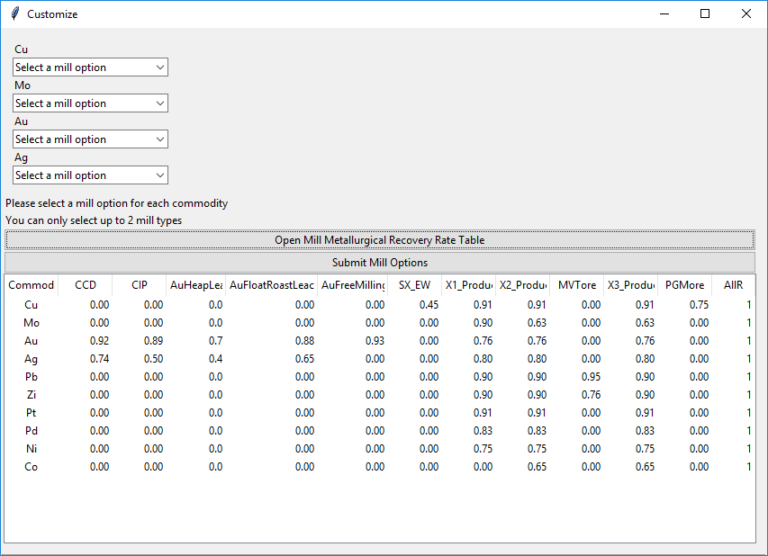

1. Customize Mill Option Dialog

The “User Define” option in the Customize Mill Option dialog allows users to specify parameters for a new mill option in RAEF. The “User Define” option will launch a new dialog, as seen in Figure 2. In the new dialog, users will be asked to enter the capital and operating cost equation parameters. The cost parameters include an equation constant and exponent term. For example the capital cost equation for the 3- Product Flotation Mill equation is 83600 * Mill Capacity0.703, where the constant is 83600 and the mill capacity exponent is 0.703. Users also need to define the metallurgical recovery rate of the commodity for the specific mill.

Specific commodities can also be withdrawn from the economic calculations by selecting “None” in the Customize Mill option for the corresponding commodity drop-down menu. This will result in no cost and no recovery for that specific commodity.

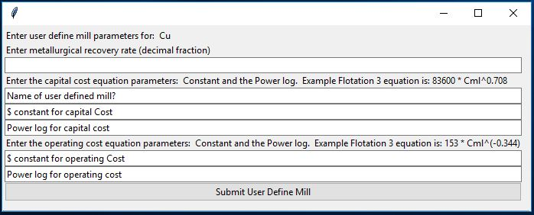

1. Example of the User Define dialog for the commodity Copper

The next input parameter is the days of operation per year for the mine operations. Default options are full time operation at 350 days/year or restricted time at 260 days/year. Underground mines and mines in harsh climates are more likely to operate on a restricted schedule of 260 days/year (Smith, 1992).

RAEF uses a default investment rate of return (IRR) value of 0.15 (15%/year) for its calculations. The IRR value is equivalent to the interest rate required to secure capital funding for mine development. The IRR can be changed by pressing “Change Default Investment Rate of Return” and entering the new value in the popup text box while using the RAEF GUI option or entering a new value in a Pre-Set parameters file.

The final RAEF input parameter is the waste management options for a tailings pond and waste rock storage. Waste management choices include (1) a tailings pond and dam, and (2) an optional tailings pond liner. The liner is optional only if a tailings pond has been chosen.

# RAEF Economic Filter Process

RAEF estimates the aggregate costs and revenue features over estimated mine lifetimes for a variety of mine and mill options, based on simulated deposit characteristics, to estimate potentially recoverable resources. The analysis calculates a mine capacity, mine lifetime, and mine and mill costs defined by simulated deposit tonnage. The ore grades and their commodity values define mine revenue over mine lifetime. Net present value (NPV) using a deferred rate of return is calculated using the capital costs and operating costs offset by mine revenue (Camm, 1991; Robinson & Menzie, 2010).

The value of the production estimates are based on total ore value, mill capacity and the days of operation of the mine and mill (Robinson & Menzie, 2010, pg 5). Present value of a mine determines the value derived from the production value and the mine life. Using an investment rate of return (default value is 15%/year) RAEF estimates the present value of the mine revenue over mine lifetime as: PV= ((((1-(1/(0.15)Life))/0.15) * Value of Production (Robinson & Menzie, 2010, p 5). The present value of the deposit production is the present value minus the total capital costs. The equation for the present value of deposit for mine is PVD= PV - Total Capital Cost TotK (Robinson & Menzie, 2010, pg 5).

RAEF concludes with the determination of the Net present value for each deposit. Net present value is the value of the mining process after taking account of the cash flow, rate of return, and the costs (Robinson & Menzie, 2010). During the RAEF process simulated mines with a negative NPV are assigned a resource value and contained resources value of zero. Simulated mines with a positive NPV are assigned a resource value equivalent to the resources recovered by mine and mill selections, and a deposit value equal to the NPV result. For simulated deposits with a positive NPV, recovered resource estimates are calculated. The recovered resources equation is Recovery Factor * metallurgical recovery factor *Metric Tons tonnage* commodity grade (Robinson & Menzie, 2010).

The potential economic analysis is done for each simulated deposit with the results aggregated by the simulation file index criteria. The series of economic filter process steps and results are written to an output file named *EF_02_Output_RunID.csv*. The file shows the parameters, variables, and results calculated for each simulated deposit. The variable names and calculation steps are explained in supplemental table, *RAEFVariableGlossary.xlsx.* This glossary provides a list and description of the variables that are used in the RAEF analysis. Each variable is listed by its variable name accompanying a description of its calculation and use in the RAEF analysis.

# RAEF ZIP File

The RAEF ZIP file contains two R-program scripts to install the required R packages and run the RAEF program, a ReadMe file with step-by-step instructions for the installation and operation of the RAEF program, and a directory folder (Package). Inside the Package directory folder are four folders containing 1) Auxiliary R-based scripts used during RAEF execution (AuxFiles), 2) a set of files created by MapMark4GUI to be used as sample input (MapMark4Results), 3) a tutorial folder containing sample input files to run tutorial exercises and examples of RAEF output files for these tutorial exercises, and 4) a folder to receive output from the tutorial exercises (Output). The RAEF ZIP package includes all of the important files to run RAEF analysis, documentation to understand program installation, operation, processes, and file output, and sample tutorial exercises. The PACKAGE file address is required to be entered in the RAEF GUI for the program to run successfully.

The RAEF ZIP directory includes 1) the R-script code for the RAEF graphical user interface (GUI) (*RunRAEF.R*), 2) the R-script to install the required packages (*InstallPackages.R*), 3) a batch file template (*BatchFileTemplate.xlsx*), 4) a glossary of the program variables (*RAEFVariableGlossary.xlsx*) that are in reported in output files named *EF_02_Output_RunID*.csv, 5) RAEF ReadMe documentation that provides a step-by-step Installation and Operation Guide for RAEF (*RAEFReadMe12718.docx*), 6)RAEF User Guide document (*UserGuide_RAEF2119.docx*), and 7) the RAEF PACKAGE directory.

*RunRAEF.R* will launch and run RAEF. Prior to running the GUI script, the R packages need to be installed. This is done by running the installation script, identified by the file name “*InstallPackages.R*.” *BatchFileTemplate.xlsx* provides a guide in filling out the batch input file.

## RAEF Package

The RAEF PACKAGE directory is organized into 4 folders which include, 1) AuxFiles (auxiliary files), 2) MapMark4Results, and 3) Output folder, and a 4) Tutorial folder.

*AuxFiles*, includes the important program files that support the RAEF program. AuxFiles has a set of 3 subfolders that houses the key process files. The subfolders include: RScripts, a set of internal process R scripts; ValueTabs, a set of key tables RAEF looks at during its calculations; and Images, image files the RAEF GUI uses. RScripts subfolder has a range of 50 internal process R scripts that help the RAEF to run and calculate the resources successfully. These scripts do not need to be accessed or edited to run RAEF. The second subfolder, ValueTabs, includes the key tables that supports the range of resource economic calculations. The tables include the resource metallurgical recovery rates table and the commodity values table. The rates and values are set to a default value. Users could edit these for a run by accessing these tables or while running the GUI dialog.

The second folder, *MapMark4Results*, provides a sample MapMark4GUI run results using the MapMark4 package that can be used to test and learn the RAEF GUI and processes. The file, *RunID_05_SIM_EF.csv*, can be entered as the grade-tonnage model (GTM) in the RAEF run.

The third folder, *Output*, is a folder that can be used to store the RAEF run outputs. It also stores a sample set of RAEF results. The sample set took a case study looking at a Porphyry tract, Open Pit and Block Caving mine type example. It is not required to use this folder as the output directory for the RAEF runs. It is recommended to use a unique folder that pertains to the specific RAEF run projects.

The fourth folder, *Tutorial_pkg* is a folder that includes a set of tutorial exercises that can be used to the understanding RAEF program operation. These tutorial exercises are discussed below in the RAEF Tutorial Exercises section. The *Tutorial_pkg* folder includes sample sets of input files needed for the tutorial exercises and examples of tutorial output results.

# Installation Comments

## Required Software

RAEF was developed to be used with an R console. The R console window is the place where computations are performed to read and process R scripts. Installation of an R console is required to run RAEF. It is recommended that you use the Comprehensive R Archive Network (CRAN) 64- or 32-bit R console to run RAEF. To download the R console for Windows, go to the CRAN R project website (<https://cran.r-project.org/bin/windows/base>). At the website, click on the “Download R for Windows” option and follow the instructions provided at the website to complete the installation. The version available for download will be the current release.

## Required Packages

When working with R, many processes are dependent on external packages that can be installed and uploaded to the R console for future work. RAEF requires a selection of R packages to run. R packages need only be installed once so long as the packages have not been removed or edited; however, packages can be reinstalled multiple times without errors.

A script provided in the GUI package (*InstallPackages.R*) installs the required packages automatically. The following R packages are required for the RAEF GUI to operate:

* + ggplot2
  + gWidgets
  + gWidgetstcltk
  + dplyr
  + compositions
  + mvtnorm
  + ks
  + reshape2
  + reshape
  + Hmisc
  + Pid
  + Akima
  + sqldf

# Inputs to RAEF

RAEF requires a set of three input files to successfully run the economic analysis. It requires MapMark4GUI’s simulation results (*RunID_05_Sim_EF.csv*) or equivalent file, the commodity value table (*CValues.csv*), and the metallurgical recovery rate table (*MillR.csv*).

RAEF uses the MapMark4GUI simulation results to enter simulated deposits into RAEF. The MapMark4 simulation file includes ore tonnages, ore commodity grades, and in-ground contained resources for each simulated deposit. Operational details about MapMark4 resulting can be found in Ellefsen (2017a, b); operational details and a description of MapMark4GUI output can be found in Shapiro (2018).

The commodity value table and the metallurgical recovery rate tables are stored in the AuxFiles ValueTabs folder. The commodity value table lists assigned values for a series of commodities. The reported values are a 1989-2008 average value in 2008 U.S. dollars per metric ton of commodity. This file is included in the auxiliary package folder; it is accessed automatically by the RAEF program. A user can edit or add new commodity values to the table by accessing it in the folder and using a csv editor, like Microsoft Excel. If a commodity is not listed in the value table, the program will ask the user to enter the commodity value using a popup dialog during the RAEF run. This commodity and value will not be saved permanently to the ValueTabs folder.

The final input is the metallurgical recovery rate for each commodity based on the mill option table. Metallurgical recovery rates are the rates of recovery for each commodity using specific mills. The metallurgical recovery rates (MRR) may differ by commodity and mill type. The rates are reported in decimal fractions. For example, a MRR of 0.91 corresponds to a 91percent recovery rate for that commodity and mill option. The MRR table in RAEF is from (Smith, 1992, p.19). The metallurgical recovery rate table (*MRR.csv)* is included in the auxiliary folder. In addition, the default metallurgical rates in the MRR.csv table can be revised using the GUI option.

# GUI Option vs. Batch Run Option

RAEF can be launched and run using two different methods: 1) GUI dialog mode or 2) batch run mode using a Pre-Set Parameters file as input. Using the GUI mode, a user enters the RAEF run parameters into the GUI dialog when prompted by the program. The GUI run, gives a series of user input prompts fill out and submit the run parameters. It provides users the ability to see all available run options and provide a visual demonstration of the RAEF process workflow. The GUI option is recommended if you are a novice RAEF user, explore different variable from previous runs, or create a Pre-Set Parameters template file.

Using the batch run mode, users can input a Pre-Set Parameters file into the system and proceed directly to the confirm data and run prompts. The batch run option allows users to run processes without the need to go through multiple dialog steps and enter a set of pre-determined parameters directly into the RAEF program. The batch run mode allows users to run RAEF processes with similar parameters from previous runs by submitting an earlier RAEF parameters output file into the system. This is useful for situations where multiple assessment tracts are evaluated using similar RAEF run parameters. The batch run option gives users the ability to edit or change the variables easily. However, because depth estimates are randomly selected during each run, the run output will never be identical to as previous runs even though the same parameters were used.

## GUI Option

Running RAEF using the GUI option requires user input to enter the economic filter parameters. The GUI option opens a dialog box, as shown in Figure 3, where users enter a series of parameter options starting in the upper left-hand proceeding down and to the left to define the parameters guiding the analysis and create summary tables and graphs. This option allows users to see the available parameter choices while running RAEF interactively.

The RAEF dialog has 5 different sections of user input: 1) input files, 2) deposit information, 3) mine and mill methods, 4) days of operation, 5) and waste management.

Figure 3 shows an example RAEF dialog with assigned options. The case study used a deposit simulation file based on the Porphyry Copper deposit grade-tonnage model. Porphyry copper deposits are assigned a massive/disseminated ore body geometry. For this ore body geometry, open pit mine methods are assigned to deposits located less than 61 meters under cover rock and block caving mine methods are assigned to deposits located at greater depths. The reported commodities in the porphyry copper grade-tonnage model are copper, molybdenum, gold, and silver. The user selected the 3 Product Flotation Mill option, with the option to omit recovery of the lowest value commodity determined by ore grade, commodity value, and metallurgical recovery rate. The mine was assigned a full time operation schedule of 350 days per year. Waste rock management options of a tailings pond, dam, and liner were selected.

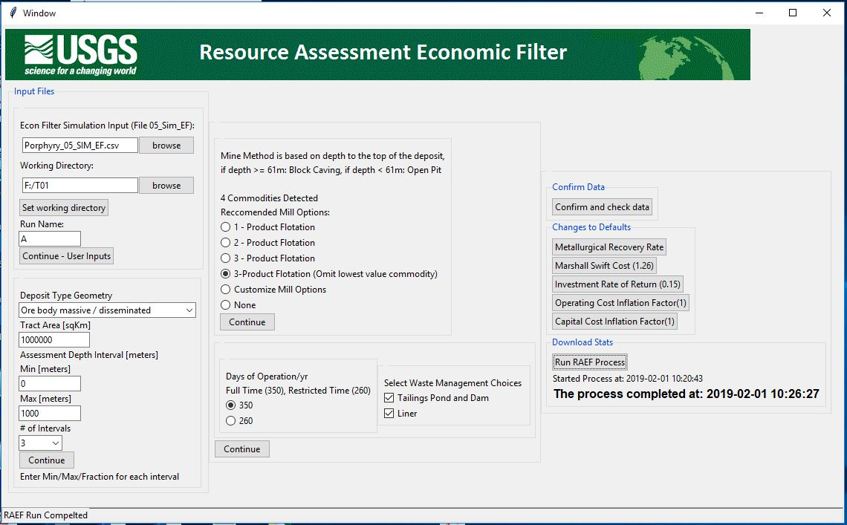

1. Example of a filled out RAEF GUI dialog, using a case study of an Open Pit and Block Caving mine type study with a 3-Product Flotation mill option (omitting the lowest value commodity).

### Input Files Dialog

The first section in the GUI, “Input Files”, identifies the file locations of the deposit simulation input file (MapMark4GUI file or equivalent), output folder directory to contain the results of the analysis, and a run name to be attached to output files. The working directory is the folder address of where the RAEF run output files will be saved. The run name will be added to the beginning of each file. It is recommended that the working directory name and run name be a short character string that identify a specific resource assessment tract (working directory) identifier and a unique set of RAEF parameters (run name).

### Deposit Information

The second section specifies mineral deposit and study area information that include geometry classification of the deposit type orebody, study area size, and a depth profile describing the distribution of undiscovered deposits. The selection of a deposit orebody geometry class results in RAEF assigning appropriate mine type options for the run. Tract Area is the area of the assessment tract in square kilometers. The final part of the section is a user-defined depth profile describing the distribution of undiscovered deposits. Users enter the minimum and maximum depth values (meters) for undiscovered deposit distribution in the assessment tract area in the text boxes, where it says “Min” and “Max”. The minimum and maximum depth criteria are typically assigned to assessment tracts during the initial assessment study. Users have the option to choose between 1 to 4 depth intervals to describe the distribution of undiscovered deposits by depth. In each depth interval, deposit depths are assigned randomly throughout the depth interval during the RAEF analysis. A choice of one depth interval results in a uniform depth distribution of undiscovered deposits with depth. Multiple depth intervals with assigned fractions of the total deposits allow the user to skew the depth distribution to favor shallow, deep, or intermediate depths for deposit occurrence.

A new dialog will open asking for further details on the assigned depth intervals. For each interval, users enter the minimum depth, maximum depth, and the fraction of deposits assigned to the interval. The interval fractions for all intervals need sum to 1. Figure 4 shows the depth profile interval dialog. In this example, there are 3 intervals with the ranges of 0-250, 251-500, and 501-1000 meters for depth groups and deposit fractions assigned to each interval as 0.2, 0.2, and 0.6.

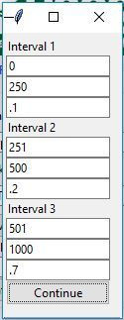

1. Example of the depth profile interval dialog for three intervals.

### Mine and Mill Methods

In the third section, mine and beneficiation methods are assigned. Mine type options are assigned according to deposit orebody geometry. Mill options include a series of default mill types, user-defined customized mill types, or an option to select no beneficiation method or costs. To assign or define a mill type not included in the list of default mill types, select the “Customize Mill Options” as the mill type selection. The customize mill option enable users to assign individual mill types to specific commodities (up to 2 mill types). A user can also forgo the mill cost in the RAEF calculation by selecting “None”. This will run the economic filter with just using the mine costs.

The customize mill option permits users to assign individual commodities to specific mill types that are in the RAEF model but not offered as default choices expressed earlier. In the new dialog a list of commodities that were detected from the MapMark4GUI simulation input are displayed with a drop-down box below each commodity abbreviation. In this drop-down menu there is a selection of available mill methods that a user can select that can recover the specific commodity. The drop-down menu also has a choice of “None” and “User Define” for mills. Users need to make a selection for each of the commodities by clicking on the mill choice in the drop-down menu. Users can choose up to 2 mill methods, not including “None”.

Users can also correspond commodities to a user defined mill by clicking on “User Define”. This allows users define a mill into the RAEF program process. The cost parameters include the constant and the exponent for the mill capacity. For example, the capital cost equation for the 3- Product Flotation equation is 83600 * Mill Capacity0.703, where the constant is 83600 and the exponent is 0.703. Users also will need to define the metallurgical recovery rate of the commodity for the custom mill. Figure 2 above shows the input dialog for users to input a user defined mill.

Users can also select “None” in the drop-down menu as the customize mill type for specific commodities. This will recover 0 metric tons of that commodity during the RAEF run.

### Days of Operation

The fourth RAEF GUI section specifies the days of operation of a mine. The default options are full time operation at 350 days or restricted time at 260 days a year.

### Waste Management

The fifth section specifies waste rock management options. Waste management choices include (1) a tailings pond and dam and (2) an optional tailings pond liner. The liner is optional if the tailings pond and dam has been chosen. Users have a choice whether to add the cost of these waste management choices to the economic analysis.

### Change Default Parameters

The GUI provides options to change the RAEF default parameters dealing with the mine and mill costs and metallurgical recovery rates. Metallurgical recovery rates for specific commodities and mill methods can be modified by selecting the “Change Default MRR” option. This option opens a new dialog allowing the user to edit the recovery rates for specific commodities.

The next option allows users can change the cost updating index (Marshall Swift Cost Index, MSC). The default MSC value is set at 1.26, that adjusts the Camm (1991) mine and mill cost parameters to a 2008 U.S. dollar basis. The cost updating methodology is described in the “Commodity Values and Cost Updating” section. Users can update the MSC by clicking on the button “Change Default MSC”.

Users can also change the default investment rate of return (IRR) value, 0.15 (15 percent). The final parameters that can be changed are the capital and operating cost inflation factors. These inflation factors are study area specific estimates of cost inflation factors that reflect the increased mine capital and operating cost features of the area. The default values for both inflation factors is 1, which indicate cost settings typical of mining areas like the western U.S. and most developed countries. High-cost mining areas with harsh climates or lacking infrastructure typically inflate capital costs by a factor of 1.8 or higher and operating costs by a factor of 1.4 or higher. Higher numbers reflect increasing capital and operating mining costs in the study area. To change the cost inflation factors, click the on “Change Operating Cost Inflation Factor” or “Change Capital Cost Inflation Factor” buttons.

### Run RAEF Process

Once all the parameters are entered, users can start the RAEF process by pressing “Run RAEF Process.” The process will start by downloading a summary of the parameters. Then it will start the RAEF analysis. The parameters table is downloaded into a CSV format file, *EF_01_Parameters_RunName.csv.* After the parameters are set and downloaded, the RAEF economic filter process is started. The RAEF process will write output results to a CSV format file with the name format *EF_02_Output_RunName.csv.*

After the completion of the RAEF computation, a set of tables, statistics, and plots are created to summarize the economic filter results. The statistics and plots are described below. If users would like to run another RAEF process, keep the RAEF GUI start up dialog box open and relaunch the selected RAEF mode.

In addition to the parameters input, the GUI dialog also displays the status of the RAEF process using the status bar on the bottom of the GUI. Once the RAEF process is started, it will read: “RAEF Process Started” until the process is done. If the process was successful, it will read: RAEF Run Completed”. If the run was not successful, it will print the last step that was completed. The GUI will also print the start and completion time of the process run on the GUI under the “Run RAEF Process” button. Figure 3, provides an example of the status messages for a successful RAEF process.

## Batch Run Option

If a user would like to run RAEF with the batch mode, using a Pre-Set Parameters file, this can be done by selecting the RAEF’s “Launch with PreSet Parameters” option. This RAEF option allows users to enter a pre-determined parameters file and quickly run the economic filter process.

To run RAEF in batch mode, a Pre-Set Parameters input file (PreSet parameters file) listing the user specified run parameters will need to be created. The parameters are the same as those defined using the GUI option. Table 1 provides a list of available RAEF parameter choices and how they should be entered. Parameters need to be entered using the same case and wording as shown in Table 1. Table 2 below provides an example of the batch input file. Each of the parameters need to be entered with the specific order that are shown. Parameters can be edited and changed in file. In the input file as shown in Table 2, Column A is the parameter name, and Column B is the parameter input value. The batch file should be formatted similar to the RAEF parameters output file from RAEF previous runs, *RunID_EF_01_InputParameters.csv*. Previous run parameters files can be used as the batch input file, as long their output names and addresses are updated with new information. Previous run files could be used either to run a duplicate economic filter run, or can have its parameters edited to run a similar but new run.

Once pressing the launch button, the RAEF process will start immediately. A new window will open, showing the status of the process. It will also show the start and completion times of the process. Figure 5, provides an example of the status dialog for a successful run.

1. List of available batch input parameter options

|  |  |
| --- | --- |
| **Number of Depth Intervals** | **Mill Type (Default)** |
| 1 | 1 – Product Flotation |
| 2 | 2 – Product Flotation |
| 3 | 3 – Product Flotation |
| 4 | 3 – Product Flotation (Omit lowest value commodity) |
|  | |
| **Deposit Type** | **Days of Operation** |
| Flat-bedded/stratiform | 350 |
| Ore body massive / disseminated | 260 |
| Vein deposit / steep |  |
|  | |
| **Tailings pond?** | **Liner?** |
| Tailings Pond and Dam | 1 |
|  | 0 |

1. Example of a filled out batch input file, using open pit and block caving mine types

|  |  |  |
| --- | --- | --- |
|  | A | B |
| 1 | Date | Thu Dec 13 2018 |
| 2 | Time | 11:19:30 AM |
| 3 | Econ Filter File | F:/RAEF/Package/TUTORIAL_Pkg/Inputs/T1/A/Porphyry_05_SIM_EF.csv |
| 4 | Working Directory | F:/T01 |
| 5 | Run Name | A |
| 6 | Number of Depth Intervals | 3 |
| 7 | Min1 | 0 |
| 8 | Max1 | 250 |
| 9 | Per1 | 0.1 |
| 10 | Min2 | 251 |
| 11 | Max2 | 500 |
| 12 | Per2 | 0.2 |
| 13 | Min3 | 501 |
| 14 | Max3 | 1000 |
| 15 | Per3 | 0.7 |
| 16 | Min4 | 0 |
| 17 | Max4 | 0 |
| 18 | Per4 | 0 |
| 19 | Deposit Type | Ore body massive / disseminated |
| 20 | Mine Method | Mine Method is based on depth to the top of the deposit, if depth >= 61m: Block Caving, if depth < 61m: Open Pit |
| 21 | Mill Type 1 | 3 - Product Flotation |
| 22 | Mill Type 2 | NA |
| 23 | Days of Operation | 350 |
| 24 | Environment Choice 1 | Tailings Pond and Dam |
| 25 | Liner? | Liner |
| 26 | MSC | 1.26 |
| 27 | Investment Rate of Return | 0.15 |
| 28 | Cap Cost Inflation Factor | 1 |
| 29 | Operating Cost Inflation Factor | 1 |
| 30 | Area | 1000000 |
| 31 | User Define Mill Name (if applicable) | NONE |
| 32 | User Define: Mill Capital Cost Constant | 0 |
| 33 | User Define: Mill Capital Cost Power log | 0 |
| 34 | User Define: Mill Operating Cost Constant | 0 |
| 35 | User Define: Mill Operating Cost Power log | 0 |
| 36 | Custom_Mill_Option1 | No set custom mill option for commodity #1 |
| 37 | Custom_Mill_Option2 | No set custom mill option for commodity #2 |
| 38 | Custom_Mill_Option3 | No set custom mill option for commodity #3 |
| 39 | Custom_Mill_Option4 | No set custom mill option for commodity #4 |
| 40 | Custom_Mill_Option5 | No set custom mill option for commodity #5 |
| 41 | Custom_Mill_Option6 | No set custom mill option for commodity #6 |
| 42 | CV_Cu | 3813.958 |
| 43 | MRR_Cu | 0.91 |
| 44 | CV_Mo | 23567.174 |
| 45 | MRR_Mo | 0.63 |
| 46 | CV_Au | 16557636.25 |
| 47 | MRR_Au | 0.76 |
| 48 | CV_Ag | 257849.015 |
| 49 | MRR_Ag | 0.8 |

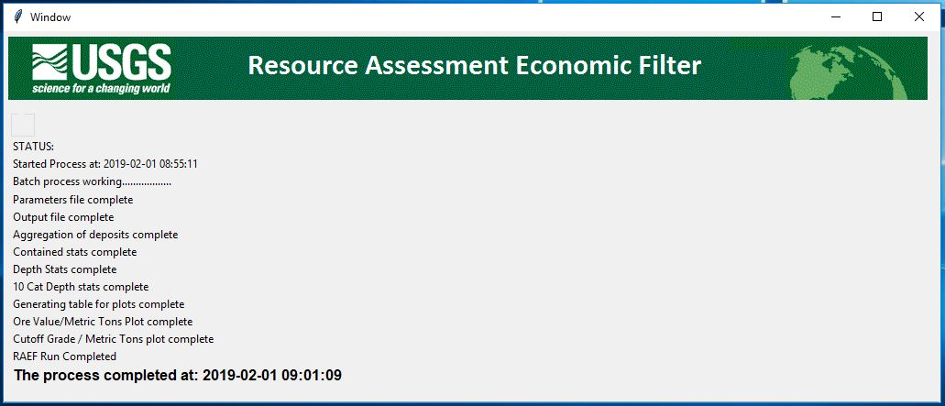

1. Example of the Batch Run status dialog

# RAEF Start Up Dialog

Running *RunRAEF.R* script will first open the RAEF startup dialog. The RAEF startup dialog is the central base for the RAEF options. This is where users decide to launch and run RAEF with the GUI run (using without pre-set parameters) or a batch run (using pre-set parameters). Users can also develop an empirical input dataset using a grade tonnage model for RAEF by selecting the “Run Empirical Mode” option.

The startup dialog can stay open throughout the process, allowing users to reopen RAEF modes and running multiple RAEF runs without the need of re-reading the R script code, saving time. It is recommended to leave this dialog open during the processes until the users are finish of the RAEF runs. Figure 6 shows the RAEF startup dialog.

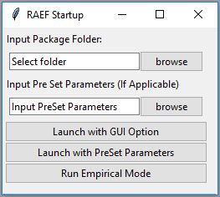

1. Example of the RAEF startup dialog

# Economic Filter Results

After completion of RAEF analysis, the economic filter results are written as a CSV table (*EF_02_Output_RunName.csv*). This table shows the RAEF computation steps and results for each simulated deposit. Corresponding Table, *RAEFVariableGlossary.xlsx*, provides a description of the RAEF computation workflow, parameters, and results.

RAEF provides a series of six statistical tables that summarize the economic filter results, and provides two graphs that portray calculated mine cutoff grades as a function of ore tonnage and deposit depth.

The first set of statistical tables aggregate the deposit results by the simulation run index and report cumulate ore tonnage of the deposits, the tonnage of the in-ground contained resources, the tonnage of the recovered resources and the net present value estimates. Table 3 shows an example of the aggregated results. The aggregation results are saved to the *EF_03_AggregateD_Totals_RunName.csv* file.

1. Example of the aggregated deposit results

|  |  |  |  |  |  |  |  |  |  |  |  |
| --- | --- | --- | --- | --- | --- | --- | --- | --- | --- | --- | --- |
|  | SimIndex | Ore | Cu _Con | Mo _Con | Au _Con | Ag _Con | Cu _Rec | Mo _Rec | Au _Rec | Ag _Rec | NPV_Tract |
| 1 | 1 | 616736156.2 | 3279124.808 | 96998.83182 | 82.64264493 | 606.8683777 | 0 | 0 | 0 | 0 | 0 |
| 2 | 2 | 454847599.8 | 1939474.65 | 60707.79503 | 105.0697956 | 482.7161122 | 0 | 0 | 0 | 0 | 0 |
| 3 | 3 | 76665940.89 | 385438.1083 | 1713.128816 | 2.667974743 | 152.568289 | 0 | 0 | 0 | 0 | 0 |
| 4 | 4 | NA | NA | NA | NA | NA | NA | NA | NA | NA | NA |
| 5 | 5 | 244112419.7 | 861546.2436 | 11704.11643 | 60.05165525 | 685.5726429 | 0 | 0 | 0 | 0 | 0 |
| 6 | 6 | 2008698692 | 12505450.51 | 114136.9561 | 155.7458314 | 3581.300485 | 7149115.943 | 46018.02873 | 82.34618464 | 1166.314725 | 475557534.7 |

[SimIndex: Simulation index number, Ore: Deposit ore tonnage in metric tons, Contained in-ground mineral resource tonnage in metric tons (Cu_Con: Copper, Mo_Con: Molybdenum, Au_Con: Gold, Ag_Con: Silver), Recovered mineral resources tonnage in metric tons: (Cu_Rec: Copper, Mo_Rec: Molybdenum, Au_Rec: Gold, Ag_Rec: Silver), and NPV_Tract: Net present value of the tract]

RAEF creates a statistical summary using the aggregated data to summarize in-ground contained resources and the recovered resources. This provides statistics on means, maximums, standard deviations, percentiles, probability of zero, and probability of values greater than the mean for the simulated undiscovered resources. These commodity statistics are tabulated by row in a file named *EF_04_Contained_Stats_RunName.csv*. Table 4 shows an example of this table.

1. Example of the statistics for the in-ground contained resources and the recovered resources.

|  |  |  |  |  |  |  |  |  |  |  |  |  |  |  |  |  |  |  |
| --- | --- | --- | --- | --- | --- | --- | --- | --- | --- | --- | --- | --- | --- | --- | --- | --- | --- | --- |
|  | Means | Max | Min | Median | STD | P99 | P90 | P80 | P70 | P60 | P50 | P40 | P30 | P20 | P10 | P1 | Prob of Zero | Prob >= Mean |
| Ore | 1.77E+09 | 4.31E+10 | 0 | 4.61E+08 | 3.47E+09 | 0 | 0 | 0 | 16014490 | 2.03E+08 | 4.61E+08 | 8.57E+08 | 1.46E+09 | 2.56E+09 | 4.86E+09 | 1.81E+10 | 0.2982 | 0.26325 |
| Cu._Con | 7609219 | 3.2E+08 | 0 | 1892066 | 15834691 | 0 | 0 | 0 | 52618 | 799884 | 1892066 | 3455919 | 6019941 | 10641428 | 20739391 | 78674585 | 0.2982 | 0.25815 |
| Mo._Con | 239160 | 14420593 | 0 | 41254 | 631706 | 0 | 0 | 0 | 643 | 15859 | 41254 | 83729 | 150763 | 278384 | 601178 | 3041112 | 0.2982 | 0.2241 |
| Au._Con | 335 | 37376 | 0 | 35 | 1164 | 0 | 0 | 0 | 0 | 13 | 35 | 77 | 154 | 318 | 782 | 4668 | 0.2982 | 0.1938 |
| Ag._Con | 4043 | 232239 | 0 | 756 | 10538 | 0 | 0 | 0 | 15 | 299 | 756 | 1470 | 2671 | 4930 | 10409 | 47641 | 0.2982 | 0.2323 |
| Cu._Rec | 1604334 | 2.76E+08 | 0 | 0 | 8407939 | 0 | 0 | 0 | 0 | 0 | 0 | 0 | 0 | 0 | 1384574 | 36963436 | 0.89015 | 0.09745 |
| Mo._Rec | 29579 | 8615192 | 0 | 0 | 199184 | 0 | 0 | 0 | 0 | 0 | 0 | 0 | 0 | 0 | 10880 | 659231 | 0.89015 | 0.0857 |
| Au._Rec | 85 | 26929 | 0 | 0 | 647 | 0 | 0 | 0 | 0 | 0 | 0 | 0 | 0 | 0 | 14 | 1890 | 0.89015 | 0.07335 |
| Ag._Rec | 674 | 173499 | 0 | 0 | 4422 | 0 | 0 | 0 | 0 | 0 | 0 | 0 | 0 | 0 | 368 | 15072 | 0.89015 | 0.09125 |
| NPV_Tract | 1.82E+08 | 2.32E+10 | 0 | 0 | 9.47E+08 | 0 | 0 | 0 | 0 | 0 | 0 | 0 | 0 | 0 | 85937042 | 4.43E+09 | 0.89015 | 0.09135 |
| NPV_Area | 10000.5 |  |  |  |  |  |  |  |  |  |  |  |  |  |  |  |  |  |

[Statistics: Means, Max: Maximum, Min: Minimum, Median, STD: Standard deviations, and the percentiles of the ore tonnage and grades from the 99th percentile to the 1 percentile: P99 to P1, Prob of Zero: Probability of zero, Prob >= Mean: Probability of greater than or equal to the mean, SimIndex: Simulation index number, Ore: Deposit ore tonnage in metric tons, Contained in-ground mineral

resource tonnage in metric tons (Cu_Con: Copper, Mo_Con: Molybdenum, Au_Con: Gold, Ag_Con: Silver), Recovered mineral resources tonnage in metric tons: (Cu_Rec: Copper, Mo_Rec: Molybdenum, Au_Rec: Gold, Ag_Rec: Silver), and NPV_Tract: Net present value of the tract]

Raef tabulates statistics by deposit depth categories. This selection provides estimates of mean contained and recovered resources by commodity the user-defined depth intervals. The reporting unit is metric tons of commodity. This table is written as the *EF_05_Depth_Stats_RunName.csv* file. Table 5 shows an example of this table for a three depth interval analysis.

1. Example of statistics on the depth results of the economic filter by interval group for a Porphyry model

|  |  |  |  |  |  |  |  |  |  |
| --- | --- | --- | --- | --- | --- | --- | --- | --- | --- |
| Depth | Cu _Con _ Means | Cu _Rec _ Means | Mo _Con _ Means | Mo _Rec _ Means | Au _Con _ Means | Au _Rec _ Means | Ag _Con _ Means | Ag _Rec _ Means | ProbOfZero |
| Depth_Cat_1_0-250_0.1 | 728845 | 323641 | 23170 | 6816 | 32 | 14 | 396 | 145 | 66.3 |
| Depth_Cat_2_251-500_0.2 | 1502676 | 412384 | 47011 | 7270 | 69 | 21 | 801 | 178 | 87.66 |
| Depth_Cat_3_501-1000_0.7 | 5377699 | 868309 | 168979 | 15492 | 234 | 49 | 2846 | 350 | 93.68 |

[Means statistics for each in-ground contained commodity tonnage in metric tons: (Cu_Con: Copper, Mo_Con: Molybdenum, Au_Con: Gold, Ag_Con: Silver); Means statistics for each recovered mineral resources tonnage in metric tons: (Cu_Rec: Copper, Mo_Rec: Molybdenum, Au_Rec: Gold, Ag_Con: Rec); ProbOfZero: Probability of zero, Depth_Cat_#_####-###_##: Specified depth level group, along with its group number, depth interval in meters, and it’s corresponding fraction of probability being chosen]

RAEF tabulates mean resources summarized by ten equal depth intervals defined by the depth range specified for the assessment. Depth intervals are set as: (max depth – min depth / 10). This table is written as *EF_06_10Depth_Stats_RunName.csv*. Table 6 shows an example of this output.

1. Example of statistics on the depth results of the economic filter by 10 equal interval groups for a Porphyry model

|  |  |  |  |  |  |  |  |  |  |
| --- | --- | --- | --- | --- | --- | --- | --- | --- | --- |
|  | Cu _Con _ Means | Cu _Rec _ Means | Mo _Con _ Means | Mo _Rec _ Means | Au _Con _ Means | Au _Rec _ Means | Ag _Con _ Means | Ag _Rec _ Means | ProbOf Zero |
| Depth_Cat_1_Max:_100 | 286539 | 174176 | 8386 | 3518 | 12 | 7 | 150 | 83 | 42.38 |
| Depth_Cat_2_Max:_200 | 300118 | 100960 | 9940 | 2115 | 14 | 5 | 173 | 43 | 82.78 |
| Depth_Cat_3_Max:_300 | 436003 | 151359 | 13814 | 2934 | 22 | 8 | 240 | 69 | 84.29 |
| Depth_Cat_4_Max:_400 | 563438 | 155407 | 17734 | 2671 | 23 | 6 | 300 | 62 | 87.07 |
| Depth_Cat_5_Max:_500 | 645422 | 154123 | 20307 | 2849 | 29 | 8 | 335 | 66 | 89.43 |
| Depth_Cat_6_Max:_600 | 1098751 | 228887 | 33913 | 4285 | 46 | 12 | 582 | 91 | 91.06 |
| Depth_Cat_7_Max:_700 | 1078759 | 184863 | 33679 | 3311 | 48 | 10 | 555 | 75 | 93.28 |
| Depth_Cat_8_Max:_800 | 1067372 | 196748 | 33964 | 3372 | 48 | 11 | 537 | 63 | 93.47 |
| Depth_Cat_9_Max:_900 | 1101161 | 135778 | 34500 | 2202 | 47 | 9 | 592 | 57 | 94.75 |
| Depth_Cat_10_Max:_1000 | 1031655 | 122033 | 32922 | 2322 | 44 | 8 | 580 | 63 | 95.97 |

[Means statistics for each in-ground contained commodity tonnage in metric tons: (Cu_Con: Copper, Mo_Con: Molybdenum, Au_Con: Gold, Ag_Con: Silver); Means statistics for each recovered mineral resources tonnage in metric tons: (Cu_Rec: Copper, Mo_Rec:

Molybdenum, Au_Rec: Gold, Ag_Con: Rec); ProbOfZero: Probability of zero; Depth_Cat_#_Max:###: Specified depth level group, along with its group number and corresponding maximum depth level]

# Ore Grade and Ore Value Tonnage Plots

RAEF generates plots that portray estimated ore deposit cutoff grade and recovered ore value as a function of ore tonnage, mine type, and deposit depth. The cutoff grade is the lowest grade or value of ore material in a deposit that has reasonable prospects for application of a feasible mining method. It is the ore grade at which the revenue generated by the mining and beneficiation enterprise is equal to the capital and operating costs of producing the revenue. The cutoff grade varies as a function of ore deposit tonnage, deposit depth, and mine and mill methods. In one plot, cutoff grade is expressed as copper equivalent grade (CuEQ%), in the other cutoff grade is expressed as ore value ($/t) based on the metallurgical recovery. Metal equivalent calculations, such as copper equivalent (CuEQ%), are used to compare similar deposits with different metal grade components using a similar metric. The metal equivalence calculation uses the sum of ore commodity component grades times commodity values times commodity metallurgical recovery rates to portray the ore value in terms of an equivalent representative copper grade or recovered ore value.

The set of depth contours in Figures 7 and 8 portray how the variation of ore tonnage and deposit depth influence the cutoff grade in the economic analysis.

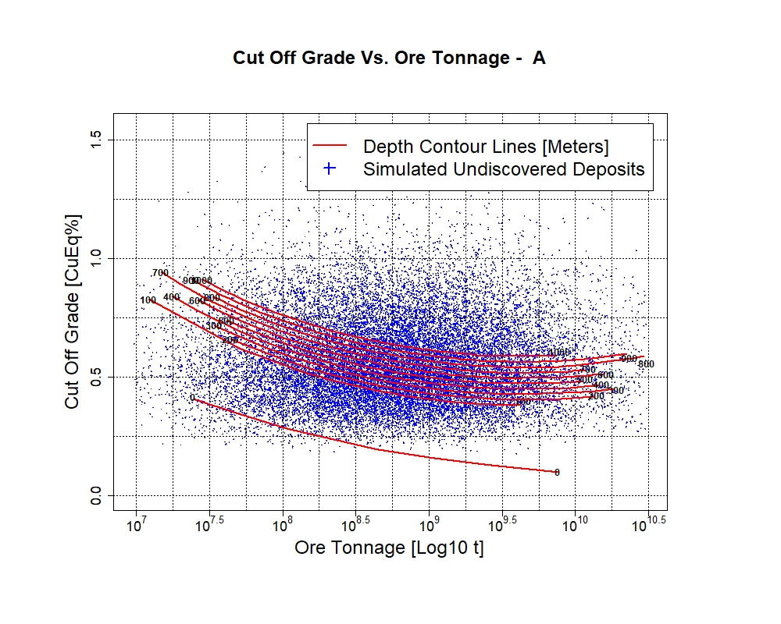

1. Example Grade Tonnage plot of cutoff grade vs. ore tonnage

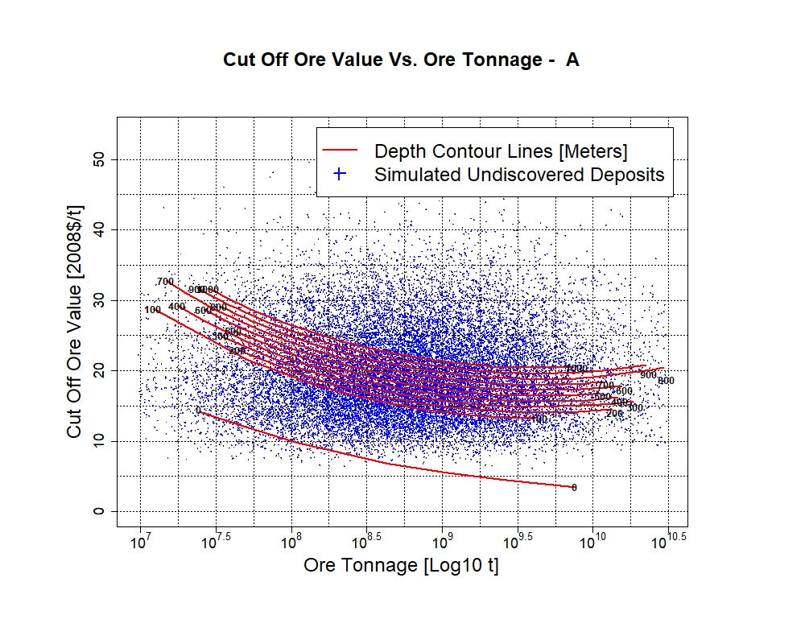

1. Example Ore Value Tonnage plot of cutoff ore value vs. ore tonnage. The cutoff ore value is the metallurgical recovery value of the ore material.

# Empirical Mode

The MapMark4 and Mapmark4GUI programs require a deposit type grade-tonnage model with no missing data. To use MapMark4 and MapMark4GUI, deposit grade-tonnage models with missing grade values need to be replaced with estimated grade values or eliminate individual deposit records or grade components with missing data from the model. RAEF provides an Empirical Mode option to sample a grade-tonnage model with missing grade values to create a substitute simulation file using the MapMark4GUI simulation file as a template. This provides an option to evaluate the effects of imputing data or deleting records from the grade-tonnage model in the economic filter analysis.

To create the empirical mode model for RAEF, a sample MapMar4GUI simulation file that applies the PMF estimates of interest will need to be created and/or selected. The sample file defines the deposit aggregation structure and number of grade commodities a user would like the empirical file to include. A previous MapMark4GUI simulation output file that contains the needed parameters is a convenient file to use. Once that is complete press “Run Empirical Model” in the RAEF start up dialog. An Empirical Option dialog box will open. Browse and select the MapMark4 simulation file to be used as the empirical model template. Browse and select the grade-tonnage model that will be used to generate the empirical simulation file. Browse and select the output directory where the empirical file should be stored and enter a name for the empirical run in the text box. Click “Create Empirical Model” to start creating the empirical simulation file by randomly sampling the grade-tonnage model data. The empirical file will be named using the format: *RunName _EmpTable.csv*

After the model has been created, the empirical model file is submitted instead of the MapMark4GUI simulation file in the RAEF dialog.

# References Cited

Camm, T.W., 1991, Simplified cost models for prefeasibility mineral evaluations: U.S. Bureau of Mines Information Circular 9298, 35p.

Ellefsen, K.J., 2017a, Probability calculations for three-part mineral resource assessments: Techniques and Methods.

Ellefsen, K.J., 2017b, User’s guide for MapMark4—An R package for the probability calculations in three-part mineral resource assessments: Techniques and Methods.

Robinson, G. R., Jr.and Menzie, W.D., 2012, Economic filters for evaluating porphyry copper deposit resource assessments using grade-tonnage deposit models, with examples from the U.S. Geological Survey global mineral resource assessment: Chapter H in Global mineral resource assessment: Scientific Investigations Report.

Singer, D., and Menzie, W.D., 2010, Quantitative Mineral Resource Assessments: An Integrated Approach: Oxford University Press, 213p.

Smith, C.R., 1992, PREVAL: Prefeasibility Software Program For Evaluating Mineral Properties: U.S. Bureau of Mines Information Circular 9307, 35p.