**Smart Vehicles Application**

### ****Component Interaction****

Based on the requirement document, the **Connected Vehicle IoT Platform** consists of multiple interacting components that work together to enable real-time vehicle monitoring, remote control, and predictive maintenance. Below is a structured breakdown of the **component interactions** within the system.

### ****1. Major Components and Their Roles****

| ****Component**** | ****Description**** |
| --- | --- |
| **Vehicle IoT Device** | Sends telemetry data (GPS, speed, battery, engine status) via MQTT. |
| **Message Broker** | AWS IoT Core ensures real-time event-driven processing. |
| **Backend Microservices** | Handles authentication, business logic, and user commands (NodeJs). |
| **Database Layer** | Stores structured (PostgreSQL/MySQL) and unstructured (MongoDB/DynamoDB) data. |
| **Caching Layer** | Redis/Memcached for storing frequently accessed data. |
| **APIs & Gateway** | Manages API traffic, security, and rate limiting (GraphQL/REST with API Gateway). |
| **Mobile/Web App** | User dashboard for vehicle control, alerts, and analytics (React/React Native). |
| **Third-Party Services** | Integrations like Google Maps, Twilio, AI-based fraud detection. |
| **Logging & Monitoring** | Centralized logging (AWS cloudwatch) and anomaly detection. |

### ****2. Interaction Flow****

#### 🚗 ****Vehicle Telemetry Data Flow****

1. **Vehicle IoT device** captures sensor data (speed, battery, location, diagnostics, etc.).
2. Sends data **securely** via **MQTT/WebSockets** to the **Message Broker** (AWS IoT Core).
3. Data is stored in **time-series databases** (DynamoDB/MongoDB for logs, PostgreSQL for structured data).
4. **Caching Layer (Redis)** improves response times for frequently queried data.
5. **APIs expose the data** to the frontend (React) via **GraphQL/REST**.
6. Users **view vehicle data** on the **mobile/web app**.

### 🔑 ****Remote Vehicle Control****

1. User initiates a command (**Lock/Unlock, Engine Start, Climate Control**) from the **mobile/web app**.
2. The request goes through **API Gateway** and is validated via **RBAC & MFA**.
3. The **Backend Microservices** process the request and send it to the appropriate vehicle.
4. The **Vehicle IoT device** receives the command, executes it, and sends a confirmation response.

### 🔥 ****Predictive Maintenance & Alerts****

1. **Telemetry data** is analyzed by **AI-based predictive analytics services**.
2. If a **fault is detected** (e.g., low battery, engine issue), an **alert is generated**.
3. The alert is sent via **Twilio (SMS), AWS SES (email), and mobile push notifications**.
4. **Users & service centers** get notified and can schedule maintenance.

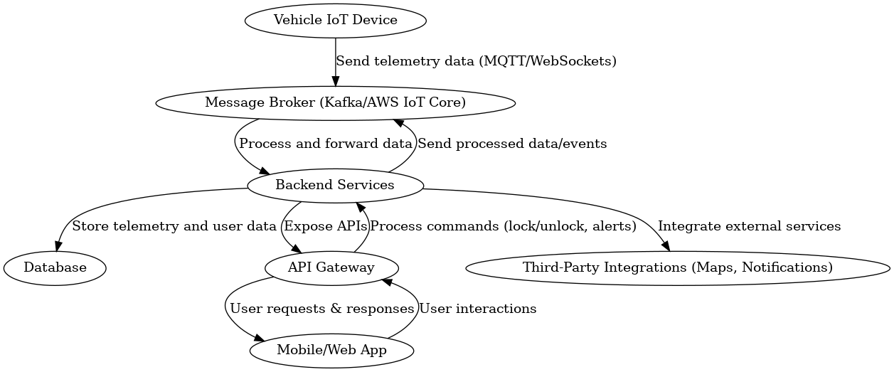

### ****3. How the Vehicle IoT Device Connects with AWS IoT Core****

The **Vehicle IoT Device** communicates with **AWS IoT Core** securely using **MQTT** (Message Queuing Telemetry Transport). Below is the step-by-step process:

### ****1. Device Registration & Authentication****

* Each **Vehicle IoT Device** is registered with **AWS IoT Core**.
* AWS IoT Core assigns a **unique certificate** to each device for secure authentication.
* Authentication is handled using **Mutual TLS (mTLS)** or **token-based authentication**.

### ****2. Secure Data Transmission****

* The **IoT Device** collects real-time telemetry data (GPS, speed, battery, engine status).
* It publishes this data to AWS IoT Core over an **MQTT topic**.
* AWS IoT Core **validates** the message and routes it to downstream services.

### ****3. AWS IoT Rules Engine & Processing****

* The **AWS IoT Rules Engine** processes incoming data and forwards it to:
  + **Amazon Kinesis / Kafka** (for real-time analytics).
  + **AWS Lambda** (for event-driven functions).
  + **Amazon DynamoDB / RDS** (for long-term storage).
  + **Amazon S3** (for large-scale data storage).

### ****4. Command & Control from Backend****

* If a user requests a **remote action** (e.g., lock/unlock car):
  + The **mobile app** sends a request to the **API Gateway**.
  + The **backend service** validates the request and sends a **command to AWS IoT Core**.
  + AWS IoT Core **publishes a message** to the appropriate topic.
  + The **Vehicle IoT Device subscribes** to this topic and executes the command.

### ****5. Logging & Monitoring****

* AWS IoT Core logs events to **Amazon CloudWatch** for monitoring.
* Anomalies are detected using **AWS IoT Device Defender**.

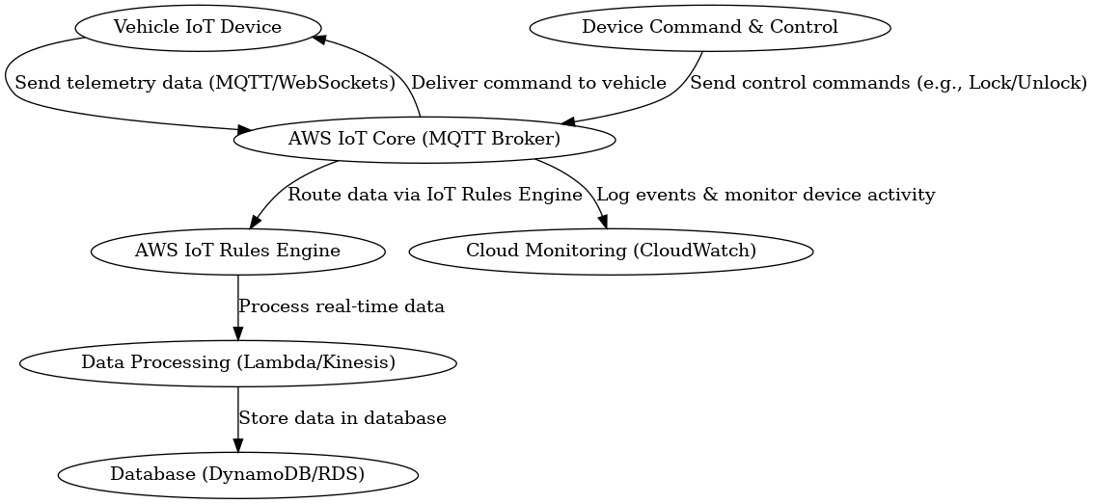

### ****4. Security Considerations for Connected Vehicle IoT Platform****

Security is critical for **Connected Vehicle IoT Platforms** as they deal with sensitive **telemetry data, remote control commands, and user information**. Below are key security measures:

### ****1. Authentication & Authorization****

* **Mutual TLS (mTLS) Authentication** → Ensures **secure communication** between **Vehicle IoT Devices and AWS IoT Core**.
* **OAuth 2.0 / JWT for API Authentication** → Secures access to **backend services and APIs**.
* **Role-Based Access Control (RBAC)** → Users (e.g., **owners, fleet managers, service personnel**) get only necessary access.
* **Multi-Factor Authentication (MFA)** → Adds an **extra security layer** for critical actions like **remote unlock/start**.

### ****2. Data Encryption & Privacy****

* **AES-256 Encryption** → Protects **stored vehicle telemetry data**.
* **TLS 1.3 for Data in Transit** → Secures **communication between devices, backend, and mobile apps**.
* **Tokenization & Data Masking** → Prevents **exposure of sensitive user information**.
* **Data Retention Policies** → **Old telemetry data** is **automatically purged** after a defined period unless required.

### ****3. Secure API & Command Execution****

* **API Gateway with Rate Limiting** → Prevents **DDoS attacks** and **API abuse**.
* **Command Validation & Logging** → Ensures **remote commands (e.g., unlock, start) are authorized and logged**.
* **Replay Attack Prevention** → Uses **timestamped, signed requests** to avoid unauthorized repeated commands.

### ****4. Threat Detection & Monitoring****

* **Intrusion Detection Systems (IDS) & Anomaly Detection** → Alerts when **suspicious activities** occur.
* **AWS IoT Device Defender** → Monitors **unusual device behavior** and **automatically responds**.
* **Centralized Logging with CloudWatch** → Detects **security breaches in real time**.

### ****5. Compliance & Regulations****

* **GDPR & Data Privacy Compliance** → Ensures **secure handling of personal and location data**.
* **SOC 2, ISO 27001 Compliance** → Security frameworks for **cloud and IoT data protection**.
* **Audit Logging & Access Control Reviews** → Maintains a **detailed record of who accessed what**.

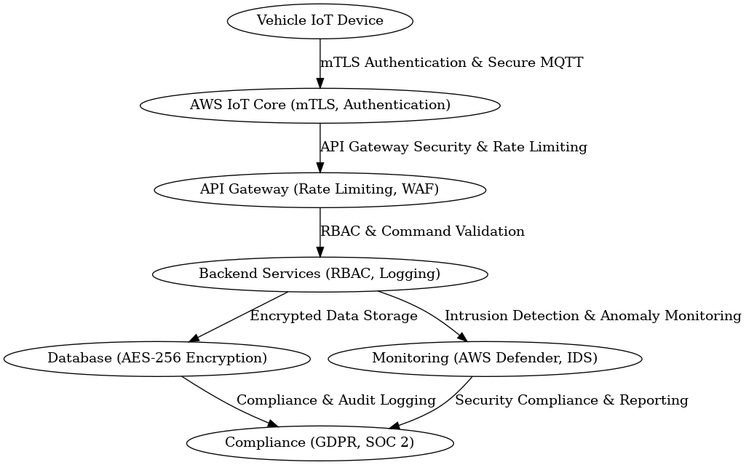

### ****5. Tech Stack Selection & Justification****

The technology stack is chosen based on scalability, maintainability, and security.

### ****Web:****

* React.js: Component-based, SEO-friendly, strong ecosystem

### ****MobileApp:****

* React Native: React Native

### ****Backend:****

* Node.js with NestJS: Asynchronous, scalable, modular architecture
* TypeScript: Strong typing and maintainability

### ****Databases:****

* PostgreSQL: ACID-compliant, relational data storage
* MongoDB/DynamoDB: NoSQL, high availability, unstructured telemetry data
* Redis: In-memory caching, session storage

### ****Other Technologies:****

* Kubernetes (EKS): Container orchestration for scalability
* AWS CloudFormation: Infrastructure as Code (IaC) for deployment automation
* AWS Lambda: Serverless compute for event-driven actions
* AWS IoT Core: Secure IoT communication and device management
* SonarQube:- Static code analysis for **vulnerability detection**.
* Cloud:- **AWS (Preferred Choice)** → **Scalability, security, managed services** (IoT Core, Lambda, S3).

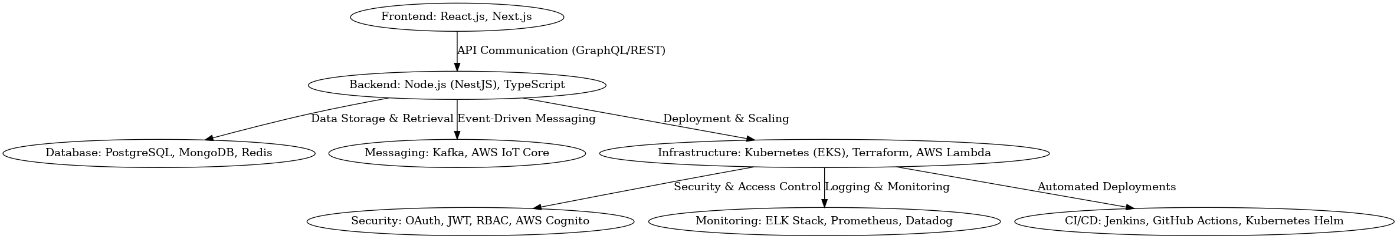

## 6. Deployment Playbooks & Infrastructure-as-Code (IaC) Scripts

Deployment playbooks help automate infrastructure provisioning and application deployment.

### ****Automation Tools:****

* AWS CloudFormation: AWS-native IaC for provisioning resources
* Terraform (Optional for hybrid/multi-cloud): Used when infrastructure extends beyond AWS

### ****Playbook Components:****

* Server provisioning and setup (EC2, RDS, EKS)
* Database configuration and migration scripts
* Load balancer setup and auto-scaling (ALB, Auto Scaling Groups)
* Rollback and disaster recovery mechanisms

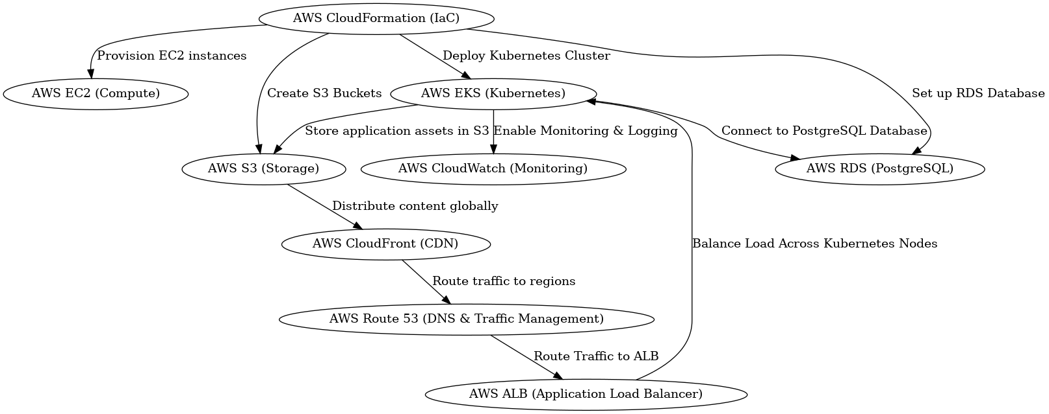

## 7. Multi-Region & High Availability Deployment Strategy

Ensuring high availability and fault tolerance across multiple regions.

### ****Strategies:****

* **Multi-region Deployment:** AWS Route 53 for intelligent traffic routing
* **Active-Active Setup:** Load balancing across multiple regions
* **Active-Passive Setup:** Disaster recovery with failover regions
* **Content Delivery Network (CDN):** AWS CloudFront for global caching

### ****Scaling Strategies:****

* **Auto-scaling:** Kubernetes Horizontal Pod Autoscaler (HPA), AWS Auto Scaling Groups

## 8. CI/CD Pipeline & Branching Strategy

Automating code integration, testing, and deployment ensures a smooth release cycle.

### ****Branching Mechanism:****

* **Development Branch (dev):** Active development and testing
* **Quality Assurance Branch (qa):** Staging environment for final testing
* **Master Branch (master):** Production-ready code for deployment

### ****CI/CD Tools:****

* AWS CodePipeline & AWS CodeDeploy for seamless AWS-native CI/CD
* Docker & Kubernetes CI/CD for automated builds, tests, and deployments using Kubernetes Helm

### ****Deployment Strategies:****

* **Blue-Green Deployment:** Minimize downtime by switching traffic to a new environment

## 9. Logging & Monitoring Strategy

Ensuring system reliability and observability through proper logging and monitoring.

### ****Logging Tools:****

* AWS CloudWatch & Sentry for code error logging (Production exception)

### ****Monitoring & Alerting:****

* AWS CloudWatch for infrastructure monitoring

### ****Code Level Analysis:****

* **SonarQube for static code quality and vulnerabilities analysis.**

## ****10. High Level System Diagram****

