Word Document

Your name

10/4/2018

## Introduction

## Method

R Core Team (2018); Wickham, François, Henry, and Müller (2018); Rudis, Bolker, and Schulz (2017); Wickham, Chang, Henry, Pedersen, Takahashi, Wilke, and Woo (2018); Arnold (2018); Müller (2017); Xie (2018a); Aust and Barth (2018); Pedersen (2017); Wickham, Hester, and Francois (2017); McLean (2018); Xie (2018b)

## Results

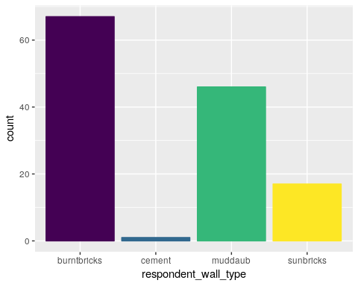

## Discussion

## References

Arnold, J. B. (2018). *ggthemes: Extra Themes, Scales and Geoms for ‘ggplot2’*. R package version 3.5.0. URL: <https://CRAN.R-project.org/package=ggthemes>.

Aust, F. and M. Barth (2018). *papaja: Prepare reproducible APA journal articles with R Markdown*. R package version 0.1.0.9842. URL: <https://github.com/crsh/papaja>.

McLean, M. W. (2018). *RefManageR: Straightforward ‘BibTeX’ and ‘BibLaTeX’ Bibliography Management*. R package version 1.2.0. URL: <https://CRAN.R-project.org/package=RefManageR>.

Müller, K. (2017). *here: A Simpler Way to Find Your Files*. R package version 0.1. URL: <https://CRAN.R-project.org/package=here>.

Pedersen, T. L. (2017). *patchwork: The Composer of ggplots*. R package version 0.0.1. URL: <https://github.com/thomasp85/patchwork>.

R Core Team (2018). *R: A Language and Environment for Statistical Computing*. R Foundation for Statistical Computing. Vienna, Austria. URL: <https://www.R-project.org/>.

Rudis, B, B. Bolker and J. Schulz (2017). *ggalt: Extra Coordinate Systems, ‘Geoms’, Statistical Transformations, Scales and Fonts for ‘ggplot2’*. R package version 0.4.0. URL: <https://CRAN.R-project.org/package=ggalt>.

Wickham, H, W. Chang, L. Henry, et al. (2018). *ggplot2: Create Elegant Data Visualisations Using the Grammar of Graphics*. <http://ggplot2.tidyverse.org>, <https://github.com/tidyverse/ggplot2>.

Wickham, H, R. François, L. Henry, et al. (2018). *dplyr: A Grammar of Data Manipulation*. R package version 0.7.6. URL: <https://CRAN.R-project.org/package=dplyr>.

Wickham, H, J. Hester and R. Francois (2017). *readr: Read Rectangular Text Data*. R package version 1.1.1. URL: <https://CRAN.R-project.org/package=readr>.

Xie, Y. (2018a). *knitr: A General-Purpose Package for Dynamic Report Generation in R*. R package version 1.20. URL: <https://CRAN.R-project.org/package=knitr>.

Xie, Y. (2018b). *xaringan: Presentation Ninja*. R package version 0.7.1. URL: <https://github.com/yihui/xaringan>.