

**Locus Techfest 2020**

**A Smart Agriculture Project Prototype with IoT**

Prepared by: Niraj Duwal

Rewan Gautam

Sushovan Shakya

Utshav Parajuli

**IOE, Thapathali Campus**

**Kathmandu, Nepal**

1. **Problem Statement:**

In recent times, the condition of agriculture in Nepal has been miserable. The statement “Nepal is an agricultural country” has turned out to be an unrealistic cliché, as the national economy is no longer supported by agriculture. Some factors causing this misery are climate change, lack of youth encouragement towards farming, and the traditional inefficient ways of cultivation. The farmers have sound experience but no proper knowledge about the crops like the ideal temperature, humidity required, moisture in soil and so on. This doesn’t help in large-scale production. As a result, people don’t see a good future in this occupation and start quitting.

A possible remedy for this issue is making farming easier, more efficient, and systematic. Our project shall accomplish this goal through automation and Internet of Things (IoT).

1. **Objectives:**

The main aim of our project is to make agriculture more systematic. For achieving this goal, it holds the following objectives:

* To apply smart irrigation, where the sufficient amount of water is passed to the soil until its ideal moisture level is reached for different crops.
* To know the current Temperature and humidity of the field instantly via mobile application and automate the regulation system.

1. **Utilized Technology:**

To explain the objectives of our project, we created a prototype where we used a number of sensors, microcontrollers, and other components to demonstrate the working of proposed smart-agriculture system. Some of them are:

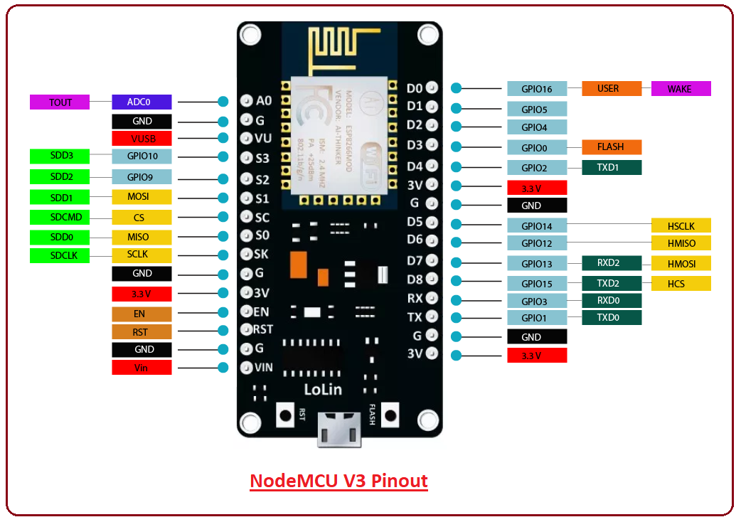

**ESP8266 NodeMCU V3** is a development board which runs on the ESP8266 with the Espressif Non-OS SDK, and hardware based on the ESP-12 module. The device features 4MB of flash memory, 80MHZ or system clock, around 50K of usable RAM and an on-chip Wi-Fi trans receiver.

NodeMCU is an open source prototyping board, similar to Arduino, which is prevalent in Internet of Things (IoT) projects. The embedded ESP8266 module on the board allows the microcontroller unit to connect to a WiFi network and make a simple TCP/IP connection, thus enabling various sensors and components to be controlled and monitored remotely through the internet.

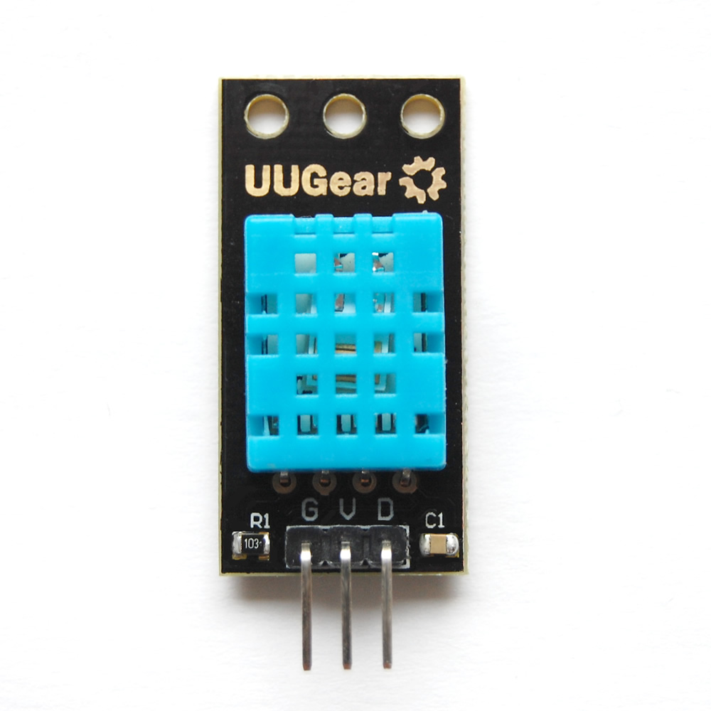

**DHT11 module**, also known as Temperature and Humidity Sensor, consists of a humidity sensing component and a thermistor, which senses the change in humidity and temperature of the surrounding, respectively. The module also consists of an 8-bit microcontroller unit, which outputs the values of temperature and humidity as serial data.

The DHT11 module works within the temperature range of 0°C to 50°C and humidity range of 20% to 90% with accuracy of ±1°C and ±1%.

In agriculture, temperature of the surrounding is to be maintained for the healthy growth of the crops. Different crops require different temperatures to grow properly, for example, for tomato farming, the temperature needs to be maintained in the range of 18°C (65°F) to 30°C (85°F), with tolerance up to 35°C (95°F), beyond which the plant will be stunted.

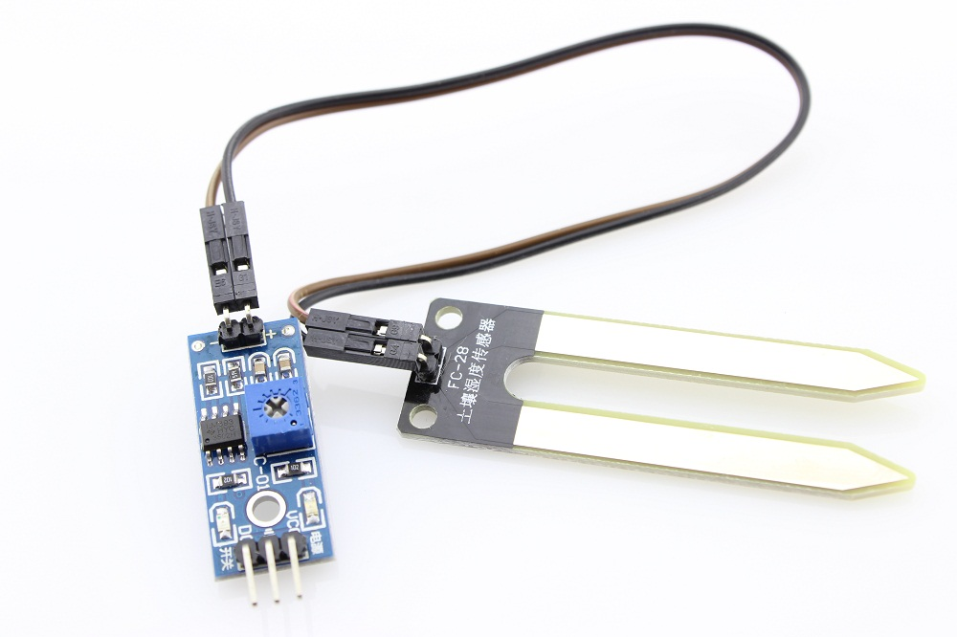

**Soil Moisture Sensor,** also known as Hygrometer, consists of two probes which measure the volume of water in the soil. The probes allow current to pass through the soil, and according to the change in resistance, the moisture level is measured. If the soil has high water content, it becomes conductive, and thus will have low value of resistance. This change is resistance is processed by the 8-bit microcontroller unit, which sends the read value as a serial data.

If the soil contains more moisture than required, or is very dry, then the growth of the crops is affected, and thus, the sensor is used to check the moisture level, which allows the maintenance of proper soil moisture level. The change in moisture level will also enable the automation of irrigation process.

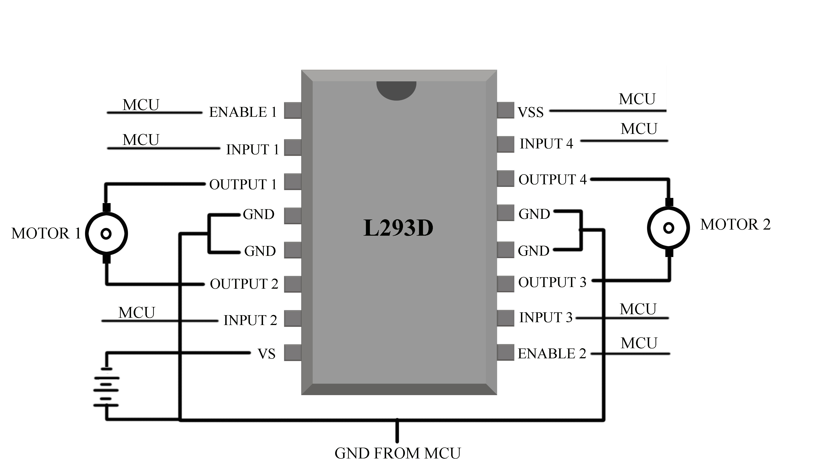

**ICs: L293D and LM7805,** The L293D IC consists of an integration H-bridge circuit. A custom motor driver can be designed through the use of L293D IC, allowing speed and direction control of DC motors through digital signals from the

microcontroller unit. Two DC motors can be controlled at a time through the use of the L293D.

The motor driver is used to control the DC water pump, which is used to automate the irrigation process in the prototype, and a DC outlet fan, which is used for temperature maintenance of the surrounding.

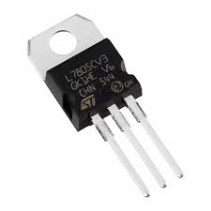

The LM78 series of integrated circuits is a family of self-contained fixed linear voltage regulators. The ICs are often referred to as LM78XX, where XX is replaced by the value of output voltage. The LM7805 IC thus takes DC input and outputs 5V DC output.

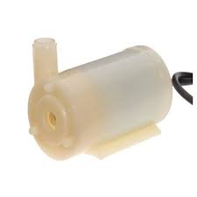

**DC water pump,** which works on 9-12v power supply is simply used to pump out the water from reserve to the field. It is controlled with motor driver and NodeMCU to supply the required amount of water until the ideal soil moisture is achieved.

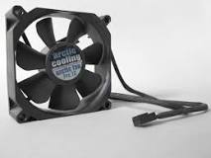

**Cooling fan and heating coil,** these are used to maintain the ideal temperature in the field which is measured by using the DHT-11 module. The fan is treated as motor and hence is controlled using motor driver. We can switch it on or off via mobile application.

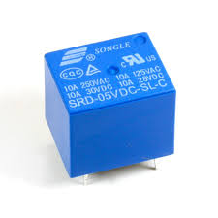

**RELAY** is an [electrically](https://en.wikipedia.org/wiki/Electric) operated [switch](https://en.wikipedia.org/wiki/Switch). It consists of a set of input terminals for a single or multiple control signals, and a set of operating contact terminals. The switch may have any number of contacts in multiple [contact forms](https://en.wikipedia.org/wiki/Electrical_contact#_blank), such as make contacts, break contacts, or combinations thereof.

Relays are used where it is necessary to control a circuit by an independent low-power signal, or where several circuits must be controlled by one signal. Relays were first used in long-distance [telegraph](https://en.wikipedia.org/wiki/Electrical_telegraph) circuits as signal repeaters: they refresh the signal coming in from one circuit by transmitting it on another circuit. Relays were used extensively in telephone exchanges and early computers to perform logical operations.

1. **Obtained outputs**

Following outputs were obtained through this project.

* The temperature and humidity was monitored through the DHT11 sensor, and the data was sent into Google Firebase database. The data is retrieved from the database and can be monitored through a custom app.
* Similarly, the data obtained through the soil moisture sensor can be monitored through an app. The soil moisture data, similar to the temperature and humidity, is monitored through a custom app.
* The value of soil moisture is taken as a feedback signal, which triggers the DC water pump, and thus irrigation is carried out.

1. **Limitation analysis**

For power source, Lithium Polymer battery is used, which can be hazardous if charging is left unmonitored. On the other hand, the soil moisture sensor becomes susceptible to corrosion through prolonged expose to moisture.

1. **Referencesss:**

* Wikipedia
* You tube
* Datasheets of individual components
* [www.arduino.cc](http://www.arduino.cc/)