RINA Project Design Document
Gordon Towne, Ethan DeGracia, Robert Russo
April 14, 2011

Abstract RINA Application-level Interface

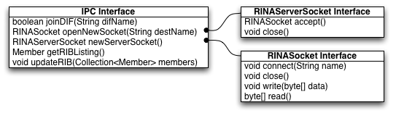

RINA networks are made accessible through an application-level interface. An application can instantiate one or more IPCs, which are seen as unique members of a DIF. The IPC provides an application the facility to join a specific DIF, given the DIF name, and communicate with other members of that DIF. The specifics of this initialization process are left to the implementation of a particular DIF layer, and are hidden from the application programmer. Once initialized, the IPC can be used to open a RINAServerSocket to advertise a particular service on the DIF, and to spawn one or more RINASockets to communicate with other specific DIF members. Again, the specifics of packetization, transport, and routing are left to the implementation of a specific DIF level.

Internet Level DIF Implementation

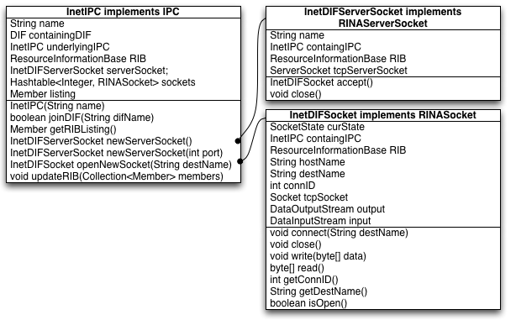
A specific instance of this RINA interface has been implemented in the form of an internet-level DIF. This DIF implements all of the functionality specified in the above RINA API, and uses TCP as the underlying protocol for all interprocess communication. An application can access RINA functionality at this DIF level through the instantiation of an InetIPC.

Joining a DIF

At the application level, a process can join a specific DIF by calling joinDIF with the unique DIF name. This procedure call then handles the specifics of initializing membership for the new process. The InetIPC must then contact the DIFManager for this particular DIF in oder to negotiate membership. In order to do this, the InetIPC issues a DNS query for the address of the InterDIFDirectory (IDD) that lists this particular DIF. It then uses the response of this query to issue a request to the IDD over TCP to obtain the URL of the DIFManager for the target DIF. The InetIPC then opens a new InetDIFSocket to connect to the DIFManager, and sends its username and password credentials. If these credentials are accepted by the DIFManager, the InetIPC is now a member of the target DIF, and will receive a notification from the DIFManager of such. It will then receive a list of the other members of the DIF, and their respective points of attachment. the InetIPC uses this information to populate its internal ResourceInformationBase (RIB) to route future connections.

Communicating with other IPCs

Any two members of a given DIF are able to communicate with one another through an InetDIFSocket. The InetIPC of a DIF member acts as a factory for such sockets. An application instantiates a new InetDIFSocket, with the name of the DIF member with which they want to communicate. The InetIPC will then check in its internal RIB for the point of attachment of the target host, and use this information to open a new TCP socket to that point of attachment. If the TCP connection initializes successfully, the two processes will then negotiate to establish a unique connection ID for the RINA connection. The sending InetIPC sends a proposed connection ID with its INIT packet that is a random 32-bit integer unique from its other outstanding connections. The receiving InetIPC then checks to see if this proposed connection ID is unique from its other outstanding connections. If so, it responds with the same proposed connection ID. If not, the receiving process replies with its own proposed ID that is unique for its set of connections. This negotiation continues until the processes have reached a consensus on the unique ID of the connection, at which point the connection is considered open.

Advertising a Service

An InetIPC can instantiate at most one InetDIFServerSocket with which to accept incoming connections. The InetDIFServerSocket relies on an underlying TCP server socket to accept incoming connections from other processes. When the InetIPC is instantiated, it binds the underlying TCP socket to a specific open port on the local machine. This port is then supplied to the DIFManager when the process attempts to join a DIF as the process's unique point of attachment. This point of attachment is then supplied to the other members of the DIF through the periodic RIB updates from the DIFManager. The InetDIFServerSocket of and InetIPC also handles receipt of control messages from the DIF, including these RIB updates when new processes join. An application can access this server socket to receive application-level connections through the InetIPC's newServerSocket() method. The InetIPC interface also allows for an InetDIFServerSocket to be bound to a specific port on the local machine. This is a special case that is implemented for use by a DIFManager, which must always bind itself to a well-known port so that prospective members that have not yet received the internal RIB for the DIF may contact it.

Legacy Client Access Scenario

This implementation of the RINA architecture supports a scenario where a legacy client (ie. a client that only knows of existing TCP/IP, DNS and HTTP protocols), may access a resource offered by a server hosted by a RINA network by means of an intermediate proxy. Given the URL for a target resource, the legacy client issues a DNS request to resolve the URL. The DNS system replies with the address of a unique proxy capable of marshaling between TCP and RINA connections. The legacy client issues an HTTP-GET request to the proxy, as though the target resource was hosted by the proxy itself. The proxy then joins the DIF of the target server, and forwards the HTTP-GET through a RINA connection to the server. The proxy will then forward the RINA server's response to the legacy client.

IDD Initialization

In order for this scenario to operate, the InterDIFDirectory (IDD) must first be initialized to allow any RINA network to operate. The IDD is responsible for keeping track of all active DIFs, including the points of attachment of their respective DIFManagers, and a listing of all of the of the services offered. This allows processes that want access to a given service to resolve which DIF hosts that service, and how to contact the DIFManager about joining. This database is offered by means of the TCPIDDServer.
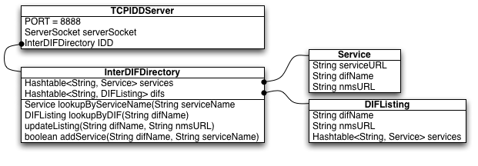On startup, the TCPIDDServer binds itself to a specific well-known port, and issues a request to register its address with DNS under a well-known domain name. Other processes can now use DNS to resolve the address of the IDD.

The operating TCPIDDServer accepts CDAP_IDD_UPDATE_REQ messages to list a new DIF with a specified DIFManager, or to update the DIFManager IPC for an existing DIF. Upon receipt of such a message, the TCPIDDServer will update its database to reflect the modification, and reply with a CDAP_IDD_UPDATE_RSP indicating the success of the operation.

The TCPIDDServer also accepts CDAP_IDD_SRVADD_REQ messages to register a specified new service URL with a particular existing DIF. The server then adds the new service to its database listing for the specified host DIF, informs the proxy of the new service (see Proxy Initialization for more on this communication), and replies with a CDAP_IDD_SERVADD_RSP indicating the success of the operation.

The IDD supports three types of lookups: 1) requests for the DIF name that hosts a given service, 2) requests for the DIF name that hosts a given service and the point of attachment of its respective DIFManager, 3) requests for the point of attachment of a DIFManager of a given DIF.

DIF Manager Initialization

A DIFManager is required to supervise a given DIF. To initialize a DIF, the DIFManager starts up, instantiates a new InetIPC for itself, adds its own InetIPC listing as a member in the DIF's RIB, and binds an InetDIFServerSocket on a specific well-known underlying port. The DIFManager must then register itself as the NMS for the new DIF with the IDD. To do this, it first resolves the address of the TCPIDDServer through DNS, and then issues a CDAP_IDD_UPDATE_REQ to the IDD server to register itself. If successful, it receives back a CDAP_IDD_UPDATE_RSP indicating such. At this point, the DIFManager is fully operable and ready to accept incoming membership requests.
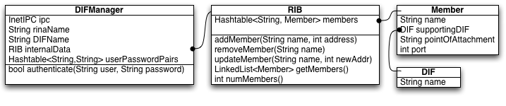

When the DIFManager receives a new membership request via a CDAP_CONNECT_REQ message, it authenticates the username and password credentials of the new prospective member against those of a database that it keeps. If the credentials are valid, the DIFManager replies with a CDAP_CONNECT_RSP indicating success, and then adds the new member to the DIF's internal RIB. The DIFManager then sends the updated RIB to all members of the DIF so that the new member is informed of the locations of all of the existing members, and the existing members are informed of the new member. These updates are communicated through CDAP_UPDATE_RIB_REQ messages, and the DIFManager receives CDAP_UPDATE_RIB_RSP messages from each member acknowledging the update.

Proxy Initialization

For the proxy to operate successfully, any legacy client wishing to access a specific service hosted on a RINA network must know to contact the proxy to access the service. Thus, the DNS system must be informed that requests for the name of the target RINA server should map to the address of the proxy. In order to do this, when the proxy starts up, it contacts the IDD to inform it of its intent to act as a proxy via a CDAP_REGISTER_PROXY_REQ. The IDD then stores the address of the contacting proxy, and replies with a CDAP_REGISTER_PROXY_RSP. When the IDD receives a new CDAP_SRVADD_REQ to list a new service with a particular DIF, the IDD then forwards the URL of the new service to the registered proxy via a CDAP_PROXY_SRV_REQ. The proxy then contacts DNS to list this new service URL with the address of the proxy. The proxy responds to the IDD with a CDAP_PROXY_SRV_RSP indicating whether registration of the new service URL with DNS was successful.

At this point the system is completely initialized, and HTTP-GET requests from legacy clients will be successfully propagated through the proxy to a specific RINA-hosted server, and responses will be propagated back to the legacy client.

System Message Formats

DNS_REQ = 1;
Type: 1;
Length: length of remaining message in bytes
String: target domain name

DNS_RSP = 2;
Type: 2;
Length: length of remaining message in bytes
String: IP address query domain maps to

DNS_UPDATE_REQ = 16;
Type: 16;
Length: length of remaining message in bytes
String: domain name to list at the sending address

DNS_UPDATE_RSP = 17;
Type: 17;
Length: length of remaining message in bytes
ErrorCode: 0 if success, 1 if failure

HTTP_GET = 3;
Type: 3;
Length: length of remaining message in bytes
String: target URL

HTTP_RSP = 4;
Type: 4;
Length: length of remaining message in bytes
Data: data requested by associated GET

CDAP_IDD_REQ = 5;
Type: 5;
Length: length of remaining message in bytes
LookupType: either
    - 1 = get DIF name by service URL
    - 2 = get DIF name and NMS URL by service URL
    - 3 = get NMS URL by DIF name
String: query, either service URL or DIF Name depending on depending on LookupType

CDAP_IDD_RSP = 6;
Type: 6;
Length: length of remaining message in bytes
Status: 1 if success, 0 if failure
String DIFName (optional): DIF name if requested by query
String NMSName (optional): name of DIF Manager if requested by query

CDAP_CONNECT_REQ = 7;
Type: 7;
Length: length of remaining message in bytes
String Username: credential to access this DIF
String Password: credential to access this DIF

CDAP_CONNECT_RSP = 8;
Type: 8;
Length: length of remaining message in bytes

CDAP_UPDATE_RIB_REQ = 9;
Type: 9;
Length: length of remaining message in bytes
Address: private address within the DIF
LinkedList<Member> Members: list of all of the members of this DIF and their points of attachment

CDAP_UPDATE_RIB_RSP = 10;
Type: 10;
Length: length of remaining message in bytes
ErrorCode: 0 if success, 1 if failure

CDAP_IDD_UPDATE_REQ = 13;
Type: 13;
Length: length of remaining message in bytes
String DIFName: name of the DIF to update in the database
String NMSName: name of the DIF manager for this DIF

CDAP_IDD_SERVADD_REQ = 14;
Type: 14;
Length: length of remaining message in bytes
String DIFName: name of the DIF hosting this new service
String ServiceURL: name of the new service to list

CDAP_UPDATE_RSP = 15;
Type: 15;
Length: length of remaining message in bytes
ErrorCode: 0 if success, 1 if failure

CDAP_REGISTER_PROXY_REQ = 18;
Type: 18;
Length: length of remaining message in bytes

CDAP_REGISTER_PROXY_RSP = 19;
Type: 19;
Length: length of remaining message in bytes
ErrorCode: 0 if success, 1 if failure

CDAP_PROXY_SRV_REQ = 20;
Type: 20;
Length: length of remaining message in bytes
String ServiceURL: name of new service to register

CDAP_PROXY_SRV_RSP = 21;
Type: 21;
Length: length of remaining message in bytes
ErrorCode: 0 if success, 1 if failure

