Multithreading and Breadth-First Search Optimization

Graham Traines
Georgia Southern University
CSCI3232
Semester Project

Abstract
Searching is one of the fundamental problems of computer science, particularly when the search space is large. As the search space grows, the speed and efficiency of the search algorithm becomes a matter of primary importance. Although revolutionary new approaches to searching are unlikely to change the computational expense of a search, optimization of existing algorithms can offer improvements in the execution time of a search. Leveraging multiple processors simultaneously to conduct a search is one promising way to improve the execution time of a search relative to the size of the problem space. Unfortunately, not all search algorithms can benefit from multiple simultaneous threads of execution. One search algorithm which may be able to accommodate multiple threads is the Breadth-First Search (BFS).
The Breadth-First Search is used for searching graphs for a shortest path between a source node and a target. Because BFS must search all nodes of k distance from the source prior to moving to k + 1, one can imagine multiple threads simultaneously checking all nodes at distance k, reporting on their findings, and then moving on to k + 1.
My hypothesis is that a small number of threads (two to four) can offer a speed up to searching graphs of higher complexity (many edges between nodes) and size but provide little improvement to less complex and smaller graphs and may even negatively impact performance.
In order to test my hypothesis, I will implement two, three, and four-threaded versions of Breadth-First Search and compare their performance to a traditional, single-threaded implementation of BFS. Their performance will be benchmarked using graphs of increasing complexity. The experiment will be implemented with POSIX threads using C++. C++ is preferable in this instance due to the more complete library of abstract data types available in the standard C++ libraries as compared to C.
Background
Many researchers have recognized the potential for parallelization in BFS [1] [2] but historical attempts at parallelization have been hindered by the fundamental structure of the traditional BFS algorithm. Specifically, the “first in, first out” (FIFO) queue used to track the progress of the search frontier in the serial form of BFS constrains multi-threaded parallel searching of the frontier space. The addition and removal of vertexes to the queue constitutes a critical section where no more than one thread can be accessing the structure at a time. This limitation has been identified in papers by Leiserson and Schardl [2] as well as Bader and Madduri [1]. Sparse graphs (where the number of edges is linearly related to the number of vertexes) with random connectivity have posed a particular difficulty to the performance of historical multithreaded BFS algorithms due to their unpredictability.
Methodology
My graph data structure consists of a C++ vector containing a list of integers, with each vector item representing a numbered graph vertex and its associated list representing its adjacent vertexes. This structure is necessary to accommodate the n-ary graph structure I use in my search scenarios (as opposed to a binary graph structure, an n-ary graph structure can support an arbitrary number of connections between vertexes). This structure was chosen initially because the Boost C++ library offers vector-to-graph casting [5]. Ultimately, I did not use the Boost Graph Library (BGL) but kept the vector structure because it offers direct access to items through subscript notation (similar to an array) but can be dynamically resized. Direct access to items is necessary in parallelization because accessing data structures through iterators (e.g., lists) can create race conditions.
As mentioned by Bader and Madduri, “synthetic sparse random graphs … are hard cases for parallelization.” [2, pg. 2] Fortunately, synthetic sparse random graphs were the most ideal and easiest for me to obtain. First, sparse graphs are most efficiently represented using adjacency list data structures, which I had already chosen (dense graphs are most efficiently represented using adjacency matrices) [5]. Second, with code provided by Sedgewick and Wayne [3], I was able to implement a Java program to produce random graphs of a user-specified size and complexity within the sparse range. I use only directed acyclic graphs (DAG) to remove the need for cycle detection and simplify path finding. One drawback of the Sedgewick and Wayne graph generator is its upper limit of 400,000 edges per graph, which may not be sufficiently large for multithreaded implementations to distinguish themselves when compared to sequential implementations.

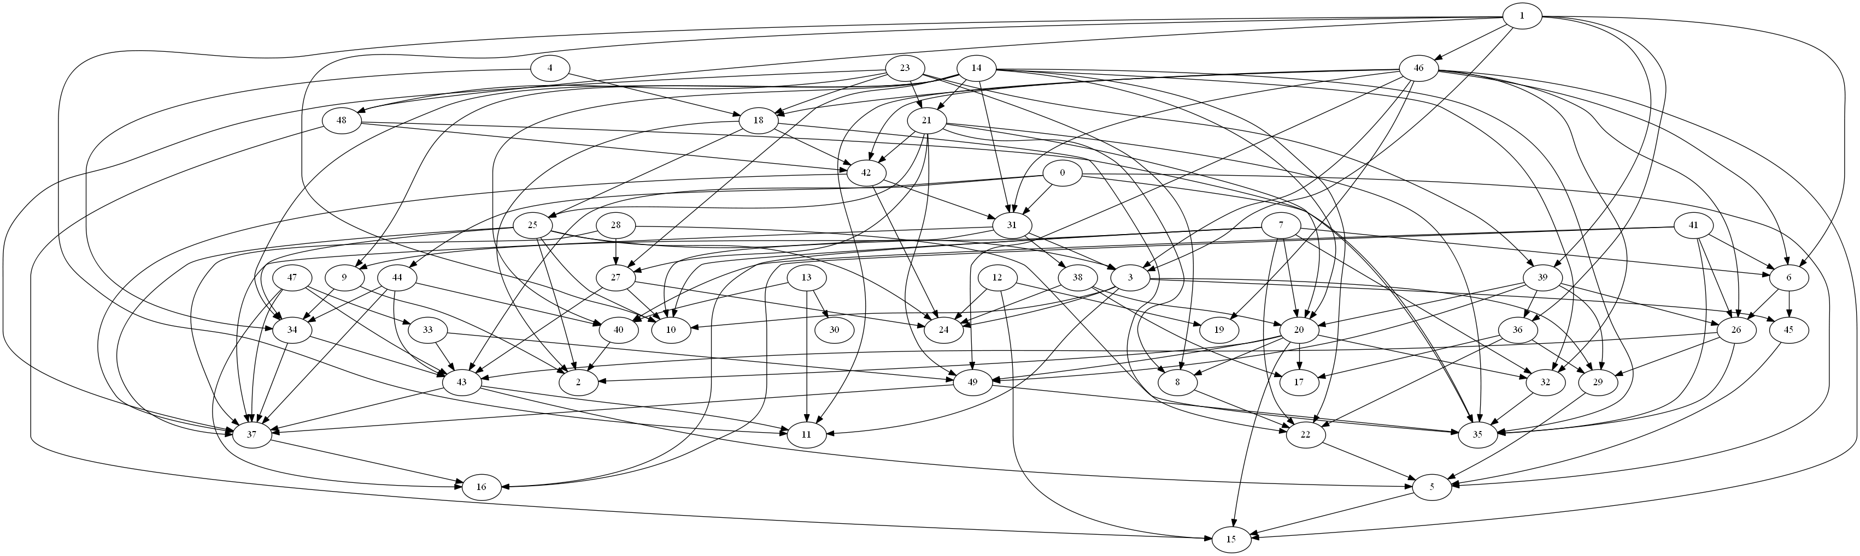
Directed Acyclic Graph generated by Java program and visualized using GraphViz

Each approach to solving the BFS problem actually produced two algorithms although they are grouped by approach (Sequential or serial, OpenMP, and POSIX). The “POSIX” approach actually uses the threading abstractions provided by the C++ 11 standard but the underlying implementation when compiled on a Linux machine is POSIX, so pthreads and mutexes aren’t referenced directly. The algorithms explored two aspects of breadth-first search: the initial search itself and st-connectivity or shortest pathfinding. The initial search crawls the graph from a starting node/vertex to discover all directed pathways available from that node. The shortest pathfinding then enumerates the shortest path available from that node to all connected nodes (if they are connected at all). Performance of these tasks was measured separately for each approach because they rely on separate algorithms. All tests were run on an Intel i5 processor with four cores operating at 3.40 GHz and 4 GB RAM.
Performance of the algorithms was measured against two scenarios. First, a constant number of vertexes (10000) is searched with an increasing factor of edges per vector for each trial (10, 20, 30, 100, etc.). The second scenario is an increasing number of vertexes with a constant factor of edges per vertex. It should be noted that while the overall graph has a certain number of vertexes and edges, the graph is randomly generated and therefore the number of actual vertexes and edges explored by the algorithm may vary. The same node was used for all trials, however, so each approach explored the same graph. Five different randomly-generated graphs were used for each data point and the average time of the five trials was plotted.
Implementation of the serial BFS closely followed that provided by Sedgewick and Wayne’s Algorithms, 4th ed [3, pg. 540], with some adaptations for use in C++. Parsing of the text files created by the Java program was enhanced with the use of OpenMP to parallelize loops which were converting strings into vertexes and edges in the graph. Using a similar approach, I used OpenMP directives in my first attempt at a parallelized BFS. Loops for exploring adjacent vertexes and returning connecting paths were turned into “parallel for” loops using OpenMP directives with a critical section protecting the updating of the frontier queue.
My initial attempt at parallelizing BFS with POSIX threads produced abysmal results, with running times significantly slower (up to a factor of 5) than the sequential implementation. This was partly due to my use of a bag data structure of my own creation as a replacement for the traditional queue (which produced erroneous results) and partly due to how I was using the threads. In the BFS algorithm, I used a thread pool which kicked off at every node k and marked the adjacent vertexes (k+1). This produced a situation where each thread was checking a mutex-protected bag of the vertexes at k+1, marking the vertex as visited, then returning to check the queue. The potential for convoy conditions here, as well as resource wasting by frequent creation and destruction of threads should be obvious (though it wasn’t to me when designing it).
My solution to this was to return to a mutex-protected queue and parallelize at k-1 once the queue reached a number of elements equal to the number of threads which would be used (defined by the user or by the hardware concurrency heuristic). That is, the algorithm would run sequentially until the number of adjacent vertexes needing exploration at k+1 reached sufficient size. I then kicked off the thread pool, which would feed the queue at a rate equal or faster than consumption by the threads for the duration of the algorithm’s execution. This significantly improved performance. It reduced checking of a mutex-protected variable as well as removing the constant creation and destruction of threads; instead, the same thread pool is in use for almost the entire execution.
My first version of the POSIX st-connectivity/shortest path algorithm suffered from much the same problems as the BFS algorithm. I used a thread pool which would iteratively check a bag of all of the vertexes in the graph for the next vertex, then find the paths from the source node to it. Using a thread pool essentially reduced the algorithm to an expensive sequential algorithm. To remedy this problem, I used a divide-and-conquer approach where the graph was split into roughly equal blocks for each thread, which could then be searched without any blocking or waiting. This also greatly improved performance, turning shortest-path finding into an almost trivial operation.

Experimental Results
The first notable feature of the results is that the POSIX optimization never produces a speed up of a factor equal to the number of additional threads being used. In the BFS algorithm, POSIX searching with two, three, and four threads is vastly superior to sequential search when the number of edges per vertex increases significantly but is at best competitive with the OpenMP four-threaded results. When the overall size and complexity of the graph increases constantly, however, POSIX is the clear winner in performance, regardless of the number of threads used.
Shortest-path finding results were more mixed. With a small graph (1000 vertexes), POSIX parallelization is clearly superior, regardless of the number of edges. When the overall complexity of the graph increases constantly (with eight edges per vertex), three- and four-threaded POSIX searches maintain a marginal advantage over the traditional sequential search.
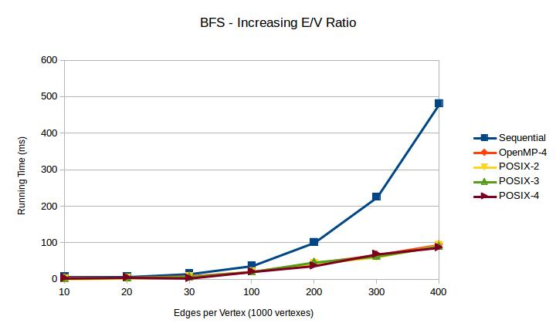
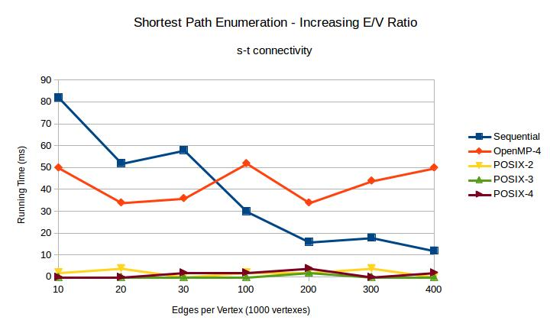
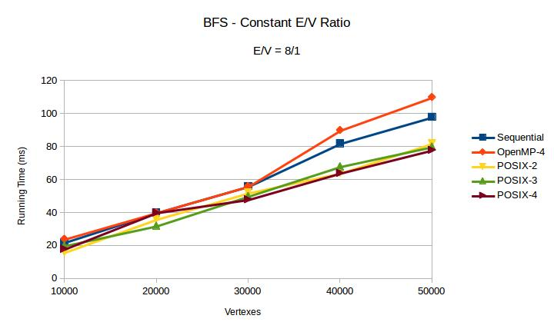
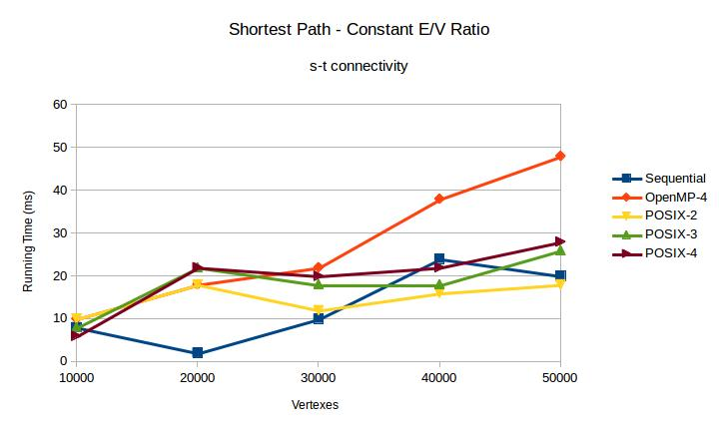
While at the small scale of these trials POSIX BFS does not exhibit a clear advantage to the traditional BFS, much larger scales may allow POSIX BFS to take the lead. Using a “large” graph provided by Sedgewick and Wayne’s companion website [4], the POSIX implementation delivered more definitively promising performance. For a graph with 1,000,000 vertexes and 7,586,063 edges, the algorithms produced the following results:
Approach | Breadth-First Search | Shortest-Path Finding
POSIX | 1580ms | 40ms
OpenMP | 1660ms | 720ms
Sequential | 2040ms | 50ms

Here, POSIX was 22.5% faster than the sequential implementation at BFS and 20% faster at shortest-path finding.
Conclusions
While many factors could contribute to the worse-than-expected performance of the POSIX optimizations of breadth-first search and shortest-path finding, two prime suspects should be investigated. The first is BFS’s sharing of data structures. In addition to the queue, which must be protected by a mutex in order to prevent race conditions (presenting obvious blocking situations), the arrays holding the graph vertexes and edges are also being accessed by multiple threads. This has a high probability of resulting in “cache ping-pong” [6, pg 236]. Cache ping-pong in this case, because processor caches may contain more than one element of an array in its cache line, “ownership of the cache line needs to be transferred to the processor running the that thread, only to be transferred to the cache for the processor running the thread for entry 1 when that thread needs to update its data item” [6, pg. 237]. The second is the assumption that with the number of threads at or below the number of processor cores, the thread will be able to carry out its instructions relatively uninterrupted. This does not take into account the number of tasks being performed by the operating system at any given time and the scheduling priority being given to other processes. For example, while each test was being run, Linux was also maintaining a responsive user interface, keeping a connection to the Internet, and running a spreadsheet program.
Possible Solutions for Future Research
One area for possible improvement of my POSIX algorithms is finding ways to reduce data sharing across threads. The shared queue for BFS is an area of high contention due to the requirement for a mutex. Anthony Williams describes a lock-free, wait-free queue which could alleviate some of this contention, although the additional processing requirements for each interaction could offset the advantages [6, pg. 209].
In their experimental implementation of a parallel BFS (PBFS) algorithm, Leiserson and Schardl introduced a “multiset” data structure called a “bag” as a replacement for the traditional BFS queue. This data structure proved to be a keystone of their PBFS implementation, allowing it to produce consistent speedups when compared to serial BFS. Where the queue-based BFS runs optimally in O(E + V) time (where E is the set of all edges and V is the set of all vertexes), Leiserson and Schardl report a run time of O((E + V)/P + Dlg^3(V/D)) (where P is the number of processors and D is the diameter of the graph) [2, pg.304]. Two challenges for application of Leiserson and Schardl’s solution to my scenarios may reduce its feasibility. The first, which could require some non-trivial additional coding, is that they use a special implementation of C++ created for MIT called Cilk++, which provides support for “hyperobjects” and reducers. This capability would have to be replicated to obtain the same performance in a standard implementation of C++. Second, Lieserson and Schardl’s bag depends on a binary graph structure. This would have to be adapted into a form that could accommodate n-ary graphs such as those I used.

References
[1] David A. Bader and Kamesh Madduri. 2006. Designing Multithreaded Algorithms for Breadth-First Search and st-connectivity on the Cray MTA-2. In Proceedings of the 2006 International Conference on Parallel Processing (ICPP '06). IEEE Computer Society, Washington, DC, USA, 523-530
[2] Charles E. Leiserson and Tao B. Schardl. 2010. A work-efficient parallel breadth-first search algorithm (or how to cope with the nondeterminism of reducers). In Proceedings of the twenty-second annual ACM symposium on Parallelism in algorithms and architectures (SPAA '10). ACM, New York, NY, USA, 303-314.
[3] Robert Sedgewick and Kevin Wayne. 2011. Algorithms 4th ed. Addison-Wesley, San Francisco, CA, USA.
[4] Robert Sedgewick and Kevin Wayne. 2011. Algorithms 4th ed companion site. http://algs4.cs.princeton.edu/code/
[5] Lie-Quan Lee, Andrew Lumsdaine, and Jeremy Siek. 2002. The Boost Graph Library User Guide and Reference Manual. Addison-Wesley, San Francisco, CA, USA, 12.
[6] Anthony Williams. 2012. C++ Concurrency in Action. Manning, Shelter Island, NY, USA.

