Link : https://github.com/gtsiwicki/DSCI_425_lab1_2

Body Fat:
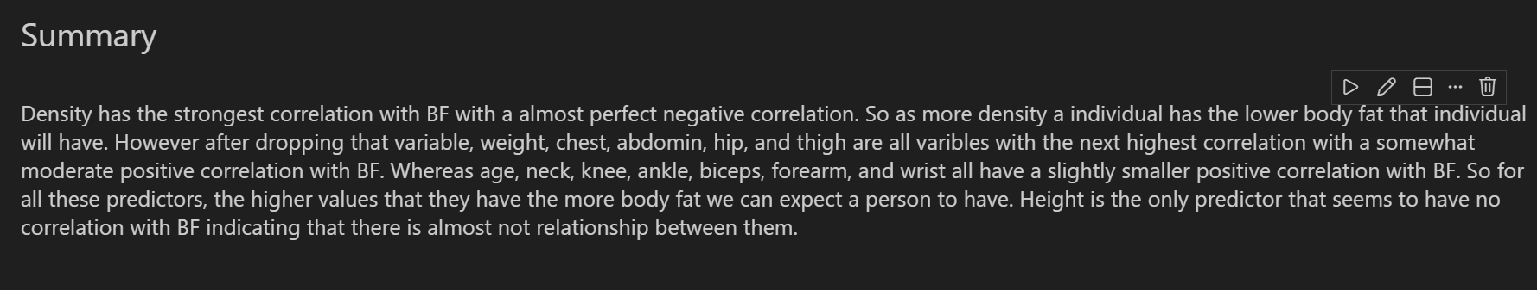
Home Prices:

