Review and Modelling of Electrochemical Hydrogen Compressors

Graham Smith

graham.smith@sintef.no +47 98 230 499

SINTEF Industry, Sem Sælands vei 12, Trondheim, 7034, Norway

# Introduction

Hydrogen refuelling stations filling vehicles to 70 MPa will require a supply of hydrogen at approximately 90 MPa. As electrolysers typically produce hydrogen at 0.3 MPa, compressors are a key component in the refuelling system. Transportation of hydrogen to refuelling stations and storage of hydrogen at refuelling stations is expected to be at 25 MPa, therefore at least some of this compression will happen at the refuelling station. There is therefore a requirement for economical compressors producing pure hydrogen at the scale required for widespread refuelling.

There are several different technologies capable of compressing hydrogen, one of the most promising is the electrochemical hydrogen compressor (ECHC).

|  |  |  |  |  |
| --- | --- | --- | --- | --- |
| **Property** | **ECHC** | **Pump** | **Metal Hydride** | **Liquefaction** |
|  |  |  |  |  |
|  |  |  |  |  |
|  |  |  |  |  |
|  |  |  |  |  |
|  |  |  |  |  |
|  |  |  |  |  |
|  |  |  |  |  |

Generically, an ECHC is an electrochemical cell running as a ‘proton pump’ with a higher hydrogen partial pressure on the anode than the cathode, Figure 1. In practice the electrodes used are very similar to cells in proton exchange membrane fuel cells with proton exchange membranes (PEM) acting as both a physical gas separator and an electrolyte.

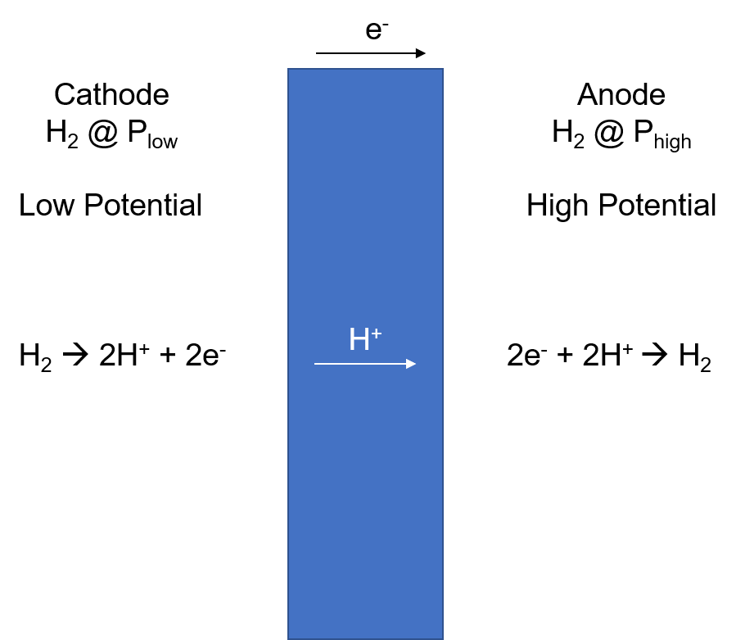

Figure 1: Operating schematic of an electrochemical hydrogen compressor

# Model Details

## One Dimensional DC Model

A one-dimensional model

Assumes a uniform current density

Isothermal model

### Equilibrium Potential

As the cell is symmetrical, the equilibrium potential (E0) is 0.00 mV at all temperatures. At 25°C the equilibrium potential will increase 59 mV for every order of magnitude increase in partial pressure.

|  |  |  |  |
| --- | --- | --- | --- |
| **Parameter** | **Symbol** | **Unit** | **Value** |
|  |  | mV | 0.00 |
|  |  | J K-1 mol-1 | 8.314 |
|  |  | K | 298.15 |
|  |  | C mol-1 | 96 485 |
|  |  | MPa |  |
|  |  | MPa |  |

### Ionic Resistance

The ionic resistance is modelled using ohms law. The

|  |  |  |  |
| --- | --- | --- | --- |
| **Parameter** | **Symbol** | **Unit** | **Value** |
| Current Density |  | A cm-2 |  |
| Resistance |  | Ω cm-2 |  |
| Temperature |  |  |  |
| Relative Humidity |  |  |  |
| Membrane Thickness |  | μm | 50 |

#### Membrane Resistance

#### Resistance in the Catalyst Layer

### Anode and Cathode Overpotential

Butler-Volmer kinetics are assumed. Assume that α = 0.5. Don’t use the tafel approximation because at low current densities / high exchange current densities i0>i and approximation is not valid (we’re in the micro-polarisation region)

There are a significant range of values reported for the exchange current density for the HOR and HER reactions. The values used here are from a paper by Gasteiger et al. running a proton exchange membrane fuel cell in a proton pump configuration at 313K. Operation was at 313K and 100 kPa H2 on both sides using 5wt% Pt/C with a mean particle size of 2.2 nm.

As both the HOR and HER are assumed to have a alpha value of 0.5 the Butler-Volmer equation can be rewritten as:

This equation provides the overpotential for one electrode. The two electrodes are then summed together.

#### Exchange current density variation with temperature and pressure

The exchange current density is sensitive to conditions such as pressure and temperature.

|  |  |  |  |
| --- | --- | --- | --- |
| **Parameter** | **Symbol** | **Unit** | **Value** |
|  | j0 | A cmspec-2 | 0.216 |
|  | α | - | 0.5 |

### Concentration Polarisation

Finite mass transport lowers the concentration at the surface of the electrode.

This has an impact on the equilibrium potential:

The exchange current density is sensitive to the partial pressure at the catalyst layer. See derivation for example.

|  |  |  |  |
| --- | --- | --- | --- |
| **Parameter** | **Symbol** | **Unit** | **Value** |
| Diffusion layer thickness | d |  |  |
|  |  |  |  |

### Crossover

Hydrogen gas will crossover through the membrane. This is a net reduction in the amount of hydrogen pressurised and is modelled as a negative current.

Net diffusion of hydrogen will occur from the high-pressure anode to the low-pressure cathode. This diffusion is proportional to the pressure.

**Relative Humidity At Different Pressures**

#### At Equilibrium

Assume that water in the system is at equilibrium between anode and cathode.

Low pressure RH –

High pressure RH –

#### With Current Flow

Drag from water crossover

Diffusion of water

**Durability**

Catalysts

Membranes

Gaskets

**Gas Purity**

Water removal from gas stream

Poisoning effects

# Results and Analysis

# Discussion

# Conclusions

# Acknowledgments

This work was supported by

The author extends their thanks to Martijn Mulder and Alejandro Barnett for helpful discussions.

# BIBILOGRAPHY