**Calendar App User Guide**

v1.0

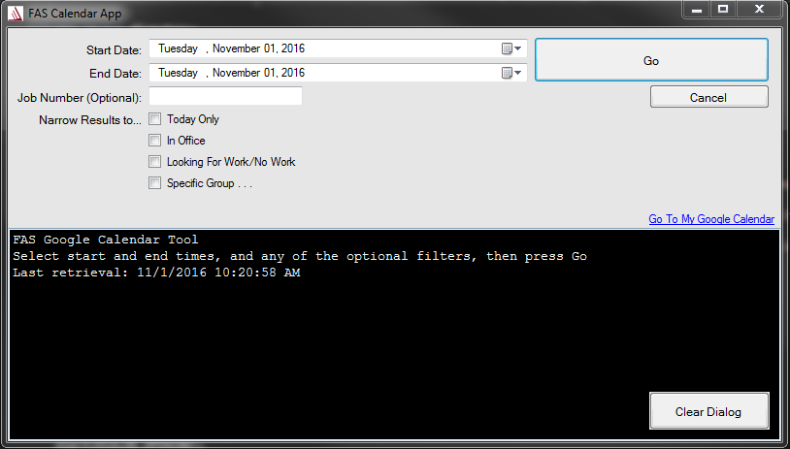

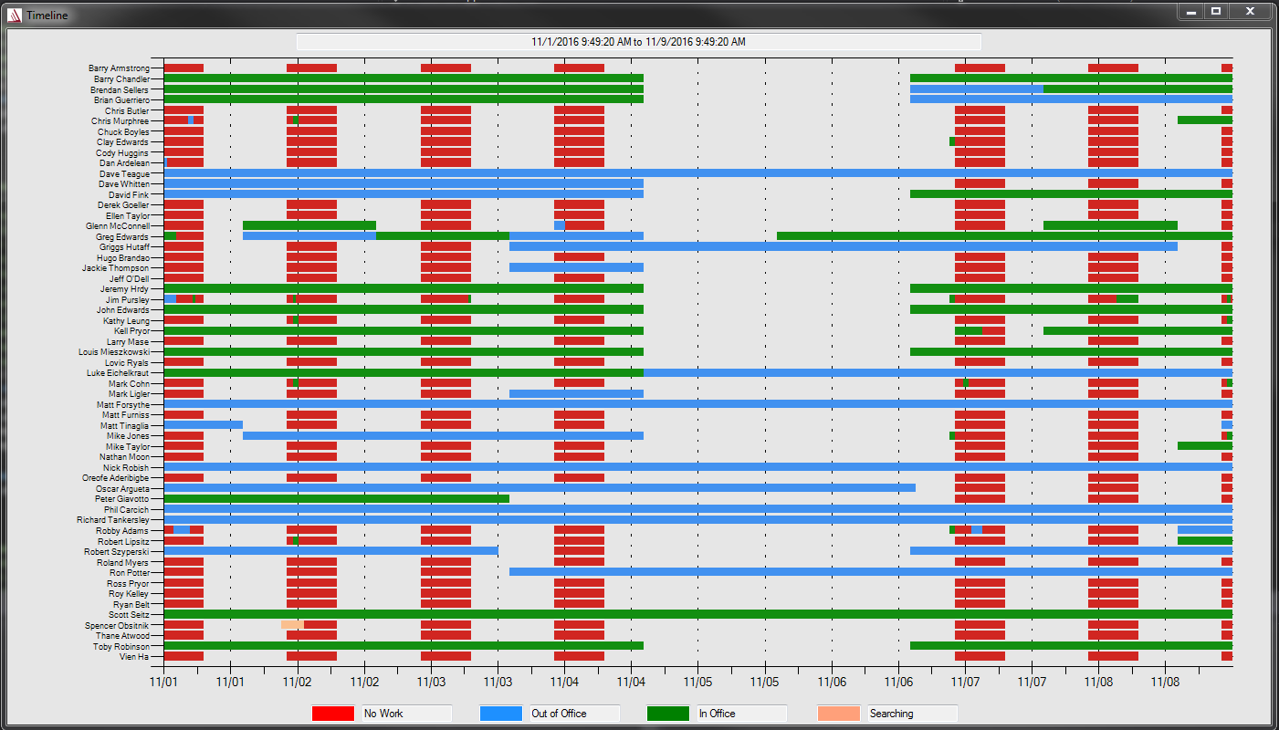This app was developed as a tool for engineers to be able to easily determine when/who is in office. **The minimum input needed for the application to work is the start and end dates**. Selecting “Go” will result in the following screen for the specified timespan:

A **Red** tag means no work or nothing in the employee’s calendar. The **Blue** signifies the employee is out of office. **Green** tags mean in office working on a job, and **Salmon** signifies the employee is searching for work.  *Mouse over individual timespans to see details of event.*

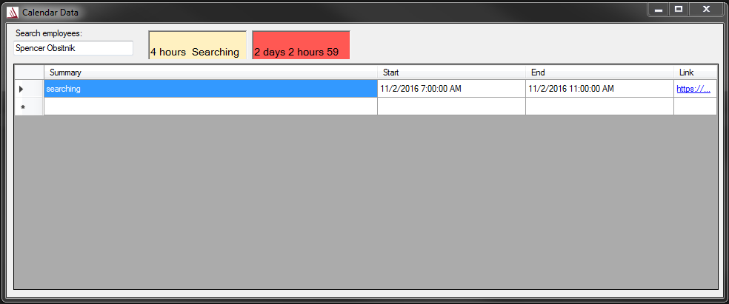Bringing up an instance of the graph also shows an **employee search screen**. This allows the user to search individual employees and bring up a textual representation of their calendar for the desired timespan.

The main search form also allows for filtering results based on a few parameters:

* **Job Number**: filters only users with this job number in their event description
* **Today Only**: single day filter, disables input start and end time
* **In Office**: returns only people in office (or without the OOO tag) regardless of what they are working on
* **Looking For Work/No Work**: returns anyone in office without an event or with the searching tag
* **Specific Group**: opens a new form to select individual employees

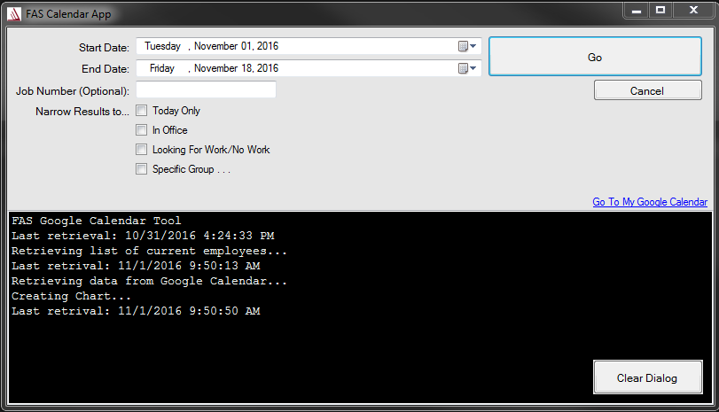

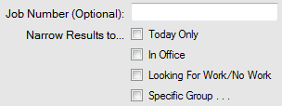

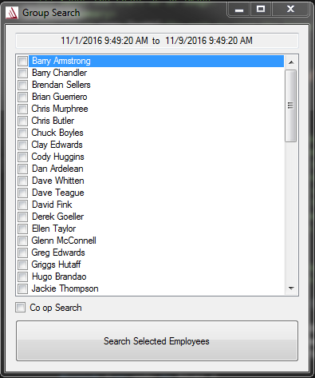 **Narrowing results to a specific group opens a new form that allows the user to select only certain employees**. Select the desired employees, then press the search button to open an instance of the graph with only the filtered employees.

**A Co op search field** is provided that will return a graph of the Co op’s timespan. *This list is hardcoded in and must be changed whenever coops change in order for it to be up to date.*

Filtering by group search yields only selected employees’ timespans.