**What is pseudocode and flowcharts?**

Flowcharts and Pseudocode provide ways for computer programmers and other working on a project to have an upper-level Understanding of both the entire projects and any algorithms involved in it. Both have benefits in describing the logic of the algorithms and can be used at different points in the programming process. However, either of these methods of planning for a project can save time and ensure everyone is on the same page *(Jackson, G. S., Darrington, J., Southern, M., Wang, S., & Techwalla Contributor.).*

**What are Flowcharts?**

It is a type of diagram that represents an algorithm, workflow or process, showing the steps as boxes of various kinds, and their order by connecting them with arrows according to *(Codeinminutes,2017).* Each shape represents a step in the process, and the arrows show the order in which they occur. Flowcharting combines symbols and flowlines, to show figuratively the operation of an algorithm.

**Flowcharting Symbols**

There are 6 basic symbols commonly used in flowcharting of assembly language programs: Terminal, Process, input/output, Decision, Connector and Predefined Process. This is not a complete list of all the possible flowcharting symbols, it is the ones usedmost often in the structure of Assembly language programming.

*(Table is shown in the next page)*

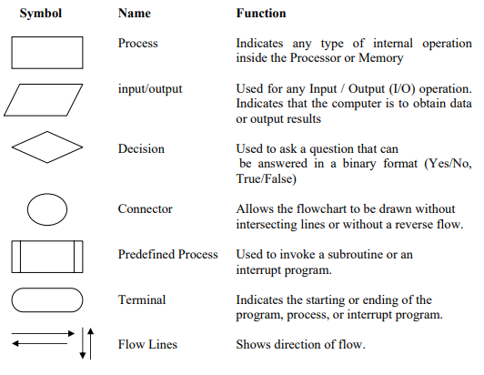**Example:**

The problem with this algorithm is that, some of the steps appear more than

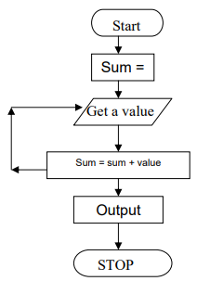once, i.e. step 5 get second number, step 7, get third number, etc. One could shorten the algorithm or flowchart as follows:

1. Start

2. Sum = 0

3. Get a value

4. sum = sum + value

5. Go to step 3 to get next Value

6. Output the sum

7. Stop

**What is Pseudocode?**

Is a method of describing computer algorithms using a combination of natural language and programming language. It is essentially an intermittent step towards the development of the actual code. It allows the programmer to formulate their thoughts on the organization and sequence of a computer algorithm without the need for actually following the exact coding syntax. Although pseudocode is frequently used there are no set of rules for its exact implementation.

In general, here are some rules that are frequently followed when writing pseudocode:

* The usual Fortran symbols are used for arithmetic operations (+, -, *, / , **).
* Symbolic names are used to indicate the quantities being processed.
* Certain Fortran keywords can be used, such as PRINT, WRITE, READ, etc.
* Indentation should be used to indicate branches and loops of instruction.

**Example:**

Suppose you are required to design an algorithm for finding the average of

six numbers, and the sum of the numbers is given. The pseudocode will be as follows

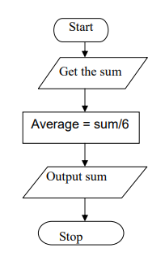Start

Get the sum

Average = sum / 6

Output the average

Stop

The corresponding flowchart will appear as follows:

References:

Jackson, G. S., Darrington, J., Southern, M., Wang, S., & Techwalla Contributor. (n.d.). Differences Between Psuedocode and Flowcharts. Retrieved from <https://www.techwalla.com/articles/differences-between-psuedocode-and-flowcharts>.

Codeinminutes. (2017, January 25). FLOWCHART VS PSEUDOCODE. Retrieved from <https://codeinminutes.wordpress.com/2016/04/04/flowchart-vs-pseudocode/>.

(n.d.). Retrieved from http://www.owlnet.rice.edu/~ceng303/manuals/fortran/FOR3_3.html.