KNOWLEDGE WORKER EDITION

Daily AI Brief
Command Center
  - A practical guide to monitoring publication, understanding editorial evidence, reviewing quality, and keeping every high-impact decision human-controlled.
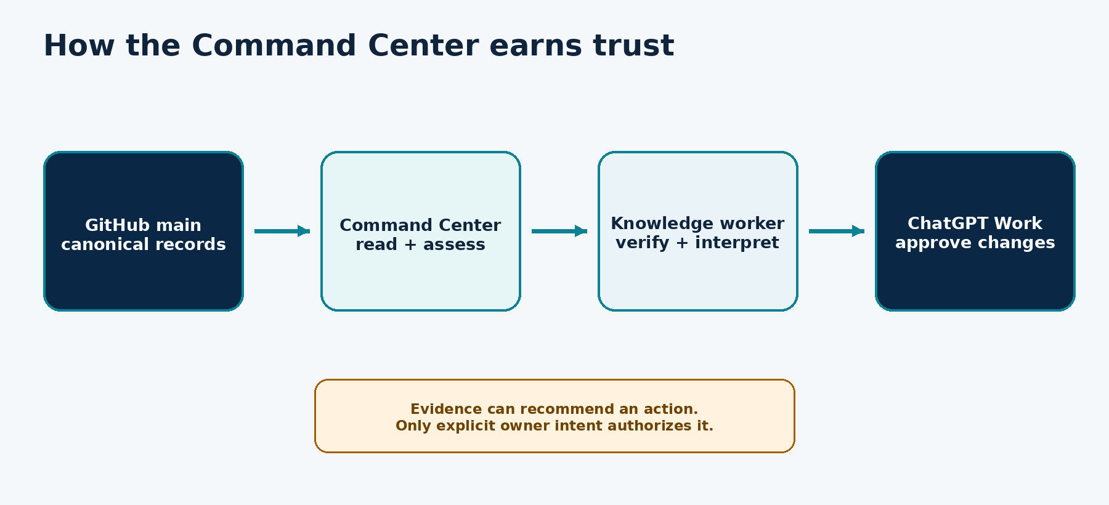
The Command Center turns GitHub evidence into an understandable, read-only operational view.
AUDIENCE  Knowledge workers using AI | GUIDE  Version 1.0 • Sep 2026 | SITE  Owner-only Command Center
Open the Daily AI Brief Command Center
START HERE

How to use this guide
Read Chapters 1-3 first. Then jump directly to the view or decision you need.
IF YOU NEED TO… | GO TO | YOU WILL LEARN
Understand the system | Chapters 1-2 | What the Command Center controls, where evidence comes from, and what remains public.
Run a morning check | Chapters 3-5 | How to scan Overview and trace Today’s Run.
Judge editorial quality | Chapters 6-9 | Selection, reader evidence, QA, incidents, and corrections.
Explore the system | Chapters 10-12 | History, components, automations, and Trend Radar.
Make a safe decision | Chapters 13-15 | Evidence language, approval boundaries, and operating rhythm.
Solve a problem | Appendices | Troubleshooting, glossary, and the one-page checklist.

LEARNING PATTERN Each chapter follows concept → interpretation → action → what good looks like. You do not need to understand code, Git, or automation design.

Five rules worth remembering
- GitHub is authoritative - The dashboard explains canonical records; it does not replace them.
- Missing is not healthy - Unavailable evidence stays Pending, Degraded, or Not measured.
- Green is evidence-bounded - A passing card means the configured checks passed - not that every imaginable risk is gone.
- History is append-only - Corrections preserve prior observations and add the resolution.
- Silence is not approval - High-impact production and editorial changes require explicit owner intent.
01

What the Command Center does
See the Daily AI Brief as a governed publishing system - not just a webpage.
The Daily AI Brief Command Center is a private, owner-only operational console. It brings today’s edition, editorial selection, quality evidence, reader signals, incidents, history, automations, and trends into one read-only view. The public brief, story pages, archive, feeds, feedback, QA history, and Trend Radar remain separate public assets.
LAYER | SOURCE OF TRUTH | COMMAND CENTER JOB
Editorial | Canonical dated edition and candidate records | Explain why six stories were selected.
Quality | QA, accessibility, CI, and deployment records | Surface pass, failure, repair, and evidence links.
Readers | Privacy-safe aggregate analytics and ratings | Show signal strength without overstating a small audience.
Operations | Automation summaries and append-only ledgers | Expose status and history without changing configuration.
Governance | Program state, policy profile, and owner decisions | Keep high-impact actions outside the dashboard.

PLAIN LANGUAGE Use the Command Center to answer five questions: Did today publish? Are the six stories valid? Did QA pass? Is anything broken? Does anything need my decision?
02

The source-of-truth model
Understand why “Live GitHub records” matters before reading any score.
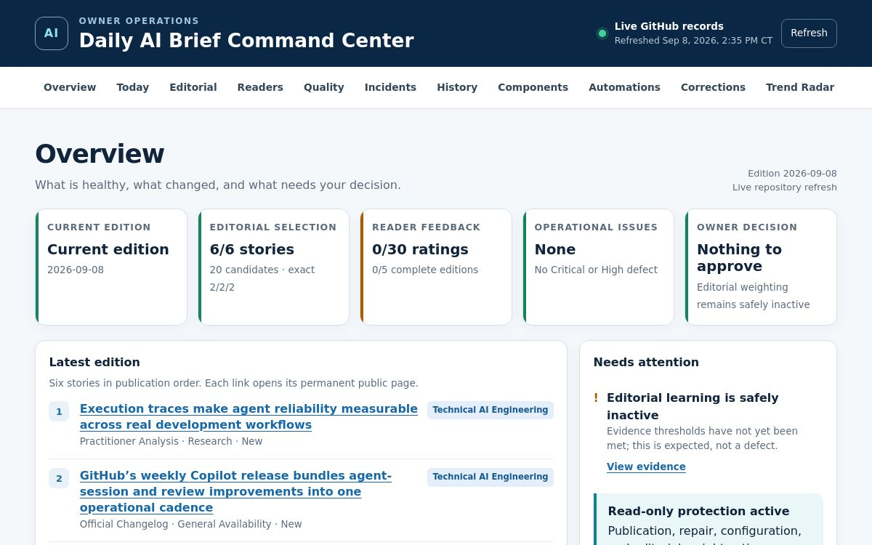
Live Overview: evidence status, edition, selection, feedback, issues, and owner decision.
The evidence indicator shows whether the page loaded current repository records or a timestamped verified fallback. If live retrieval fails, a safe fallback may appear, but the overall state cannot be presented as fully healthy.
SOURCE LABEL | MEANING | ACTION
Live GitHub records | Current canonical records loaded successfully. | Use timestamps and evidence links for normal review.
Verified fallback | A known snapshot is shown because live retrieval failed. | Treat as degraded; verify before any decision.
Data unavailable | Neither live records nor a usable fallback could load. | Do not infer publication or quality state.

03

Your 10-minute quick start
Build confidence with one safe scan from publication to evidence.

Minute 0-2: orient
- Confirm the evidence label and refresh time.
- Read Current edition, Editorial selection, Operational issues, and Owner decision separately.
- Open Needs attention before following a green total.

Minute 2-5: trace the edition
- Open Today.
- Confirm 20 candidates narrowed to six selected stories with exact 2/2/2 focus balance.
- Confirm deterministic CI, GitHub Pages, independent QA, and accessibility evidence.

Minute 5-8: inspect quality and corrections
- Open Quality and read the initial and final QA states.
- Open Incidents for current findings and the approval queue.
- Open Corrections to distinguish unique corrections from immutable ledger rows.

Minute 8-10: close the loop
- If no action is needed, leave the system unchanged.
- If evidence is stale or missing, request a targeted verification.
- If a high-impact change is proposed, decide in ChatGPT Work - not in the dashboard.
WHAT GOOD LOOKS LIKE You can explain what published, why the stories were chosen, what evidence passed, what remains uncertain, and whether a human decision is required.
04

Read the Overview
Turn five summary cards into a reliable priority order.
CARD | READ IT AS | DO NOT ASSUME
Current edition | Freshness of the latest canonical edition. | That the public page is correct without deployment evidence.
Editorial selection | Selected count and 2/2/2 balance. | That popularity can override evidence or novelty gates.
Reader feedback | Progress toward the learning evidence threshold. | That zero ratings is a defect.
Operational issues | Current findings derived from available records. | That “None” proves every subsystem is healthy.
Owner decision | Whether a bounded recommendation needs review. | That the dashboard can execute the decision.

Reliable triage order
- Evidence source - Fallback or unavailable data changes how every other card should be read.
- Owner decision - A prepared recommendation may be waiting.
- Operational issues - Failed or degraded evidence can affect today’s edition.
- Current edition - Freshness determines whether you are reviewing today or yesterday.
- Editorial and reader signals - Interpret them after hard operational gates.
05

Trace Today’s Run
Follow the current edition from evidence-screened candidates through publication and QA.
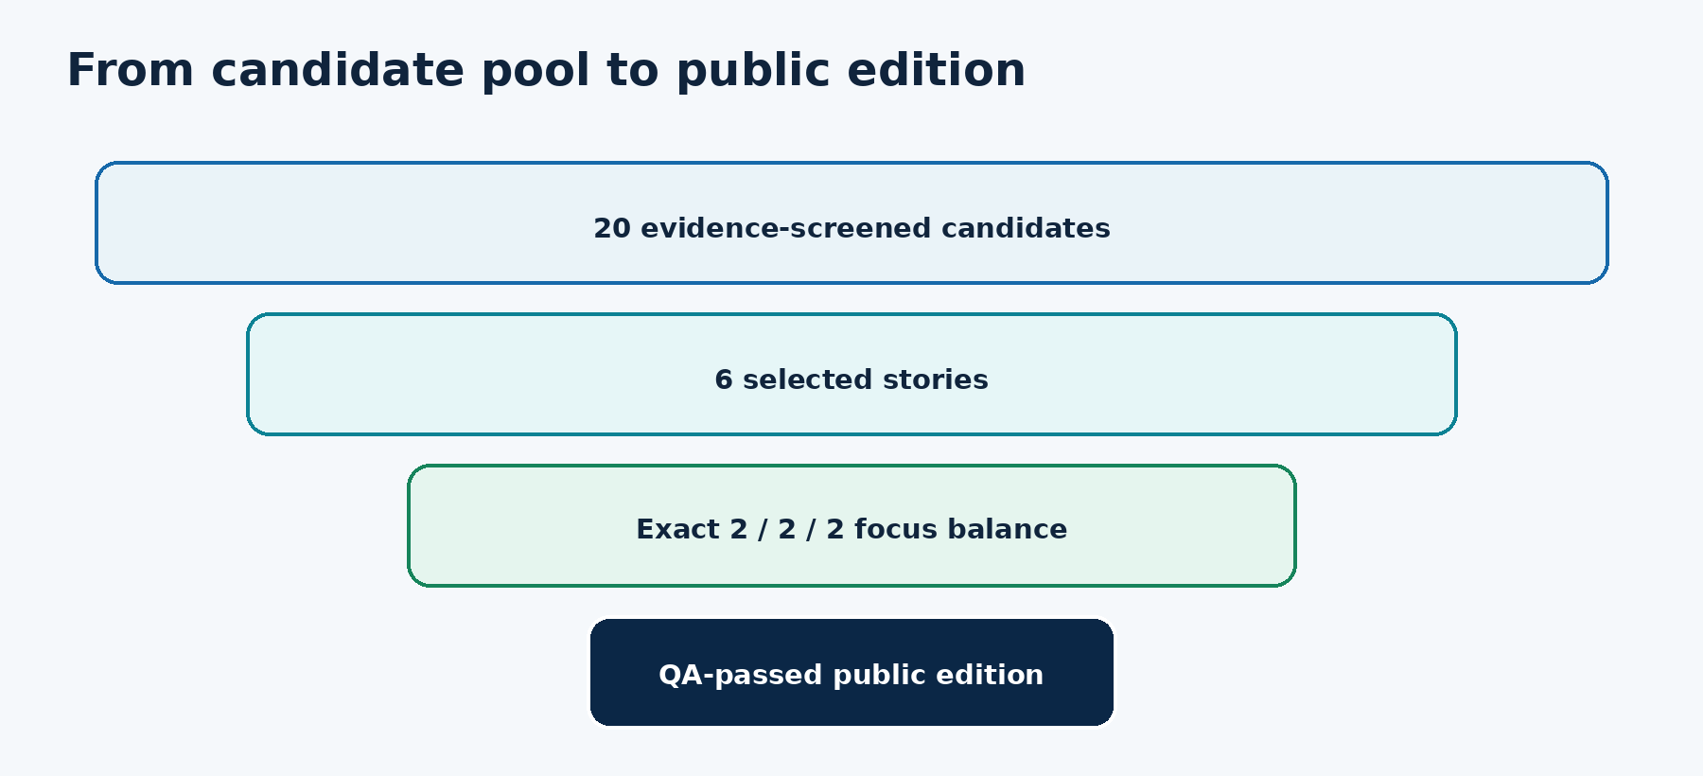
The editorial funnel preserves evidence quality and exact focus-area balance.
CHECKPOINT | WHAT TO VERIFY | EVIDENCE LINK
Candidate selection | Candidate count, selected count, scoring rationale, policy profile. | Candidate record
Deterministic CI | Latest check conclusion matches the observed repository head. | Workflow evidence
GitHub Pages | Deployment completed for the intended revision. | Deployment evidence
Independent QA | Initial result, repairs, final result, and defects. | QA record
Accessibility | Story alternatives and disposition were reviewed. | Accessibility record
Public edition | Permanent story pages and dated brief open correctly. | Current brief

KEY DISTINCTION A successful deployment proves a revision reached GitHub Pages. It does not, by itself, prove the editorial record or rendered content is correct.
06

Understand Editorial Intelligence
See why the six stories earned a place without turning scoring into a black box.
Editorial Intelligence summarizes the edition’s evidence mix, novelty disposition, focus allocation, and selection record. It links back to the canonical edition and candidate rationale so that every summary can be checked.
SIGNAL | WHY IT EXISTS | HARD BOUNDARY
Evidence class | Distinguishes official announcements, research, practitioner analysis, and other support. | Weak evidence cannot be rescued by popularity.
Novelty disposition | Protects the 30-day novelty gate and makes repeats visible. | Repetition requires an explicit supported exception.
2/2/2 allocation | Balances Technical AI Engineering, Applied GenAI, and Agents for Non-Technical People. | The exact allocation remains protected.
Candidate rationale | Explains why selected stories outranked alternatives. | Scores do not override accessibility or privacy.

INTERPRETATION Editorial scoring supports judgment. Evidence, novelty, accessibility, privacy, and exact focus balance are hard gates.
07

Use Readers & Editorial Learning
Learn from a small audience without pretending weak signals are strong evidence.
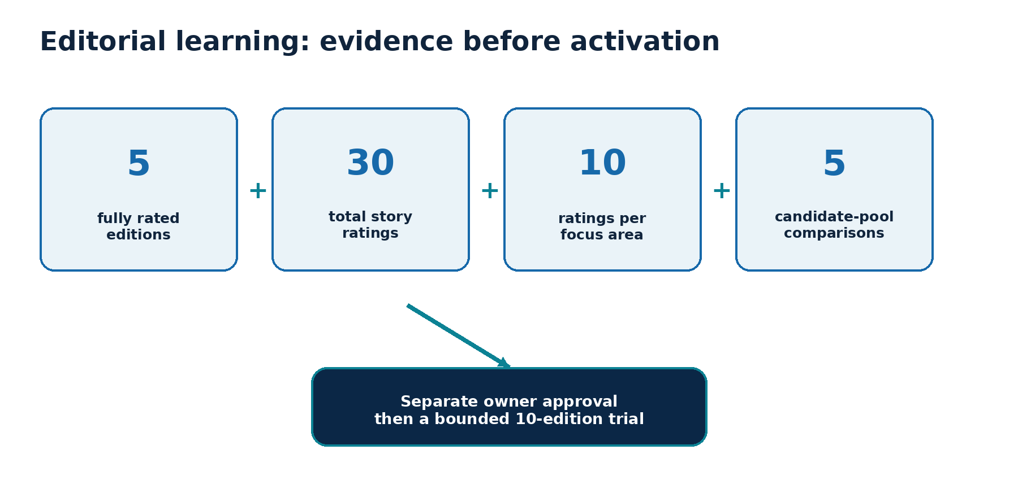
Every learning threshold must pass before a separate owner approval.
Reader analytics are directional: small counts are suppressed, shares count initiations, and ratings stay anonymous. Ratings may recommend a small Practical Value adjustment; they cannot weaken evidence, novelty, accessibility, privacy, or focus balance. Learning inactivity is expected until every threshold is met; it is not a defect.
THRESHOLD | MINIMUM | WHY
Fully rated editions | 5 | Prevents one unusual day from dominating.
Total story ratings | 30 | Creates a minimally useful signal base.
Ratings per focus | 10 each | Protects balanced learning across all three areas.
Candidate-pool comparisons | 5 passing sets | Checks that the proposed weighting improves selection quality.
Owner decision | Explicit approval | Keeps editorial authority human-controlled.

08

Interpret Quality & QA
Separate initial defects, automated repairs, final validation, and deployment proof.
FIELD | QUESTION
Initial QA | Did the first validation pass before any repair?
Repairs | What was changed, and was each change bounded to the defect?
Final QA | Did the complete required check set pass after repair?
Accessibility | Were alternatives, structure, links, and readable presentation checked?
Deployment evidence | Did the validated revision reach the public site?
Public QA history | Can a reader inspect the edition’s quality record?

FAILURE RULE A critical publication failure forces Failed even when every other available indicator is green.

When QA repairs something
- Read the initial failure and severity.
- Verify the repair is specific to the cause.
- Confirm final QA reran the full relevant checks.
- Confirm the deployed revision matches the validated revision.
- Keep the repair and result in append-only history.
09

Handle incidents and corrections
Move from a signal to a decision-ready assessment without erasing history.
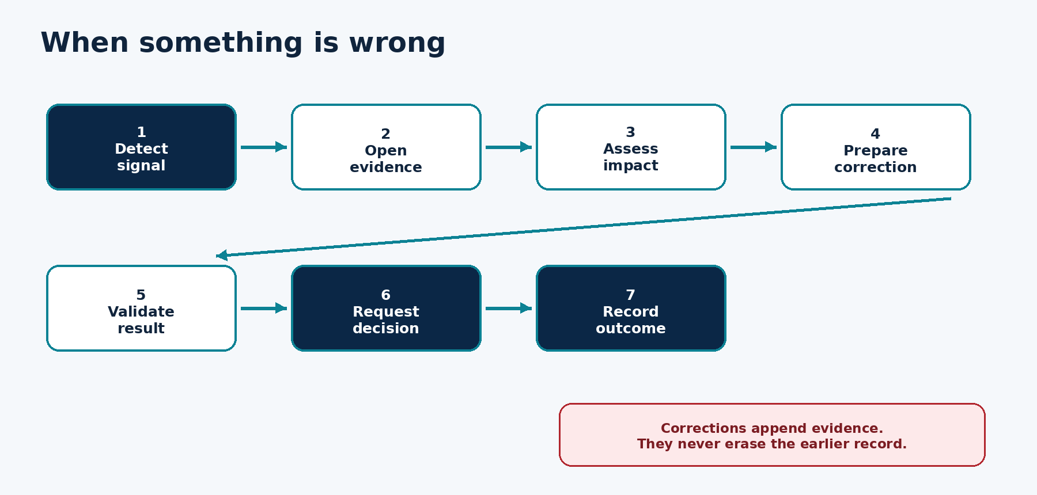
A controlled path turns a detected issue into evidence, validation, a human decision, and an auditable outcome.
VIEW | USE IT FOR | IMPORTANT DISTINCTION
Incidents | Current findings, impact, evidence, proposed action, validation, rollback, and approval state. | No ledger entries does not prove health.
Corrections | Material factual changes and affected public pages. | Unique corrections differ from immutable ledger rows.
Approval queue | Decision-ready high-impact changes. | No action is enabled inside the Command Center.

APPEND-ONLY RULE When duplicate observations or a corrected fact exist, preserve the original rows and append reconciliation evidence. Report canonical event counts without deleting history.
10

Search Story & Edition History
Use local search to explore the archive without sending your query to another service.
The History view lets you search by story, company, or topic and filter by focus area. Results show date, permanent story page, focus, evidence class, and availability. The current implementation can display up to 125 indexed stories.
TASK | ACTION | WHAT GOOD LOOKS LIKE
Find prior coverage | Search a company, product, or concept. | You see dated permanent pages and evidence types.
Check focus balance over time | Filter one focus area. | The list narrows without losing dates or evidence labels.
Investigate repetition | Compare related headlines and dates. | Novelty and prior-coverage evidence can be traced.
Share a story | Open the permanent page. | The URL remains stable beyond the daily homepage.

PRIVACY Search filtering happens in your browser. The query text is not sent to a search service.
11

Read Components and Automations
Understand subsystem health and schedules without exposing private configuration.
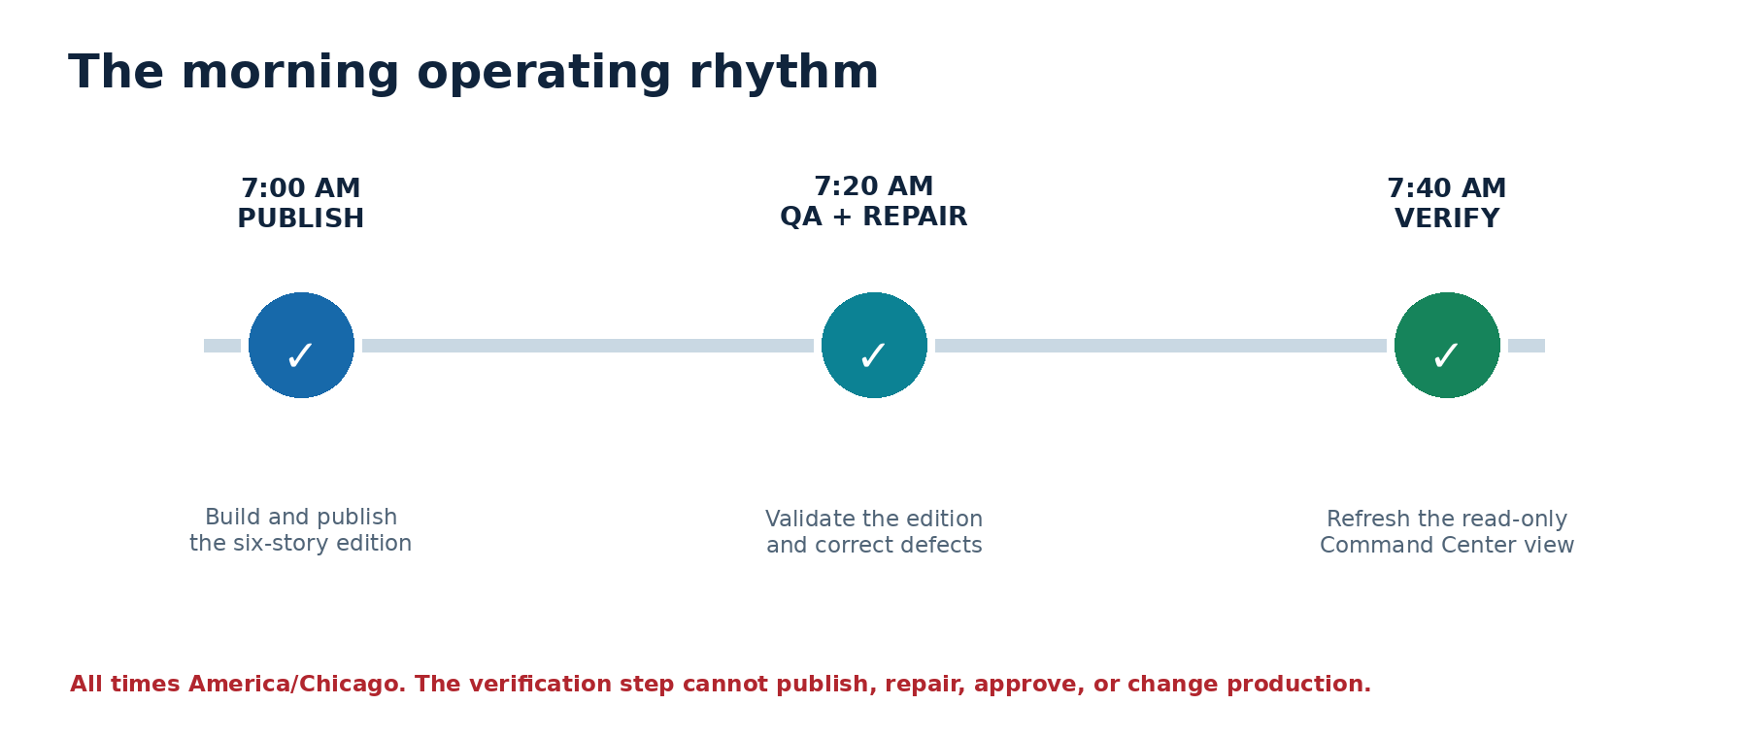
The publisher, QA, and read-only verification run in sequence each morning.
AREA | WHAT YOU CAN SEE | WHAT YOU CANNOT DO
Components | Publisher, ranker, Story Memory, CI, Pages, QA, analytics, learning, and feeds. | Change a subsystem from the dashboard.
Automations | Name, state, schedule, last verified run, and safe scope summary. | Pause, resume, edit, or reveal private instructions.
Evidence links | Public records and workflow results. | Access credentials, tokens, raw headers, or private prompts.

OPERATING BOUNDARY The 7:40 AM Command Center validation is intentionally unable to repair, publish, approve, or change production.
12

Use Trend Radar responsibly
Treat trend classification as descriptive evidence - not a forecast or editorial shortcut.
FIELD | MEANING | SAFE INTERPRETATION
Classification | Descriptive movement across recent evidence windows. | A pattern in observed stories, not a prediction.
Confidence | Strength and consistency of the supporting record. | Confidence in classification, not certainty about the future.
Evidence count | Supporting stories across the configured windows. | Volume, not importance by itself.
Linked record | Dated trend evidence in GitHub. | The place to verify the summary.

EDITORIAL SAFEGUARD Trend prominence can guide attention, but it does not override story-level evidence, novelty, or focus allocation.
13

Read evidence states correctly
Use explicit language so missing data never turns into false reassurance.
STATE | MEANING | NEXT MOVE
Healthy / Pass | Configured current evidence passed. | Continue normal monitoring.
Pending | Evidence is expected but incomplete or not yet due. | Wait or request the smallest needed check.
Degraded / At risk | A limitation, stale input, or failed noncritical signal exists. | Open the evidence and assess impact.
Failed | A critical publication or hard-gate condition failed. | Stop assumptions; investigate and recover.
Not measured | No trustworthy metric exists for this field. | Do not substitute zero.
Unspecified | Legacy records lack the modern field. | Keep the limitation visible.

GOLDEN RULE The Command Center must never create a green card from missing evidence.
14

Keep high-impact decisions human
Know which actions stay in ChatGPT Work and how to give an unambiguous answer.
DECISION-READY FIELD | WHAT TO EXPECT
Error or proposal | Exact behavior, record, route, or policy change.
Assessment | Impact, affected audience, cause, and confidence.
Corrective action | The smallest prepared change that addresses the cause.
Validation | QA, link, accessibility, publication, and regression evidence.
Recovery | Rollback or tested correction if the change regresses.
Decision | A direct request to approve, hold, or reject the specific scope.

Clear decision language
- Approve production - Authorize only the named version and stated scope.
- Do not publish - Reject the proposed production move.
- Hold - verify X - Name the one missing fact that must be checked before deciding.
HUMAN CONTROL A notification, acknowledgement, question, or silence is not authorization.
15

Adopt a sustainable operating rhythm
Keep oversight light enough to use every day and rigorous enough to trust.
CADENCE | REVIEW | SUCCESS SIGNAL
Daily after 7:40 AM | Source label, edition, QA, issues, owner decision. | Today’s state is explained in under ten minutes.
Weekly | Reader evidence, learning thresholds, corrections, automation freshness. | Every stale or unusual signal has a follow-up.
Monthly | Trend evidence, archive patterns, recurring defects, policy fitness. | Recommendations remain bounded and evidence-backed.
After an incident | Cause, impact, correction, validation, decision, outcome. | History tells the complete story end to end.
Before any high-impact change | Scope, evidence, rollback, protected dimensions. | Explicit approve, hold, or reject language exists.

16

Troubleshoot common symptoms
Choose the smallest safe next check before changing anything.
SYMPTOM | LIKELY INTERPRETATION | NEXT CHECK
Overview still shows yesterday | Today’s canonical record may be missing, stale, or before the expected window. | Refresh, check source label, then open Today evidence.
Live GitHub changed to fallback | Repository retrieval failed; a verified snapshot is displayed. | Treat as degraded and recheck GitHub evidence.
Six stories but QA is Pending | Editorial selection exists; quality evidence is incomplete. | Open QA and deployment records before trusting publication.
No operational issues | No finding was derived from current records. | Do not infer that every subsystem was audited.
Zero reader ratings | Learning evidence is insufficient. | Continue rating; do not activate weighting.
Immutable rows exceed unique corrections | Duplicate or reconciliation rows are preserved. | Use canonical unique count and read reconciliation evidence.
Automation appears stale | Safe snapshot or last-verified time may be old. | Verify the authoritative schedule outside the dashboard.
A public page looks wrong | Deployment success and content correctness differ. | Open permanent page, edition record, QA, and correction history.

17

Glossary
Use shared language to keep operational decisions precise.
TERM | DEFINITION
Canonical edition record | The authoritative dated machine record for the selected stories and edition facts.
Candidate pool | The evidence-screened set considered before the six-story selection.
Deterministic CI | Repeatable automated checks applied to the observed repository revision.
Evidence link | A direct path to the supporting public record or workflow result.
Hard gate | A requirement that scoring or popularity cannot override.
Owner decision | Explicit approval, hold, or rejection made outside the read-only dashboard.
Permanent story page | A stable public URL for one story after it leaves the homepage.
Policy profile | The named publication and editorial rule set used for the edition.
Source mode | Whether evidence came from live GitHub records or a verified fallback.
Story Memory | The record that supports novelty and prior-coverage checks.
Trend Radar | Descriptive classification of observed story patterns across evidence windows.

18

One-page operator checklist
Print this page or keep it beside the Command Center.

SCAN
- □ Confirm source label and refresh time
- □ Confirm current edition and six-story selection
- □ Review operational issues and owner decision

VERIFY
- □ Trace candidate, CI, deployment, QA, and accessibility evidence
- □ Read Pending, Degraded, Failed, Not measured, and Unspecified literally
- □ Check corrections and incident history before assuming closure

INTERPRET
- □ Separate deployment success from content correctness
- □ Treat reader analytics as directional
- □ Keep hard editorial gates separate from popularity

DECIDE
- □ Review scope, impact, validation, and recovery
- □ Use Approve production / Do not publish / Hold - verify X
- □ Confirm the outcome is appended to history
OPERATOR PROMISE No guessed facts. No silent promotion. No erased history. No high-impact action without explicit owner intent.
19

Sources and document control
Know what is universal, what is implementation-specific, and when to review this guide.

Primary implementation sources
Daily AI Brief repository Canonical publication code, records, ledgers, public routes, and documentation.
Public Daily AI Brief Current edition, archive, story pages, QA, Trend Radar, feedback, and feeds.
Daily AI Brief Command Center Private owner-only operational console documented in this guide.
This guide describes the observed Command Center implementation and its evidence contracts as of September 2026. Counts, dates, and current states will change. The reading method, source hierarchy, privacy boundary, append-only history, and approval gate remain the durable operating principles.
DOCUMENT RECORD Daily AI Brief Command Center User Guide • Knowledge Worker Edition • Version 1.0 • Prepared September 2026 • Review after a major navigation, evidence-contract, approval, privacy, or automation change.

